ECC Recommendation (YY)XX

Frequency planning and frequency coordination for Land Mobile systems operating at 26 GHz
Approved DD Month YYYY (Arial 9pt bold)

- The document has not been discussed and needs to be further discussed in the upcoming CG/ ECC PT1 meeting.

introduction

ECC recommendation of YY(XX) on Frequency planning and frequency coordination for Land Mobile systems operating at 26 GHz. (style: Heading 1)
“The European Conference of Postal and Telecommunications Administrations, (style: ECC paragraph)
considering
- that ECC/DEC/(18)06 provides the harmonised conditions for mobile/fixed communications networks (MFCN) operating in the bands 24.25-27.5 GHz
- That ECC Report 303 provide guidance to administrations for coexistence between 5G systems and Fixed Links in the 26 GHz
- That the 26 GHz frequency band will mainly be used for urban and suburban hotspot areas.
- that in CEPT countries the deployment of networks will need a bilateral agreement concerning the use of stations in the mobile service in one country and stations of other primary services in a neighbouring country
- that differences in the market demand for spectrum for MFCN and different authorisations regimes across CEPT countries is likely to lead to different timescales concerning the introduction of MFCN in the band 24.25-27.5 GHz;
- that bilateral agreement will be needed for coexistence between fixed links and MFCN in the 26 GHz frequency band will be managed at national level or through the cross-border coordination framework;
- that the use of UAS is subject to coordination and agreement between the administrations concerned
- That radioastronomy stations are observing in the adjacent (passive) band 23.6-24 GHz and require specific national measures for their protection.
- That this recommendation could be subject to review in a shorter time than 5 years in order to consider the possible impact of scenarii of deployments and density of equipment under general authorization
- that in many CEPT member countries there may be multiple operators for MFCN systems;
- that frequency planning of MFCN in border areas will be based on coordination between national administrations in cooperation with their operators;
- that different administrations may wish to adopt different approaches to cross border coordination;
- that administrations may diverge from the technical parameters, propagation models and procedures described in this Recommendation subject to bilateral / multilateral agreements;
- that coordination is necessary between countries operating different technologies and different channel bandwidths in the same frequency band;
- that in the case of operator arrangements approved by national administrations it is possible to deviate from this Recommendation;
- that Physical Cell Identifier (PCI) coordination is necessary for NR systems to avoid unnecessary signalling load and handover failures;

recommends
- that coordination between MFCN systems in border areas should be based on bilateral / multilateral agreements between administrations;
- that frequency coordination between MFCN systems and other systems in neighbouring countries should be based on bilateral / multilateral agreements between administrations;
- that operation between MFCN systems should be based on the principles and the field strength limits provided in Annex 1;
- that interference field strength predictions should be made using the appropriate propagation models defined in Annex 2 for MFCN systems;
- that if the levels in Annex 1 are exceeded the coordination is required and the procedure detailed in Annex 3 should be used;
- that coordination between neighbouring MFCN systems using NR technology in border areas should use the PCIs provided in Annex 4 when channel centre frequencies are aligned;
- that administrations should encourage and facilitate the establishment of arrangements between operators in different countries with the aim to enhance the efficient use of the spectrum and to optimise the coverage/throughput in their respective border areas;
- that this Recommendation should be reviewed within 5 years of its adoption in the light of practical experience of its application and of the operation of MFCN systems.

Note:
Please check the Office documentation database http://www.ecodocdb.dk for the up to date position on the implementation of this and other ECC Recommendations.
- FIELD STRENGTH LEVELS FOR THE CROSS-BORDER OPERATION between mfcn systems
  - field strength for indoor base station
MFCN TDD systems may be operated without coordination if the mean field strength produced by the cell (all transmitters within the sector) does not exceed the value of [tbc ] dBµV/m/5 MHz at 3 metres above ground level at the borderline.
Administrations may wish to agree on frequency coordination, in this case, the following principle applies:
- if MFCN TDD systems using preferential frequencies are in operation across both sides of a border and are synchronised or not synchronised across the border, base station may be used without coordination with a neighbouring country if the predicted mean field strength of each carrier produced by the base station does not exceed a value [tbc] dBµV/m/5MHz at a height of 3 m above ground at the borderline between countries for preferential PCIs and [tbc] dBµV/m/5MHz at a height of 3 m above ground at the borderline between countries for non-preferential PCIs.
- if MFCN TDD systems using non preferential frequencies are synchronised or not synchronised across the border, base station may be used without coordination with a neighbouring country if the predicted mean field strength of each carrier produced by the base station does not exceed a value [tbc] dBµV/m/5MHz at a height of 3 m above ground at the borderline between countries for all PCIs.
  - field strength for outdoor base station
MFCN TDD systems may be operated without coordination if the mean field strength produced by the cell (all transmitters within the sector) does not exceed the value of [tbc ] dBµV/m/5 MHz at 3 metres above ground level at the borderline for all PCIs.
If MFCN TDD systems are synchronised across the border, base station may be used without coordination with a neighbouring country if the predicted mean field strength of each carrier produced by the base station does not exceed a value [tbc] dBµV/m/5MHz at a height of 3 m above ground at the borderline between countries for preferential PCIs and [tbc] dBµV/m/5MHz at a height of 3 m above ground at the borderline between countries for non-preferential PCIs.
Administrations may wish to agree on frequency coordination, in this case, the following principle applies:
- if MFCN TDD systems using preferential frequencies are in operation across both sides of a border and are synchronised or not synchronised across the border, base station may be used without coordination with a neighbouring country if the predicted mean field strength of each carrier produced by the base station does not exceed a value [VV] dBµV/m/5MHz at a height of 3 m above ground at the borderline between countries.
- if MFCN TDD systems using non preferential frequencies are synchronised or not synchronised across the border, base station may be used without coordination with a neighbouring country if the predicted mean field strength of each carrier produced by the base station does not exceed a value [DD] dBµV/m/5MHz at a height of 3 m above ground at the borderline between countries.

- PROPAGATION MODELS
The following methods are proposed for assessment of anticipated interference inside neighbouring country based on established trigger values. Due to complexity of radiowave propagation nature different methods are proposed to be considered by administrations and are included here for guidance purposes only.
It should be noted that following methods provide theoretical predictions based on available terrain knowledge. It is practically impossible to recreate these methods with measurement procedures in the field. Therefore only some approximation of measurements could be used to check compliance with those methods based on practical measurement procedures. The details of such approximation are not included in this recommendation and should be negotiated between countries based on their radio monitoring practices.
Path specific model
Where appropriate detailed terrain data is available, the propagation model for interference field strength prediction is the latest version of Recommendation ITU-R P.452 [4]. For the relevant transmitting terminal, predictions of path loss would be made at x km steps along radials of y km at z degree intervals. The values for those receiver locations within the neighbouring country would be used to construct a histogram of path loss – and if 10% of predicted values exceed the threshold the station shall be required to be coordinated.
Values for x, y and z are to be agreed between the administrations concerned.
Site General model
If it is not desirable to utilise detailed terrain height data for the propagation modelling in the border area, the basic model to be used to trigger coordination between administrations and to decide, if coordination is necessary, is Recommendation [ to be completed]. This model is to be employed using a receiver height of 3 m.
Administrations and/or operators concerned may agree to deviate from the aforementioned model by mutual consent .
Area calculations
In the case where greater accuracy is required, administrations and operators may use the area calculation below.
For calculations, all the pixels of a given geographical area to be agreed between the Administrations concerned in a neighbouring country are taken into consideration.
For the relevant base station, predictions of path loss should be made for all the pixels of a given geographical area from a base station and at a receiver antenna height of 3 m above ground.

- EXCHANGE OF INFORMATION
When requesting coordination the relevant characteristics of the base station, the code group number and the PCI (physical-layer cell-identity) numbers (in case of a network, e.g. NR, uses PCI), should be forwarded to the Administration affected. All of the following characteristics should be included:
- carrier frequency (MHz)

- name of transmitter station

- country of location of transmitter station

- geographical coordinates (W/E, N; WGS84)

- effective antenna height (m)

- antenna polarisation

- antenna azimuth (deg)

- directivity in antenna systems or antenna gain (dBi)

- effective radiated power (dBW)

- expected coverage zone

- date of entry into service (month, year).

- PCI numbers used

- antenna tilt (deg / Electric and mechanic tilt)

- antenna pattern or envelope.

The Administration affected shall evaluate the request for coordination and shall within 30 days notify the result of the evaluation to the Administration requesting coordination.
If in the course of the coordination procedure an Administration may request additional information.
If no reply is received by the Administration requesting coordination within 30 days it may send a reminder to the Administration affected. An Administration not having responded within 30 days following communication of the reminder shall be deemed to have given its consent and the code coordination may be put into use with the characteristics given in the request for coordination.
The periods mentioned above may be extended by common consent.
As a basis during the exchange of information besides listed characteristics above administrations could use formats created within ITU in accordance with Resolution 906 (WRC-12) [9].

- PROPAGATION MODELS
The following methods are proposed for assessment of anticipated interference inside neighbouring country based on established field strength levels. Due to complexity of radio wave propagation nature different methods are proposed to be considered by administrations and are included here for guidance purposes only.
It should be noted that following methods provide theoretical predictions based on available terrain knowledge. It is practically impossible to recreate these methods with measurement procedures in the field. Therefore only some approximation of measurements could be used to check compliance with those methods based on practical measurement procedures. The details of such approximation are not included in this recommendation and should be negotiated between countries based on their radio monitoring practices.
Path specific model
Where appropriate detailed terrain data is available, the propagation model for interference field strength prediction is the latest version of Recommendation ITU-R P.452 [4]. For the relevant transmitting terminal, predictions of path loss would be made at x km steps along radials of y km at z degree intervals. The values for those receiver locations within the neighbouring country would be used to construct a histogram of path loss – and if 10% of predicted values exceed the threshold the station shall be required to be coordinated.
Values for x, y and z are to be agreed between the administrations concerned.
Site General model
If it is not desirable to utilise detailed terrain height data for the propagation modelling in the border area, the basic model to be used to trigger coordination between administrations and to decide, if coordination is necessary, is Recommendation [ ITU-R M.2412]. This model is to be employed using a receiver height of 3 m.
Administrations and/or operators concerned may agree to deviate from the aforementioned model by mutual consent.
Area calculations
In the case where greater accuracy is required, administrations and operators may use the area calculation below.
For calculations, all the pixels of a given geographical area to be agreed between the Administrations concerned in a neighbouring country are taken into consideration.
For the relevant base station, predictions of path loss should be made for all the pixels of a given

- PREFERENTIAL PHYSICAL-LAYER CELL IDENTITIES (PCI) FOR 5G NR
- This Annex has been modified in line of that of ECC/REC(08)02. It is planned that the text of the two Annexes is identical as far as possible.
ETSI TS 138 211 defines NR Physical channels and modulation, in NR 2-step identification using PSS/SSS detection of the Physical Cell ID.
Each country should use their own preferential PCIs as a result of sharing of PCIs, depending on cross-border co-ordination scenario and interference field strength.
Sharing of PCIs between operators of neighbouring countries should only be applied where channel centre frequencies used in the neighbouring countries are aligned independent of the channel bandwidth or where it is not known whether or not the channel centre frequencies used in the neighbouring countries are aligned, or where there is no network in operation in the neighbouring country unless otherwise stated in Annex 1 or administration agreements / operator arrangements. In addition, the trigger values of field strength given in Annex 1 for non-preferential PCIs should also be examined.
The preferential PCIs of a two country PCI sharing should be applied for a base station if the trigger value of field strength relating to non-preferential PCIs (in Annex 1) could be exceed at the borderline of only one neighbouring country. The preferential PCIs of a three country PCI sharing should be applied for a base station if the trigger value of field strength relating to non-preferential PCIs (Annex 1) could be exceed at the borderline of only two neighbouring countries.
As shown in the Table 3 below, the PCIs for NR are divided into 6 sub-sets containing each one sixth of the available PCIs. Each country is allocated three sets (half of the PCIs) in a bilateral case and two sets (one third of the PCIs) in a trilateral case, therefore dividing the PCI groups or PCIs is equivalent. Four types of countries are defined in such a way that no country will use the same code set as any one of its neighbours. The following lists describe the distribution of European countries:
Type country 1: AZE, BEL, CVA, CYP, CZE, DNK, E, FIN, GRC, IRL, ISL, LTU, MCO, SMR, SRB, SUI, SVN and UKR,
Type country 2: AND, BIH, BLR, BUL, D, EST, G, GEO, HNG, I, MDA and RUS (Exclave),
Type country 3: ALB, AUT, F, HOL, HRV, MLT, POL, POR, ROU, RUS and S,
Type country 4: LIE, LUX, LVA, MKD, MNE, NOR, SVK, TUR.
(Note: Country type map can be found in the figure below).
For each type of country, the following Tables and figure describe the sharing of the PCIs with its neighbouring countries, with the following conventions of writing:
Preferential PCI
non-preferential PCI

Table 3: PCI sub-sets for use in border areas
PCI | Set A | Set B | Set C | Set D | Set E | Set F |  | PCI | Set A | Set B |  | Set C | Set D | Set E | Set F
Country 1 | 0..83  504-587 | 84..167  588..671 | 168..251  672..755 | 252..335  756..839 | 336..419  840..923 | 420..503  924..1007 |  | Country 2 | 0..83  504-587 |  | 84..167  588..671 | 168..251  672..755 | 252..335  756..839 | 336..419  840..923 | 420..503  924..1007
Border 1-2 |  |  |  |  |  |  |  | Border 2-1
Zone 1-2-3 |  |  |  |  |  |  |  | Zone 2-3-1
Border 1-3 |  |  |  |  |  |  |  | Border 2-3
Zone 1-2-4 |  |  |  |  |  |  |  | Zone 2-1-4
Border 1-4 |  |  |  |  |  |  |  | Border 2-4
Zone 1-3-4 |  |  |  |  |  |  |  | Zone 2-3-4
PCI | Set A | Set B | Set C | Set D | Set E | Set F |  | PCI | Set A |  | Set B | Set C | Set D | Set E | Set F
Country 3 | 0..83  504-587 | 84..167  588..671 | 168..251  672..755 | 252..335  756..839 | 336..419  840..923 | 420..503  924..1007 |  | Country 4 | 0..83  504-587 |  | 84..167  588..671 | 168..251  672..755 | 252..335  756..839 | 336..419  840..923 | 420..503  924..1007
Border 3-2 |  |  |  |  |  |  |  | Border 4-1
Zone 3-1-2 |  |  |  |  |  |  |  | Zone 4-1-2
Border 3-1 |  |  |  |  |  |  |  | Border 4-2
Zone 3-1-4 |  |  |  |  |  |  |  | Zone 4-2-3
Border 3-4 |  |  |  |  |  |  |  | Border 4-3
Zone 3-2-4 |  |  |  |  |  |  |  | Zone 4-3-1

Notes
- In certain specific cases (e.g. AUT/HRV) where the distance between two countries of the same type number is very small (< few 10s km) and at the same time harmful interference for that distance could occur, it may be necessary to address the situation in bilateral /multilateral coordination agreements as necessary, and further subdivision of the allocated PCIs may be included in certain areas.

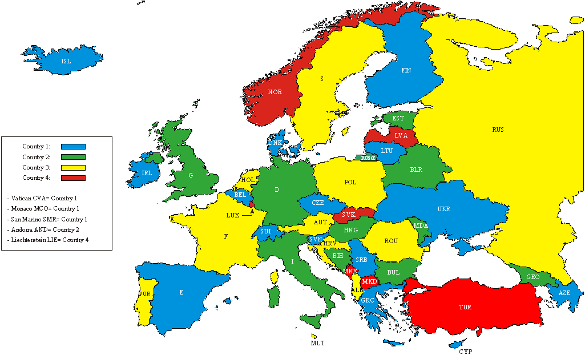
- Country type map

- practical approaches for cross-border coordination of SYNCHRONIZED AND unsynchronized systems
[This annex could be aligned with section 6 of the ECC Report on synchronization framework at 26 GHz.]

- List of reference
This annex contains the list of relevant reference documents.
- Example of the first reference (style: reference)
- The second reference
- etc.

e.g. as used by members of the HCM-Agreement [6]

