regulatory example from UK

Overview
On 25 July 2019, Ofcom (UK) published a Statement, Enabling wireless innovation through local licensing, which set out two new licence products the UK introduced to make it easier for a wider range of users in the UK to access radio spectrum on a shared basis.
These licence products are:
- the Shared Access licence, which gives access to four spectrum bands which support mobile technology; and,
- the Local Access licence, which provides a way for other users to access spectrum which has already been licensed to the UK’s Mobile Network Operators (MNOs), in locations where an MNO is not using their spectrum.
One of the bands available for the Shared Access licence in the UK is 3.8-4.2 GHz (specifically 3805-4195 MHz).

Introduction to the UK Shared Access licence

The UK Shared Access licence is part of a new framework for enabling shared use of spectrum
The UK’s spectrum sharing framework is intended to provide a simple method for users to access spectrum in a number of frequency bands.
One of the aims of this new framework is to make it easier for people and businesses to access spectrum which can be used to support a wide range of local wireless connectivity applications.
This spectrum sharing framework enables access to a number of bands under a common process as outlined below:
- New users will apply to Ofcom to get licences for the locations, bands and bandwidths that they need to provide their service.
- Ofcom will assess applications to see if any interference would be caused to, or received from, other licensees in the band.
- Ofcom will grant individual licences for the requested locations, bands and bandwidths on a first come, first served basis, provided that the application passes this coordination process.
- Users will pay licence fees to Ofcom, which are due annually.
The UK provides guidance setting out the approach Ofcom generally expects to take when assessing and issuing Shared Access licences. However, Ofcom may consider exceptional applications on a case-by-case basis, and retains the discretion to amend its approach, and to make exceptions or disapply the guidance if it is appropriate to do so in the particular circumstances. Ofcom will also keep this general guidance under review and may amend it from time to time as appropriate, accounting for how these licences are used in practice.

There are two kinds of licence: low power and medium power
To provide a range of options for new users, the UK offers two different versions of the Shared Access licence, which authorises uses in slightly different ways:
Low power licence
The low power licence product could be suitable for industrial and enterprise users looking to deploy their own private networks. This could be to support voice and text applications or other wireless data applications around their sites; it could also potentially be used for indoor mobile coverage extension schemes, for example through a neutral host model.
The low power licence authorises users to deploy as many base stations as they require within a circular area with a radius of 50 metres, centred on a coordinate provided to Ofcom by the user when they apply for the licence. Users have the flexibility to move their base stations around within the licensed area without requiring further coordination by Ofcom.
Users looking for the flexibility to place base stations anywhere within a larger area can apply for multiple low power licences, which could be contiguous or spaced out over a larger area. You can see some examples of this in Figure 2 and Figure 3 below.
There is an indoor-only option available, as well as an indoor/outdoor option for users looking to deploy either partly or wholly outdoors.
Base stations covered by the low power Shared Access licence can connect to fixed, nomadic or mobile terminals.
Medium power licence
This licence could be suitable for users who need a longer transmission range from their base station, but don’t expect to need to change the locations of base stations once they’re deployed. This could suit providers of Fixed Wireless Access (FWA) services in rural areas, along with industrial or enterprise users with sites spread over a larger area, such as ports, agriculture or forestry.
The medium power licence will authorise a single base station. The base station can connect to fixed, nomadic or mobile terminals.
Medium power base stations are generally only permitted in rural areas, as their increased power and transmitting range mean that if they were deployed in urban areas, they could potentially prevent a large number of low power users from deploying.
Comparison
Figure 1 below shows how the two types of licence differ, with the low power licence authorising an area where the base stations could operate, and the medium power licence authorising each base station individually.
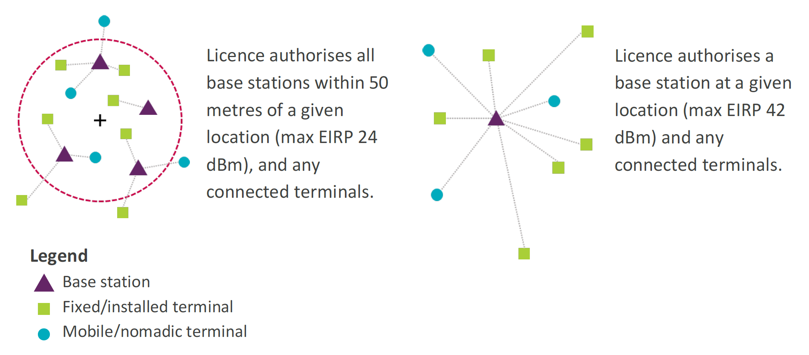
Figure 1: Low power (left) and medium power (right) Shared Access licences
Airborne use is not permitted for both the low and medium power licences.

Deployment restrictions
Although the Shared Access licence is generally available all around the UK, there are some exceptions to this:
- The medium power licence is generally only available in rural areas.
- Licences in the 3.8-4.2 GHz band are not currently accepted within 5 km of some MOD sites.
Additionally, it is not permitted to use the 3.8-4.2 GHz band to provide national mobile broadband services; national licences for spectrum in the 3.6-3.8 GHz band have been awarded in the UK for that purpose.

Dynamic Spectrum Access and how this might affect licences
In the future, Ofcom may move towards a Dynamic Spectrum Access (DSA) approach if appropriate, where users’ equipment would communicate directly with a central database in order to access spectrum. This means that frequencies are only assigned when requested directly from the spectrum assignment database.
This would help to ensure that the shared spectrum is being used effectively and efficiently, and would mean that if a user no longer transmits in their assigned frequency in a particular place, this would automatically become available again for other users.
Therefore, there may be changes to Ofcom’s licencing in the future if a DSA approach is deemed appropriate. If a DSA approach is introduced in the shared access bands, the first come, first served principle will remain.
However, at this time the DSA concept is embedded in UK Shared Access licences as follows:
- The licensee must start transmitting within six months of being issued a licence, and continue to remain operational after this time.
- Ofcom may request a licensee to change frequency from time to time; this may be for spectrum planning purposes, or to deal with interference.

The low power Shared Access licence
Rather than authorising one specific base station, the low power licence authorises any number of base stations located in a circular area with a radius of 50 metres, centred on a coordinate provided to Ofcom by the user.
Fixed, mobile or nomadic terminals can be connected to any base stations operating within the area covered by your licence, and these terminals are also authorised by a licence.
Users are free to deploy as many base stations as they like in the licensed area, and can move base stations around within this area without needing to inform Ofcom of such changes.
If a user wants to deploy base stations in a larger area, they can apply for multiple areas as part of the same licence application. It could be that these areas are next to each other and overlapping, as shown in Figure 2 below, or spaced out around a larger site, like in Figure 3 further down.
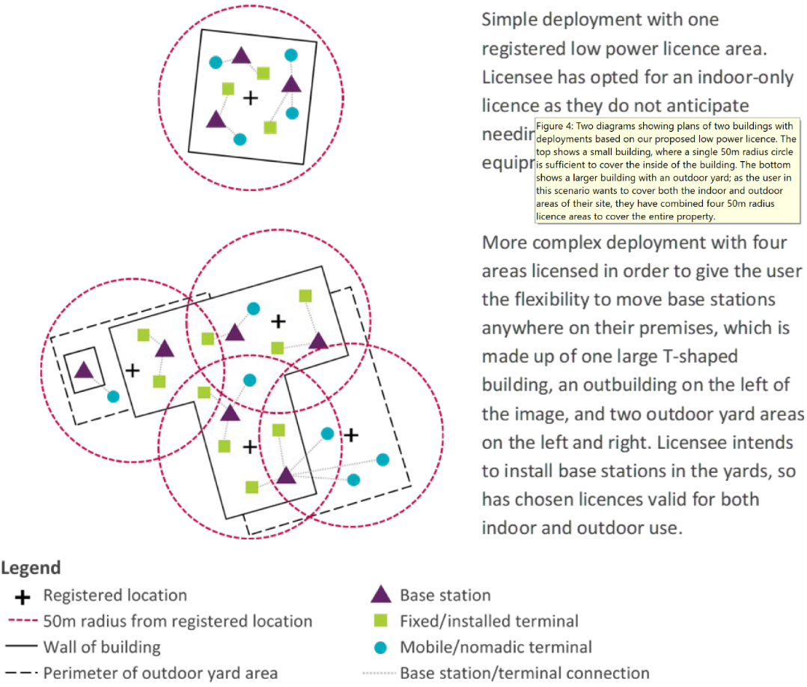
Figure 2: Examples of low power Shared Access licence use
Base stations can only be deployed within the licensed 50 metre-radius areas, but terminals just need to be connected to a base station in a licensed area. Terminals don’t need to be situated inside a licensed area. In practice the coverage provided by base stations is likely to be more than the 50 metre-radius circle licenced, especially when deployed outdoor. It will therefore be possible to connect devices across a larger site area without needing to obtain low power licences to cover the entire area. An example of this is shown in Figure 3 below.
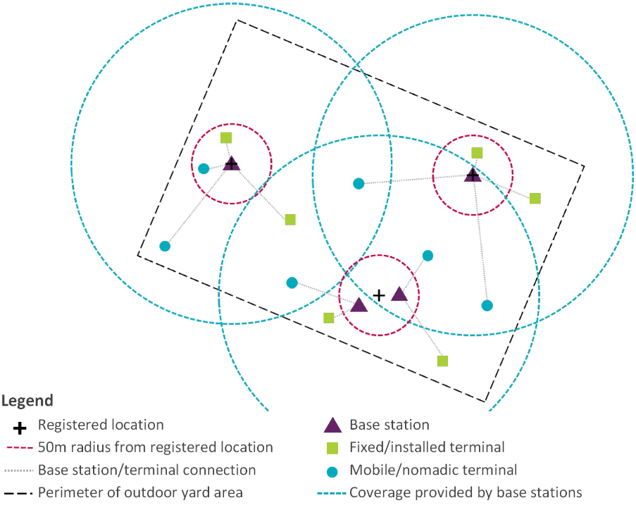
Figure 3: Example of terminal stations outside the areas licensed by the Shared Access low power licence, but connected to licensed base stations within these areas
Users can apply for an indoor-only licence or one which allows both indoor and outdoor use.
In this context, “indoors” means inside premises which have a ceiling or a roof; and except for any doors, windows or passageways, are wholly enclosed.
For outdoor base stations, these can be a maximum of 10 metres above ground level. For indoor base stations, these can be at any height within your building.

Technical conditions
The following table contains the technical conditions for the low power Shared Access licence in the 3.8-4.2 GHz band.
Table 1: Technical licence conditions for low power Shared Access licence in the 3.8-4.2 GHz band in the UK
Condition | Parameter
Permitted deployment | Indoor and outdoor  Outdoor antennas limited to 10 m height above ground
Authorised bandwidth | 10, 20, 30, 40, 50, 60, 80 and 100 MHz
Maximum base station power  (EIRP) | 24 dBm / carrier for carriers ≤ 20 MHz; or  18 dBm / 5 MHz for carriers > 20 MHz
Maximum terminal station power  (TRP for mobile/nomadic; EIRP for fixed) | 28 dBm (including a 2 dB tolerance consistent with the European harmonisation)
The following tables outlines the out-of-channel and in-band/out-of-band limits.
Table 2: 3.8-4.2 GHz base station out-of-channel emission limits
Frequency Offset | Maximum Mean EIRP Density
−5 to 0 MHz offset from lower channel edge  0 to 5 MHz offset from upper channel edge | (Pmax − 40) dBm / 5 MHz EIRP per antenna
−10 to −5 MHz offset from lower channel edge  5 to 10 MHz offset from upper channel edge | (Pmax − 43) dBm / 5 MHz EIRP per antenna
Out of block baseline power limit (BS)  < −10 MHz offset from lower channel edge  > 10 MHz offset from upper channel edge | (Pmax − 43) dBm / 5 MHz EIRP per antenna
Note: Pmax is the maximum mean carrier power for the base station in question.
Table 3: 3.8-4.2 GHz base station out-of-band emission limits
Frequency | Maximum Mean EIRP Density
3795 MHz – 3800 MHz  4200 MHz – 4205 MHz | (Pmax − 40) dBm / 5 MHz EIRP per antenna
3760 MHz – 3795 MHz  4205 MHz – 4240 MHz | (Pmax − 43) dBm / 5 MHz EIRP per antenna
Below 3760 MHz  Above 4240 MHz | −2 dBm / 5 MHz EIRP per antenna
Synchronisation
Ofcom does not impose any synchronisation requirement in the 3.8-4.2 GHz band. However, Ofcom does reserve the rights to mandate synchronisation at a later date if this turns out to be necessary to ensure spectrum is being used efficiently.
This means there’s a small chance that if licensees in this band operating in very close proximity to each other happen to be using adjacent channels within the band, they may interfere with each other. In these situations, Ofcom encourage both parties to work together and reach a mutual agreement on how to avoid this. Measures to avoid interference might include users synchronising their transmissions.
If the licensees can’t come to a mutual agreement to avoid interference within a reasonable time, say, within a few months, Ofcom may require the licensees to adopt a synchronisation regime regime which Ofcom considers to be appropriate in the circumstances.
There’s also a chance that if a user uses spectrum at the lower end of the band, they could possibly experience interference from users in the adjacent 3.6-3.8 GHz band. In this case, users may want to consider adopting the synchronisation requirement which Ofcom have outlined for users of the 3.6-3.8 GHz band.

The medium power Shared Access licence
The medium power licence authorises a single base station and any connected terminal stations.
Users are not permitted to deploy wide area networks in the 3.8-4.2 GHz band; this includes national or regional mobile networks.

Availability in rural areas
It is expected that users of the low power Shared Access licence are more likely to want to deploy in urban areas. If medium power users also deployed in urban areas, with their higher power and increased range, this could risk low power users suffering from limited or no availability of spectrum.
For this reason, Ofcom generally only consider applications for medium power in rural areas.
Medium power operation in urban areas
Ofcom may consider exceptions to allow medium power licences in urban areas on a case-by-case basis.
In assessing whether to allow a medium power licence application in an urban area, there are several factors Ofcom consider, such as:
- If what the user wants to do would not be technically possible using one or more low power licences; for example, you need the extra range made possible by the higher power limit in the medium power licence.
- If emissions from the users site, to the extent that these would be likely to reduce access to spectrum for other users, would not be higher using a medium power base station than they would using low power base stations. For example, this could be because in practice nobody else would be able to deploy anything near enough to the users site to make any difference, because the land is owned or operated only by the one user. This could also be because the users site is in some way shielded from the outside, for example if it is underground.
- The boundaries between what’s classed as a rural area and an urban area can be quite irregular. It could be that these boundaries place the users site in an “urban” area even though surrounding locations with similar conditions on the ground have been classed as “rural”.
Using the licence at sea
Any location which falls outside one of the “rural areas”, but which falls inside the limits of the UK’s territorial seas, will also be treated as a rural area. For any location further out to sea cannot be licenced through the Shared Access framework. Any equipment installed on a ship may also have to be recorded on a separate Ship Radio licence.

Technical conditions
The following table contains the technical conditions for the medium power Shared Access licence in the 3.8-4.2 GHz band.
Table 4: Technical licence conditions for medium power Shared Access licence in the 3.8-4.2 GHz band in the UK
Condition | Parameter
Permitted deployment | Rural areas
Authorised bandwidth | 10, 20, 30, 40, 50, 60, 80 and 100 MHz
Maximum base station power  (EIRP) | 42 dBm / carrier for carriers ≤ 20 MHz; or  36 dBm / 5 MHz for carriers > 20 MHz
Maximum terminal station power  (TRP for mobile/nomadic; EIRP for fixed) | 28 dBm TRP (including a 2 dB tolerance consistent with the European harmonisation)  35 dBm / 5 MHz EIRP
The following tables outlines the out-of-channel and in-band/out-of-band limits.
Table 2: 3.8-4.2 GHz base station out-of-channel emission limits
Frequency Offset | Maximum Mean EIRP Density
−5 to 0 MHz offset from lower channel edge  0 to 5 MHz offset from upper channel edge | (Pmax − 40) dBm / 5 MHz EIRP per antenna
−10 to −5 MHz offset from lower channel edge  5 to 10 MHz offset from upper channel edge | (Pmax − 43) dBm / 5 MHz EIRP per antenna
Out of block baseline power limit (BS)  < −10 MHz offset from lower channel edge  > 10 MHz offset from upper channel edge | (Pmax − 43) dBm / 5 MHz EIRP per antenna
Note: Pmax is the maximum mean carrier power for the base station in question.
Table 3: 3.8-4.2 GHz base station out-of-band emission limits
Frequency | Maximum Mean EIRP Density
3795 MHz – 3800 MHz  4200 MHz – 4205 MHz | (Pmax − 40) dBm / 5 MHz EIRP per antenna
3760 MHz – 3795 MHz  4205 MHz – 4240 MHz | (Pmax − 43) dBm / 5 MHz EIRP per antenna
Below 3760 MHz  Above 4240 MHz | −2 dBm / 5 MHz EIRP per antenna

Synchronisation
Ofcom does not impose any synchronisation requirement in the 3.8-4.2 GHz band. However, Ofcom does reserve the rights to mandate synchronisation at a later date if this turns out to be necessary to ensure spectrum is being used efficiently.
This means there’s a small chance that if licensees in this band operating near each other happen to be using adjacent channels within the band, they may interfere with each other, particularly if deploying antenna heights significantly above the surrounding clutter. Ofcom encourage both parties to work together and reach a mutual agreement on how to avoid this. Measures to avoid interference might include users synchronising their transmissions.
If the licensees can’t come to a mutual agreement to avoid interference within a reasonable time, say, within a few months, Ofcom may require the licensees to adopt a synchronisation regime which Ofcom considers to be appropriate in the circumstances.
There’s also a chance that if a user uses spectrum at the lower end of the band, they could possibly experience interference from users in the adjacent 3.6-3.8 GHz band. In this case, users may want to consider adopting the synchronisation requirement which we have outlined for users of the 3.6-3.8 GHz band.

The UK coordination approach
The UK coordinates new users with other licences users in the 3.8-4.2 GHz band, but does not consider coordination with uses in adjacent bands. Adjacent band interference is mitigated by defining the technical conditions in such a way that the risk of undue interference is reduced or removed.
Potential assignments are coordinated on the basis that the proposed deployment may both cause interference to other users within the shared spectrum, as well as suffer interference from them, providing users with an understanding of the likely quality of services that they will experience.
For new sharers in the 3.8-4.2 GHz band, the UK coordinates proposed base stations with both existing and new users as follows:
- other licensees’ co-channel low and medium power base stations in the band;
- co-channel and adjacent channel fixed links;
- co-channel and adjacent channel UK Broadband deployments (within 3925-4009 MHz); and,
- co-channel and adjacent channel Earth stations (receive-only) which have protection afforded to them as part of a PES licences or grant of RSA for ROES. In addition, the UK considers the Crown use by MOD at Bude and Menwith Hill.
The UK does not consider base stations of the same licensee in the coordination approach, as the licensee is better placed to manage interference in its own network(s).
Summary of coordination between Shared Access base stations
While the full details of the UK coordination and the reasoning for this approach can be found in Ofcom’s publications1, a brief summary of the coordination between two (or more) low and medium power base stations is given here.
Coordination of co-channel low and medium power base stations:
- As synchronisation is not mandated in the band, co-channel low and medium power base stations are coordinated based on an interference to noise ratio (I/N) of −6 dB, a base station noise figure of 13 dB assumed for low power base stations and 10 dB assumed for medium power base stations.
- Coordination takes into account the EIRP declared by the new and existing users. A omnidrection antenna pattern is assumed based on ITU-R F.1336-4, even for sectorised sites, allowing the impact of terminal stations to be included in the impact assessment without requiring additional coordination of each terminal station which would burdensome for both Ofcom and the user.
- For low power base stations a receive antenna gain of 0 dBi is assumed, while for medium power base stations the receive antenna gain declared by the user is applied.
- When considering indoor-only low power base station deployments, a building attenuation value of 12 dB is taken into account.
- For low power Shared Access licences, which allow any number of base station to be deployed within an area of 50 metre radius, a single ”proxy” base station is assumed at the centre of the authorised area. For assessing interference from this ”proxy” base station to other users, the EIRP is increased by 2 dB compared to that declared by the user, to account for the effect of deploying the base station close to the edge of the 50 metre area, as well as the effect of aggregation. Similarly, when interference to the low power Shared Access licensee is assessed, the receive gain of this ”proxy” base station is increased by 1 dB.
- Propagation loss is calculated used ITU-R P.452 with a percentage of time equal to 20%, using a 50-metre resolution terrain and clutter map.
Co-ordination between adjacent channel Shared Access base stations is not undertaken. While Ofcom recognise that there could be a risk of interference when adjacent channels are operating in close proximity to each other, particularly when operating at medium power and with antenna heights significantly above the surrounding clutter, it is decided that a reactive approach is more appropriate to ensure efficient use of spectrum in this band.
- In the event of undue interference, Ofcom encourages users to cooperate and reach mutual agreement on mitigation measures including, for example, appropriate synchronisation arrangements. Information on licences that are issued is available in Ofcom’s Spectrum Information Portal. This includes the location, technical details and licensee name.
- In cases where undue interference occurs and where the licensees have been unable to agree suitable mitigation measures after a reasonable time (in the order of a few months), Ofcom reserve the right to enforce a synchronisation regime that Ofcom consider appropriate in the circumstances. The factors that Ofcom may take into account when deciding an appropriate synchronisation regime will likely include, but are not limited to, which user deployed first in an area and the size/extent of networks that have been deployed. This means that users, when procuring radio equipment, should take into account the fact that they may need to adjust to different synchronisation regimes or risk having to replace their radio equipment in order to comply with any future synchronisation requirements.

Protection of users adjacent to the 3.8-4.2 GHz band
The UK have not authorised the top 5 MHz of the 3.8-4.2 GHz band (i.e. 4195-4200 MHz) to ensure that out-of-band emissions of new users’ base stations falling above 4.2 GHz are low enough for no undue interference to be cause to the radio altimeter service.
The 10 MHz minimum bandwidth and UK channel plan results in the bottom 5 MHz of the 3.8-4.2 GHz band (i.e. 3800-3805 MHz) not being authorised. This reduces the risk of interference to and from the uncoordinated and potentially unsynchronised base stations below 3.8 GHz. Limiting medium power deployments to rural areas only also helps manage the risk of interference.
The analysis behind these decisions is set out in Annex 5 of Ofcom’s published Consultation1.
If new users experience interference from the spectrum access licensees below 3.8 GHz, Ofcom provide the following guidance²:
“There’s also a chance that if you use spectrum at the lower end of the band, you could possibly experience interference from users in the adjacent 3.6-3.8 GHz band. If you do have a problem with this, you may want to consider adopting the synchronisation requirement which we have outlined for users of the 3.6-3.8 GHz band. You could also consider other methods of protecting yourself from interference, such as screening your site from unwanted transmissions.”

Annex 2 – regulatory example from NOR
Example of test licenses in Norway
Norway is currently working on establishing a regulatory regime for local/private 5G networks in 3.8-4.2 GHz - the application process will open up from 1 January 2023 (test licenses already issued). The regulatory regime is to a large extent based on the Shared access licences regime introduced in UK in July 2019 (see https://www.ofcom.org.uk/manage-your-licence/radiocommunicationlicences/shared-access)
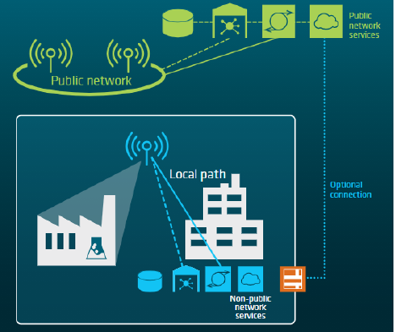
The local/private networks shall cover the need for non-commercial networks and networks within a limited geographical area (e.g. BWA) - cannot be used to increase coverage or capacity of a public mobile network. Only SA-NPN (Standalone Non-Public Networks) will be allowed - this causes some requests from MNO’s on how to be able to use shared radio access networks (virtual NW’s on shared spectrum resources).
Power classes
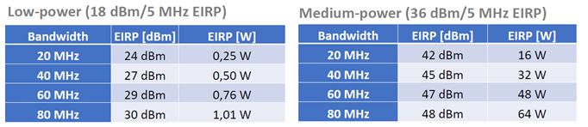
From ETSI TS 138 104: (Norway have chosen not to offer 10, 30, 50 and 100 MHz BW as of now)
Application handling
Nkom will upon an application for one or more base stations (50 m circles for low-power) conduct the necessary interference calculations – both for new base stations into existing, and existing into new base stations (base stations within same network are ignored).
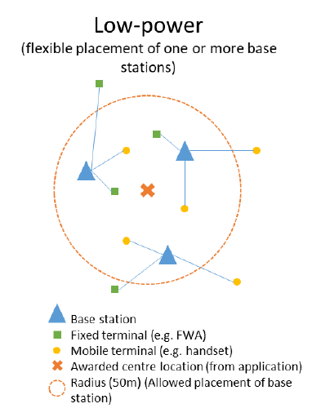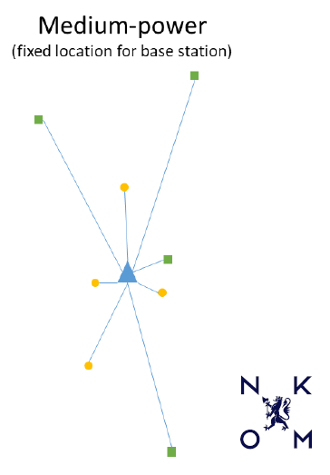
A 50 m circle for low-power, instead of a given extent of e.g. a factory, is chosen to make it possible to calculate interference. 2 dB added to output power and 1 dB subtracted for I/N Nkom to compensate for the 50 m circle. Do not use antenna pointing direction or antenna diagram in any interference calculations – Omni antenna used.
All licenses issued with a maximum allowed EIRP Antenna height, indoor/outdoor, Rx gain (medium-power) and wanted EIRP (medium-power) in accordance with application.
Network principle
Network operators may apply for more than one 50 m radius area to cover wanted low power base station placements. For indoor base stations a 12 dB loss is added for Tx and Rx. If one or more low power base station within a 50 m radius are to be located outside interference calculations are done as outdoor Indoor antenna height set to 5 m in calculations. Max. 10 m allowed outdoor for low power.
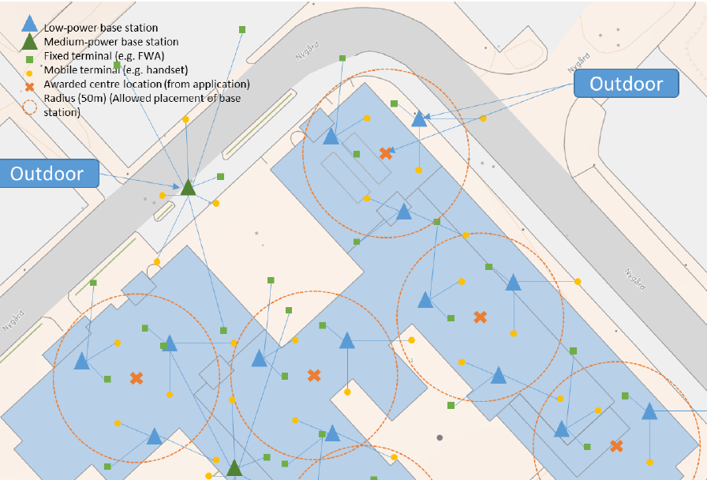
Synchronization
Intention is to keep the regulation technology neutral with no requirements for synchronization. Also want to keep flexibility regarding frame structure. Synchronization may be used in BWA cases, then with same frame structure as the commercial networks and starting from 3800 MHz (no guard band).
Nkom will in the licenses keep the flexibility for requiring synchronization between networks if needed.
Nkom can also request networks to move within the bands if they see the need for replanning in a certain geographical area.
Masks used in calculations

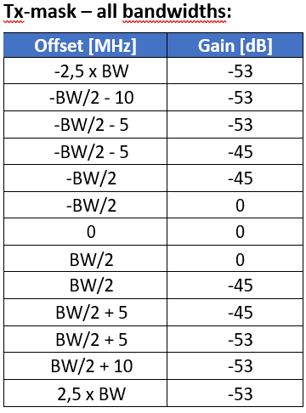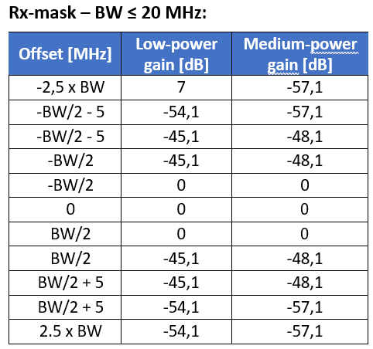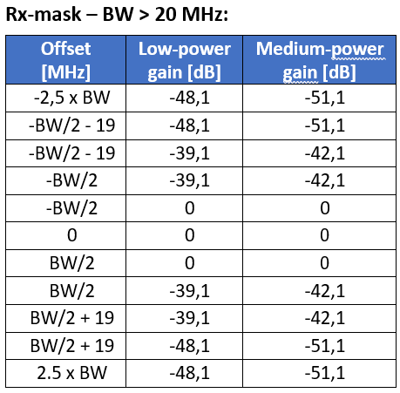
I/N calculations
I/N calculation done between base stations in different networks – terminals are ignored when it comes to interference calculations. Propagation model: ITU-R P.452 (v17) for 20% of the time. 12 dB building entry and exit loss. Omni directional antennas used for all base stations.
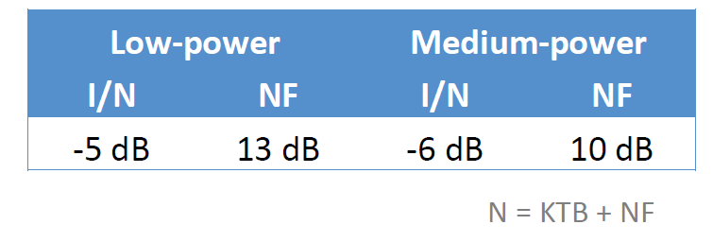
Protection of commercial 5G networks below 3.8 GHz
Commercial 5G base stations will not be considered when planning local 5G networks, so the base stations have to be able to operate in close vicinity to each other.
As a starting point a 40 MHz guard-band will be used between commercial 5G networks below 3800 MHz and local 5G networks above 3800 MHz. Real-life tests will be conducted to confirm this assumption.
Possible mitigation if this guard-band is proven to small, is to require synchronization between the commercial 5G networks below 3800 MHz and the first channel above 3800 MHz.
Protection of FSS earth stations
Existing FSS earth stations operating within 3.4-4.2 GHz will be protected within the whole frequency band, and in all directions. The earth station antennas are assumed to be pointing above the horizon, i.e. assuming off axis angle separation. An antenna discrimination of 40 dB lower gain in other directions than in the main beam assumed.
Mobile base stations may not exceed an PFD limit of -142.6dBW/m2/MHz, 20 m above ground, at the earth stations locations. This PFD limit is calculated from an actual link-budget from one of the existing earth stations, for the 5G mobile networks to not cause a harmful degradation of the link budget. ITU-R P.452 (v17) for 20% of the time used for the PFD calculations.
It is noted that this PFD limit includes the FSS earth station receiver characteristics, i.e., I/N protection criterion value, FSS antenna gain, etc. It gives a flexibility for the earth station operators to install additional antennas, as well as changing frequencies of their links.
Remaining considerations
- Frequency separation between two unsynchronized local/private networks real life tests planned
- Rx and Tx masks used in I/N calculations
- Aeronautical radio altimeters and the need for protection

ETSI TS 138 104 (table 6.2.1-1)
The BS conducted output power requirement is at antenna connector for BS type 1-C, or at TAB connector for BS type 1-H.
The rated carrier output power of the BS type 1-C shall be as specified in table 6.2.1-1.
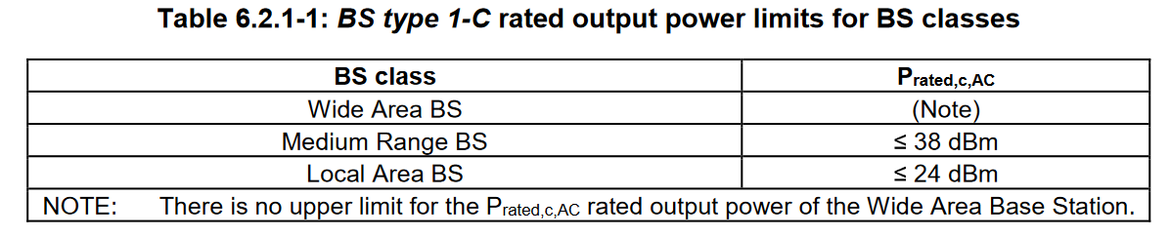
The rated carrier output power of the BS type 1-H shall be as specified in table 6.2.1-2.
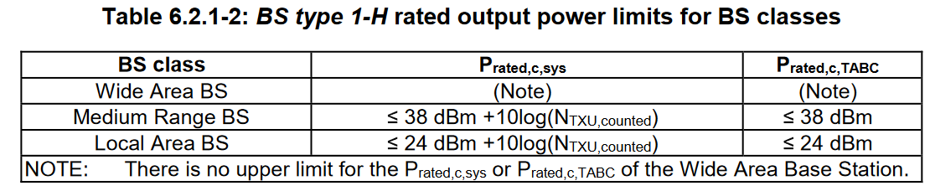

https://www.ofcom.org.uk/consultations-and-statements/category-1/enabling-opportunities-for-innovation
https://www.ofcom.org.uk/manage-your-licence/radiocommunication-licences/shared-access
If equipment is switched off from time to time (e.g. for maintenance) this is fine, this condition is about making sure that licensees who’ve stopped transmitting for good aren’t blocking access to spectrum for new users.
See paragraphs 11.32-11.36 of https://www.ofcom.org.uk/__data/assets/pdf_file/0019/130726/Award-of-the-700-MHz-and-3.6-3.8-GHz-spectrum-bands.pdf
For definition of “rural areas”, see paragraph 4.6 of https://www.ofcom.org.uk/__data/assets/pdf_file/0035/157886/shared-access-licence-guidance.pdf
https://www.ofcom.org.uk/spectrum/information/spectrum-information-system-sis/spectrum-information-portal

