|  |  |  |  |
| --- | --- | --- | --- |
| Plenary | | Doc. ECC(18)INFO 06 | |
| 48th Meeting | | | |
| Roma, 3-6 July 2018 | | | |
|  | | | |
| Date issued: | 28 June 2018 | | |
| Source: | ECO | | |
| Subject: | New ECO Documentation Database (DocDB) | | |
| Group membership required to read? (Y/N)  N | | | |
|  | | | |
| Summary: | | | |
| This document briefly describes the new ECO Documentation Database (DocDB, <https://www.ecodocdb.dk/home>) which has been developed in 2017 and deployed live in 2018. | | | |
| Proposal: | | | |
| ECC is invited to   * note the information available in this document, in particular regarding the new features of DocDB, and to provide feedback. | | | |
| Background: | | | |
| After about 10 years of operation with some limited developments, ECO identified the need in 2016 to develop a brand new ECO Documentation Database (DocDB). Most of the development and testing activities were performed in 2017. After some months during which the old DocDB and the new DocDB (as a test version) were publicly available in parallel, the new DocDB has become the official version available at [https://www.ecodocdb.dk/home as of April 2018](https://www.ecodocdb.dk/home%20as%20of%20April%202018). The old docDB is not publicly available anymore (only ECO internal for some time; until it will be terminated). | | | |

# General Principles

Like the previous version, the new DocDB contains ECC Deliverables (ECC Decisions, Recommendations and Reports and CEPT Reports in response to Mandates from the European Commission), national implementation information for ECC Decisions and additional informative documents, such as the European Commission Decisions related to ECC Deliverables. The new DocDB also includes ECO Reports (results of internal studies) and information about ETSI harmonised standards.

The improvements implemented in the new DocDB followed the following principles:

* To maintain the primary function of DocDB, which is to act as the library of ECC deliverables;
* To increase its usefulness with the inclusion of additional features and information;
* To build upon an enhanced synergy between DocDB and EFIS, in particular in terms of content management (application and frequency information related to documents, inclusion of links between the information tools);
* To benefit from the technology developments (e.g. use of state-of-the-art editing functions) since the previous version of DocDB was set up in 2007.

Based on this new DocDB platform, it will be possible to further expand the usefulness of the DocDB in the future by improving the showing of information, adding additional features (e.g. via the new API currently under development) and exploring further the synergies between DocDB and other tools (EFIS but also the ECC work programme database).

# Overview of the improvements and additional features

The main new features and improvements of the new database are described in this section.

## new layout

The new layout intends to enhance the visibility of the information and to provide additional options for display as illustrated below:

|  |  |
| --- | --- |
|  |  |
| New DocDB main page <https://www.ecodocdb.dk/home> | Old DocDB main page |

For each category of deliverables, the category main page (e.g. <https://www.ecodocdb.dk/document/category/ECC_Decisions?status=ACTIVE> for ECC Decision) gives access to all deliverables from this category with:

1. Direct access to all texts;
2. Options for sorting (date of publication, reference number);
3. Filter by status (default: active, all, withdrawn);
4. Link to detailed information for each deliverable.

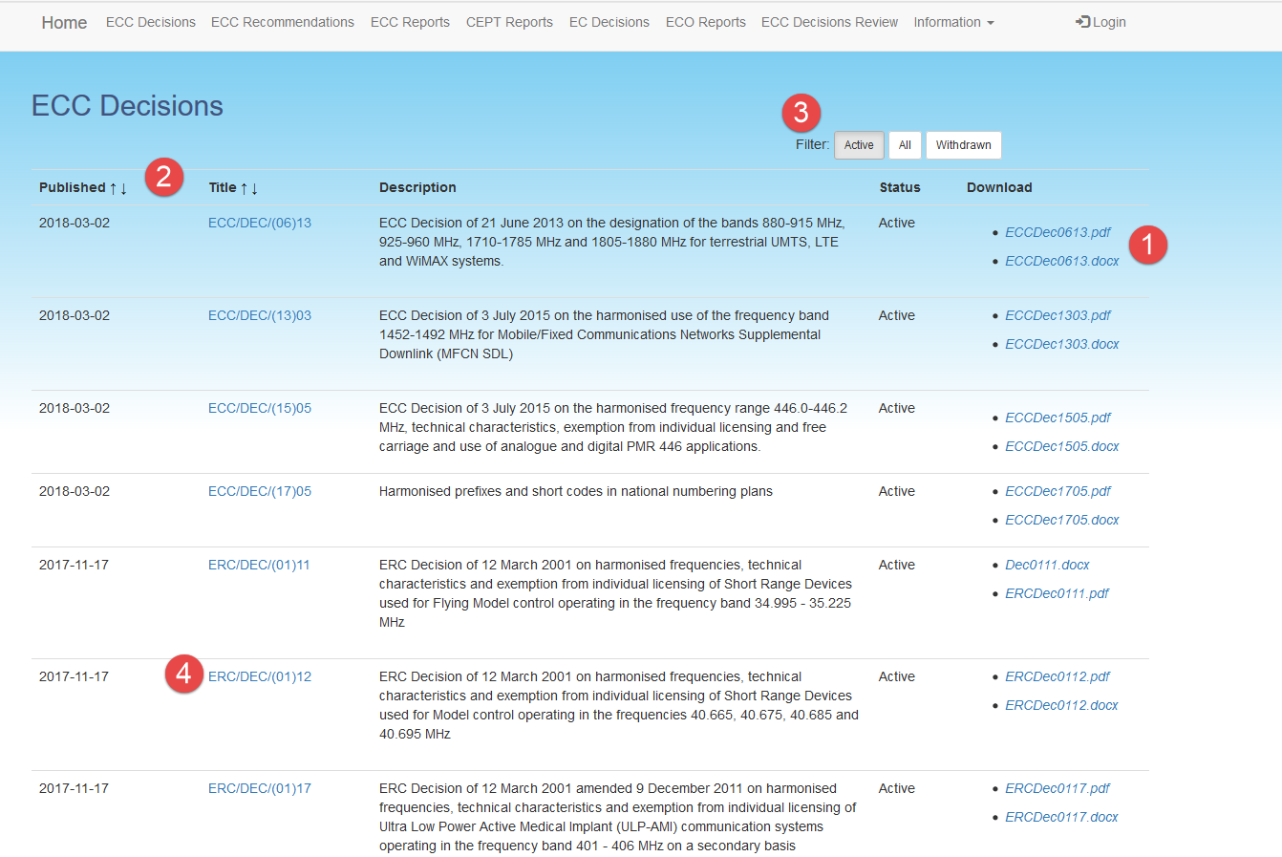

## Information related to each ECC Deliverable

For each deliverable, a range of relevant information is included such as:

1. An archive showing the previous versions of this deliverable;
2. Attached documents (RIS template, corresponding SEAMCAT files or Excel calculation sheets…);
3. Applicable frequency ranges and application terminology (as imported from EFIS; application terminology as in ECC/DEC/(01)03 Annex 2);
4. Relevant ETSI harmonised standards (as imported from EFIS -> ECA Table);
5. Link to implementation status information;
6. Link to related documents;
7. Possibility to export in one compressed folder the doc and pdf versions and the associated documents.

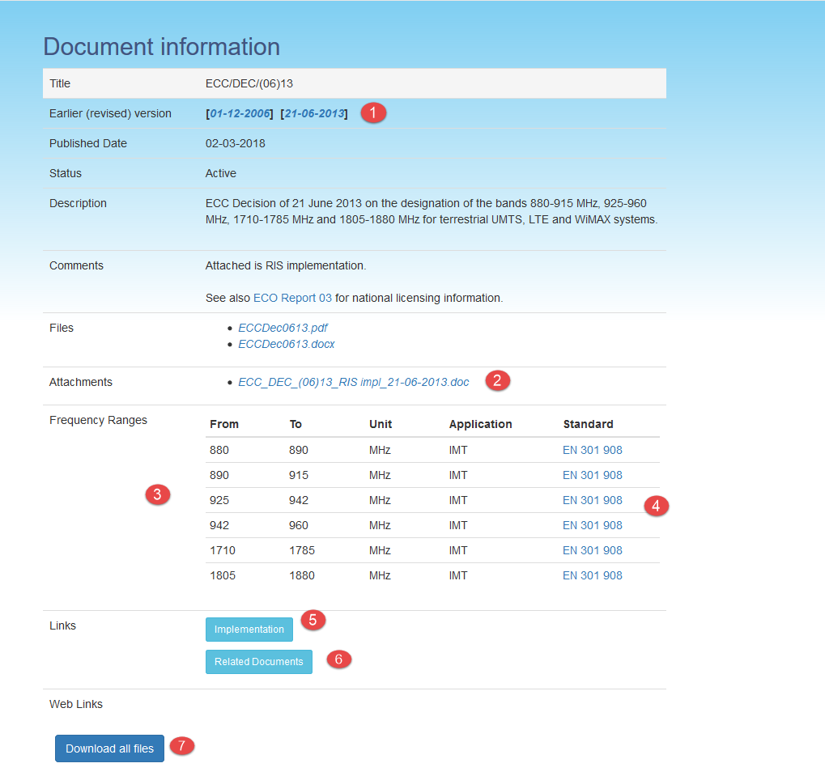

## advanced search functionality

With the implementation of the new DocDB, significant progress has been done concerning the search functionality (available on the main page: <https://www.ecodocdb.dk/home> ).

Two options are implemented:

* A quick search function with a free text field;
* A more advanced search feature which enables users to find ECC Deliverables by inputting a range of criteria:
* Type of ECC deliverables;
* Frequency range;
* Application term (as per EFIS terminology);
* Related ETSI harmonised standard;
* Responsible group within ECC.

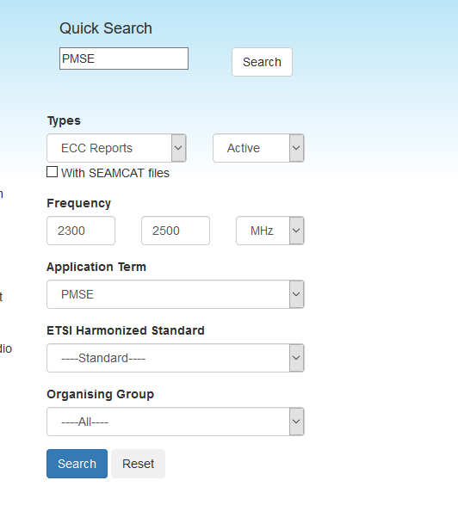

## Information and notification on recent updates of the database content

The ‘Update history’ page (<https://www.ecodocdb.dk/document/updateHistory> gives access to recent updates in DocDB concerning:

* Changes about the documentation (new, revised, withdrawn deliverables) uploaded in the database;
* Update of national information on the implementation of ECC deliverables.

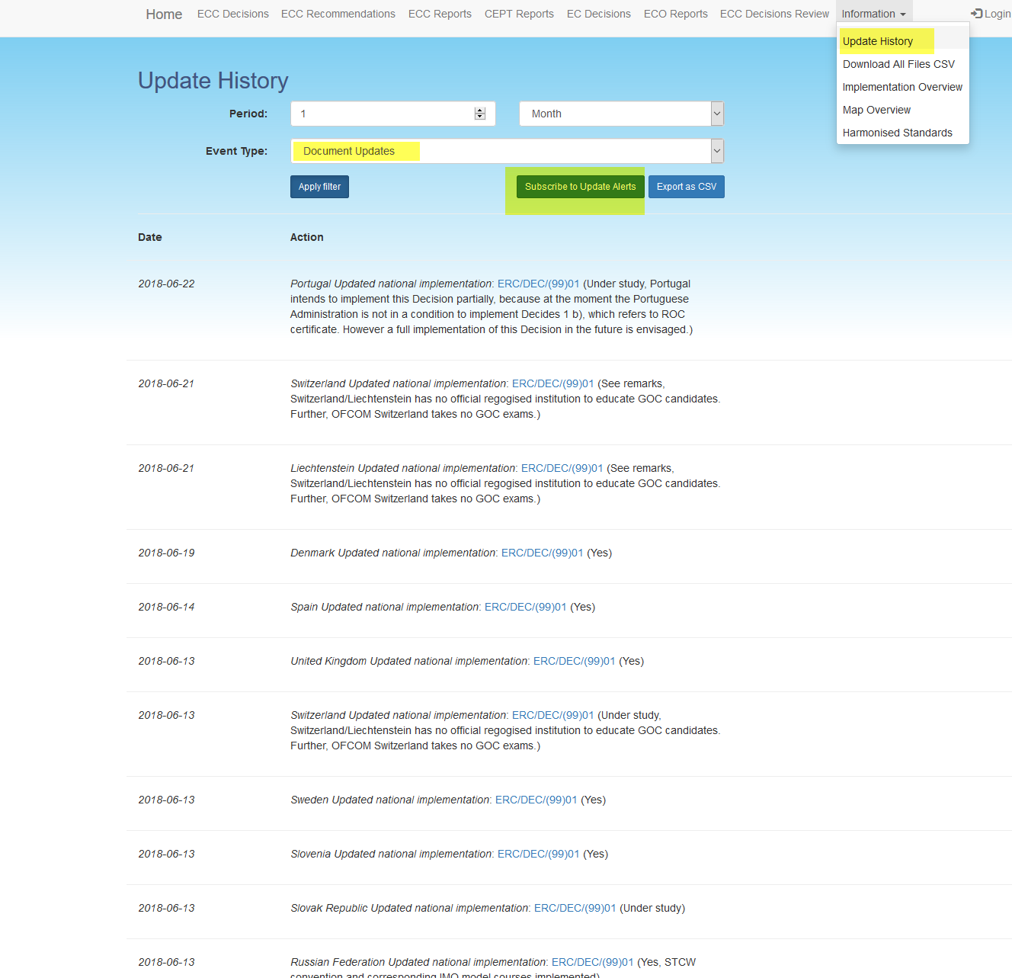

Any user can also subscribe on this page to a dedicated notification system (**Update Alert email reflector**) in order to receive once in a month a file by email informing about the changes in the documentation database.

## Information related to the national implementation of ECC deliverables

### Information related to a particular deliverable

For each ECC Decision and, where applicable, ECC Recommendation, the following information is available regarding the status of national implementation:

1. Summary of the level of implementation within CEPT;
2. Detailed information of the implementation status and conditions as provided by CEPT national administrations;
3. Map display of the implementation status within CEPT;
4. Possibility to export the implementation information in one single file.

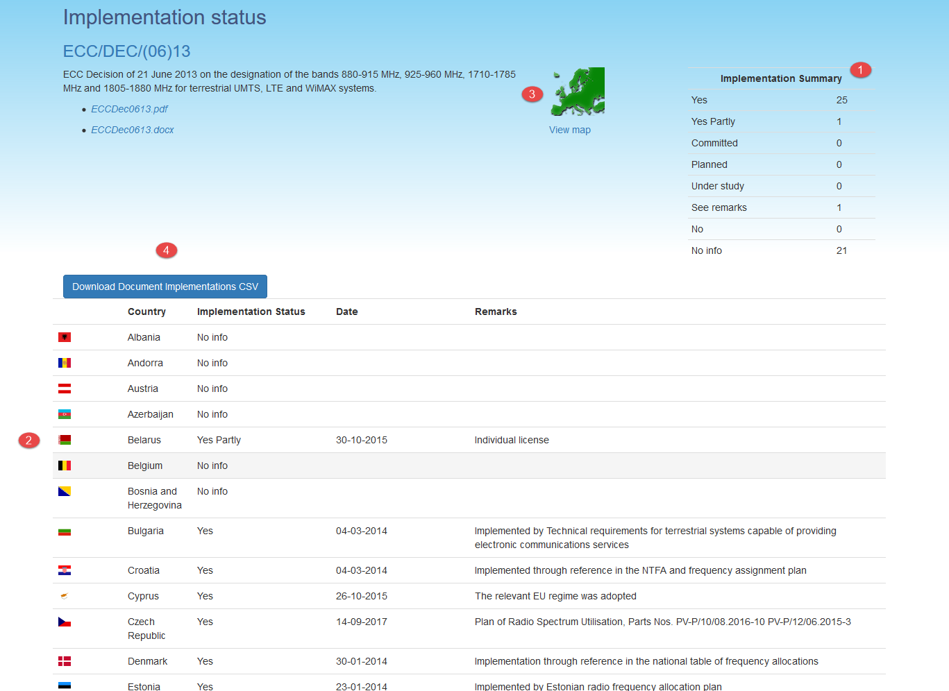

### Implementation overview

A dedicated page (<https://www.ecodocdb.dk/implementation/overview> ) displays a 2-dimension overview of the level of implementation of all applicable ECC Deliverables across the 48 CEPT countries with an associated map display (also available through <https://www.ecodocdb.dk/implementation/mapoverview> ).

### Uploading of information related to national implementation of ECC deliverables

The new DocDB offers the opportunity for national CEPT administrations to provide themselves the status of their national implementation of ECC deliverables.

This is done via a national login provided by ECO, using the same account management solution as for the introduction of national information within EFIS.

## Overview of ETSI HArmonised Standards

A dedicated page (<https://www.ecodocdb.dk/frequencies/list> ) provides the list of ETSI Harmonised Standards per frequency band as contained in ERC Report 25 (European Common Allocations Table) with the associated application terminology extracted from EFIS.

## Status of ECC/ERC Decisions for review

A dedicated page (<https://www.ecodocdb.dk/document/category/ECC_Decisions/review> ) is supporting the ECC regular process of the review of ECC (and also ERC and ECTRA) Decisions. It shows all active ECTRA, ERC and ECC Decisions within the scope of WG FM, ECC PT1, and WG NaN and provides a range of information:

* Responsible group for this Decision;
* Current status of the review process for this Decision (to be retained, to be reviewed, to be revised, to be withdrawn);
* Date of the next step of the review process;
* Additional relevant information (implementation status, impact on ETSI standards and additional comments).

The information of this list is updated after each ECC meeting by the ECO.