|  |  |  |  |  |
| --- | --- | --- | --- | --- |
|  | | | Doc. ECC(20)073 | |
| 53rd ECC Plenary Meeting | | | | |
| Web meeting, 29 June – 3 July 2020 | | | | |
|  | | | | |
| Date issued: | | 23 June 2020 | | |
| Source: | | ECO | | |
| Subject: | | ECO Bulletin on on-going/new issues in other regions or organisations – June 2020 edition | | |
| Group membership required to read? (Y/N)  N | | | | |
|  | | | | |
| **Summary:** | | |
| This ECO Bulletin provides a summary update on aspects of progress in spectrum management outside the CEPT. The items in this bulletin include:  1 Asia Pacific Region (APT)  1.1 Thailand 5G auction  1.2 New Zealand 3.5 GHz 5G spectrum award  2 Americas (CITEL)  2.1 CITEL starts WRC-23 preparation  2.2 USA  2.2.1 Update on FCC mmWave auctions – 40 GHz  2.2.2 FCC 6 GHz update (5.925-7.125 GHz)  2.2.3 USA C Band (3.7-4.2 GHz) update  2.2.4 FCC VHF and UHF White Spaces revised rules  2.3 Brazil 6 GHz revised rules (5.925-7.125 GHz)  3 Arab Region (ASMG)  3.1 New ASMG Working Group  4 Global developments  4.1 Update on NGSO megaconstellation plans and launches  4.2 5G deployments update  4.3 3GPP updates | | |

|  |
| --- |
| **Proposal:** |
| ECC is invited to note this Bulletin.  Several of the issues covered in this bulletin should be noted or discussed at the respective WG/ PT level, in particular in WG FM, WG SE, CPG, ECC PT1, FM44, FM57, SE7, SE40, SE45. |
| **Background:** |
| The Office brings to each ECC meeting a bulletin on activities in radio communications in other regions outside CEPT, where a regulatory dimension is raised (e.g. by innovative services or technology).  The primary objective is to identify whether the ECC needs to investigate further or consider possible new actions. A secondary but more frequently addressed objective is to enable comparison to be made with the regulatory approach in other regions for subjects already treated by the ECC (including, where relevant, to the work of the CPG). |

# Asia Pacific Region (APT)

## Thailand 5G auction

Thailand has completed its auction of spectrum in the 700 MHz, 2.6 GHz and 26 GHz. The 1800 MHz band was also included but no bids were received. Revenues were more than 50% higher than expected, with the 700 MHz band attracting the highest prices.

**(For information in ECC PT1)**

## New Zealand 3.5 GHz 5G spectrum award

New Zealand had originally planned an [auction of spectrum in the 3.5 GHz band](https://www.rsm.govt.nz/projects-and-auctions/auctions/current-and-upcoming-spectrum-auctions/) to commence in March 2020. However this auction was first delayed and subsequently cancelled in May 2020 due to the COVID-19 pandemic. Instead the spectrum will be directly allocated to 3 operators.

**(For information in ECC PT1)**

# Americas (CITEL)

## CITEL starts WRC-23 preparation

The 35th meeting of the CITEL Permanent Consultative Committee II, Radiocommunications (PCC.II) was held online on 11 May, in replacement of the physical meeting cancelled due to the COVID-19 pandemic.

PCC.II developed the framework for structuring Working Group relative to CITEL's Preparation for WRC-23. A number of coordinators and alternate coordinators for the subworking groups, as well as rapporteurs and alternate rapporteurs for WRC-23 agenda items have been appointed so far. The work will continue in dedicated webmeetings.

**(For information in CPG)**

## USA

### Update on FCC mmWave auctions – 40 GHz

The FCC’s final ‘Spectrum Frontiers’ millimetre wave spectrum auction ([Auction 103](https://www.fcc.gov/auction/103)) concluded the final assignment phase on 5 March. This auction includes spectrum in the upper 37 GHz (37.6–38.6 GHz), 39 GHz (38.6–40 GHz) and 47 GHz (47.2–48.2 GHz) bands. The [winning bidders](https://docs.fcc.gov/public/attachments/DA-20-253A3.pdf) of the majority of the licences were AT&T (bidding under FiberTower Spectrum Holdings), T-Mobile, Verizon (under Straight Path Spectrum) and Dish Network (under Window Wireless).

**(For information in ECC PT1)**

### FCC 6 GHz update (5.925-7.125 GHz)

The FCC has completed its plans to open up 1200 MHz of spectrum in 5925-7125 MHz for additional Wi-Fi usage, as reported in [previous editions of the ECO Bulletin](https://www.cept.org/Documents/ecc/57701/ecc-20-038_eco-bulletin-on-other-regions-march-2020-edition). The final [Report and Order](https://www.fcc.gov/document/fcc-opens-6-ghz-band-wi-fi-and-other-unlicensed-uses) was adopted on 23 April 2020. The Report and Order authorises indoor low-power (250 mW) operations over the full 1200 MHz and standard-power devices (1 W) within 500 and 350 MHz portions of the band (5925-6425 and 6525-6875 MHz). An automated frequency coordination system will prevent standard power access points from operating where they could cause interference to incumbent services. A Further Notice of Proposed Rulemaking seeks comment on a proposal to permit very low-power devices to operate across the 6 GHz band to support high data rate applications including high-performance, wearable, augmented-reality and virtual-reality devices. The notice also seeks comment on increasing the power at which low-power indoor access points may operate.

See 2.3 below for information on similar activities in Brazil.

**(For information in WGFM, FM57, WGSE and SE45)**

### USA C Band (3.7-4.2 GHz) update

On February 28 2020 the FCC adopted the [plans for clearance of 3.7-4.2 GHz](https://www.fcc.gov/document/fcc-expands-flexible-use-c-band-5g-0) for 5G use, as outlined in the [previous edition of the ECO Bulletin](https://www.cept.org/Documents/ecc/57701/ecc-20-038_eco-bulletin-on-other-regions-march-2020-edition).

Intelsat filed for bankruptcy on 13 May, reportedly as a means to participate in the clearance program. The bankruptcy filing will enable Intelsat to clear customers from its spectrum in order to meet the FCC’s deadline and thus receive the additional funding.

**(For information in ECC PT1, WGFM, FM44 and CPG)**

### FCC VHF and UHF White Spaces revised rules

The FCC adopted a [Notice of Proposed Rulemaking (NPRM)](https://docs.fcc.gov/public/attachments/FCC-20-17A1.pdf) to revise the rules to provide additional opportunities for unlicensed white space devices operating in broadcast TV bands to deliver wireless broadband services in rural areas and applications associated with the Internet of Things (IoT). The proposed changes are in response to a request from Microsoft, and include relaxation EIRP from 10 to 16 W for fixed devices in less congested areas and mobile devices within geo-fenced areas, as well as relaxtion of some height restrictions.

**(For information in WGFM and CPG)**

## Brazil 6 GHz revised rules (5.925-7.125 GHz)

In May Brazil´s regulator Anatel approved the revision of the Restricted Radiation Radiocommunication Equipment Regulation to include the possibility of using the frequency band 5925-7125 MHz for unlicensed services. With this, 1200 MHz frequency range in 6 GHz will be available for Wi-Fi 6 equipment use. This allocation can make available wide band channels resulting in achieving high data rate applications. The technical conditions of this frequency use are still to be defined after the public consultation by Anatel later this year. These activities are similar to the decisions made by the FCC in USA for the 6 GHz band (see 2.2.2 above).

**(For information in WGFM, FM57, WGSE and SE45)**

# Arab Region (ASMG)

## New ASMG Working Group

ASMG has launched a new working group to develop spectrum harmonisation decisions for the Arab region. Initial work will focus on channel plans for the 600 MHz and 2.6 GHz bands.

**(For information in CPG)**

# Global developments

## Update on NGSO megaconstellation plans and launches

OneWeb filed for bankruptcy on 27 March 2020, citing the economic impact of COVID-19 as the main reason. The announcement came shortly after the successful 3rd launch of 34 satellites on 21 March. The future of the company and the existing constellation of 74 satellites are unclear, although several bidders have expressed interest in the assets, including rivals SpaceX and Amazon as well as Eutelsat. On 26 May OneWeb submitted a [filing](https://licensing.fcc.gov/cgi-bin/ws.exe/prod/ib/forms/reports/swr031b.hts?q_set=V_SITE_ANTENNA_FREQ.file_numberC/File+Number/%3D/SATMPL2020052600062&prepare=&column=V_SITE_ANTENNA_FREQ.file_numberC/File+Number) to the FCC to increase its constellation size to 47,844 satellites (previously 1980 satellites were requested – see previous [ECO Bulletin](https://www.cept.org/Documents/ecc/57701/ecc-20-038_eco-bulletin-on-other-regions-march-2020-edition)) for US market access. The reasons behind this move are not clear but could be related to a possible sale.

Viasat announced their intention to join the LEO race with proposals for a constellation of 288 satellites to replace previous plans for 20 MEO satellites. The new plans may allow the company to apply for subsidy funding under the FCC’s [Rural Digital Opportunity Fund](https://www.fcc.gov/document/fcc-launches-20-billion-rural-digital-opportunity-fund-0). The FCC has [agreed](https://www.fcc.gov/document/fcc-adopts-procedures-rural-digital-opportunity-fund-auction) to consider applications from LEO satellite operators for this fund. The LEO constellation would operate at 1300 km using the same Ka and V Band frequencies [recently authorised for MEO](https://docs.fcc.gov/public/attachments/FCC-20-56A1.pdf) (various ranges from 17.8 to 51.4 GHz), according to an FCC [filing](https://licensing.fcc.gov/cgi-bin/ws.exe/prod/ib/forms/reports/swr031b.hts?q_set=V_SITE_ANTENNA_FREQ.file_numberC/File+Number/%3D/SATMPL2020052600056&prepare=&column=V_SITE_ANTENNA_FREQ.file_numberC/File+Number) submitted on 26 May. Each satellite would support 96 gigabits per second of throughput, enabling a collective 27 terabits of internet connectivity fanning out 60 degrees north and south of the equator

SpaceX have continued the launch program for the Starlink constellation, with 537 satellites now in orbit following the most recent launch of 58 satellites on 13 June. The next launch of 60 satellites is planned on 22 June. The launch program has recently been accelerated following some delays in April and May. One of the latest satellites, dubbed ‘VisorSat’, will test [experimental sun-shade technology](https://www.spacex.com/updates/starlink-update-04-28-2020/) to mitigate visual interference into astronomy. This solution is expected to replace the previous ‘DarkSat’ proposal to paint satellites black, which was not found to sufficiently reduce the brightness. Another mitigation technique under consideration is to rotate the satellites during the orbit raising phase.

Debate continues [within the FCC process](https://licensing.fcc.gov/cgi-bin/ws.exe/prod/ib/forms/reports/related_filing.hts?f_key=-443498&f_number=SATMOD2020041700037) regarding collision probabilities and debris mitigation procedures related to SpaceX’s request to lower its orbital planes, with concerns raised by rivals Amazon and Viasat over the process and calculations.

Satellite startup [Lynk Global](https://lynk.world/) claimed the world’s first successful connection from a satellite to a standard mobile phone on 24 February. The demonstration showed a cell broadcast from the NG-12 Cygnus cargo spacecraft which had recently undocked from the ISS, at around 400 km, to a GSM phone on the Earth operating in the 2 GHz band. It is understood the company plans to target the rural connectivity market in sub-1 GHz bands and is collaborating with several MNOs.

**(For information in WGFM, FM44, WGSE, SE40 and CPG)**

## 5G deployments update

According to the latest data from the [GSA](https://gsacom.com/) (Global mobile Suppliers Association), as of the end of May 2020 there are now 81 commercial 5G networks in 42 countries. 386 operators in 125 countries had announced they were investing in 5G.

Of the 81 commercial networks, 73 provide 3GPP-compliant 5G mobile services (67 full launches, 6 limited availability launches), and 39 provide 3GPP-compliant 5G FWA or home broadband services (33 full launches, 6 limited availability launches). The breakdown by country and the growth since previous quarters are shown in the following figures.

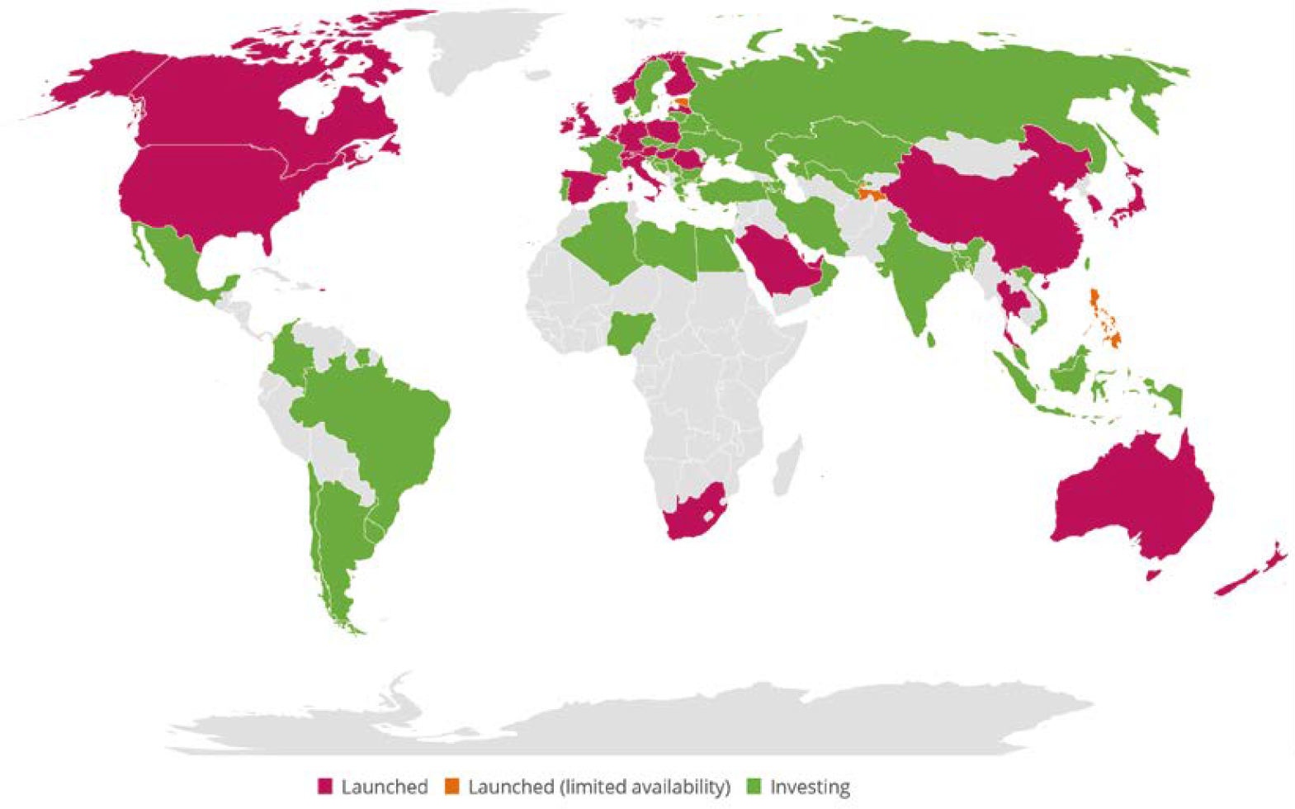

Figure 1: Global status of 5G deployments (Source: GSA)

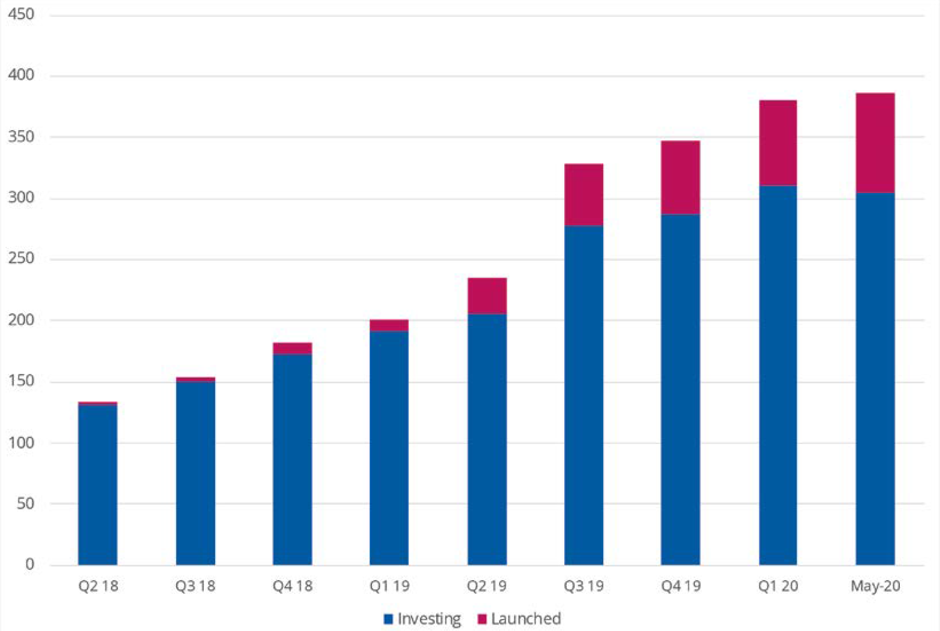

Figure 2: Count of operators investing in 5G and with launched commercial services (Source: GSA)

Spectrum usage of current 5G deployments is dominated by the C Band (3300- 4200 MHz – 3GPP bands n77 and n78) followed by 26.5-29.5 GHz (3GPP bands n257, n258 and n261).

There has been a recent increase in the number of devices supporting millimetre wave ranges, however the market is still dominated by the sub-6 GHz ranges. In addition to C-Band, 2.6 GHz (n41), 4.5-5 GHz (n77) 2.1 GHz (n1) and 1800 MHz (n3) are also prevalent in available devices.

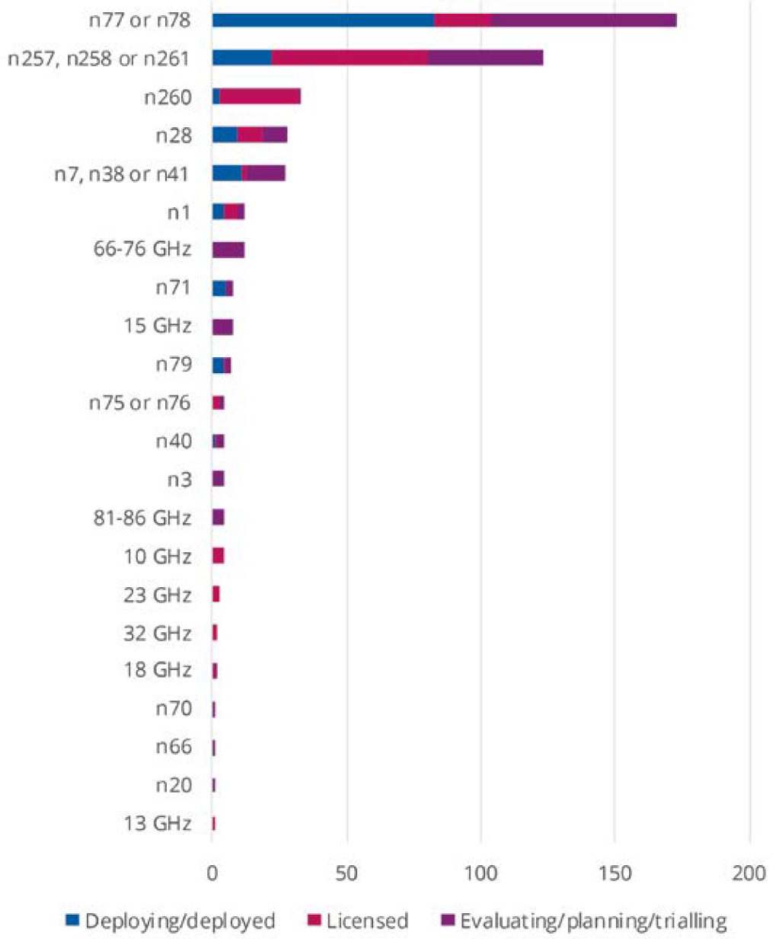 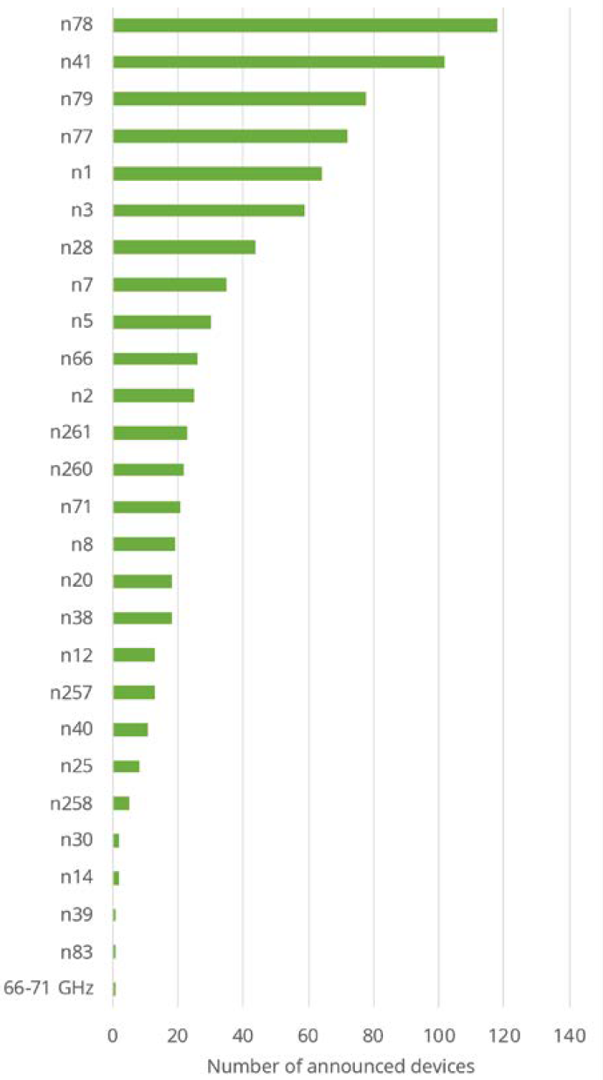

Figure 3: 5G Spectrum band by networks (left) and device support (right) (Source: GSA). See [here](https://en.wikipedia.org/wiki/5G_NR_frequency_bands) for band numbers

**(For information in ECC PT1)**

## 3GPP updates

In March 2020 the timetable for 3GPP Release 16 Stage 3 and Release 17 was [agreed](https://www.3gpp.org/specifications/releases) to be delayed by 3 months. Release 16 Stage 3 is now due to be finalised in June 2020 and Release 17 by December 2021. The delay is due to disruption to the 3GPP meeting schedule caused by the COVID-19 pandemic. All 3GPP meetings for the remainder of 2020 have been [moved online](https://www.3gpp.org/news-events/2108-3gpp).

The latest 3GPP 5G specifications (v16.3.0) now include the Globalstar 2483.5-2495 MHz band as a 5G band (n53), reflecting the [recent interest](https://investors.globalstar.com/news-releases/news-release-details/globalstar-announces-3gpp-approval-band-53-5g-band) in this band for terrestrial applications.

**(For information in ECC PT1, WGFM, SE7)**