|  |  |  |  |  |
| --- | --- | --- | --- | --- |
|  | | | Doc. ECC(20)105 | |
| 54th ECC Plenary Meeting | | | | |
| Web meeting, 16 – 20 November 2020 | | | | |
|  | | | | |
| Date issued: | | 9 November 2020 | | |
| Source: | | ECO | | |
| Subject: | | ECO Bulletin on on-going/new issues in other regions or organisations – November 2020 edition | | |
| Group membership required to read? (Y/N)  N | | | | |
|  | | | | |
| **Summary:** | | |
| This ECO Bulletin provides a summary update on aspects of progress in spectrum management outside the CEPT. The items in this bulletin include:  1 Africa (ATU)  1.1 WRC-23 preparation  1.2 ATU establishment of task groups  1.3 Loon starts commercial service in Kenya and Mozambique  1.4 South africa mobile spectrum auction plans announced  2 Asia Pacific Region (APT)  2.1 WRC-23 preparation  2.2 South Korea and Taiwan plans for 6 GHz RLAN  3 Americas (CITEL)  3.1 USA C Band 5G 3.7-3.98 GHz: RTCA Report on potential interference into radio altimeters in 4.2-4.4 GHz  3.2 Brazil - L-Band (1427-1518 MHz) for 5G  4 Global developments  4.1 Update on NGSO megaconstellation plans and launches  4.2 5G deployments update | | |

|  |
| --- |
| **Proposal:** |
| ECC is invited to note this Bulletin.  Several of the issues covered in this bulletin should be noted or discussed at the respective WG/ PT level, in particular in WG FM, WG SE, CPG, ECC PT1, FM44, FM57, SE7, SE40, SE45. |
| **Background:** |
| The Office brings to each ECC meeting a bulletin on activities in radio communications in other regions outside CEPT, where a regulatory dimension is raised (e.g. by innovative services or technology).  The primary objective is to identify whether the ECC needs to investigate further or consider possible new actions. A secondary but more frequently addressed objective is to enable comparison to be made with the regulatory approach in other regions for subjects already treated by the ECC (including, where relevant, to the work of the CPG). |

# Africa (ATU)

## WRC-23 preparation

The African Telecommunications Union (ATU) held the first virtual meeting for the preparation of the next WRC-23 on 3-7 August. The Preparation Work Plan for WRC-23 was adopted, which identified 7 Working Groups working under the African Preparatory Meeting (APM) and defined their schedule and expected outputs.

The Working Groups deal with:

* Working Group 1A: IMT in the mobile service/ Broadband applications in the mobile service
* Working Group 1B: Fixed, Mobile and Broadcasting issues
* Working Group 2: Aeronautical and maritime issues
* Working Group 3: Science issues
* Working Group 4A: Satellite services issues
* Working Group 4B: Satellite regulatory issues
* Working Group 5: General issues

The WGs have the twofold scope of conducting studies related to WRC-23 agenda items and studies related to the implementation of the outcomes of previous WRCs.

APM noted several initial proposals for the development of draft ATU preliminary positions on a number of WRC-23 agenda items. African administrations were invited to follow and participate in the studies, and to take a favourable position towards allowing ESIMs to operate with non-GSO FSS systems. Member states were also encouraged to actively participate to the work of ITU-R TG 6/1 on agenda item 1.5 (UHF Review), in particular to re-evaluate the current utilisations, future needs and available frequency bands, while protecting the existing services in the band.

**(For information in CPG and its PTs)**

## ATU establishment of task groups

ATU has established five task groups to promote and develop activities for Africa in the sector of radiocommunications. The task groups have been assigned the following mandates:

* TG Spectrum Recommendations:  
  To draft Spectrum Management Recommendation in the areas of spectrum management, spectrum licensing, spectrum evolution, spectrum use audits.
* TG Emerging Technologies:  
  To develop draft recommendations on 5G/IMT2020 implementation in Africa as well as other forms of emerging technologies such as HAPS, ESIMs, MSS, FSS and WiFi/WiGig.
* TG on AfriSAP (1 st Edition of the African Spectrum Plan):  
  To develop draft 1st Edition of the African Spectrum Allocation Plan (AfriSAP)
* TG on Satellite Resources for Africa:  
  To produce draft study report, and develop draft strategy for the optimum acquisition, retention and use of satellite resource in Africa.
* TG on Spectrum for Rural Connectivity:  
  To develop draft recommendations, mainly based on best practices in Africa and around the world, on how spectrum policy, regulations and practices could be used to promote rural ICT connectivity in Africa.

These TGs started work in July.

**(For information in WGFM and PT1)**

## Loon starts commercial service in Kenya and Mozambique

Loon has started its first commercial services to provide rural connectivity from a fleet of stratospheric balloons in Kenya and Mozambique.

The services are offered as part of a partnership with local cellular operators to provide enhanced 4G LTE coverage from balloons operating up to 20 km in the stratosphere.

This marks the first full-scale commercial deployment of the Loon technology, which to date has been used to provide temporary emergency coverage for disaster relief, as reported in previous Bulletins.

Loon is now focusing on LTE in the 700 MHz and 800 MHz bands (3GPP bands 20 and 28) following initial use of the 2.4 GHz and 5.8 GHz ISM bands. Loon has also [applied to the FCC](https://apps.fcc.gov/els/GetAtt.html?id=260311&x=.) to run tests in the 3.5 GHz band in the US. The application also makes reference to possible future use of E-Band feeder links which would reportedly allow interconnection of HAPS balloons at distances exceeding 1000 km.The company is one of the “moonshot” projects developed by Google parent company Alphabet’s “X” research and development initiative.

**(For information in CPG, PT1)**

## South africa mobile spectrum auction plans announced

The Independent Communications Authority of South Africa (ICASA) has [announced plans](https://www.icasa.org.za/news/2020/plans-for-the-licensing-of-high-demand-spectrum-and-the-woan) to auction mobile spectrum in the 700 MHz, 800 MHz, 2.6 GHz and 3.5 GHz bands. Coverage obligations will be included in certain lots below 1 GHz. 80 MHz of dedicated spectrum will also be set aside for a Wireless Open Area Network (WOAN) to allow for a private wholesale operator.

The auction is expected to commence in late 2020 and to conclude by end of March 2021. Previously temporary emergency licences had been issued to operators in response to the COVID-19 pandemic – these will be extended until the completion of the auction.

Spectrum in the 2.3 GHz band has been put on hold until a later date while a strategy for migration of fixed service from the band is developed.

**(For information in PT1 and WGFM)**

# Asia Pacific Region (APT)

## WRC-23 preparation

The first APT Conference Preparatory Group (APG) for WRC-23 and RA-23 met virtually on 24-25 September 2020.

The main objective of APG is to organise coordinated regional activities for WRCs and RAs in order to ensure that the interests of APT Members on Radiocommunication issues are properly represented. This includes the development of APT Common Proposals to WRC-23.

The APG structure was formed based on the CPM-23 Report Chapters with minor modifications. 5 Working Parties were agreed as follows:

* WP1: Fixed, Mobile and Broadcasting issues
* WP2: Aeronautical and Maritime issues
* WP3: Science issues
* WP4: Satellite issues
* WP5: General issues

Additional information is available [here](https://www.apt.int/2020-APG23-1).

**(For information in CPG and its PTs)**

## South Korea and Taiwan plans for 6 GHz RLAN

The South Korea Ministry of Science and IST (MSIT) has approved rules for usage of the 5925-7125 MHz band for RLAN/Wi-Fi. Unlicensed services will be permitted to operate indoors at 240 mW across the entire band, and outdoor operations will be permitted in the lower 5925-6425 MHz range at 25 mW.

The announcement was [welcomed](https://www.wi-fi.org/news-events/newsroom/msit-brings-wi-fi-into-6-ghz) by the Wi-Fi Alliance.

Taiwan have also launched a consultation to determine rules for unlicensed usage of the band, which closed on 7 August.

These developments follows similar announcements in the US and Brazil earlier this year (see [previous ECO Bulletin](https://www.cept.org/Documents/ecc/59493/ecc-20-073_eco-bulletin-on-other-regions-june-2020-edition))

**(For information in WGFM, WGSE, FM57, SE45)**

# Americas (CITEL)

## USA C Band 5G 3.7-3.98 GHz: RTCA Report on potential interference into radio altimeters in 4.2-4.4 GHz

The Radio Technical Commission for Aeronautics (RTCA), a US aeronautical industry SDO, has submitted a [Report](https://www.rtca.org/wp-content/uploads/2020/10/SC-239-5G-Interference-Assessment-Report_274-20-PMC-2073_accepted_changes.pdf) to the FCC raising concerns on potential interference into radio altimeters operating in 4.2-4.4 GHz from 5G networks in 3.7-3.98 GHz following the FCC’s clearance plans in this band as reported in previous editions of the ECO Bulletin. The main conclusions of the studies are summarised [here](https://ecfsapi.fcc.gov/file/1020108265289/RTCA_FCC_Ex_Parte_Meeting_10_16_2020.pdf).

**(For information in PT1)**

## Brazil - L-Band (1427-1518 MHz) for 5G

Brazil’s National Telecommunications Agency (Anatel) has recently reviewed the use of L-Band (1 427 - 1518 MHz). The National Frequency Allocation Plan has been updated in order to allow the implementation of 5G in the band while further regulatory measures have been put in place to allow coexistence between the mobile service and other existing services.

**(For information in PT1)**

# Global developments

## Update on NGSO megaconstellation plans and launches

The sale of OneWeb to a consortium consisting of the UK government and Indian operator Bharti Global was approved by a federal bankruptcy court in the US on 2 October. The FCC additionally [approved](https://docs.fcc.gov/public/attachments/DA-20-1271A1.pdf) the transfer of OneWeb’s US licences on October 27. This marks the exit from the bankruptcy process reported in the [previous ECO Bulletin](https://www.cept.org/Documents/ecc/59493/ecc-20-073_eco-bulletin-on-other-regions-june-2020-edition). The company now plans to recommence its launch program in December with an additional 36 satellites. 74 satellites were launched prior to the bankruptcy announcement in March. 15 further launches are planned in 2021-2022 to complete the planned first generation constellation of 648 satellites.

Separately, the FCC [approved](https://www.fcc.gov/document/fcc-grants-oneweb-us-market-access-expanded-ngso-constellation) OneWeb’s request for US market access for an additional 1280 MEO satellites at 8500 km. The approval also grants permission to operate all 2000 satellites in V-Band spectrum. (37.5-43.5GHz, 47.2-50.2 GHz, and 50.4-51.4GHz). The previous approval for 720 LEO satellites was for operation in Ku and Ka Bands. OneWeb’s additional request submitted to the FCC in May to increase the constellation size to 47,844 satellites remains pending.

Amazon’s Kuiper constellation received [approval](https://docs.fcc.gov/public/attachments/FCC-20-102A1.pdf) from the FCC for US market access. The system is planned to consist of 3,236 LEO satellites in 98 orbital planes at altitudes of 590 km, 610 km, and 630 km, operating in both Ku and Ka Bands - 17.7-18.6 GHz (space-to-Earth), 18.8-20.2 GHz (space-to-Earth), and 27.5-30.0 GHz (Earth-to-space). Commercial service is expected to commence once the first 578 satellites are launched. The Order requires Kuiper to launch and operate 50% of its satellites by July 2026, and the full constellation by July 2029.

SpaceX have continued regular launches of the Starlink constellation, with 895 satellites now in orbit following the most recent launch on 24 October. Launches of 60 satellites each are scheduled around every 2 weeks for the remainder of 2020. Beta-test services to consumers have recently started in the US and Canada. Ookla Speedtest has reported peak download speeds of 160 Mbps, and 80 Mbps on average. Average reported latency is 42 ms. Beta-test services are reportedly planned to be expanded to Europe in early 2021 and India by mid-2021.

Microsoft have announced plans to deliver its Azure Cloud platform via satellite connectivity through both Starlink and SES’s O3b mPower. As part of this Microsoft plans to offer a modular datacentre (MDC) solution to provide cloud computing capabilities via satellite connectivity in remote environments.

On August 26 the FCC issued a [Report and Order](https://docs.fcc.gov/public/attachments/FCC-20-119A1.pdf) eliminating the previous requirement for NGSO FSS systems to provide domestic coverage to the entire US territory. The relaxation is provided to facilitate innovative systems that provide targeted coverage to areas such as Alaska and the Arctic region or to islands and ships in the Pacific Ocean, which inherently could not meet the wider coverage requirements. NGSO systems referenced in the Order that this would benefit include the Arctic Satellite Broadband System (Space Norway), Audacy, Kepler, Kuiper and Viasat.

**(For information in WGFM, FM44, WGSE, SE40)**

## 5G deployments update

The global deployment of 5G continues rapidly throughput 2020.

According to the latest data from the [GSA](https://gsacom.com/) (Global mobile Suppliers Association), as of October 2020 there are now 112 commercial 5G 3GPP compliant networks in 47 countries. 402 operators in 129 countries had announced they were investing in 5G (including trials, planned and actual deployments).

The breakdown by country and the growth since previous quarters are shown in the following figures.

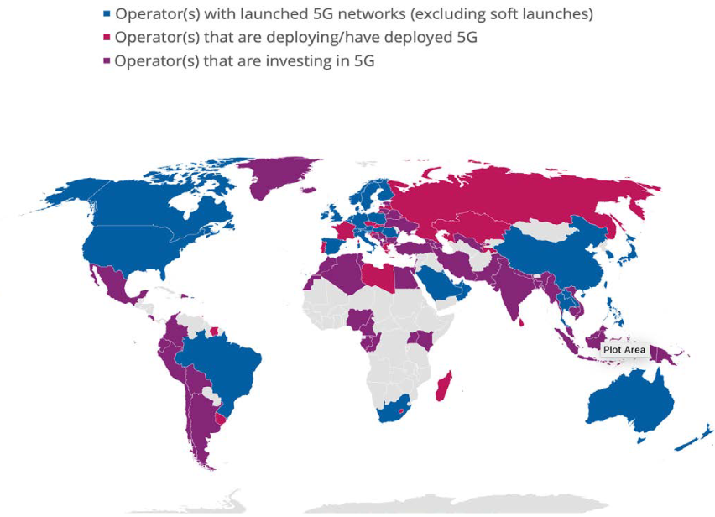

Figure 1: Global status of 5G deployments September 2020 (Source: GSA)

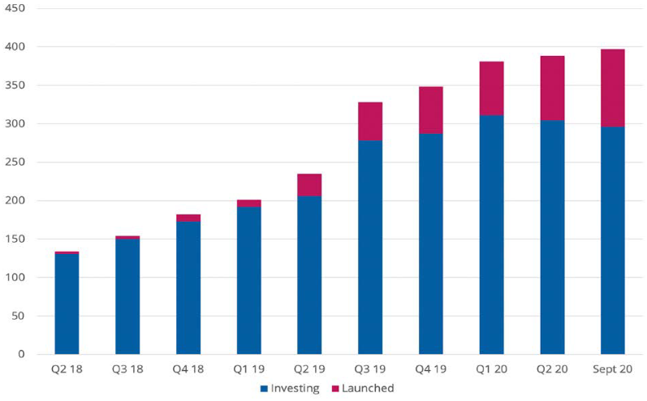

Figure 2: Count of operators investing in 5G and with launched commercial services up to September 2020 (Source: GSA)

There are now 444 announced 5G devices by the end of September 2020, with 222 commercially available – double the amount since May.

**(For information in ECC PT1)**