Correspondence Group “Methodology for receivers recommendation”

REPORT METHODOLOGY TO SE21

Methodology to be used for specifying recommended levels of receiver resilience to transmission on adjacent frequency ranges

This is a technical report aiming at helping SE21 to develop an ECC Recommendation on “Receiver resilience to transmission on adjacent frequency ranges”.

Contents
1. introduction 6
2. Basic theory on receivers resilience 6
2.1 Frequency offset interfering signal power received by the victim receiver 6
2.2 Relation between FOS, RIR and ILR 9
2.3 Derivation of levels of receiver resilience to transmission on adjacent frequency ranges 9
3. Method to derive blocking and selectivity levels 10
3.1 Use of the method 10
3.2 Consideration of different bandwidths of victim and interferer 10
3.3 Consideration of PAPR 10
3.4 Basics and application of RRM 11
ANNEX 1: Derivation of the Methods proposed in this report 14
ANNEX 2: EXAMPLES OF APPLICATIONs OF RRM 16
ANNEX 3: GENERAL GUIDANCE ON PARAMETERS M, N, ILR AND FOS 25
ANNEX 4: Potential Methods for testing 34
ANNEX 5: reference interfering signal and a single interference scenario to be used in the calculation of receivers resilience levels using RRM 36
ANNEX 6: List of referenceS 48

ABREVIATIONS

ACLR | Adjacent Channel Leakage Ratio
ACS | Adjacent Channel Selectivity
A/D | Analog/Digital
BS | Base Station
BER | Bit Error Rate
BW | Bandwidth
C/I | Carrier-to-Interference ratio
CW | Continuous Wave
D/A | Digital/Analog
DFRS | Digital fixed Radio Systems
DVB-T | Digital Video Broadcasting – Terrestrial
EIRP | Effective Isotropic Radiated Power
ETSI | European Telecommunications Standards Institute
E-UTRA | Evolved Universal Terrestrial Radio Access
FOS | Frequency Offset Selectivity
FS | Fixed Service
GSM | Global System for Mobile
HS | Harmonised Standards
ILR | Interference Leakage Ratio
IMT | International Mobile Telecommunications
IoT | Internet of Things
LNA | Low Noise Amplifier
NB | Narrow-Band
N | Noise Floor
NF | Noise Figure
NFD | Net Filter Discrimination
OOBE | Out-Of-Band Emissions
PAPR  PR | Peak-to-Average Power Ratio  Protection ratio
QoS | Quality of Service
RF | Radio-Frequency
RIR | Receiver Interference Ratio
RMS | Root-Mean-Square
RRM | Receiver Resilience Method
RX | Receiver
SEAMCAT | Spectrum Engineering Advanced Monte Carlo Analysis Tool
SINR | Signal to Interference and Noise Ratio
S/N | Signal/Noise
SNR | Signal to Noise Ratio
SRD | Short Range Devices
SRR | Short Range Radar
TX | Transmitter
UWB | Ultra-Wide Band
WBSEL | Wide-Band Selectivity

EXECUTIVE SUMMARY

SE21 has been tasked to develop an CEPT / ECC Recommendation on “Receiver resilience to transmission on adjacent frequency ranges”, including CEPT / ECC recommended levels for receiver resilience.

This report proposes a method called receiver resilience method “RRM” to calculate the receiver resilience levels, namely the adjacent channel PR and blocking levels, to be included in CEPT / ECC Recommendation on receivers.

RRM is a technology neutral generic method developed by the SE21 CG Methodology. It uses four parameters N, M, ILR and FOS to calculate the receivers resilience levels by a single equation derived from fundamental equations describing the mechanism of receivers resilience to a frequency offset interfering signal.

The validity of RRM was assessed by calculating receivers resilience levels defined in eight different ETSI Harmonised Standards for numerous receiver configurations. The results obtained showed good agreement with the adjacent channel PR and blocking levels defined in the respective harmonised standards.

Five distinct steps should be followed to derive the receivers resilience levels when using RRM. The most important step is Step 3, which aims to identify the interfering signal and interference scenario, and to determine the ILR value to be used in the calculation. This can be achieved, as proposed in this report, by two different approaches each having their own advantages and disadvantages:

- Based on the existing or planned deployment of victim and interfering systems and the compatibility studies presented in various CEPT/ECC, ETSI and ITU-R technical reports or ETSI harmonised standards.

Advantages:
1. Possibility to choose the interfering signal and interference scenario for each system/service if they are specified in the existing technical reports or harmonised standards.
2. Possibility to compare the calculated resilience levels with those assessed in the existing technical reports or defined in the existing harmonised standards.

Disadvantages:
1. Possible difficulty to choose the most relevant interfering signal and interference scenario for each system/service if they are not clearly specified in the existing technical reports or harmonised standards. Note that this difficulty may not apply to all systems/services and can be overcome by dealing with the issue within the competent CEPT or ETSI technical group.
2. Difficulty to choose the most relevant interfering signal and interference scenario for a given system/service if there are no technical reports or harmonised standards available.
3. Difficulty to choose the ILR value if it is not clearly defined in the existing technical reports or harmonised standards, or if there are no technical reports or harmonised standards available.

- From a reference interfering signal and interference scenario (one example is specified in Annex 5 of this report):

Advantages:
1. No need to choose an interfering signal and interference scenario for each system/service, since a single well specified reference interfering signal and interference scenario are used for all systems/services.
2. No need to choose the ILR value, since it is calculated from the well-defined spectrum mask of the reference interfering signal.
[3. The receiver resilience level is calculated based on the useful and interference signal levels at the receiver input independent of the radio environment in the field.]

Disadvantages:
1. The specified reference interfering signal and interference scenario cannot be changed and should be used for all systems/services;
2. The specified reference interfering signal and interference scenario may not be fully relevant to some systems/services.
[3. The real radio environment in the field is not considered in this approach]

The choice between these two alternatives might not be easy, but it would be sensible to choose only one of them when using RRM to derive the receivers resilience levels to be included in CEPT / ECC Recommendation on receivers.

Note that Method RRM was developed to calculate the resilience levels of receivers in the presence of a single frequency offset interfering signal as it is done in all harmonised standards. It was not developed to evaluate the impact of undesired signal variations, inherent in receivers, on receiver performances (e.g., to predict intermodulation response rejection or to model a badly-behaved non-linear receiver), neither to predict the behaviour of a specific receiver or for system design/development. Furthermore, in some cases the initial outcome of RRM may not lead directly to receiver limits which improve spectrum efficiency.

The report also presents the main information on how RRM was developed and can be used to calculate/specify the receiver resilience levels in CEPT / ECC Recommendation on receivers.

MAIN DEFINITIONS
The definitions below, except “Receiver desensitisation”, are from ECC Report 310 and used in this report for receivers working in their linear range.

Blocking:
A measure of the receiver capability to receive a wanted signal without exceeding a given degradation due to the presence of an unwanted signal at any frequency other than those of the spurious responses or of the adjacent channels and it is defined as the maximum interfering signal level expressed in dBm reducing the specified receiver sensitivity by a certain number of dBs (desensitisation).

Frequency Offset Selectivity (FOS):
A measure of the receiver ability to receive a wanted signal at its assigned channel frequency in the presence of an unwanted adjacent signal at a given frequency offset from the centre frequency of the assigned channel. It is most often defined as the ratio of the receiver filter attenuation on the offset frequency to the receiver filter attenuation on the assigned channel frequency (normally a positive number in dB).
FOS is of general use for any mixed wanted and unwanted signal situation.

Interference Leakage Ratio (ILR):
The ratio of the (nominally rectangular) filtered mean power centred on the assigned channel frequency to the similarly filtered mean power centred on a given frequency offset.

Receiver Interference Ratio (RIR):
The ratio of the in-channel interference power on a given frequency offset to the interference power received by the victim receiver.

Receiver desensitisation (M):
Reduction in the signal to noise ratio of the receiver or a reduction in the effective sensitivity in the presence of an interfering signal, given in dB. It corresponds to the ‘noise rise’ due to the interfering signal.

Receiver noise floor (N):
The total noise power at the receiver including the effect of thermal noise and the receiver noise figure.

introduction

SE21 is currently working on the development of an ECC Recommendation that should provide CEPT/ECC with a framework for continuous improvement of receiver resilience for a wide range / categories of receivers as per the SE21 WI 24:
“1. Be used by CEPT / ECC in its sharing and compatibility work and to be considered by ETSI when developing Harmonised Standards, giving an CEPT/ECC framework for continuous improvement of receiver resilience for a wide range / categories of receivers.
2. List existing receiver resilience limits from ETSI Standards, for information.
3. Provide CEPT / ECC recommended levels for receiver resilience.
4.Provide a separate annex with additional levels that can be considered by CEPT / ECC for use in sharing and compatibility studies.”

This technical report is based on the studies conducted under the SE21 WI 24. It aims to develop a methodology, which will be part of the ECC Recommendation, to be used for specifying recommended levels of receiver resilience to transmission on adjacent frequency ranges. Two different levels of receiver resilience will potentially be specified in the future recommendation; These are receiver adjacent channel (adj-ch) PR and blocking level (I_{blk}), both with a related frequency offset selectivity (FOS).

Section 2 provides the basic theory of receiver resilience and Section 3 presents RRM developed to calculate/specify the receiver resilience levels to be included in CEPT / ECC Recommendation on receivers.
.

Basic theory on receivers resilience

It is important to understand the mechanism of receivers resilience to a frequency offset interfering signal before attempting to develop a methodology to be used for specifying recommended levels of receiver resilience to transmission on adjacent frequency ranges, which are blocking (I_{blk}) or frequency offset selectivity (FOS).

Actually, the resilience of a receiver to a frequency offset interfering signal depends on the receiver overall performance based on filtering, linearity impairment effects, demodulation and decoding technics used. Nevertheless, more simply, it can be defined by the receiver blocking (I_{blk}), frequency offset selectivity (FOS) or receiver interference ratio (RIR) levels.

Note that in the theoretical development presented in the following sections the receiver intermodulation response rejection is not considered.

Receiver intermodulation response rejection is a measure of the capability of the receiver to receive a wanted signal, without exceeding a given degradation due to the presence of at least two interfering signals at frequencies f1 and f2, with a specific frequency relationship to the wanted signal frequency, which give rise to 2nd and 3rd order intermodulation products that may fall into the victim receiver channel.

However, the receiver intermodulation response rejection test is not included in all ETSI Harmonised Standards, because intermodulation in the RF tuner will result in a degradation in the adjacent channel selectivity, which is extensively tested in all ETSI Harmonised Standards. Moreover, real-life experience indicates that interference due to intermodulation in not a widespread problem between different system/services in Europe.

For example, HS dealing with DTT, DAB and Fixed service do not include a specific intermodulation response rejection test. The impact of the intermodulation products on the receiver performances are covered by adjacent channel selectivity tests. RRM developed in this report aims to derive blocking or selectivity levels of a receiver in the presence of a single interfering signal as it is done in all harmonised standards.

Frequency offset interfering signal power received by the victim receiver

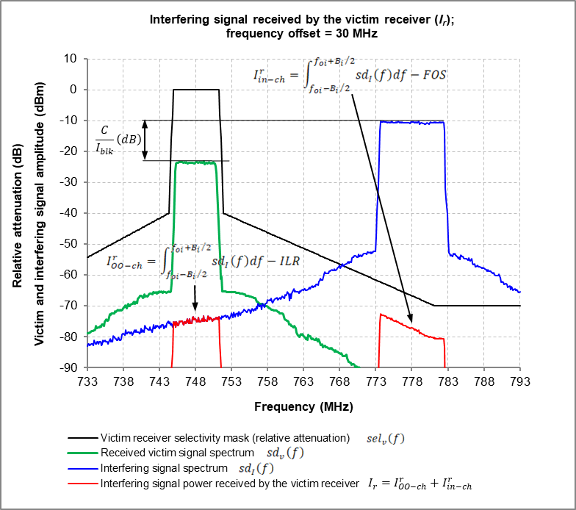

Figure 1 Frequency offset interfering signal power received by the victim receiver

The victim receiver receives both the interfering signal in-channel emissions (I_{in-ch}) attenuated by FOS and the interfering signal out-of-channel emissions (I_{oo-ch}) falling into its channel, which are defined by ILR. This is shown in Figure 1 and can be expressed in the linear domain as:

$$I_{r}=I_{oo-ch}^{r}+I_{in-ch}^{r}$$
$$=\frac{I_{in-ch}}{ILR}+\frac{I_{in-ch}}{FOS}$$
$=I_{in-ch}\left(\frac{1}{ILR}+\frac{1}{FOS}\right)$ (1)

In the logarithmic domain:

$I_{r}\left(dBm\right)=I_{in-ch}\left(dBm\right)+10\log_{10}{({10}^{-ILR(dB)/10}+{10}^{-FOS(dB)/10})}$ (2)

where

$I_{r}$: frequency offset interfering signal power received by the victim receiver;
$I_{in-ch}$: frequency offset interfering signal in-channel power at the receiver input;
$I_{oo-ch}^{r}$: frequency offset interfering signal out-of-channel power received by the victim receiver;
$I_{in-ch}^{r}$: frequency offset interfering signal in-channel power received by the victim receiver.

Equation 1 shows the relation between I_{r}, I_{in-ch}, ILR and FOS.

Note that when defining the resilience levels of a receiver, I_{in-ch} is often referred as I_{adj-ch} or I_{blk} depending on the frequency offset between the useful and interfering signals.

Note also that, as shown in Figure 1, the ILR and FOS are, formally, calculated as the ratios of the total in-channel interfering power ($I_{in-ch}$) to the result of the following integrations:

ILR in the linear domain:

$ILR=\frac{I_{in-ch}}{I_{oo-ch}^{r}}=\frac{\int_{f_{oi}-{B_{i}}/2}^{f_{oi}+{B_{i}}/2}{{sd}_{I}\left(f\right)df}}{\int_{f_{ov}-{B_{v}}/2}^{f_{ov}+{B_{v}}/2}{{sd}_{I}\left(f\right)df}}$ (3)

ILR in the logarithmic domain:

$ILR\left(dB\right)=10\log_{10}\left(\frac{\int_{f_{oi}-{B_{i}}/2}^{f_{oi}+{B_{i}}/2}{{sd}_{I}\left(f\right)df}}{\int_{f_{ov}-{B_{v}}/2}^{f_{ov}+{B_{v}}/2}{{sd}_{I}\left(f\right)df}}\right)$ (4)
where
$f_{0i}$: centre frequency of the interfering transmitter;
$f_{0v}$: centre frequency of the victim receiver;

FOS in the linear domain:

$FOS=\frac{I_{in-ch}}{I_{in-ch}^{r}}=\frac{I_{in-ch}}{\frac{I_{in-ch}}{\frac{1}{B_{i}}\int_{f_{ov}-{B_{i}}/2}^{f_{ov}+{B_{i}}/2}{{sel}_{v}\left(f\right)df}}}$ (5)

Therefore

$FOS=\frac{1}{B_{i}}\int_{f_{ov}-{B_{i}}/2}^{f_{ov}+{B_{i}}/2}{{sel}_{v}(f)df}$ (6)

FOS in the logarithmic domain:

$FOS\left(dB\right)=10\log_{10}\left(\frac{1}{B_{i}}\int_{f_{ov}-{B_{i}}/2}^{f_{ov}+{B_{i}}/2}{{sel}_{v}(f)df}\right)$ (7)

Where:
$B_{i}$ and $B_{v}$: interferer and victim bandwidth respectively;${sd}_{I}\left(f\right)$: interferer spectral density in the linear domain;
${sel}_{v}$: victim selectivity in the linear domain, in number, relative to the 0 value at its centre frequency f_{ov}.

For relatively high offset frequency, where the interferer relative spectral density and the victim receiver selectivity can be considered flat at constant value resulting in a constant FOS value independent from the interference signal bandwidth (B_{i}) as shown in Equation (7) and in an ILR value varying as a function of ${B_{i}}/{B_{v}}$ ratio as shown in Equation (4).

Receiver desensitisation “M” is the reduction in the signal to noise ratio of the receiver or a reduction in the effective sensitivity in the presence of an interfering signal. It corresponds to the ‘equivalent noise rise’ due to the interfering signal, which can be repressed in the linear domain as:

$M=\frac{N+I_{r}}{N}$ (8)

Where:
N: receiver noise floor within the Rx bandwidth defining together with the signal to noise ratio its sensitivity;
M: receiver desensitisation.

Note from the above equation that M is always greater than 1. Then, interfering signal power received by the victim receiver is:

$I_{r}=NM-N$ (9)

In the logarithmic domain:

$$I_{r}\left(dBm\right)=10log\left(NM-N\right)$$
$$=10log\left({10}^{\frac{N\left(dBm\right)}{10}}{10}^{\frac{M\left(dB\right)}{10}}-{10}^{\frac{N\left(dBm\right)}{10}}\right)$$
$=10log\left({10}^{\frac{N\left(dBm\right)+M\left(dB\right)}{10}}-{10}^{\frac{N\left(dBm\right)}{10}}\right)$ (10)

Equation 9 shows the relation between I_{r}, N and M. For more detailed information on N, M, I_{r} see ANNEX 3:.

Relation between FOS, RIR and ILR

From its definition RIR can be repressed in the linear domain as:

$RIR=\frac{I_{in-ch}}{I_{r}}$ (11)

By replacing I_{r} with the expression given in Equation 1:

$$RIR=\frac{I_{in-ch}}{\frac{I_{in-ch}}{ILR}+\frac{I_{in-ch}}{FOS}}$$
$=\frac{1}{\frac{1}{ILR}+\frac{1}{FOS}}$ (12)

Or, equivalently,

$\frac{1}{RIR}=\frac{1}{ILR}+\frac{1}{FOS}$ (13)

By rearranging the above equation:

$FOS=\frac{1}{\frac{1}{RIR}-\frac{1}{ILR}}$ (14)

In the logarithmic domain:

$$FOS\left(dB\right)=-10log\left(\frac{1}{{10}^{\frac{RIR\left(dB\right)}{10}}}-\frac{1}{{10}^{\frac{ILR\left(dB\right)}{10}}}\right)$$
$=-10log\left({10}^{\frac{-RIR\left(dB\right)}{10}}-{10}^{\frac{-ILR\left(dB\right)}{10}}\right)$ (15)

Equation 14 shows the relation between FOS, RIR and ILR.

Derivation of levels of receiver resilience to transmission on adjacent frequency ranges

The levels of receiver resilience to transmission on adjacent frequency ranges for a given receiver desensitisation “M” can be defined either by I_{r}, FOS or RIR. These three levels are directly linked to each other as demonstrated in the previous sections, the first two levels being more commonly used in harmonised standards to specify receivers resilience.

Equations (1), (9) and (14) developed in Sections 2.1 and 2.2 are the fundamental equations describing the mechanism of receivers resilience to a frequency offset interfering signal. They can be used to develop a method to derive levels of receiver resilience to transmission on adjacent frequency ranges.
By equating equations (1) and (9) (linear terms) we are getting the core equation used to derive levels of receiver resilience to transmission on adjacent frequency ranges as described in Annex 1, Section A.1:

$I_{blk}=\frac{NM-N}{\left(\frac{1}{ILR}+\frac{1}{FOS}\right)}$ (16)

Or in the logarithmic domain:

$I_{blk}\left(dBm\right)=10log\left({10}^{\frac{N\left(dBm\right)+M\left(dB\right)}{10}}-{10}^{\frac{N\left(dBm\right)}{10}}\right)-10log\left({10}^{\frac{-ILR \left(dB\right)}{10}}+{10}^{\frac{-FOS \left(dB\right)}{10}}\right)$ (17)

Method to derive blocking and selectivity levels

Use of the method
RRM aims to calculate/specify the receiver resilience levels to be included in CEPT / ECC Recommendation on receivers. The basic equation of the method (Equation (16)) predicts the frequency offset interfering signal level (I_{in-ch}) at the receiver input and consequently the adj-ch PR and blocking level (I_{blk}) of the receiver based on four input parameters N, M, ILR and FOS.

The basic equation of RRM was not developed to evaluate the impact of undesired signal variations inherent in receivers on their performances (or to model a badly-behaved non-linear receiver), neither to predict the behaviour of a specific receiver.

Consideration of different bandwidths of victim and interferer

The parameters ILR and FOS of the basic equation of RRM implicitly take into account the interfering and victim signal bandwidths as explained in ANNEX 3:, Section A3.2.2.

Consideration of PAPR

In modern communication systems, the PAPR of the majority of transmitted signals is optimized (minimized) to improve the efficiency of transmitters, that is to prevent high undesirable power dissipation at the transmitter (cost reduction) and to improve the reliability of the transmitted signal (high QoS). This minimize the impact of interfering signal on the receivers resilience levels.

However, the intended operation of some of radio systems requires significantly high peak to mean ratio (e.g. most radio-determination/radio-location and UWB applications).

In most of the ETSI HS the blocking level of receivers (I_{blk}) is defined as mean power of the interfering signal. . Usually, I_{blk} is measured in rms (root mean square) measurement mode in a BW equal to the interfering signal channel BW at the input of the victim receiver in the presence of the interfering signal under normal operating conditions. In the case of a time varying interfering signal the I_{blk} is the maximum rms power of the active portions of the interfering signal measured over an interval of time sufficiently long. The I_{blk} predicted by the basic equation of RRM is the interfering signa in-block mean power.

In the presence of interfering signals with a relatively small average power associated with a possible high peak-to-average ratio as pulse modulated signals, both peak and average power may need to be considered. Applicability of the basic equation of RRM to such interfering scenarios should be checked. Harmonised Standard EN 303 340 is one of the rear harmonised standards that uses a pulsed type interfering signal, for a specific interference configuration, to define the blocking level of DTT receivers. In this specific case the blocking level is defined based on the mean rms value of the interference signal measured during its active period (which should be of the same order as the peak power), the PAPR being about 18 dB. The validity of the defined blocking level was successfully checked by using RRM. Finally, if for a specific interference configuration there is a need to consider the impact of pulsed type signals on a receiver performance, it should be done first in harmonised standards and after a revision of the future Recommendation on receivers might be proposed to also consider these scenarios.

Basics and application of RRM

3.4.1 Basics of the method

This method derives the frequency offset interfering signal level (I_{in-ch}) at the receiver input and consequently the blocking level (I_{blk}) and adj-ch PR of the receiver, for given values of M, N, ILR and FOS, from the equation below (see ANNEX 1:).

The blocking level $\left(I_{in-ch}=I_{blk}\right)$:

$I_{blk}\left(dBm\right)=10log\left({10}^{\frac{N\left(dBm\right)+M\left(dB\right)}{10}}-{10}^{\frac{N\left(dBm\right)}{10}}\right)-10log\left({10}^{\frac{-ILR \left(dB\right)}{10}}+{10}^{\frac{-FOS \left(dB\right)}{10}}\right)$ (18)

Or, the carrier to interference ratio (${C/I}_{in-ch}={C/I}_{adj-ch}$) as follows:

$${C/I}_{adj-ch}\left(dB\right)=C(dBm)-I_{adj-ch}\left(dBm\right)$$
$=C_{sens}(dBm)+M(dB)-I_{adj-ch}\left(dBm\right)$ (19)

where
N: Noise floor of the victim receiver;
M: Victim receiver maximum acceptable desensitization at a given frequency offset;
FOS: Frequency offset selectivity of the victim receiver;
ILR: Leakage power ratio of the interfering signal at offset frequency;
C: useful signal level received by the victim receiver;
$C_{sens}$: receiver sensitivity level, specified for the victim receiver.
3.4.2 Application of the method

The steps below should be followed to derive the receiver blocking level (I_{blk}) or adjacent channel level (I_{adj-ch}):

Step 1 Calculate the noise floor (N) of the receiver:

Every radio receiver is subject to a noise floor that can be described using the following equation and expressed in dBm:

$N\left(dBm\right)=10\log_{10}\left(kTB\right)+NF\left(dB\right)+30$ (20)

Where:
N: receiver noise floor (dBm);
K: Boltzmann constant in Joules per Kelvin (1.381×10⁻²³);
T: temperature in degrees Kelvin (for common terrestrial radio receivers, 290 K can be used);
B: receiver bandwidth in Hertz;
kTB: receiver thermal noise in W/Hertz;
NF: receiver Noise Figure (dB).

Step 2 Calculate the receiver desensitization (M) (go to Step 3 if M is known):

M is often found in ETSI harmonised standards, either explicitly mentioned, or calculated from the required “Receiver sensitivity” (in absence of interference) and the “Minimum wanted received signal level” required in the blocking test through the equation:

$M\left(dB\right)=Minimum wanted received signal level\left(dBm\right)-Receiver sensitivity\left(dBm\right)$ (21)

If it is not possible to find/calculate M from the ETSI harmonised standard as above, the following values: M=3 and/or M= 15 dB should be assumed. The M=3 dB value may be assumed for systems deployed in a “noise driven performance” operational environment, while the M=15 dB may be assumed for systems deployed in a “interference driven performance” operational environment (see ANNEX 3:, Section A3.2.2).

Note that when choosing M it should be ensured that the value of M is based on the expected operational range of the receiver.

Step 3 Determine the ILR value to be used in Step 4 (see ANNEX 3:, section A3.2.4 for more detailed information):

Identify the interfering signal and interference scenario:

- The relevant interfering signal and interference scenario can be identified based on the existing or planned deployment of victim and interfering systems and the compatibility studies presented in various CEPT/ECC, ETSI and ITU-R technical reports (see Annex 3.3)
- or from the reference interfering signal and interference scenario defined in Annex 5 for inter-system compatibility.

Determine the ILR value

Once the relevant interfering signal and interference scenario are identified the following approach can be used to determine the appropriate ILR value:

Option 1: If the victim receiver channel is in the OOB domain of the interfering signal (see ANNEX 3:, Section A3.2.4):

Use:
- the ILR (ACLR) value defined in existing EC/ECC decisions, CEPT/ITU-R recommendations, CEPT/ECC reports and ETSI harmonised standards/technical specifications/reports;
- or the ILR value determined by measurements;
- or the ILR value derived from the reference interfering signal defined in its OOB domain defined in Annex 5 for inter-system compatibility.

Option 2: If the victim receiver channel is in the spurious domain of the interfering signal (see ANNEX 3:, Section A3.2.4):

Use:
- the ILR value derived from the spurious emission levels defined in the existing EC/ECC decisions, CEPT/ITU-R recommendations (e.g. ERC/REC 74-01 [4], Rec. ITU-R SM.329-12) and ETSI harmonised standards;
- or the ILR value determined by measurements;
- or the ILR value derived from the reference interfering signal defined in its spurious domain defined in Annex 5 for inter-system compatibility.

Step 4 Define the frequency offset selectivity (FOS) of the receiver based on the following options:

Option 1: If the victim receiver channel is in the OOB domain of the interfering signal:

- FOS (dB) ≥ ILR (dB) + X dB depending on the quality of service of the victim service, e.g.:
- X = 10 dB would correspond to $I_{r}=I_{oo-ch}^{r}+0.4 dB$
- X = 6 dB would correspond to $I_{r}=I_{oo-ch}^{r}+1 dB$
- or FOS= ILR (ILR value derived from the reference interfering signal defined in Annex 5) + 10 dB for inter-system compatibility
Option 2: If the victim receiver channel is in the spurious domain of the interfering signal:

FOS can be determined:
- as the 95th percentile of the measured receivers FOS values;
- or based on the blocking level defined in ETSI harmonised standards as follows (see ANNEX 1:):

$FOS\left(dB\right)=-10log\left(\frac{{10}^{\frac{N\left(dBm\right)+M\left(dB\right)}{10}}-{10}^{\frac{N\left(dBm\right)}{10}}}{{10}^{\frac{I_{blk}\left(dBm\right)}{10}}}-{10}^{\frac{-ILR\left(dB\right)}{10}}\right)$ (22)
Note: for the above calculation (equation 22) the frequency offset value for I_{blk} used in the concerned ETSI harmonised standard (Offset1) should be of the same order of magnitude as the frequency offset value used in the considered interference scenario (Offset2). That is |Offset1-Offset2| < BW_{I}/4;

- or FOS=ILR (ILR value derived from the reference interfering signal defined in Annex 5) for inter-system compatibility

Step 5 Derive the receiver blocking level (I_{blk}) from the following equation:

$I_{blk}\left(dBm\right)=10log\left({10}^{\frac{N\left(dBm\right)+M\left(dB\right)}{10}}-{10}^{\frac{N\left(dBm\right)}{10}}\right)-10log\left({10}^{\frac{-ILR \left(dB\right)}{10}}+{10}^{\frac{-FOS \left(dB\right)}{10}}\right)$ (23)

Or if the ILR of the interfering signal can be considered infinite (very high):

$I_{blk}\left(dBm\right)=10log\left({10}^{\frac{N\left(dBm\right)+M\left(dB\right)}{10}}-{10}^{\frac{N\left(dBm\right)}{10}}\right)+FOS(dB)$ (24)

Or, in terms of ${C/I}_{adj-ch}$ ratio, once evaluated $I_{adj-ch}\left(dBm\right)$from the above formulas:

${C/I}_{adj-ch}\left(dB\right)=C(dBm)-I_{adj-ch}\left(dBm\right)=C_{sens}(dBm)+M(dB)-I_{adj-ch}\left(dBm\right)$ (25)

- Derivation of the Methods proposed in this report

Derivation of the basic equation of RRM

The basic equation of RRM shown below allows to calculate the receiver blocking level as a function of N, M, ILR and FOS:

$I_{blk}\left(dBm\right)=10log\left({10}^{\frac{N\left(dBm\right)+M\left(dB\right)}{10}}-{10}^{\frac{N\left(dBm\right)}{10}}\right)-10log\left({10}^{\frac{-ILR \left(dB\right)}{10}}+{10}^{\frac{-FOS \left(dB\right)}{10}}\right)$ (A..1.1)

This equation has been derived through the following steps. Note that the derivation is carried out in the linear domain and only the final result is transformed from the linear domain to the logarithmic domain:

The victim receiver receives both the interfering signal in-channel emissions (I_{in-ch}) attenuated by FOS and the interfering signal out-of-channel emissions (I_{oo-ch}) falling into its channel, which are defined by ILR.

$$I_{r}=I_{oo-ch}^{r}+I_{in-ch}^{r}$$
$=\frac{I_{in-ch}}{ILR}+\frac{I_{in-ch}}{FOS}$ (A.1.2)

Note that when defining the resilience levels of a receiver, I_{in-ch} is often referred as I_{adj-ch} or I_{blk} depending on the frequency offset between the useful and interfering signals.

The blocking level of the receiver (I_{blk}) being defined as the maximum interfering signal level reducing the specified receiver sensitivity by a certain amount (desensitisation):

$I_{r}=\frac{I_{blk}}{ILR}+\frac{I_{blk}}{FOS}$ (A.1.3)

The received interfering signal power causing a receiver desensitization of M can be calculated as follows, where N is the noise floor of the receiver:

$I_{r}=NM-N$ (A.1.4)

By equating Equations A.1.3 and A.1.4:

$\frac{I_{blk}}{ILR}+\frac{I_{blk}}{FOS}=NM-N$ (A.1.5)

The above equation can be rewritten as:

$I_{blk}\left(\frac{1}{ILR}+\frac{1}{FOS}\right)=NM-N$ (A.1.6)

and then

$I_{blk}=\frac{NM-N}{\left(\frac{1}{ILR}+\frac{1}{FOS}\right)}$ (A.1.7)

Converting back from linear to logarithmic domain:

$I_{blk}\left(dBm\right)=10log\left(NM-N\right)-10log\left(\frac{1}{ILR}+\frac{1}{FOS}\right)$ (A.1.8)

As the values of N, M, ILR and FOS are always defined in the logarithmic domain the above equation can be rewritten as:

$I_{blk}\left(dBm\right)=10log\left({10}^{\frac{N\left(dBm\right)+M\left(dB\right)}{10}}-{10}^{\frac{N\left(dBm\right)}{10}}\right)-10log\left({10}^{\frac{-ILR \left(dB\right)}{10}}+{10}^{\frac{-FOS \left(dB\right)}{10}}\right),$ which is the basic equation of RRM.

Note that the receiver frequency offset selectivity can also be expressed as a function of N, M, I_{blk} and ILR from Equation A.1.6:

$\frac{1}{ILR}+\frac{1}{FOS}=\frac{NM-N}{I_{blk}}$ (A.1.9)

and

$\frac{1}{FOS}=\frac{NM-N}{I_{blk}}-\frac{1}{ILR}$ - (A.1.10)

then

$FOS=\frac{1}{\frac{NM-N}{I_{blk}}-\frac{1}{ILR}}$ (A.1.11)

Converting from the linear domain to the logarithmic domain:

$FOS\left(dB\right)=-10log\left(\frac{NM-N}{I_{blk}}-\frac{1}{ILR}\right)$ (A.1.12)

and finally:

$FOS\left(dB\right)=-10log\left(\frac{{10}^{\frac{N\left(dBm\right)+M\left(dB\right)}{10}}-{10}^{\frac{N\left(dBm\right)}{10}}}{{10}^{\frac{I_{blk}\left(dBm\right)}{10}}}-{10}^{\frac{-ILR\left(dB\right)}{10}}\right)$ (A.1.13)

- EXAMPLES OF APPLICATIONs OF RRM

Application of RRM where receiver blocking level is independent of the ILR for the requirement

In a real-life interference scenario, desensitization of the receiver will depend on both ILR and FOS as shown in ANNEX 1:, leading to Method #1 for deriving receiver blocking described in section 3.1. While in a sharing/compatibility scenario this is true and the impact of both FOS and ILR is important, it may be desirable to define a receiver requirement based only on FOS, in cases where it is difficult to determine the specific ILR of the interfering signal that is used in a harmonised standard and it is instead better to assume a sufficiently high ILR that would not impact the requirement. Achieving adequate ACLR/ILR on test signals is important to reduce the impact on I/C measurements. The ideal configuration uses separate signal generators for the wanted and interferer signals which also allow a band pass filter to be added to the interference path to improve the ACLR/ILR further.

While some harmonised standards only imply such requirements on the interfering signal through the way receiver requirements are defined, other standards have explicit requirements on interfering signals. One example is EN 303 340, which stresses the importance of improving ACLR in informative Annex D.3 and sets normative requirements for minimum ACLR of the interfering signal in informative Annex F.

Another aspect is that it may be reasonable in certain scenarios to select a FOS value that is at least as high, or even considerably higher than ILR, in order for the FOS not to be limiting in the sharing/compatibility scenario. If we assume that FOS >> ILR, Step 4 of Method #1 deteriorates into

$$I_{blk}\left(dBm\right)≈10log\left({10}^{\frac{N\left(dBm\right)+M\left(dB\right)}{10}}-{10}^{\frac{N\left(dBm\right)}{10}}\right)+ILR, when FOS ≫ILR$$

This is clearly not desirable, since it means that the blocking level will depend very little on the desired receiver resilience (FOS), but almost completely on the ILR of the interfering signal. Such a requirement is not very useful.

Note that the same reasoning (but reversed) can be made for transmitters, where defining a transmitter requirement using a receiver with a non-adequate FOS would impair the definition of the requirement and make the result depend mostly on the receiver impairments. Clearly the limits in ERC Rec 74-01 are not defined that way, but rather assumes a sufficiently good spectrum analyser to catch the unwanted emissions independent of receiver impairments.

The solution would be to separate the assumptions of the sharing scenario from the requirement scenario. In the sharing scenario, we analyse FOS and ILR and make an informed choice of FOS for the receiver according to Step 3 of Method #1, for example
1. FOS based on “balance” between Tx and Rx requirements: FOS (dB) = ILR (dB);
2. FOS defined with some margin above the impairment from unwanted emissions, in cases where it is desirable to not be limited by the receiver: FOS (dB) > ILR (dB).
3. FOS defined with some margin below the impairment from unwanted emissions, in cases where it is desirable to not be limited by the transmitter, e.g. when the allowed complexity is much higher for the transmitter than for the receiver: FOS (dB) < ILR (dB).

Once FOS is selected, the blocking requirement is defined using a different scenario, ensuring that ILR >> FOS. It is reasonable to assume that ILR is infinite and has no impact, leading to a blocking level in Step 3 of RRM independent of the ILR of the interfering (test) signal:

$I_{blk}\left(dBm\right)=10log\left({10}^{\frac{N\left(dBm\right)+M\left(dB\right)}{10}}-{10}^{\frac{N\left(dBm\right)}{10}}\right)+FOS(dB)$, assuming ILR >> FOS

where
N: Noise floor of the victim receiver (dBm);
M: Victim receiver desensitization at a given frequency offset (dB);
FOS: Frequency offset selectivity of the victim receiver (dB);
ILR: Leakage power ratio of the interfering signal at offset frequency (dB).

  - Generic application of RRM for specifying recommended levels of receivers resilience to transmission on adjacent frequency ranges in ETSI Harmonised Standards

A generic method “RRM” is proposed in the working document on the Methodology to be used for specifying recommended levels of receivers resilience to transmission on adjacent frequency ranges. It’s technology neutral and uses N, M, ILR and FOS to derive the receivers blocking level by a single equation derived from the basic equations describing the receivers resilience mechanism (see Section 2 of the working document).

The validity of RRM was not questioned. However, discussions are ongoing in the CG Methodology on:
• the choice of Rx desensitization value (M) when calculating I_{blk;}
• testing aspects (conformity testing);
• how is RRM applied (examples of application).

This document presents the results of in-depth analysis carried out:
to understand how receivers adjacent channel selectivity and blocking requirements are defined in different ETSI harmonised standards;
to check if the basic equation of RRM can be used to derive the blocking requirements defined in harmonised standards;
to check if the basic equation of RRM can be used to verify the consistency between different requirements defined in harmonised standards;
to find out how to choose Rx desensitization value (M) when calculating I_{blk.}

RRM consists of deriving the receiver blocking level (I_{blk}) or the carrier to interference blocking level ratio (${C/I}_{blk}$), for a given acceptable receiver desensitization “M”, from the equation below:

$I_{blk}\left(dBm\right)=10log\left({10}^{\frac{N\left(dBm\right)+M\left(dB\right)}{10}}-{10}^{\frac{N\left(dBm\right)}{10}}\right)-10log\left({10}^{\frac{-ILR \left(dB\right)}{10}}+{10}^{\frac{-FOS \left(dB\right)}{10}}\right)$

Or, in terms of ${C/I}_{blk}$ ratio:

$${C/I}_{blk}\left(dB\right)=C(dBm)-I_{blk}\left(dBm\right)$$
$=C_{sens}(dBm)+M(dB)-I_{blk}\left(dBm\right)$

Where:
N: Noise floor of the victim receiver (dBm);
M: Victim receiver maximum acceptable desensitization at a given frequency offset (dB);
FOS: Frequency offset selectivity of the victim receiver (dB);
ILR: Leakage power ratio of the interfering signal at offset frequency (dB);
C_{sens}: receiver sensitivity level, specified for the victim receiver

Note that even if the basic equation is proposed to calculate I_{blk}, the calculated I_{blk} is simply I_{adj} in the case of adjacent channel interference and I_{co-ch} in the case of co-channel interference, as far as the victim receiver operates in its linear range. This is demonstrated in the analysis presented in this document.

RRM has been used in the analysis presented in this document. No circular calculations have been made in the analysis. That is blocking requirements defined in harmonised standard were not used to calculate ILR or FOS needed to derive the receiver blocking level by using RRM.

    - Receivers blocking requirements defined in different ETSI harmonised standards and applicability of RRM to determine the receiver blocking levels

Four ETSI Harmonised Standards have been analysed to understand how receivers resilience requirements (FOS and I_{blk}) are defined in these standards. The analysed harmonised standards deal with Broadcasting, Mobile, Fixed services and GSM respectively:
ETSI EN 303 340 V1.2.1: Digital Terrestrial TV Broadcast Receivers; Harmonised Standard for access to radio spectrum;
ETSI EN 301 908-14 V13.1.1: IMT cellular networks; Harmonised Standard for access to radio spectrum; Part 14: Evolved Universal Terrestrial Radio Access (E-UTRA) Base Stations (BS);
ETSI EN 302 217-2 V3.3.1: Fixed Radio Systems; Characteristics and requirements for point-to-point equipment and antennas; Part 2: Digital systems operating in frequency bands from 1 GHz to 86 GHz; Harmonised Standard for access to radio spectrum;
ETSI EN 301 502 V12.5.1: Global System for Mobile communications (GSM); Base Station (BS) equipment; Harmonised Standard covering the essential requirements of article 3.2 of the Directive 2014/53/EU.

    - Harmonised Standard ETSI EN 303 340 “Digital Terrestrial TV Broadcast Receivers”

Note: the ACLR (or ILR) mentioned in this section refers to the ACLR (or ILR) of the interfering test signal.
General comments

FOS and ILR defined in ECC Report 310 has not been taken into account in ETSI EN 303 340 yet. Instead, ACS (adjacent channel selectivity) and ACLR (adjacent channel leakage ratio) are used independently from the frequency offset between the useful and interfering signals in ETSI EN 303 340.

Moreover, the term ACS used in this harmonised standard does not have the same meaning as the term ACS defined in ECC Report 310 and in compatibility studies carried out within CEPT. The term ACS used in ETSI EN 303 340 is equivalent to the measured I/C ratio of the receiver under test.

The receivers ACS and blocking level (I_{blk}) are defined in the presence of an interfering signal with a minimum ACLR value (ACLR_{min}) with the assumption ACS = ACLR_{min}, which is normative (see ETSI EN 303 340, Annex F). This assumption implies that the OOBE of the interfering signal received by the receiver under test is not negligible and consequently will impact the compliance measurement results. However, note that ACLR_{min} means that the value of ACLR used in the measurement can be higher than the value of ACLR_{min}. This is explicit in ETSI EN 303 340, informative Annex D/D3, where it is proposed to improve the interfering signal ACLR to minimise its impact on measurement results.

The above findings are summarised in Table A.2.1.

ETSI EN 303 340 V1.2.1: Digital Terrestrial TV Broadcast Receivers; Harmonised Standard for access to radio spectrum
Note: the ACLR mentioned in this table refers to the ACLR of the interfering test signal
Victim receiver | Frequency offset | Requirement | Type of  interfering signal | ACLR requirement for the interfering signal | Assumption used to define blocking requirements⁽¹⁾ | ACLR proposed for conformance testing⁽²⁾
DVB-T/T (8 MHz) | 8 MHz | Receiver ACS (I_{adj}/C) | DVB-T (8 MHz) | 43 dB (ACLR_{min}) | ACS = ACLR_{min} | ACLR ≥ ACLR_{min}
DVB-T/T2 (8 MHz) | 8 MHz | Receiver ACS (I_{adj}/C) | DVB-T (8 MHz) | 47 dB (ACLR_{min}) | ACS = ACLR_{min} | ACLR ≥ ACLR_{min}
DVB-T (8 MHz) | 10 MHz | Receiver ACS (I_{adj}/C) | 10 MHz LTE 700 MHz BS light load (near idle) | 53 dB (ACLR_{min}) | ACS = ACLR_{min} | ACLR ≥ ACLR_{min}
DVB-T (8 MHz) | 73 MHz | Receiver ACS (I_{adj}/C) | 10 MHz LTE 700 MHz BS light load (near idle) | 61 dB (ACLR_{min}) | ACS = ACLR_{min} | ACLR ≥ ACLR_{min}
DVB-T2 (8 MHz) | 10 MHz | Receiver ACS (I_{adj}/C) | 10 MHz LTE 700 MHz BS light load (near idle) | 58dB (ACLR_{min}) | ACS = ACLR_{min} | ACLR ≥ ACLR_{min}
DVB-T2 (8 MHz) | 73 MHz | Receiver ACS (I_{adj}/C) | 10 MHz LTE 700 MHz BS light load (near idle) | 65 dB (ACLR_{min}) | ACS = ACLR_{min} | ACLR ≥ ACLR_{min}
DVB-T (8 MHz) | 73 MHz | Receiver blocking level (I_{blk}) | 10 MHz LTE 700 MHz BS fully loaded | 64 dB (ACLR_{min}) | ACS = ACLR_{min} | ACLR ≥ ACLR_{min}
DVB-T2 (8 MHz) | 73 MHz | Receiver blocking level (I_{blk}) | 10 MHz LTE 700 MHz BS fully loaded | 66 dB (ACLR_{min}) | ACS = ACLR_{min} | ACLR ≥ ACLR_{min}
1. The required minimum ACLR level depends on the magnitude of I/C values to be measured. Minimum ACLR values to just pass the tests in the present document are provided in table F.1. These values assume a 3 dB ACLR degradation contributing to on the measured performance (see ETSI EN 303 340 V1.2.1, Annex F (Normative).
2. In Annex D/D3 (informative) it is proposed to improve the interfering signal ACLR to minimise its impact on measurement results.
Table A.2.1

Also note the measured DTT receiver sensitivities, and not those defined in ETSI EN 303 340, have been used that in all the calculations presented in the following sections. This is justified by the fact that the DTT receiver sensitivities defined in ETSI EN 303 340 are far above the measured (actual) DTT receiver sensitivities (see ECC Report 310).

Applicability of RRM to determine the receiver blocking levels defined in ETSI EN 303 340

The applicability of RRM to determine the receiver selectivity (I_{adj-ch}/C) and blocking levels (I_{blk}) defined in ETSI EN 303 340 has been checked. The calculations have been made for two cases:
FOS = ILR = ACLR_{min};
FOS = ACLR_{min} and ILR = 100 dB (ILR>>FOS).

No calculations have been made when the values of FOS (or ACS) and ILR (or ACLR) are not defined/provided and they cannot be calculated independently from the I_{blk} defined in the harmonised standard.
Results of the calculations

The results of the calculations, presented in Doc. CG-MRxRec-SE21(21)016, Tables 2 and 3, show that for DVB-T/T2 receivers the C/I_{adj-ch} and I_{blk} derived by using RRM are quite close to those defined in ETSI EN 303 340, the difference being less than 2 dB, except 4 values (over 16) where the value of FOS used in the calculations was different than ILR. This can be explained by the fact that in ETSI EN 303 340 C/I_{adj-ch} and I_{blk} are defined with the assumption of ACS (FOS)=ACLR_{min} (ILR).

The value of M to be used in the conformity tests is not directly defined in ETSI EN 303 340.Nevertheless it can easily be calculated as follows:

$$M\left(dB\right)=Rx useful l signal level\left(dBm\right)-Rx sensitivity\left(dBm\right)$$
$$=C\left(dBm\right)-{Rx}_{sens}\left(dBm\right)$$

The calculated values of M are about 13 and 14 dB for receivers blocking tests and vary from 25 to 34 dB for receivers selectivity (C/I_{adj-ch}) tests.

    - Harmonised Standard ETSI EN 301 908-14 “IMT cellular networks”

Note: the ACLR (or ILR) mentioned in this section refers to the ACLR (or ILR) of the interfering test signal.
General comments

Note that while the receiver selectivity requirement in the harmonised standard is called ACS, it is expressed with an interferer level and not with an ACS value as used in compatibility studies within CEPT (see ECC Report 310). The term ACS used in ETSI EN 301 908-14 is equivalent to the measured interfering signal level (I_{adj}).

The receivers ACS and blocking level (I_{blk}) are defined in the presence of a 5 MHz E-UTRA interfering signal for frequency offsets lower than 20 MHz and a CW interfering signal for frequency offsets higher than 20 MHz from the uplink operating band. There is no explicit requirement for interfering signal ACLR in ETSI EN 301 908-14. Nevertheless, the ACLR_{min} of the interfering signal to be used for conformance testing should be equal to ACS+10.2 dB (see ETSI TS 136 141). This condition implies that the OOBE of the interfering signal received by the receiver under test are very low and consequently will barely impact the compliance measurement results (0.4 dB additional rise in interference,).

In the case of ACS and narrow-band blocking, the ACLR values to be used in compliance measurements are defined in ETSI TS 136 141. ACLR is not applicable to CW interfering signal.

The above findings are summarised in Table A.2.2.

ETSI EN 301 908-14 V13.1.1: IMT cellular networks; Harmonised Standard for access to radio spectrum; Part 14: Evolved Universal Terrestrial Radio Access (E-UTRA) Base Stations (BS)
Note: the ACLR mentioned in this table refers to the ACLR of the interfering test signal.
Victim receiver (10 MHz) | Frequency offset | Requirement | Type of  interfering signal | ACLR requirement for the interfering signal | Assumption on ACS/ACLR used to define blocking requirements⁽³⁾⁽⁴⁾ | ACLR requirement for conformance testing⁽³⁾⁽⁴⁾
Wide Area IMT BS | ±2,5075 MHz | Receiver ACS (I_{adj}) | 5 MHz E-UTRA signal | No requirement | ACLR_{min} =56 dB  ACS= ACLR_{min} -10.2 dB=45.8 dB | ACLR_{min}=56 dB  ACLR_{min}=ACS+10.2 dB
Wide Area IMT BS | ±(347,5 + m × 180),  m = 0, 1, 2, 3, 4, 9, 14, 19, 24 | Receiver narrowband blocking level (I_{blk}) | 5 MHz E-UTRA signal, 1 RB⁽²⁾ | No requirement | ACLR_{min} =59 dB  ACS= ACLR_{min} -10.2 dB=48.8 dB | ACLR_{min}=59 dB  ACLR_{min}=ACS+10.2 dB⁽³⁾
Wide Area IMT BS | (F_{UL_low}-20) to (F_{UL_high}+ 20)⁽¹⁾ | Receiver blocking level (I_{blk}) | 5 MHz E-UTRA signal | No requirement | ACLR_{min} =ACS+10.2 dB | ACLR_{min} =ACS+10.2 dB
Wide Area IMT BS | 1 to (F_{UL_low}-20)  (F_{UL_low}+20) to (F_{UL_high}+ 12750) | Receiver blocking level (I_{blk}) | CW signal | No requirement | ACLR not applicable | ACLR not applicable
1. F_{UL_low} and F_{UL_high} are the lowest and highest frequencies of the uplink operating band
2. Interfering signal consisting of one resource block is positioned at the stated offset, the channel bandwidth of the interfering signal is located adjacently to the lower/upper Base Station RF Bandwidth edge. Frequency offsets are such that the interfering signal is outside the channel
3. The contribution from the Test equipment ACLR is calculated to give a 0.4dB additional rise in interference. This corresponds to a Test equipment ACLR which is 10.2 dB better than the BS ACS (see ETSI TS 136 141, Table 4.1.2-2, 7.5 Adjacent Channel Selectivity (ACS) and narrow-band blocking; Note 2: d and e)
4. The contribution from the Test equipment ACLR is calculated to give a 0.4dB additional rise in interference (see ETSI TS 136 141, Table 4.1.2-2, 7.6.5.1 Blocking (General requirements))
Table A.2.2
Applicability of RRM to determine the receiver blocking levels defined in ETSI EN 301 908-14

The applicability of RRM to determine the receiver blocking levels (I_{blk}) defined in ETSI EN 301 908-14 has been checked. The calculations were carried out for two cases:
FOS = ILR = ACLR_{min};
FOS = ACLR_{min} and ILR = 100 dB (ILR>>FOS).

The ACS of the victim receiver being defined by the interfering signal level I_{adj,,} this level has also been calculated by using the basic equation of RRM.

No calculations have been made in when the values of FOS (or ACS) and ILR (or ACLR) are not defined/provided and they cannot be calculated independently from the I_{adj} or I_{blk} defined in the harmonised standard. This is the case for the receiver blocking level tests.

For the sake of not ending up with a bulky section here only 1.4 MHz, 5 MHz and 10 MHz Wide Area IMT BS receivers have been considered.
Results of the calculations

The results of the calculations, presented in Doc. CG-MRxRec-SE21(21)016, Tables 5 to 7, show that for 1.4, 5 and 10 MHz Wide Area IMT BS receiver the I_{adj-ch} and narrowband I_{blk} derived by using RRM are very close to those defined in ETSI EN 301 908. Their difference is less than 1 dB. I_{blk} cannot be calculated, since there is no information on the ACS and ACLR values used to define this parameter in ETSI EN 301 908 and TS 136 141.

The value of M to be used in the conformity tests is defined in ETSI EN 301 908. It varies from 6 to 27 dB depending on the channel BW and type of the IMT BS under test.

    - Harmonised Standard ETSI EN 302 217-2 “Fixed Radio Systems”

Note: the ACLR (or ILR) mentioned in this section refers to the ACLR (or ILR) of the interfering test signal.
General comments

Neither ACS or FOS nor ACLR or ILR are used in ETSI EN 302 217-2.

In this harmonised standard, the receiver selectivity is specified in terms of receiver sensitivity degradation (i.e. equal to M) in presence of a wanted signal like interfering signal of predefined protection ratio (PR=C/I_{ref}) in the adjacent channels and in the presence of a generic unmodulated (CW interference) signal anywhere in a large portion of the spurious domain (blocking and spurious response requirement). Then, a kind of wide-band selectivity (WBSEL) is derived (i.e. based on the NFD method for FOS assessing referred in Section A4.1 of this document) by comparing the adjacent channel C/_{Iadj-ch} ratios, or the C/I_{blk} at given BER threshold degradation (M) to the co-channel C/I_{co-ch} ratio producing the same BER degradation.

In the presence of a wanted signal like-modulated interfering signal up to 2nd adjacent channel:

${WBSEL}_{adj-ch}\left(dB\right)=\frac{C}{I_{co-ch}}\left(dB\right)-\frac{C}{I_{adj-ch}}\left(dB\right)$,

and, in the presence of a CW interfering signals beyond 2nd adjacent channel.

$${WBSEL}_{CW}\left(dB\right)=\frac{C}{I_{co-ch}}\left(dB\right)-\frac{C}{I_{CW}}\left(dB\right)$$

$$=\frac{C}{I_{co-ch}}\left(dB\right)-\frac{C}{I_{blk}}\left(dB\right)$$

Note that when defining the resilience levels of a receiver, I_{in-ch} is often referred as I_{adj-ch} or I_{blk} depending on the frequency offset between the useful and interfering signals.

It is considered that this kind of wide-band selectivity (WBSEL) response is comprehensive of all effects (linear and not linear) that define the overall response of the receiver to interference; therefore, it is intended as the real selectivity of the digital receiver.

It is worth noting that WBSEL is equivalent to RIR (receiver interference ratio) or ACIR (adjacent channel interference ratio) within the adjacent channel frequency ranges (see ECC Report 310). Note also that for ILR>>FOS, WBSEL is equal to FOS. Consequently, it can be safely assumed that ${WBSEL}_{CW}\left(dB\right)=FOS (dB)$, in the presence of CW interfering signals beyond 2nd adjacent channel.

As WBSEL is directly linked to the PR of digital fixed radio systems (DFRS) receivers, for the sake of simplicity, RRM has been be used to derive C/I_{co-ch}, C/I_{adj-ch} and C/I_{blk} defined in ETSI EN 302 217-2.

The above findings are summarised in Table A.2.3.

ETSI EN 302 217-2 V3.3.1: Fixed Radio Systems; Characteristics and requirements for point-to-point equipment and antennas; Part 2: Digital systems operating in frequency bands from 1 GHz to 86 GHz; Harmonised Standard for access to radio spectrum
Note: the ILR mentioned in this section refers to the ILR of the interfering test signal
Victim receiver | Frequency offset | Requirement | Type of  interfering signal | Assumption on ILR requirements | Assumption on FOS/ILR used to define blocking requirements | ILR requirements for conformance testing
Digital  Fixed Radio Systems (DFRS) | 0 to 2nd adjacent channel | Selectivity (C/I_{co-ch}-C/I_{adj-ch}) | Wanted signal like-modulated interfering signal | Wanted signal like-ILR⁽²⁾ | FOS=ILR (1st adjacent)  FOS ≥ ILR+ 10 dB (2nd adjacent) | No requirements
Digital  Fixed Radio Systems (DFRS) | beyond 2nd adjacent channel | Selectivity (C/I_{co-ch}-C/I_{CW})⁽¹⁾ | CW carrier | No requirements | ILR >> FOS | No requirements
1. WBSEL_{CW} range evaluated as C/I_{C} - C/I_{CW}; requirement in clause 4.3.3.3; value is valid from ±3rd CS (as centre frequency of the channel fully within the CW requirement range) and up to the frequency range where the CW test is defined by clause 7 of ETSI EN 301 390 [3]. It should also be understood that WBSEL_{CW} value is applicable on real interference environment only if the interfering signal emission exhibits a corresponding reduction of its OOB and spurious emissions within the victim DFRS RX bandwidth (see ETSI EN 302 217-2 V3.3.1, Figure P.1, NOTE 4).
2. Derived from the spectrum mask requirement, tested up to the 2nd adjacent channel included, in ETSI 302 217-2 V3.3.1 (see also Annex 3 of this document)
Table A.2.3
Applicability of the basic equation of RRM for determining the receiver protection ratios defined in ETSI EN 302 217-2

The applicability of RRM for determining the PR (C/I_{co-ch}, C/I_{adj-ch} and C/I_{blk}) of receiver defined in ETSI EN 302 217-2 has been checked. The calculations were carried out for two cases:
in the presence of a co- channel wanted signal like-modulated interfering signal. In this case Equation 1 was simplified as FOS and ILR have no impact on the calculation of Ico-ch:
$I_{co-ch}\left(dBm\right)=10log\left({10}^{\frac{N\left(dBm\right)+M\left(dB\right)}{10}}-{10}^{\frac{N\left(dBm\right)}{10}}\right)$ 3
in the presence of a 1st adjacent channel wanted signal like-modulated interfering signal. In this case there is no information on receivers FOS in ETSI EN 302 217-2. Nevertheless, the interfering signal being wanted signal like-modulated signal, it is sensibly assumed that FOS=ILR (or equivalently ACS=ACLR).

No calculations have been made when the values of FOS (or ACS) and ILR (or ACLR) are not defined/provided and they cannot be calculated independently from the I_{blk} defined in the harmonised standard. This is the case for the receiver blocking level tests with a wanted signal like-modulated interfering signal at the 2nd adjacent channel and in the presence of a CW interfering signal beyond the 2nd adjacent channel.

For the sake of not ending up with a bulky section here only 7 MHz and 14 MHz channels DFRS Class 2 receivers operating respectively in the bands 3.5 GHz and 26 GHz have been considered. On the other hand, the spectral emission requirements (spectrum mask) is parametric with the channel size and equal for frequency bands from 3.5 to 57 GHz; in addition, DFRS modulation-demodulation techniques, optimised for best S/N, apply the Nyquist principle of equal split between Tx and Rx of the overall square-cosine pulse shaping filtering (rendering parametric as well the RX filtering). Therefore, the results can be intended valid for any channels size and frequency bands.
Results of the calculations

The results of the calculations, presented in Doc. CG-MRxRec-SE21(21)016, Tables 9 and 10, show that in the 3.5 and 26 GHz bands the 7 and 14 MHz DFRS receiver C/I_{co-ch}, and C/I_{adj-ch} derived by using RRM are close to those defined in ETSI EN 301 390. Their difference is less than 3 dB.

Two single M values, 1 and 3 dB, are used in the conformity tests defined in ETSI EN 302 217-2.
    - Harmonised Standard ETSI EN 301 502 “Global System for Mobile communications (GSM)”

Note: the ACLR (or ILR) mentioned in this section refers to the ACLR (or ILR) of the interfering test signal.
General comments

Neither ACS or FOS nor ACLR or ILR are used in ETSI EN 301 502.

In this harmonised standard, the receiver selectivity is specified in terms of receiver sensitivity degradation in presence of a wanted signal like interfering signal of predefined protection ratio (PR=C/I_{ref}) in the adjacent channels (1st and 2nd). The blocking level (I_{blk}) is defined beyond the 2nd adjacent channel and in a large portion of the spurious domain (blocking and spurious response requirement) in the presence of a generic unmodulated (CW interference) signal. Consequently, RRM has been be used to derive C/I_{co-ch}, C/I_{adj-ch} and I_{blk} defined in ETSI EN 301 502.

The above findings are summarised in Table A.2.4.

ETSI EN 301 502 V12.5.1: Global System for Mobile communications (GSM); Base Station (BS) equipment; Harmonised Standard covering the essential requirements of article 3.2 of the Directive 2014/53/EU
Note: the ILR mentioned in this section refers to the ILR of the interfering test signal
Victim receiver | Frequency offset | Requirement | Type of  interfering signal | Assumption on ILR requirements | Assumption on FOS/ILR used to define blocking requirements | ILR requirements for conformance testing
GSM 400/GSM 900/DCS 1 800 BTS | 0 to 2nd adjacent channel | Selectivity⁽¹⁾ (C/I_{adj-ch}); M=20 dB | Wanted signal like-modulated interfering signal | Wanted signal like-ILR | FOS=ILR for 1st adj-channel | No requirements
GSM 400/GSM 900/DCS 1 800 BTS | Beyond 2nd adjacent channel | Blocking (I_{blk}); M=3 dB | CW signal | No information provided | No information provided | No requirements
1. Adjacent channel interference rejections for circuit switched channels except ECSD
Table A.2.4

It is also important to note here that no information has been found on GSM BS noise figure (NF) as well as SNR in ETSI HS or TS. A GSM BS NF of 8 dB is used in ECC REPORT 146. This value has also been used in this document to calculate the noise floor of GSM receivers.
Applicability of the basic equation of RRM for determining the receiver protection ratios defined in ETSI EN 301 502

The applicability of RRM for determining the PR (C/I_{co-ch}, C/I_{adj-ch} and C/I_{blk}) of receiver defined in ETSI EN 301 502 has been checked. The calculations were carried out for two cases:
in the presence of a co- channel wanted signal like-modulated interfering signal. In this case Equation 1 was simplified as FOS and ILR have no impact on the calculation of I_{co-ch}:
$I_{co-ch}\left(dBm\right)=10log\left({10}^{\frac{N\left(dBm\right)+M\left(dB\right)}{10}}-{10}^{\frac{N\left(dBm\right)}{10}}\right)$ 3
in the presence of a 1st adj channel wanted signal like-modulated interfering signal as well as in the presence of a 2nd adj channel wanted signal like-modulated interfering signal. In these cases, there is no information on receivers FOS in ETSI EN 301 502. Nevertheless, GSM BS 1st and 2nd adj channels FOS values provided in ECC Report 146 has been used in the calculation. The interfering signal being wanted signal like-modulated signal, it is sensibly assumed that FOS=ILR in the case of 1st adj channel interference.

No calculations have been made when the values of FOS (or ACS) and ILR (or ACLR) are not defined/provided and they cannot be calculated independently from the I_{blk} defined in the harmonised standard. This was the case for the receiver blocking level tests in the presence of a CW interfering signal beyond the 2nd adjacent channel.

For the sake of not ending up with a bulky section here only GSM 400/GSM 900/ER-GSM 900/DCS 1 800 Macro-BTS (GMSK modulated carrier) type receivers have been considered.
Results of the calculations

The results of the calculations show that for 200 kHz GSM BST receiver the C/I_{co-ch} and C/I_{adj-ch} derived by using RRM are very close to those defined in ETSI EN 301 502 (see Doc. CG-MRxRec-SE21(21)016). Their difference is less than 1 dB as shown in Tables 12 and 13, except the two C/I_{adj-ch} calculated with assumption of ACS=ACLR. In these latter cases the difference is 3 dB. This difference is probably due to the assumption made on the GSM ACS in ECC Report 146. It seems that in ECC Report 146 the GSM ACS values were derived as follows:

$ACS\left(dB\right)=\frac{C}{I_{co-ch}}\left(dB\right)-\frac{C}{I_{adj-ch}}\left(dB\right)$, which is RIR (dB) and not ACS (dB) unless ILR>>FOS.

RIR is equal to FOS if and only if ILR>>FOS. Consequently, it can be safely assumed that ${RIR}_{blk}\left(dB\right)=FOS (dB)$ in the presence of CW interfering signals beyond the 2nd adjacent channel.

The value of M to be used in the conformity tests is defined in ETSI EN 301 502. They are 3 and 20 dB respectively for blocking and selectivity tests.
    - Conclusions

The results of the in-depth analysis carried out on four ETSI Harmonised Standards show that, when accurate information on FOS and ILR is provided in ETSI harmonised standards, the receivers blocking level (I_{blk}) or the carrier to interference blocking level ratio C/I_{blk} derived by RRM are very close to those defined in HS. This confirms that RRM is an accurate and robust method for deriving blocking levels of receivers for the future recommendation on receivers. Moreover, the method can also be used to check the consistency between different requirements defined in HS.

The main obstacle to using RRM to check the relevance of the receivers blocking requirements defined in HS is the lack of information on the ACS and ACLR values used to define those requirements. It would be sensible that this important information is provided in HS.

- GENERAL GUIDANCE ON PARAMETERS M, N, ILR AND FOS

  - INtroduction
Administrations have a duty to ensure efficient use of spectrum. There needs to be sufficient and complete information to assess the ability of services to coexist both on the same and adjacent frequencies and bands. This is an important consideration when services are seeking spectrum to use and applies to both new and existing services.

This need was less prevalent in previous years where spectrum was more sparsely used. Administrations now face the challenge of stretching spectrum utilisation with greater numbers of users. Administrations require accurate information on the relevant parameters for the receive parts of services in addition to the transmission radio emission characteristics.

All the following need to be considered when defining the representative values for receiver parameters. All these considerations relate to the overall design of a radio receiver including for example, sensitivity, selectivity, desensitization, blocking and noise performance: To achieve efficient spectrum sharing, services should only use sufficient signal power levels which provide a satisfactory quality of required operation. This required quality of operation will vary: some services absolutely must work immediately during an emergency while others may require a less reliable service where a message is delivered even after a long delay.
A common way to overcome interference is to increase the transmitter power levels for the wanted service to increase the C/I ratio. However, this will increase the likelihood of interference to other users driving higher signal level requirements into other systems. This is clearly not energy-efficient neither cost-effective in the long term.

Services sometimes may require to operate with a very low field strength at some or all times. This can lead to services in adjacent frequencies having to operate at very low levels of unwanted emissions to avoid interference. Further, very sensitive receivers need to be able to avoid early overload effects if its receiver filtering does not remove all the adjacent signals.

The table below is an extract from ECC Recommendation (02)01 and gives an overview of the negative effects on spectrum use and sharing when the performance of receivers is poor in one or several of its characteristics:

Reference receiver performance parameters | Impact on spectrum utilisation and efficiency of radio equipment with poor receiver performance parameters
Sensitivity | Increase of number of transmitters (base stations)  Increase of transmitter power  Increased spectrum demand if number of transmitters and transmitter powers cannot be changed  Increased difficulty to elaborate channel plans which leads to more interference to other services and system capacity loss and therefore an inefficient spectrum use
Blocking, desensitization, spurious response, protection ratio, co-channel rejection, receiving mask, selectivity and adjacent band rejection | Decrease of number of transmitters of the interfering service and  Decrease of transmitter power of the interfering service which leads to system capacity loss for the interfering service and consequently more spectrum for the other service and increase of the interfering probability to the wanted radio service.
Table A.3.1

Radio services very often have the capacity to dynamically adapt the transmission modulation and operating characteristics based on the radio channel environment. Where a service has an adaptive capability, its technical specification needs to provide sufficient detail about the equipment state during each individual measurement of the dynamic adaptation (including modulation, throughput, etc.). Lack of clarity in the technical details for each measurement will result in difficulties for carrying out sharing studies. The characterising documentation should provide this additional information alongside the values measured in each case.

Similarly, the lowest signal level at which the radio service can or is designed to work at usually conveys a low capability (for example, low data rate streams or lower audio quality telephony codecs). Higher capability e.g. throughput is usually only achieved at higher quality received signal levels. Clarity around received signal levels and system performance is needed in the documented values. They should not be masked inside a large margin or, for example by omitting the margin at a particular measurement to describe a failure point. These values need to have clear explicit additional notes indicating the performance capability or operating state for each measurement and if they incorporate a safety margin or are to the point of full failure, to facilitate administrations sharing studies requirements.

Administrations also need to consider the expectation of equipment users. Measurements lacking clarity on which modulation mode is in use and that mode’s capability, can also make sharing study calculations very difficult without additional contextual information. This, for example, may then require additional bench measurement campaigns to supplement the available documentation. Clarity in how a service/application equipment works as a system is required at least for the RF air interface capability where dynamic mode changes may occur in both transmitters and receivers.

In summary, both the environment and the whole set of equipment performance parameters need to be considered in the assessment, with existing examples of services and services as well as new ones. The receiver noise figure, sensitivity, dynamic range and its signal filtering all play a part -not just the filtering alone. Similarly, the filtered final emission characteristics of the transmissions also directly interact in the assessment.

  - Overview of relevant receiver parameters to consider in the methodology

This section includes details about how the four different receiver parameters under discussion (M, N, ILR and FOS) are interlinked in the context of receiver resilience against harmful interference.
As defined in Section 2.1 of this working document, the interfering signal power received by the victim receiver is, in the logarithmic domain:

$$I_{r}\left(dBm\right)=10log\left({10}^{\frac{N\left(dBm\right)}{10}}{10}^{\frac{M\left(dB\right)}{10}}-{10}^{\frac{N\left(dBm\right)}{10}}\right)$$
$$=10log\left({10}^{\frac{N\left(dBm\right)+M\left(dB\right)}{10}}-{10}^{\frac{N\left(dBm\right)}{10}}\right)$$

Where:
N is the receiver noise floor, defined in Section 2.1 of ECC Report 310 as the total noise power at the receiver including the effect of thermal noise and the receiver noise figure and
M is the receiver desensitisation, as defined in Section 2 of ECC Report 310, the reduction in the signal to noise ratio of the receiver or a reduction in the effective sensitivity in the presence of an interfering signal, given in dB. It corresponds to the ‘noise rise’ due to the interfering signal.

When the interfering signal is adjacent to the victim, the signal power received by the victim is also defined as:

$$I_{r}\left(dBm\right)=I_{in-ch}\left(dBm\right)+10\log_{10}{({10}^{-ILR(dB)/10}+{10}^{-FOS(dB)/10})}$$

Where, as defined in Section 2.1 of ECC Report 310:

Frequency Offset Selectivity (FOS (dB)) is a measure of the receiver ability to receive a wanted signal at its assigned channel frequency in the presence of an interfering adjacent signal at a given frequency offset from the centre frequency of the assigned channel. It is most often defined as the ratio of the receiver filter attenuation on the offset frequency to the receiver filter attenuation on the assigned channel frequency (normally a positive number in dB). FOS is of general use for any mixed wanted and interfering signal situation.

Interference Leakage Ratio (ILR (dB)) is the ratio of the (nominally rectangular) filtered mean power centred on the assigned channel frequency to the similarly filtered mean power centred on a given frequency offset.

Equating $I_{r}$, the four parameters are related to the interference signal as:

$$10log\left({10}^{\frac{N\left(dBm\right)+M\left(dB\right)}{10}}-{10}^{\frac{N\left(dBm\right)}{10}}\right)= I_{in-ch}\left(dBm\right)+10\log_{10}{({10}^{-ILR(dB)/10}+{10}^{-FOS(dB)/10})}$$

    - “N”, the receiver noise floor

Every radio receiver is subject to a noise floor that can be described using the following equation and expressed in dB:
$$N\left(dBm\right)=10*\log_{10}{kTB}+NF+30$$
Where:
N is the receiver noise floor;
k is the Boltzmann constant in Joules per Kelvin (1.381×10⁻²³);
T is the temperature in degrees Kelvin (for common terrestrial radio receivers, 290 K can be used);
B is the receiver bandwidth in Hertz;
kTB is the receiver thermal noise in dBW;
NF is the receiver Noise Figure in dB.
Sharing studies require a figure for, or be able to derive, the composite value of “N”. Without this essential figure the overall baseline of the systems operating characteristics has no reference. “N” is an aggregate noise value that includes:

The receiver thermal noise, which is always present from thermal considerations by the classic k, T and the receiver bandwidth (B) and; the receiver’s own internal system noise contribution or noise figure (NF).

The NF is mainly defined by the first active device (e.g. an LNA or a simple diode for direct signal conversion/demodulation) of the front end, added to the attenuation of any passive circuitry (e.g. a filter) between the antenna port and that active device itself. The design target of the NF depends on the expected performance of the radio system in terms of the operational range (e.g. maximum distance or cell size diameter between TX and RX in the field); therefore, NF target should be balanced by the corresponding TX EIRP.

Usually the NF is minimised in order to reduce the more costly TX power; however, in some cases, e.g. in SRDs, the operational range might be significantly low, justifying a high (and cheaper) NF target. Clearly, the higher is the NF and the less sensitive is the RX to high level of “in-channel” interference (i.e. the same level of interference produces a smaller desensitisation than on an RX with better NF). When off-channel” interference is considered, the NF plays a lesser role, provided that low NF receivers would be designed with better selectivity.

If not known through the RX characteristic given by the manufacturer, the value may have to be derived from not one, but indirectly from several measurements when testing a particular product and without it there is no baseline reference for any studies.

“M” the receiver desensitization
General considerations

Elaborating from ANNEX 1: (equation A.1.2) the desensitisation M (dB) can be defined as:

$$M=10\log{*\left[\frac{I_{r}+N}{N}\right]}$$

Where:
$I_{r}$ is the total interfering signal power (in W) (see Figure 1)
N is the receiver noise floor (in W) within the Rx bandwidth

To ensure proper operation, the operational range of the radio system is designed to include a margin equal or lower than M which allows it to tolerate a certain level of interference (I) in the listened channel. This can be caused by co-channel and/or non-co-channel interference sources. When running a radio network or a radio link, the objective is to maintain the signal to interference and noise ratio SINR as close as possible to the signal to noise ratio (SNR), in any case within the factor M difference representing the operational margin to interference.

Like “N”, “M” is an aggregate value that includes the common protection ratio to ensure a stability of the service reception. This protection ratio in addition to the receiver dynamic performance need to be clearly defined.

“M” corresponds to the ‘equivalent noise rise’ due to the interfering signal (in-band and off-band) at the input stages of the receiver. Less predictable Receiver desensitisation also occurs for non-linear effects when a strong off-channel signal overloads a receiver front end and thus reduces the sensitivity to weaker on-channel wanted signals. This effect is caused for example by reciprocal mixing, due to phase noise, and A/D or D/A performance ranges.

Use of large vales of additional margin may overprotect a service unnecessarily; low values of additional margin may under-protect a service and make it prone to interference. It depends on the service requirements to achieve balanced “N” and “M” values. This must include other external effects (for example propagation fading and building signal path loss variations etc) that may require consideration as well as the expectation of the user of the equipment.

In many cases of radio services where stringent QoS is required (e.g. in Fixed Service links) M could not be considered a “variable”, but it should be considered the “maximum acceptable degradation” of the victim RX due to interference. Its value depends on (or it is related to) the QoS (Quality of Service) of the specific victim service receiver and, in some cases it is fixed by the ITU-R or other international regulation (e.g. for FS links by ITU-R Recommendation F.1094 [2] and its practical application guidelines in F.758 [3]).

Practical approach

The desensitization values (M) used for receivers blocking requirement conformity tests in the following ETSI Harmonised Standards are presented in Table A.3.2

ETSI EN 303 340 V1.2.1: Digital Terrestrial TV Broadcast Receivers; Harmonised Standard for access to radio spectrum;
ETSI EN 301 908-14 V13.1.1: IMT cellular networks; Harmonised Standard for access to radio spectrum; Part 14: Evolved Universal Terrestrial Radio Access (E-UTRA) Base Stations (BS);
ETSI EN 302 217-2 V3.3.1: Fixed Radio Systems; Characteristics and requirements for point-to-point equipment and antennas; Part 2: Digital systems operating in frequency bands from 1 GHz to 86 GHz; Harmonised Standard for access to radio spectrum;
ETSI EN 301 502 V12.5.1: Global System for Mobile communications (GSM); Base Station (BS) equipment; Harmonised Standard covering the essential requirements of article 3.2 of the Directive 2014/53/EU.

Desensitization values (M) used for blocking requirement conformity tests in the analysed ETSI Harmonised Standards
Harmonised Standard | M (dB)
DTT | 13 and 14
IMT cellular networks:  - Blocking and NB blocking  - NB blocking for NB-IoT wanted signal | 6 and 14⁽¹⁾  6⁽²⁾, 8, 10, 11 and 12
Fixed Radio Systems | 1
GSM | 3
1. Used only for Home BS which has a sensitivity 8 dB higher than that of other BS categories
2. Used in the majority of the NB-IoT wanted signal blocking tests
Table A.3.2

As shown in Table A.3.2, the value of M to be used in blocking requirement conformity tests may vary from one HS to another. It may also vary depending on the interference configurations considered as it is the case in the HS dealing with IMT cellular networks. Consequently, the choice of Rx desensitization value (M) when calculating receiver blocking levels by RRM may seem to be difficult at first, but it is all worth to look into this matter in more detail. This is done in the following section.

Variation of blocking level as a function of M

In this section Equation 1 has been used to evaluate the variation of receivers blocking level (I_{blk}) as a function of the value of M.

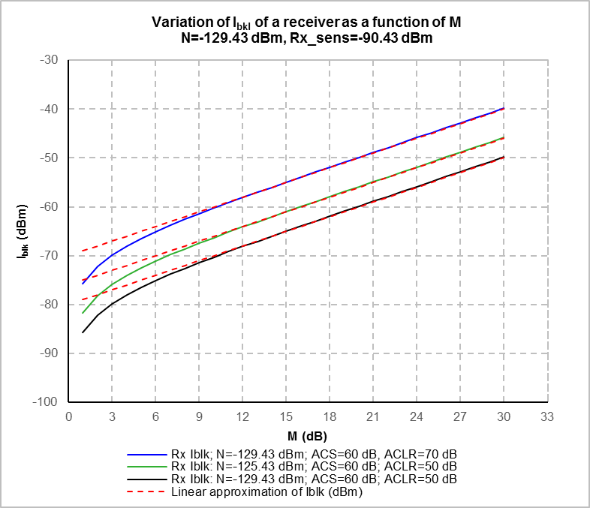
Figure A.3.1 Variation of blocking level as a function of M

Figure A.3.1 shows three different blocking curves, calculated from Equation 16, representing the variation of I_{blk} as a function of M for three different sets of N, ACS and ACLR values.

These blocking curves show that:
while the value of I_{blk} depends on N, M, ACS and ACLR, the gradient (or slope) of a blocking curve is identical for all possible sets of N, ACS and ACLR values;
for the values of M greater than 9 dB the gradient of the curve is equal to 1. Consequently, above this value of M the blocking curves can be approximated to unity slope lines;
for the values of M smaller than 9 dB the blocking curve deviates from the unity slope line due to the impact of the receiver noise floor (noise power). Actually, a low M value means a low useful signal level thus an increased impact of noise on the receiver performances, while a high M value means a high useful signal level that reduces the impact of noise on the receiver performances ($M\left(dB\right)=C\left(dBm\right)-{Rx}_{sens}\left(dBm\right)$).

In conclusion, independently from any technology, the blocking curve of receivers varies, as a function of M, linearly with unity slope for M > 9 dB and non-linearly with a slope depending on M for M < 9dB. For a given M, the gradient (or slope) of the blocking curve is identical for all possible sets of N, ACS and ACLR values.

Choice of the Rx desensitisation value M

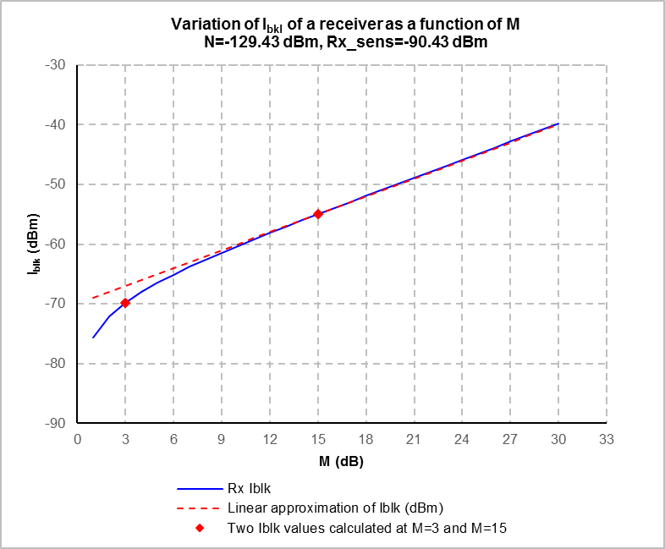
Figure A.3.2 Choice of the Rx desensitisation value M

As shown in Figures A.3.2 and explained in the previous section, for the values of M greater than 9 dB receivers blocking level varies linearly as a function of M, while for the values of M smaller than 9 dB its variation is not linear due to the impact of the receiver noise floor (noise power). Considering this behaviour, which is identical for all receivers, it would be sensible to define the blocking requirements of a receiver for two different values of M, one below and one above 9 dB.

For example, M=3 dB (historical desensitization value), which takes into account the impact of the receiver noise floor on I_{bkl} and M=9 dB, which takes into account high useful signal levels where the receiver noise floor do not have any impact on I_{bkl}, might be a reasonable choice. This choice is shown in Figure 2 (red points on the blocking curve). When the blocking level of a receiver is defined with these two values of M, its blocking curve can easily be predicted thanks to the unity slope line.

Consequently, if M is not given or cannot be calculated from $M\left(dB\right)=C\left(dBm\right)-{Rx}_{sens}\left(dBm\right),$ it is proposed to define the blocking requirements of receivers for M = 3 and/or 15 dB in the future ECC Recommendation on receivers.

    - Frequency offset selectivity and interference leakage ratio

Consideration of different bandwidths of victim and interferer

The parameters FOS and ILR of the basic equation of RRM implicitly take into account the interfering and victim signal bandwidths as described in this section.

However, when the FOS and ILR are derived from ETSI standards, it might be possible that their definition in the standard is relative to the same bandwidth of the system subject of the standard, either the victim or the interferer, Therefore, care should be taken when such ETSI data are used for compatibility study.

FOS is of general use for any mixed wanted and interfering signal situation and can be calculated as follows:

Where:
- FOS: Frequency Offset Selectivity
- RIR: Receiver Interference Ratio at offset frequency;
- ILR: Leakage Power Ratio of the interfering signal at offset frequency.

RIR and ILR can be expressed as follows:

Where:
- I: Interfering signal power measured in its bandwidth;
- I_{r}: Total interfering signal power received by the victim receiver;
- I_{OOB}: Interfering signal out-of-block or out-of-band power falling into the victim receiver bandwidth.

The above mathematical equations clearly show that ILR and therefore FOS can be calculated for all type of useful and interfering signal bandwidths. However, if ILR is measured in a bandwidth that is different than the victim receiver bandwidth under consideration, and there is no possibility to carry out new measurements, it is necessary to use an appropriate correction factor to define the ILR in the victim receiver bandwidth.
If ILR was measured in the bandwidth of victim receiver A and will be used to calculate I_{blk} of victim receiver B at the same frequency offset from the interferer and there is no abrupt variation of the interferer emission mask around this frequency offset, then the ILR in the victim receiver B bandwidth can be expressed as follows:

$${ILR}_{B}≅{ILR}_{A}-10×log⁡(\frac{{Bw}_{VB}}{{Bw}_{VA}})$$

Note also that a FOS calculated for a given interferer bandwidth may not be applicable to an interferer that have a different bandwidth, which is also true for the FOS (or ACS) values defined in ETSI HS.
It is also important to note that FOS implies attenuation ratios and not power ratios as in the case of ILR. Consequently, it is not possible to apply any bandwidth ratio correction factor to FOS. For example, if the frequency offset between victim and interferer is very large, then the receiver FOS may be flat. Under such conditions the interfering signal bandwidth will have no effect on the value of FOS. This can also be the case when two interferers with different bandwidth have the same offset frequency from the victim and there is no abrupt variation of the receiver FOS.

In conclusion, the bandwidths of victim and interfering systems in EC/ECC decisions, ECC recommendation, ETSI harmonized standards should be carefully used and possibly corrected on case by case.

    - Out-of-band and spurious domains and derivation of ILR value

Out-of-band (OOB) domain (of an emission) is the frequency range, immediately outside the necessary bandwidth but excluding the spurious domain, in which OOB emissions (OOBE) generally predominate. While spurious domain (of an emission) is the frequency range beyond the OOB domain in which spurious emissions generally predominate.

The boundary between the OOB and spurious domains is the separation between the centre frequency of an emission and the beginning of its spurious domain. According to Recommendations ITU-R SM.329-12 and ITU-R SM.1541-6, normally the boundary between the OOB and spurious domains is the frequency separated from the centre frequency of the emission by 250% of the necessary bandwidth of the emission as shown in Figure A.3.1 extracted from ECC Rec(02)05.

Note that for single carrier systems, including systems using OFDM/OFDMA, channel bandwidth or channel separation can be used as a substitute for necessary bandwidth provided that they are found in ITU-R Recommendations or in relevant regional and national regulations. Multicarrier systems are not relevant to the determination of receiver resilience levels.

OOB Emissions

Spurious Emissions

OOB Domain
(OOB predominate)

Spurious Domain
(Spurious predominate)

250 %
of the necessary bandwidth

50 %
of the necessary bandwidth

Frequency

Unwanted Emissions

Figure A.3.1. Illustration of the OOB and Spurious Domains (not part of Recommendation ITU-R SM.329)
Note: The crossover point between OOB and Spurious emissions is not defined and Figure A.3.1 shows only an example.

However, OOB/S domains boundary needs to be modified for narrow-band and wideband (including multicarrier) systems, and certain other situations. This modification is very straight forward as described in Table 2 of Rec. ITU-R SM. 1539-1.

As in OOB domain OOB emissions generally predominate, while in spurious domain spurious emissions generally predominate, it is proposed to choose the ILR value to be used in RRM according to the OOB/S domains boundary of the interfering signal. Since:

If the victim receiver channel is in the interfering signal OOB domain, the interfering signal ILR would be similar to its ACLR values defined on the 1st and 2nd adjacent channels. Consequently, the interfering signal ILR can be found in the existing EC/ECC decisions, CEPT/ITU-R recommendations, CEPT/ECC reports and ETSI harmonised standards/technical specifications/reports or can be easily determined by measurements.

If the victim receiver channel is in the interfering signal spurious domain, the interfering signal ILR can be derived from the spurious emission levels defined in the existing EC/ECC decisions, CEPT/ITU-R recommendations (e.g. ERC/REC 74-01, Rec. ITU-R SM.329-12) and ETSI harmonised standards.

  - Guidance to determine relevant interfering signal and interference scenario

- The use of reference interfering signal and a single interference scenario as proposed in Annex 5 will overcome the difficulty of identifying the relevant interfering signal and interference scenario for each service/system.

- Otherwise, the most relevant interfering signal and interference scenario can be defined between the competent CEPT and ETSI technical groups.

- Moreover, if needed, a guidance on how to determine relevant interfering signal and interference scenario for a given system can be included in the Recommendation on receivers.

- Potential Methods for testing

  - NFD oriented test of FOS

RIR is the generic extension to any frequency offset of the ACIR defined for adjacent channel offset when a channel arrangement is identified; ECC Report 310 (Equation 7) also consider the following equivalence:

$$ACIR\left(dB\right)={\left(\frac{C}{I}\right)}_{co-ch}\left(dB\right)-{\left(\frac{C}{I}\right)}_{adj-ch}\left(dB\right)$$

Where the C/I ratios are considered at the same desensitisation M; in addition, the report recognises that: “ACIR is practically equivalent to the Net Filter Discrimination (NFD) which may be extended to any wanted and interfering frequency separation;” (e.g. to the frequency offset (Δ_{f}) where the FOS is defined)
Therefore, for the purpose of this test method, when FOS evaluation can be made through C/I requirements, the following formula can also be considered:

$$RIR\left(dB\right)=10log\left(\frac{1}{\frac{1}{ILR}+\frac{1}{FOS}}\right)={\left(\frac{C}{I}\right)}_{co-ch}\left(dB\right)-{\left(\frac{C}{I}\right)}_{∆_{f}}\left(dB\right)={NFD }_{∆_{f}}(dB)$$

and, when ILR << FOS:

$FOS\left(dB\right)≅RIR\left(dB\right)={\left(\frac{C}{I}\right)}_{co-ch}\left(dB\right)-{\left(\frac{C}{I}\right)}_{∆_{f}}\left(dB\right)={NFD }_{∆_{f}}(dB)$ (A.3.1.1)

Therefore, whenever a radio equipment standardises also a ${\left(\frac{C}{I}\right)}_{co-ch}$ behaviour and assuming that the required FOS is derived as in Step 3 of Section 3.4, the tests can be made on the basis of NFD defined as in the above equation (A.3.1.1).

This imply a ${\left(\frac{C}{I}\right)}_{∆_{f}}$(usually with a CW interfering signal) at the required Δ_{f} with the same M desensitisation used for the ${\left(\frac{C}{I}\right)}_{co-ch}$ test.

- reference interfering signal and a single interference scenario to be used in the calculation of receivers resilience levels using RRM

A5.1 Introduction

Currently, when using RRM to define the adjacent channel PR and the blocking level of receivers, the relevant interfering signal and interference scenario are proposed to be determined from existing CEPT/ECC, ETSI and ITU-R technical reports, which in some cases may be difficult and time consuming. A solution to this problem is to define a reference interfering signal and a single interference scenario for all systems/services.

It assumes a reference interfering signal and a single interference scenario (composed of two sub-scenarios) for all systems/services when calculating receivers resilience levels using RRM.

A5.2 Approach used to define a REFERENCE interfering signal

In nearly all harmonized standards (HS) a wanted signal like modulated adjacent channel interfering signal is used to define receivers resilience levels for intra-system compatibility.

On the other hand, for large frequency offsets going beyond the operating band of a given system/service, in most cases an unmodulated continuous wave (CW) interfering signal is used to define receivers resilience levels for inter-system compatibility based on the assumption that beyond at a large frequency offset the victim receiver FOS is constant, thus independent of the interfering signal bandwidth. This approach allows to get around the difficulty to identify case by case the most relevant interfering signal, which is not an easy task due to the more and more densely used radio spectrum.

For the reasons above, only very few HS use a well-defined interfering signal to define receivers resilience levels for a possible inter-system/service compatibility, which justifies the need to define a reference interfering signal for all systems/services when calculating receivers resilience levels using RRM.

A5.2.1 Proposed reference interfering signal

The proposed reference interfering signal has the following characteristics:
- Signal type: OFDM, which is the most common modulation type (e.g., IMT (LTE), DVB-T, DAB, DRM, Wireless LAN, WiMax,…).
Moreover, currently, thanks to very wide range of OFDM signal generators available on the market, such a signal can easily be generated in laboratory for test purposes.
- Bandwidth: 5 MHz.
Which is a good compromise between potential narrowband and wideband OFDM interfering signals.
Note: other bandwidths maybe be needed for very low (< 30MHz) and very high frequencies (>10 GHz)
- OOBD/SD boundary: at 12.5 MHz offset from the centre frequency of the interfering signal to channel edge of victim receiver.
OOBE level joins spurious emission (SE) level at the OOBD/SD boundary;

- ILR/Out-Of-Band (OOB):
  - 1st adj-ch ILR (ACLR) = 48 dB/5 MHz
Value aproximated for IMT BS (44 dB) in ETSI EN 301 908-14 + 3 dB margin (see Figure A5.2);
  - 2nd adj-ch ILR = 67 dB/5 MHz and 68 dB/5MHz, for frequency ranges of 9 kHz ≤ f ≤ 1 GHz and 1 GHz < f < ≅ 6 GHz respectively.
Value obtained by the method described in Section A.5.2.2;
  - 1st adj-ch ILR to OOBD/SD boundary = 70 dB/5 MHz and 74 dB/5 MHz, for frequency ranges of 9 kHz ≤ f ≤ 1 GHz and 1 GHz < f < ≅ 6 GHz respectively.
Value obtained by the method described in Section A.5.2.2 based on the SE levels defined in Rec. ERC/REC 74-01 (Annex 2, Table 6, line 2.1.1) [4] – 3 dB margin.
- SE level:
  - -39 dBm/100 kHz for 9 kHz ≤ f ≤ 1 GHz and
  - -33 dBm MHz for 1 GHz < f < ≅ 6 GHz
as defined in Rec. ERC/REC 74-01 – 3 dB margin, Annex 2, Table 6, 2.1.1.
These limits are the most common limits to radio transmitters including IMT base stations. Note that the maximum SE BW is limited to 2 times of the BW of the reference interfering signal (2*BW_{RI}) to prevent from calculating non-realistic spurious emission levels for a 5 MHz interference signal over a wide range frequency.

A5.2.2 Derivation of the spectrum mask of the reference interfering signal

The spectrum mask of the reference interfering signal described in Section A5.2.1 has been derived according to the following steps:

Step 1: A 5 MHz OFDM signal having a 1st adj-ch ILR (ACLR) of 47 dB/5 MHz was generated using an OFDM signal generator. The value of 47 dB/5 MHz is the IMT BS ACLR defined in ETSI EN 301 908-14 increased by 3 dB. The 2nd adj-ch ILR of this signal is 64 dB/5 MHz as shown in Figure A5.1.

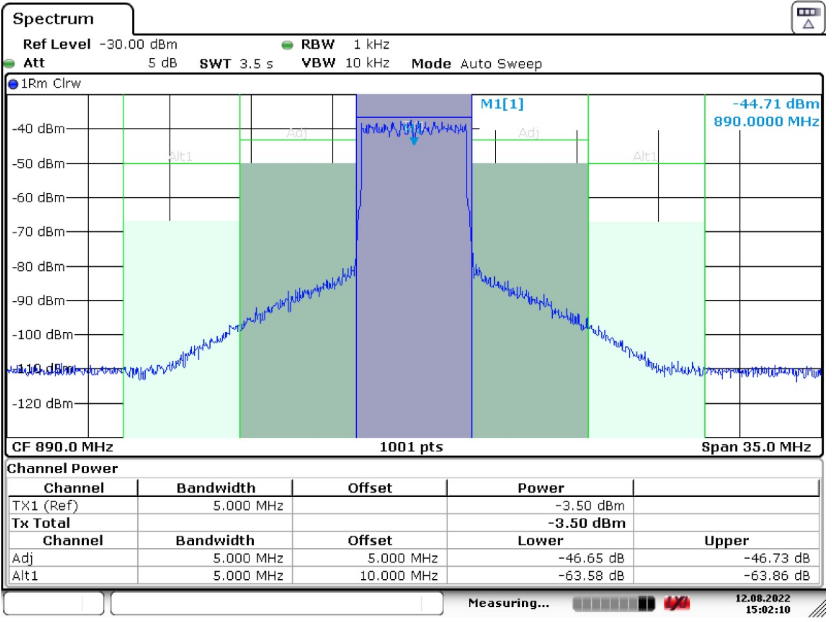

Figure A5.1 5 MHz OFDM signal (Spectrum analyser noise floor = -117.5 dBm/kHz)

A numerical integration method based on the trapezoidal rule has been used to calculate the ILR of the spectrum mask of the reference interfering signal as follows:

$$ILR\left(dB\right)=10\log_{10}\left(\frac{I_{in-ch}}{I_{oo-ch}^{r}}\right)=10\log_{10}\left(\frac{I_{in-ch}}{\int_{f_{ov}-{B_{v}}/2}^{f_{ov}+{B_{v}}/2}{{sd}_{I}\left(f\right)df}}\right)$$

Where:
$I_{in-ch}$: frequency offset interfering signal in-channel power at the receiver input;
$B_{v}$: victim bandwidth;
${sd}_{I}\left(f\right)$: frequency offset interfering signal spectral density in the linear domain.

$$\int_{f_{ov}-{B_{v}}/2}^{f_{ov}+{B_{v}}/2}{{sd}_{I}\left(f\right)df=∆f\left(\sum_{k=1}^{N-1}{{sd}_{I}\left(f_{k}\right)+\frac{{sd}_{I}\left(f_{N}\right)+{sd}_{I}\left(f_{0}\right)}{2}}\right)}$$

where

$$∆f=\frac{{B_{v}}/2-\left({{-B}_{v}}/2\right)}{N}=\frac{B_{v}}{N}$$

The validity of the integration method was checked as presented in Table A5.1.

Validation of the integration method used
Measurement BW=5 MHz / Integration BW (4.97 MHz)
Offset type | Integration BW (MHz) | ILR obtained  by measurement  (dB) | ILR obtained  by numerical  integration (dB) | Difference (dB)
Co-ch | 4.97 MHz | 0 | 0 | 0
1st adj-ch | 4.97 MHz | 46.73 | 47.27 | 0.54
2nd adj-ch | 4.97 MHz | 63.86 | 63.80 | -0.06
2nd adj-ch < | 4.97 MHz | 70 | 70.28 | 0.28

Table A5.1 Comparison of measurements and numerical integration results.

Step 2 (for 9 kHz < f < 1 GHz): A reference interfering (RI) signal has been derived from the measured 5 MHz OFDM signal spectrum using linear interpolation to join the OOBE level to SE level of -36 dBm/100 kHz decreased by 3 dB at the OOBD/SD boundary. The derived spectrum mask has four break points as shown in Figure A5.2. The ILR of the RI signal has been calculated by numerical integration of its power (W) in a BW of 5 MHz, as described above, at three different frequency offsets as shown in Table A5.2.

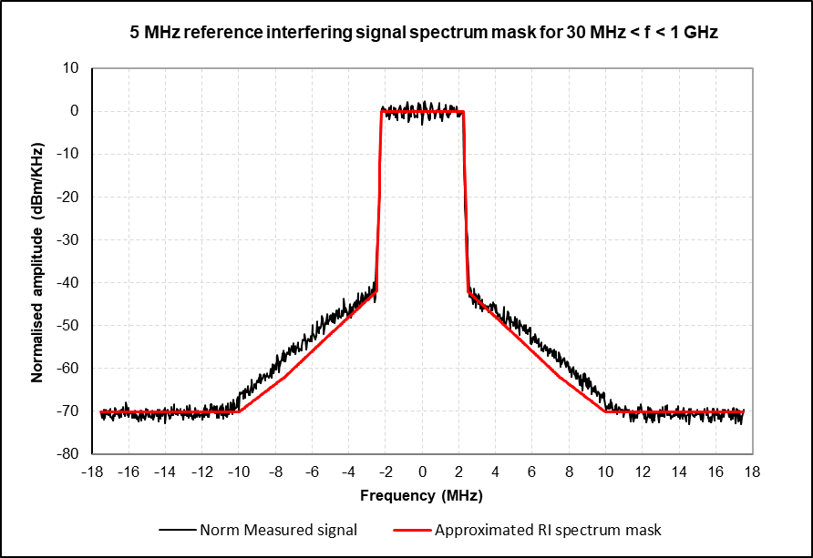

Figure A5.2 Approximation of the 5 MHz OFDM signal
to a reference interfering signal for 30 MHz < f < 1 GHz

ILR of the reference interfering signal for 30 MHz < f < 1 GHz
(60 W/5 MHz conducted Tx power normalised to 0 dBm/kHz; F_{Norm}=11.25 dB)
CH BW (MHz) | Power per CH BW (W) | Power per CG BW (dBm) | Offset type | ILR of the RI signal (dB) | ILR of the  measured signal (dB)
4.97 | 4.54E+00 | 36.57 | Co-ch | 0 | 0
4.97 | 6.61E-05 | -11.80 | 1st adj-ch | 48 | 47
4.97 | 9.25E-07 | -30.34 | 2nd adj-ch | 67 | 64
4.97 | 4.69E-07 | -33.29 (Note) | 1st adj-ch to OOBD/SD boundary in the SD | 70 | 70
Note : -33.29 dBm/5MHz+11.25 dB =-39dBm/100kHz, which is the spurious limit of -36dBm/100kHz minus a 3 dB margin

Table A5.2

Step 3 (for 1 GHz < f< ≅ 6 GHz): A reference interfering signal has been derived from the measured 5 MHz OFDM signal spectrum using linear interpolation to join the OOBE level to SE level of -30 dBm/MHz decreased by 3 dB at the OOBD/SD boundary. The derived spectrum mask has three break points as shown in Figure A5.3. The ILR of the RI signal has been calculated by numerical integration of its power (W) in its BW of 5 MHz at three different frequency offsets as shown in Table A5.3.

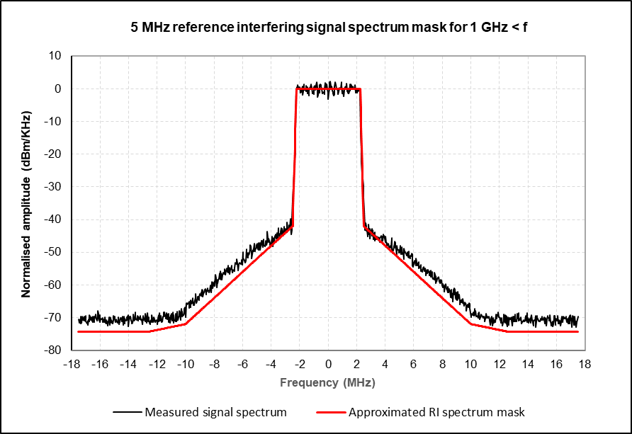

Figure A5.3. Approximation of the 5 MHz OFDM signal
to a reference interfering signal for 1 GHz < f < ≅ 6 GHz

ILR of the reference interfering signal for 1 GHz < f < ≅ 6 GHz
(60 W/5 MHz conducted Tx power normalised to 0 dBm/kHz; F_{Norm}=11.25 dB)
CH BW (MHz) | Power per CH BW (W) | Power per CH BW (dBm) | Offset type | ILR of the RI signal (dB) | ILR of the  measured signal (dB)
4.97 | 4.54E+00 | 36.57 | Co-ch | 0 | 0
4.97 | 6.61E-05 | -11.80 | 1st adj-ch | 48 | 47
4.97 | 7.22E-07 | -31.41 | 2nd adj-ch | 68 | 64
4.97 | 1.87E-07 | -37.29 (Note) | 1st adj-ch to OOBD/SD boundary in the SD | 74 | 70
Note : -37.29 dBm/5MHz+11.25 dB =-33dBm/ 1 MHz, which is the spurious limit of -30dBm/1 MHz minus a 3 dB margin

Table A5.3.

A5.3 Approach used to define a single interference Scenario

A5.3.1 Rationale

The rationale behind the idea to have a single interference scenario is:
- To treat all the systems equally;
- To define the receivers resilience levels only for the most relevant frequency offsets, thus keep the size of the future recommendation on receivers short;

A5.3.2 Detailed description of the proposed interference scenario

According to the rational presented in Section A5.3.1, it is proposed to define the receiver resilience level only for two frequency offsets between the interfering transmitter and the victim receiver:

- One is the first adjacent channel to the interfering signal, which is obviously in its OOB domain,

- while the other is the first adjacent channel to the OOBD/SD boundary of the interfering signal in its SD.

This interference scenario including reference interferer (RI) and the two offset frequencies is depicted in Figure A5.4 for the example of a victim receiver having a bandwidth of 2 MHz.

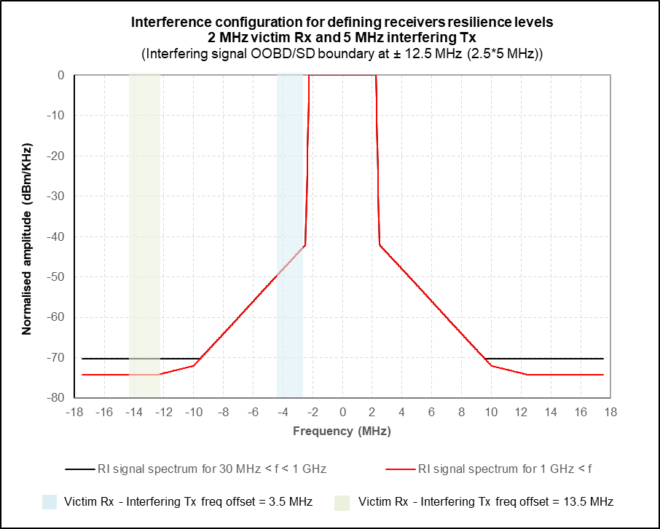

Figure A5.4 Proposed single interference scenario to be used for all systems/services
when calculating receivers resilience levels using RRM.

The resulting offset frequencies from the centre of the RI to the centre frequency of the victim receiver are for the 2 MHz receiver:
- 3.5 MHz: 2.5 MHz (B_{I}/2)) + 1 MHz (B_{V}/2);
- 13.5 MHz: 12.5 MHz (edge of spurious domain 2,5x5)) + 1 MHz (B_{V}/2).

The ILR values for the two offset frequencies are then to be derived by numerical integration from the spectrum masks defined in Table A.5.4 depending on the victim receiver bandwidth according to Equation (4).

Offset MHz | RI signal spectrum mask for  frequencies of 9 kHz ≤ f ≤ 1 GHz (dBm/1kHz) | RI signal spectrum mask for  frequencies of 1 GHz < f < ≅ 6 GHz (dBm/1kHz)
-17.5 | -70.25 | -74.25
-12.5 | -70.25 | -74.25
-10 | -70.25 | -72
-7.5 | -62 | -62
-2.5 | -42 | -42
-2.25 | 0 | 0
+2.25 | 0 | 0
+2.5 | -42 | -42
+10 | -70.25 | -72
+7.5 | -62 | -62
+12.5 | -70.25 | -74.25
+17.5 | -70.25 | -74.25
Table A5.4: Reference interfering signal spectrum mask

Some example calculations are provided in the following section.

A5.3.3 Derivation of the reference interfering signal ILR to be used in the calculation of receivers resilience levels using RRM

The ILR values of the reference interfering signal to be used to calculate the receiver resilience levels for some systems/applications identified in Doc. CG-MRxRec-SE21(22)028 have been derived by using numerical integration. These systems are DAB, DTT, IMT, Fixed service, GSM, 2.4 GHz WBDT systems, 5 GHz RLAN and 25 MHz-1GHz SRD. The results obtained are presented for information in Section A5.3.5.

A5.3.4 Choice of the FOS value

Based on the definition of the reference interfering signal, it is proposed to choose the value of FOS to be used in the calculation, when using RRM to calculate the receiver resilience levels, as follows:
- FOS = ILR + 10 dB, when the victim receiver channel is adjacent to the interfering transmitter channel (see Figure A5.4).
Reason: This configuration is critical since the interfering transmitter channel is very close to the victim receiver channel resulting in a high OOBE emission level in the receiver input, which cannot be reduced by filtering. Consequently, a good adjacent channel filtering would be necessary to minimise the interfering signal in-block power received by the receiver.
- FOS = ILR dB, when the victim receiver channel is adjacent to the OOBD/SD boundary of the interfering signal in its SD (see Figure A5.4).
Reason: This configuration is less critical compared to the first configuration, since the interfering transmitter channel is far away from to the victim receiver channel resulting in a lower OOBE emission level in the receiver input. Consequently, it is sensible to put less constraint on the receiver FOS.

A5.3.5 Derived reference interfering signal ILR to be used in the calculation of receivers resilience levels

ILR values for systems/applications as a function of the victim channel bandwidth and frequency offset
30 MHz < f < 1 GHz
System | CH BW (MHz) | Power (W) | Power (dBm) | ILR (dB)
RI | 4.97 | 4.54E+00 | 36.57 | Co-ch | 0
DAB (1.54) | 1.54 | 5.05E-05 | -12.97 | 1st adj-ch | 50
 |  |  |  | 2nd adj-ch
 | 1.54 | 1.45E-07 | -38.37 | 1st adj-ch to OOBD/SD boundary in the SD | 75
System | CH BW (MHz) | Power (W) | Power (dBm) | ILR (dB)
RI | 4.97 | 4.54E+00 | 36.57 | Co-ch | 0
DTT (8 MHz) | 7.60 | 5.70E-05 | -12.44 | 1st adj-ch | 49
 |  |  |  | 2nd adj-ch
 | 7.60 | 7.17E-07 | -31.44 | 1st adj-ch to OOBD/SD boundary in the SD | 68
System | CH BW (MHz) | Power (W) | Power (dBm) | ILR (dB)
RI | 4.97 | 4.54E+00 | 36.57 | Co-ch | 0
IMT (1.4 MHz) | 1.09 | 4.21E-05 | -13.76 | 1st adj-ch | 50
 |  |  |  | 2nd adj-ch
 | 1.09 | 1.02E-07 | -39.90 | 1st adj-ch to OOBD/SD boundary in the SD | 76
System | CH BW (MHz) | Power (W) | Power (dBm) | ILR (dB)
RI | 4.97 | 4.54E+00 | 36.57 | Co-ch | 0
IMT (3 MHz) | 2.70 | 6.12E-05 | -12.13 | 1st adj-ch | 49
 |  |  |  | 2nd adj-ch
 | 2.70 | 2.54E-07 | -35.94 | 1st adj-ch to OOBD/SD boundary in the SD | 73
System | CH BW (MHz) | Power (W) | Power (dBm) | ILR (dB)
RI | 4.97 | 4.54E+00 | 36.57 | Co-ch | 0
IMT (5 MHz) | 4.52 | 2.91E-05 | -15.36 | 1st adj-ch | 52
 |  |  |  | 2nd adj-ch
 | 4.52 | 4.26E-07 | -33.70 | 1st adj-ch to OOBD/SD boundary in the SD | 70
System | CH BW (MHz) | Power (W) | Power (dBm) | ILR (dB)
RI | 4.97 | 4.54E+00 | 36.57 | Co-ch | 0
IMT (10 MHz) | 9.00 | 4.43E-05 | -13.54 | 1st adj-ch | 50
 |  |  |  | 2nd adj-ch
 | 9.00 | 8.49E-07 | -30.71 | 1st adj-ch to OOBD/SD boundary in the SD | 67
System | CH BW (MHz) | Power (W) | Power (dBm) | ILR (dB)
RI | 4.97 | 4.54E+00 | 36.57 | Co-ch | 0
IMT (15 MHz) | 13.51 | 3.26E-05 | -14.86 | 1st adj-ch | 51
 |  |  |  | 2nd adj-ch
 | 10.01 | 9.45E-07 | -30.25 | 1st adj-ch to OOBD/SD boundary in the SD | 67
System | CH BW (MHz) | Power (W) | Power (dBm) | ILR (dB)
RI | 4.97 | 4.54E+00 | 36.57 | Co-ch | 0
IMT (20 MHz) | 18.03 | 2.92E-05 | -15.34 | 1st adj-ch | 52
 |  |  |  | 2nd adj-ch
 | 10.01 | 9.45E-07 | -30.25 | 1st adj-ch to OOBD/SD boundary in the SD | 67
System | CH BW (MHz) | Power (W) | Power (dBm) | ILR (dB)
RI | 4.97 | 4.54E+00 | 36.57 | Co-ch | 0
GSM (0.2 MHz) | 0.18 | 9.88E-06 | -20.05 | 1st adj-ch | 57
 |  |  |  | 2nd adj-ch
 | 0.18 | 1.65E-08 | -47.82 | 1st adj-ch to OOBD/SD boundary in the SD | 84
System | CH BW (MHz) | Power (W) | Power (dBm) | ILR (dB)
RI | 4.97 | 4.54E+00 | 36.57 | Co-ch | 0
SRD (0.1 MHz) | 0.11 | 6.12E-06 | -22.13 | 1st adj-ch | 59
 |  |  |  | 2nd adj-ch
 | 0.11 | 9.91E-09 | -50.04 | 1st adj-ch to OOBD/SD boundary in the SD | 87
System | CH BW (MHz) | Power (W) | Power (dBm) | ILR (dB)
RI | 4.97 | 4.54E+00 | 36.57 | Co-ch | 0
SRD (0.5 MHz) | 0.49 | 2.41E-05 | -16.17 | 1st adj-ch | 53
 |  |  |  | 2nd adj-ch
 | 0.49 | 4.63E-08 | -43.35 | 1st adj-ch to OOBD/SD boundary in the SD | 80
System | CH BW (MHz) | Power (W) | Power (dBm) | ILR (dB)
RI | 4.97 | 4.54E+00 | 36.57 | Co-ch | 0
SRD (1.7 MHz) | 1.68 | 5.25E-05 | -12.80 | 1st adj-ch | 49
 |  |  |  | 2nd adj-ch
 | 1.68 | 1.59E-07 | -38.00 | 1st adj-ch to OOBD/SD boundary in the SD | 75
System | CH BW (MHz) | Power (W) | Power (dBm) | ILR (dB)
RI | 4.97 | 4.54E+00 | 36.57 | Co-ch | 0
SRD (0.05 MHz) | 0.04 | 2.11E-06 | -26.77 | 1st adj-ch | 62
 |  |  |  | 2nd adj-ch
 | 0.04 | 3.30E-09 | -54.81 | 1st adj-ch to OOBD/SD boundary in the SD | 90
System | CH BW (MHz) | Power (W) | Power (dBm) | ILR (dB)
RI | 4.97 | 4.54E+00 | 36.57 | Co-ch | 0
SRD (0.025 MHz) | 0.04 | 2.11E-06 | -28.81 | 1st adj-ch | 65
 |  |  |  | 2nd adj-ch
 | 0.04 | 3.30E-09 | -56.85 | 1st adj-ch to OOBD/SD boundary in the SD | 93

Table A5.3

ILR values for systems/applications as a function of the victim channel bandwidth and frequency offset
1 GHz < f
System | CH BW (MHz) | Power (W) | Power (dBm) | ILR (dB)
RI | 4.97 | 4.54E+00 | 36.57 | Co-ch | 0
DAB (1.54) | 1.54 | 6.61E-05 | -11.80 | 1st adj-ch | 50
 |  | 7.22E-07 | -31.41 | 2nd adj-ch
 | 1.54 | 1.87E-07 | -37.29 | 1st adj-ch to OOBD/SD boundary in the SD | 79
System | CH BW (MHz) | Power (W) | Power (dBm) | ILR (dB)
RI | 4.97 | 4.54E+00 | 36.57 | Co-ch | 0
DTT (8 MHz) | 7.60 | 5.05E-05 | -12.97 | 1st adj-ch | 49
 |  |  |  | 2nd adj-ch
 | 7.60 | 5.79E-08 | -42.37 | 1st adj-ch to OOBD/SD boundary in the SD | 72
System | CH BW (MHz) | Power (W) | Power (dBm) | ILR (dB)
RI | 4.97 | 4.54E+00 | 36.57 | Co-ch | 0
IMT (1.4 MHz) | 1.09 | 5.69E-05 | -12.45 | 1st adj-ch | 50
 |  |  |  | 2nd adj-ch
 | 1.09 | 2.85E-07 | -35.44 | 1st adj-ch to OOBD/SD boundary in the SD | 80
System | CH BW (MHz) | Power (W) | Power (dBm) | ILR (dB)
RI | 4.97 | 4.54E+00 | 36.57 | Co-ch | 0
IMT (3 MHz) | 2.70 | 4.21E-05 | -13.76 | 1st adj-ch | 49
 |  |  |  | 2nd adj-ch
 | 2.70 | 4.08E-08 | -43.90 | 1st adj-ch to OOBD/SD boundary in the SD | 77
System | CH BW (MHz) | Power (W) | Power (dBm) | ILR (dB)
RI | 4.97 | 4.54E+00 | 36.57 | Co-ch | 0
IMT (5 MHz) | 4.52 | 6.12E-05 | -12.13 | 1st adj-ch | 52
 |  |  |  | 2nd adj-ch
 | 4.52 | 1.01E-07 | -39.94 | 1st adj-ch to OOBD/SD boundary in the SD | 74
System | CH BW (MHz) | Power (W) | Power (dBm) | ILR (dB)
RI | 4.97 | 4.54E+00 | 36.57 | Co-ch | 0
IMT (10 MHz) | 9.00 | 2.91E-05 | -15.36 | 1st adj-ch | 50
 |  |  |  | 2nd adj-ch
 | 9.00 | 1.70E-07 | -37.70 | 1st adj-ch to OOBD/SD boundary in the SD | 71
System | CH BW (MHz) | Power (W) | Power (dBm) | ILR (dB)
RI | 4.97 | 4.54E+00 | 36.57 | Co-ch | 0
IMT (15 MHz) | 13.51 | 4.41E-05 | -13.56 | 1st adj-ch | 51
 |  |  |  | 2nd adj-ch
 | 10.01 | 3.38E-07 | -34.71 | 1st adj-ch to OOBD/SD boundary in the SD | 71
System | CH BW (MHz) | Power (W) | Power (dBm) | ILR (dB)
RI | 4.97 | 4.54E+00 | 36.57 | Co-ch | 0
IMT (20 MHz) | 18.03 | 3.22E-05 | -14.92 | 1st adj-ch | 52
 |  |  |  | 2nd adj-ch
 | 10.01 | 3.76E-07 | -34.25 | 1st adj-ch to OOBD/SD boundary in the SD | 71
System | CH BW (MHz) | Power (W) | Power (dBm) | ILR (dB)
RI | 4.97 | 4.54E+00 | 36.57 | Co-ch | 0
FS (1.4 MHz) | 1.75 | 2.85E-05 | -15.45 | 1st adj-ch | 49
 |  |  |  | 2nd adj-ch
 | 1.75 | 3.76E-07 | -34.25 | 1st adj-ch to OOBD/SD boundary in the SD | 78
System | CH BW (MHz) | Power (W) | Power (dBm) | ILR (dB)
RI | 4.97 | 4.54E+00 | 36.57 | Co-ch | 0
FS (1.4 MHz) | 7.00 | 5.34E-05 | -12.73 | 1st adj-ch | 48
 |  |  |  | 2nd adj-ch
 | 7.00 | 6.58E-08 | -41.82 | 1st adj-ch to OOBD/SD boundary in the SD | 72
System | CH BW (MHz) | Power (W) | Power (dBm) | ILR (dB)
RI | 4.97 | 4.54E+00 | 36.57 | Co-ch | 0
FS (1.4 MHz) | 14.00 | 6.67E-05 | -11.76 | 1st adj-ch | 48
 |  |  |  | 2nd adj-ch
 | 10.01 | 2.63E-07 | -35.80 | 1st adj-ch to OOBD/SD boundary in the SD | 71
System | CH BW (MHz) | Power (W) | Power (dBm) | ILR (dB)
RI | 4.97 | 4.54E+00 | 36.57 | Co-ch | 0
SRD (0.1 MHz) | 0.11 | 6.70E-05 | -11.74 | 1st adj-ch | 59
 |  |  |  | 2nd adj-ch
 | 0.11 | 3.76E-07 | -34.25 | 1st adj-ch to OOBD/SD boundary in the SD | 91
System | CH BW (MHz) | Power (W) | Power (dBm) | ILR (dB)
RI | 4.97 | 4.54E+00 | 36.57 | Co-ch | 0
WLAN (20 MHz) | 19.99 | 6.12E-06 | -22.13 | 1st adj-ch | 50
 |  |  |  | 2nd adj-ch
 | 10.01 | 3.95E-09 | -54.04 | 1st adj-ch to OOBD/SD boundary in the SD | 71
System | CH BW (MHz) | Power (W) | Power (dBm) | ILR (dB)
RI | 4.97 | 4.54E+00 | 36.57 | Co-ch | 0
DCS (0.2 MHz) | 0.18 | 4.45E-05 | -13.52 | 1st adj-ch | 57
 |  |  |  | 2nd adj-ch
 | 0.18 | 3.78E-07 | -34.23 | 1st adj-ch to OOBD/SD boundary in the SD | 88

Table A5.4

- List of references

This annex contains the list of relevant reference documents.
- ECC Report 310 “Evaluation of receiver parameters and the future role of receiver characteristics in spectrum management, including in sharing and compatibility studies”
- ITU-R F.1094-2: “Maximum allowable error performance and availability degradations to digital fixed wireless systems arising from radio interference from emissions and radiations from other sources”
- ITU-R F.758-7: “System parameters and considerations in the development of criteria for sharing or compatibility between digital fixed wireless systems in the fixed service and systems in other services and other sources of interference”
- ERC/REC 74-01 “Unwanted emissions in the spurious domain”

ECC Recommendation (02)01 Specification of reference receiver performance parameters https://docdb.cept.org/download/4e071a2c-2c77/REC0201.PDF
Also defined in ECC Report 252 (SEAMCAT handbook) as the level of noise introduced by the receiver system below which the signal that is being captured cannot be isolated from the noise (see ECC Rep. 252, Section 1.2.3.

