|  |  |  |
| --- | --- | --- |
| SE24 | | Doc. SE24(20)084 |
| SE24#101 meeting | | |
| Online, 14-16 September 2020 | | |
|  | | |
| Date issued: | 07 September 2020 | |
| Source: | CRAF | |
| Subject: | WI71 – RR 5.340 passive bands and RDI-S sharing/compatibility | |
| Group membership required to read? (Y/N)  N | | |
|  | | |
| Summary: | | |
| This contribution includes CRAF comments on the answers provided by industry in the SE24 WI71 web-meeting #8. This contribution was not considered during WI71 web-meeting #9 and #10 because of lack of time.  CRAF still doesn’t see the use of the passive bands under RR 5.340 justified as urgent or necessary according to the provided information. | | |
| Proposal: | | |
| CRAF Invites the Group and administrations to  Decide to exclude the passive bands under RR 5.340 in the range 190-260 GHz from consideration.  Review the justifications provided by industry in light of the SRDoc ETSI TR 103 498 standards and CRAF comments for the band 116-190 GHz. | | |
| Background: | | |
| * The decision to allow emission in the passive bands under 5.340 is a major development for the passive services that will cause inconsistency in radio regulations, and can cause unforeseen consequences on the long term to the radio astronomy service. * The level of urgency to allow emission in the passive bands must correspond to the consequences expected from this action. * It will be impossible to avoid understanding these studies as a precedent for other applications to be repeated in the future. | | |

# SHARING AND COMPATIBILITY STUDIES between RDI-S and SERVICES OPERATING IN PASSIVE BANDS, LISTED IN ITU RR FN 5.340

## Background information

ITU Radio Regulations Footnote (FN) 5.340 is applicable for portions of the band studied in this document (e.g. for RDI-S devices). During the studies there was a controversial discussion, if the sharing and compatibility studies may be allowed to be carried out in these passive bands protected by RRs. This report focuses on the purely technical studies in terms of sharing and compatibility. The relevant information to follow the discussion on ECC level are given in document “[SE24(20)035 (Report_from_ECC](https://cept.org/Documents/se-24/57830/se24-20-035_report-from-ecc))” of the SE24#100 meeting.

ECC decided that the studies should continue as foreseen under the following conditions:

1. The studies on this very specific type of application (in particular very low number of devices) shall not be understood as precedence for general allowance for studies in bands covered by ITU RR-5.340.

* *Addressed in section 1.2*

1. There shall be no widening of the studies beyond the specific limited type of applications, meaning UWB radiodetermination applications Type C (according to SRdoc ETSI TR 103 498).

* *Addressed in section 1.2*

1. The usage scenario for those UWB radiodetermination applications Type C, which target bands listed in RR 5.340, shall be maintained to professional indoor applications (in shielded industrial environments) limited in numbers.

* *Addressed in section 1.2*

1. The studies shall also consider the technical justification for the wide bandwidth as required in the ETSI SRdoc and why notching out the bands identified by RR 5.340 is not possible. This shall not delay the ongoing compatibility and sharing studies.

* *Addressed in section 1.3*

1. After technical studies will have been undertaken in WG SE, WG FM will reassess these conditions before deciding on next steps.

## RDI-S APPLICATION DESCRITION AND DEVICE NUMBER LIMITATION

SRdoc ETSI TR 103 498 defines type C applications as: “*Applications emitting inside a confined and shielded environment or a housing*”. The only application types in this report that fit into this category are in-vehicle radars, TLPR and RDI-S devices. Regardless of the high shielding, in-vehicle radars and TLPR devices are not foreseen to sweep through the RR FN 5.340 protected bands, because the large bandwidth is not needed for this application type. But for RDI-S devices there is a physical need (see section 1.3.2) to use a very large contiguous bandwidth. RDI-S devices are the only device type that is identified in this report as a type C application and with an inherent need to use the RR FN 5.340 protected bands inside highly shielded environments. If in future any other application claims the type C device class its risk of interference has to be carefully reviewed and again separately evaluated on a case-by-case basis without referring to the RDI-S device class as a precedent. No radiation is intended to be emitted outside the shielded environment into the ITU RR FN 5.340 bands, and the power spectral density levels outside the shielded environment will be similar or below other devices’ spurious emission levels, due to the high shielding.

RDI-S devices are used in professional UWB radiodetermination applications and are only intended for use in highly shielded industrial environments (see chapter 3.3 Shielding loss for applications operated in shielded environments). Industrial environments are – compared to consumer applications – a highly controllable area, where many special rules apply, and mounting requirements and the intended use of devices are strictly respected. Companies selling RDI-S equipment have their own highly trained professional integration teams, since integration of for example a pipe wall thickness scanner or RDI-S device integration into a steel production factory is a complex task and needs a lot of specialized expertise in terms of EMC knowledge, radar knowledge and so on. Respecting installation requirements and intended use of the devices will not be an issue in this very limited and controlled application field and will be guaranteed by the operator and the commissioning experts of the RDI-S device. Professional industrial users are liable for the equipment they operate and thus have a special interest in compliance with existing laws and rules.

The number of RDI-S devices is estimated to around 80.000 in Europe for the purpose of MCL calculations. This is a very conservative estimate, because wideband RDI-S devices will be mainly used in special niche markets, like e.g. thin dielectric layer thickness measurement or micrometre precision positioning, where their high performance is essential and needed to fulfil the measurement task. Achieving the wide bandwidth instantly comes with significantly higher sensor cost, due to the demand for expensive precision-milled mechanical or PCB based wideband waveguide parts. Additionally, the signal processing chain hardware requirements in terms of bandwidth and sample- or data-rate are much higher and cost-intensive for wideband radar sensor hardware.

The resulting significantly higher cost for wideband sensors will automatically prevent the sensor from getting into the mass market. In many applications low-cost sensors with a still acceptable performance based on the lower bandwidth RDI device class (which will not use the RR FN 5.340 protected bands) will be sufficient. Those sensors will be automatically used due to the significant lower cost of small bandwidth transitions and antennas, resulting in more cost-efficient sensor designs compared to RDI-S devices. Consequently, the majority of devices in the market will be cost-effective RDI sensors and only where needed due to application performance requirements, RDI-S sensors based on more expensive wideband-technology will be used. This results in a natural limitation of the overall number of RDI-S devices in the market.

## RDI-S JUSTIFICATION OF FREQUENCY RANGE AND CONTINUOUS WIDE BANDWIDTH NEEDS

### General considerations

It is acknowledged that keeping the RR FN 5.340 passive bands clean from harmful interference is essential for passive band users like radio astronomy or passive remote sensing satellite applications. On the other hand, some industrial devices and applications also show a strong need for covering large continuous regions of the spectrum to enable new and innovative applications. This need is justified by the fact that radiodetermination applications – as the name already implies – uses the information of the propagation properties of radio waves to determine the position, velocity and/or other characteristics of an object, or obtaining information related to these parameters. This can of course be done in different frequency regions. In the following sections a justification is given why the use of the D-Band (110 to 170 GHz) and above frequency ranges, in combination with a large continuous bandwidth, is essential for RDI-S devices.

### Need for considered frequency range

Especially, the frequency range 116-190 GHz shows a strong potential for industrial application, because it is a technological sweet-spot for high precision radiodetermination applications.

From the technological point of view, the frequency range between 116 and 190 GHz is very interesting, because modern SiGe semiconductor technologies allow in these bands a still exceptional good performance, whilst providing still a good robustness against environmental challenges like dirt/dust on antennas. Designs based on half frequency VCOs and Gilbert or push-push frequency doublers allow a sufficient output power generation for short range devices and the noise figures of SiGe technology circuits are still good, while still having suitable compression points and small signal gain in the RX stages. Additionally, the frequency range is still suitable for wideband bond-wire connection between chips and PCB structures. Unwanted lower fundamental signals can easily be blocked by the high-pass nature of waveguide structures that are in a size that can still be manufactured at reasonable cost to provide a clean and efficient output spectrum. The wavelength allows manufacturing of high-gain antennas relatively small in size for even small sensors.

The higher frequency range above 200 GHz has the advantage that patch antennas can directly be integrated on-chip [1], but this leads to the disadvantage that the fundamental oscillator emissions are hard to filter and are thus also radiated, causing additional interference risk in the spurious domain. Waveguides are very hard to manufacture in the frequency range above 200 GHz and bond-wires for chip to waveguide transitions have an extensive inductive behaviour and do not work anymore. This is especially a disadvantage for wide bandwidth sensors, because other structures like patch antennas are very bandwidth-limited, but do not properly filter unwanted signals, especially if used in combination with dielectric lenses. On-chip patch antennas in comparison to waveguide-based antenna feeding concepts often show a disadvantage in achieving a precise beam alignment, when used together with dielectric lens antennas, due to alignment difficulties. Additionally, systems operating above 200 GHz are approaching the THz gap and are very limited in performance or can only be realised by using very expensive hand-picked III-V semiconductor chips. This might be suitable for high performance measurement equipment like network analysers, but is too expensive for industrial sensors.

Another disadvantage of the higher frequency bands are the much higher losses. Especially for the plastic sheet thickness measurement system, often plastics, with a large portion of carbon black or other highly lossy material layers, have to be measured. The higher frequencies would combine in this case a degraded SNR because of the technology limitations with a higher loss of the material in the application, which leads to the result that many materials cannot be measured anymore.

However, the disadvantage of the higher losses in the higher frequency bands is a big advantage in terms of the desired shielding loss in the region above 100 GHz. The propagation through buildings is almost line-of-sight-only. Compared to the frequencies below 100 GHz, the high shielding loss can much easier be guaranteed compared to e.g. around 24 GHz, where still a significant transmission through building materials occurs. In the single-entry calculations of this report a very conservative shielding loss lump sum value of 50 dB is used for RDI-S (compare chapter 3.3 “Shielding loss for applications operated in shielded environments” and ECC Report 190, where a shielding-loss value of > 60 dB is used for indoor/outdoor attenuation at 122 GHz).

Consideration of lower frequency ranges for this application is also not an option. The frequency range below 116 GHz is already widely used, the large wavelength has disadvantages in terms of antenna size and achievable antenna spot size, and this frequency range does not offer the possibility for new large bandwidth applications anymore because of many radio services and applications and the reduced shielding losses in this frequency range. Also, the achievable absolute bandwidth is smaller at lower operating frequencies assuming the same relative bandwidth.

Additionally, the widest frequency range window without the need to sweep over a ITU RR 5.340 FN band is located at 116 GHz to 148.5 GHz, which is unfortunately still too narrow to meet the requirements of industrial RDI-S applications, but is a good starting point. A bandwidth of 50 GHz as the current and urgent industrial need is backed by ETSI TR 103 498 by the sentence that “In order to measure plastic workpieces down to a thickness of only a few millimetres, a bandwidth of 25 GHz or higher is required.”. This value of 25 GHz was derived from a radar system operating at 80 GHz. Technology at 116-190 GHz allows a doubled bandwidth, which is needed to also resolve pipes with a small wall thickness. The ability to also measure pipes with a small wall thickness is an important key factor for successful integration of the RDI-S technology into the market.

### Need for contiguous wide bandwidth

RDI-S applications are high precision radiodetermination applications that can be compared to network analyser measurements for industrial applications with a high measurement rate. The RDI-S category shall be limited to applications with an inherent need to cover a large bandwidth like e.g. high precision measurements, high resolution measurements or material property measurements. Consequently, simple devices like e.g. presence detection switches shall not be allowed to be operated as RDI-S devices. Similar to network analyser systems those devices measure the frequency response over a large portion of bandwidth by means of amplitude and phase. From this transfer function the measurement signal is derived by complex mathematical model comparison or other signal processing techniques. Similar to laboratory network analyser applications for e.g. imaging, material measurements, and many more, covering a large bandwidth and thus determining a large part of the transfer function of the object $H(jω)$, is essential to deduce a high quality measurement result in combination with high spatial resolution. In contrast to systems based on operation in distinct frequency channels, like communication devices, that can easily work around the ITU RR FN 5.340 bands, RDI-S devices cannot work around these bands, because they need to acquire a continuous phase information and need to sense the object’s physical characteristics also inside the RR FN 5.340 protected part of the spectrum. Applications that directly benefit from covering a large bandwidth are:

* **High resolution imaging or material property determination** of objects with e.g. SAR or real aperture focusing techniques. In this application the X-Y direction resolution depends on the aperture and resolutions of 1mm are easily achieved in this frequency range. However, the resolution $∆r$ in Z direction is proportional to $∆r=\frac{c*c_{w}}{2B}$, where $B$ is the bandwidth covered by the FMCW sweep signal, $c$ the wave’s propagation speed, and $c_{w}$ a factor describing the influence of the window function. To get close to a uniform resolution cell, preferably a -3 dB bandwidth of 100 GHz is needed, and at least, covering 50 GHz of bandwidth is essential to achieve a suitable range resolution to distinguish between different material layers for a large number of materials. A bandwidth of 50 GHz allows, depending on the material permittivity, a resolution of pipe wall thicknesses of down to 2 to 2.5 mm. With a bandwidth of 100 GHz the systems are getting close to 1 mm wall thickness. The 2 to 2.5 mm wall thickness is an essential threshold to enable the RDI-S devices to be used in the very important market of combined and multilayer material pipes, because the used material thickness combined with the material permittivity of a large number of pipe products in this field can only be measured with a minimum bandwidth of 50 GHz. Achieving only 32.5 GHz of bandwidth would lead to a drastically reduced application field and thus a drastically reduced profitability of RDI-S devices. Furthermore, many production lines that cannot be equipped with radar technology control loops to improve product quality and raw material utilisation are wasting important resources like plastics, energy and thus carbon dioxide day by day. For this application also a high measurement rate is essential to meet the Nyquist criterion in space, while recording the measurement data.

Figure 1 shows an example to justify the argumentation above. A synthetic aperture radar image of a parking disk as a representative thin multy-layer is measured with 32.5 and 55 GHz bandwidth. The X and Y axis resolution remains the same, as this depends on the used frequency range and the aperture. But in Z axis the resolution depends on the radar bandwidth. This results in degraded imaging quality, because reflections of other layers are folding into the layer of interest and reduce image quality. The rotating disc inside of the object is for example much better visible with the wider bandwidth. Reduced image quality can especially not tolerated, if small defects need to be detected or if automated inspection of the images is desired. The 55 GHz bandwidth SAR image even allows to almost resolve the “Arrival time” marking, which is completely hidden in the reduced bandwidth image.

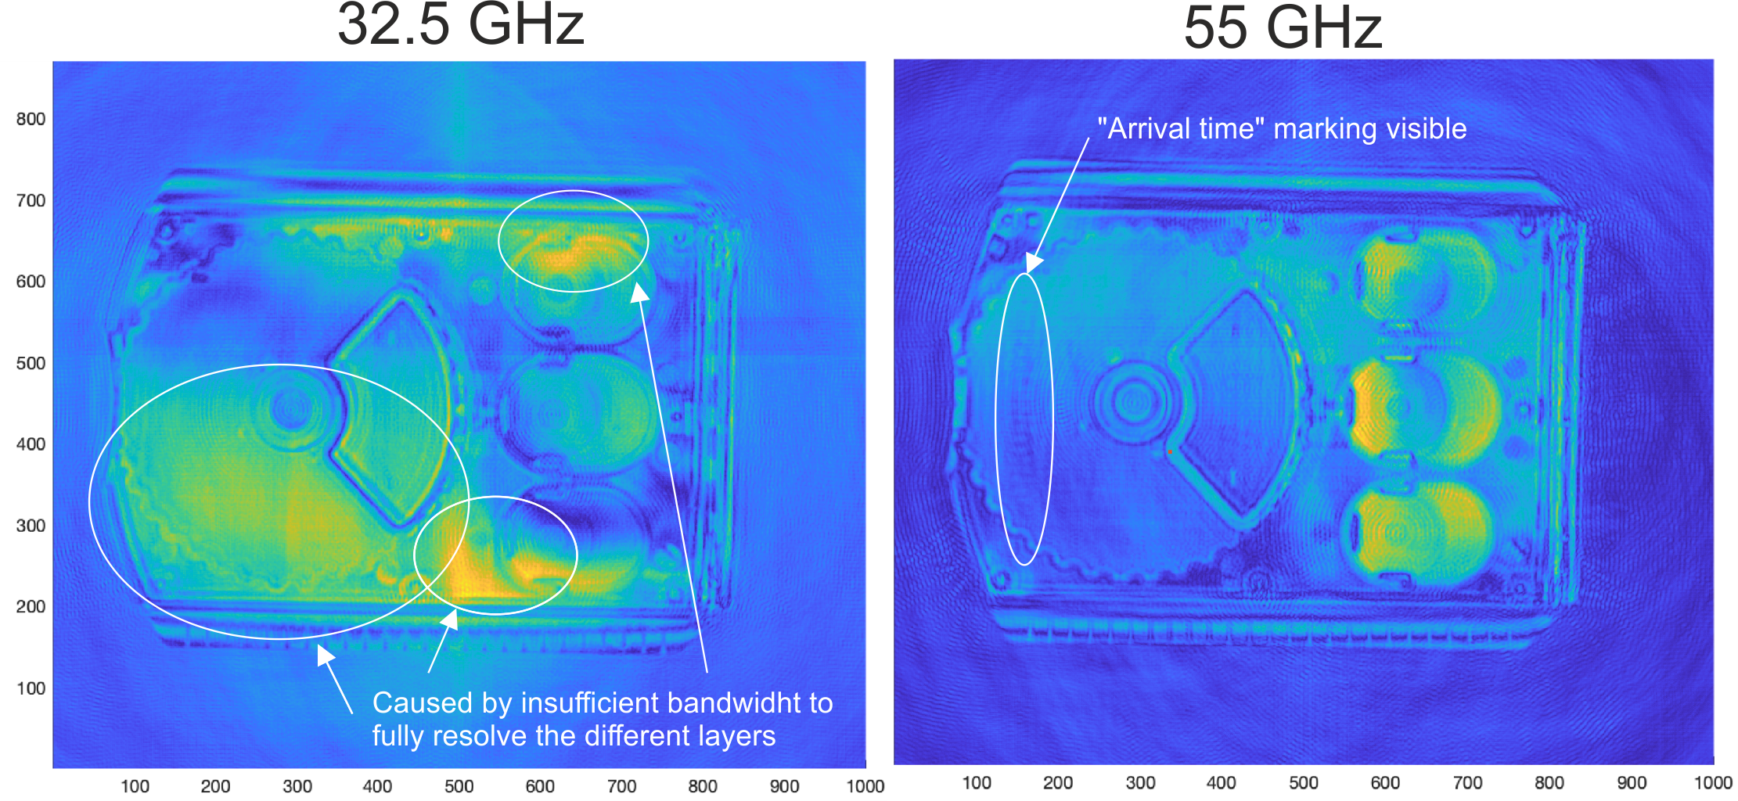

**Figure 1: Bandwidth comparison (32.5 GHz and 55 GHz modulation bandwidth) for thin layer SAR-image.**

* **Thickness and material measurements and object classification** are other very important application classes, where covering a large bandwidth is essential. From the measured object’s transfer function $H(jω)$ and a signal model according to the Fabry–Pérot interferometer concept (see Wikipedia for a detailed description) the material parameter in terms of complex permittivity or the thickness are derived. For object classification, the measured transfer function is fed into a previously trained machine learning model or is compared to an analytical model. For all these applications covering a bandwidth as large as possible is needed, because it limits the range resolution. If the covered bandwidth is too small, the detection of fine object details or thin layers, as is needed by the pipe measurement industry, become undetectable. Here a bandwidth of at least 50 GHz is required to meet the applications’ requirements and to cover a large range of applications. Reducing the bandwidth to only 32.5 GHz and thus the resolution by 35% would lead to a limited application range that will prevent radar technology from being used in this field for many common pipe thicknesses. Especially for thin pipes every additional GHz of bandwidth and improvement in resolution is important to broaden the application field. For this application a high measurement rate is needed, and the measurement range must not have notched out parts.

**Reasons for a large bandwidth – example of plastic measurements**

Plastic pipes are used in a huge range of products as different kind of infrastructural pipes (e.g. gas pipes, drinking water, wastewater, cable protection, …) or blow moulding parts (consumer products, automotive parts). This market seeks for a cost effective, easy, and harmless inline measurement technique for quality control and process optimization and automation. Manual destructive measurement methods are out of time and shall be replaced by non-destructive methods.

The radar technology is a very promising technique to fill that gap of measurement technology. However, to reach the necessary wall thickness resolution a high bandwidth is necessary as the possible resolution is anti-proportional to the bandwidth BW (resolution~1/BW).

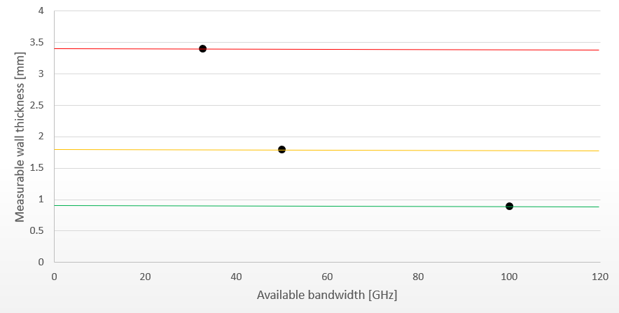

**Figure 2: Measurable wall thickness for 32.5 GHz, 50 GHz, and 100 GHz, respectively.**

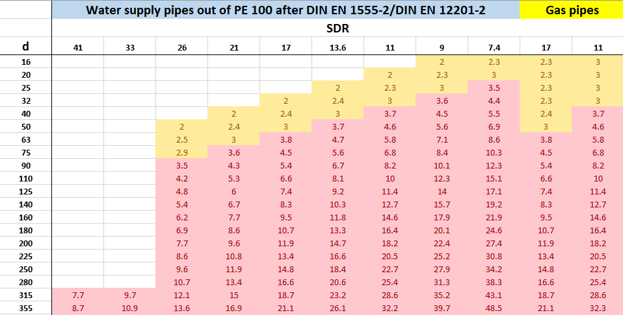

**Figure 3: Water and gas supply pipe types (diameter d and corresponding wall thicknesses) belong to a certain pressure class (SDR class). Red marked area belongs to 32.5 GHz scenario and yellow marked area belongs to 50 GHz bandwidth scenario (additional measurable product classes). With the 50 GHz scenario the large market of building infrastructure becomes available.**

Fig. 2 shows this behaviour for 3 different bandwidth scenarios as currently under discussion. The following points demonstrate which kind of pipes and markets become available when bandwidth reaches 32.5, 50 and 100 GHz, respectively.

**Scenario 1: 32.5 GHz bandwidth (red line Fig. 2)**

* + Infrastructural pipes (e.g. water and gas) for wide range distribution become measurable (compare Fig. 2)

**Scenario 2: 50 GHz bandwidth (yellow line Fig. 2)**

* Infrastructural pipes for wide range distribution become measurable (compare Fig. 3)
* Large market of end customer pipelines (e.g. gas and water supply to and in buildings) become measurable (compare Fig. 2)
* Corrugated pipes for wastewater pipelines or for agricultural water supply become measurable
* Many blow moulding parts e.g. in automotive market become measurable (e.g. inlet manifolds)

**Scenario 3: 100 GHz (green line Fig. 2)**

* All products mentioned before are measurable
* Blow moulded consumer products like packaging parts (shampoo bottles, food storages) become measurable
* Multilayer pipes or products for special applications become measurable

Due to the large growing market and product range it is strongly recommended to allow at least 50 GHz bandwidth although 100 GHz would even be preferable.

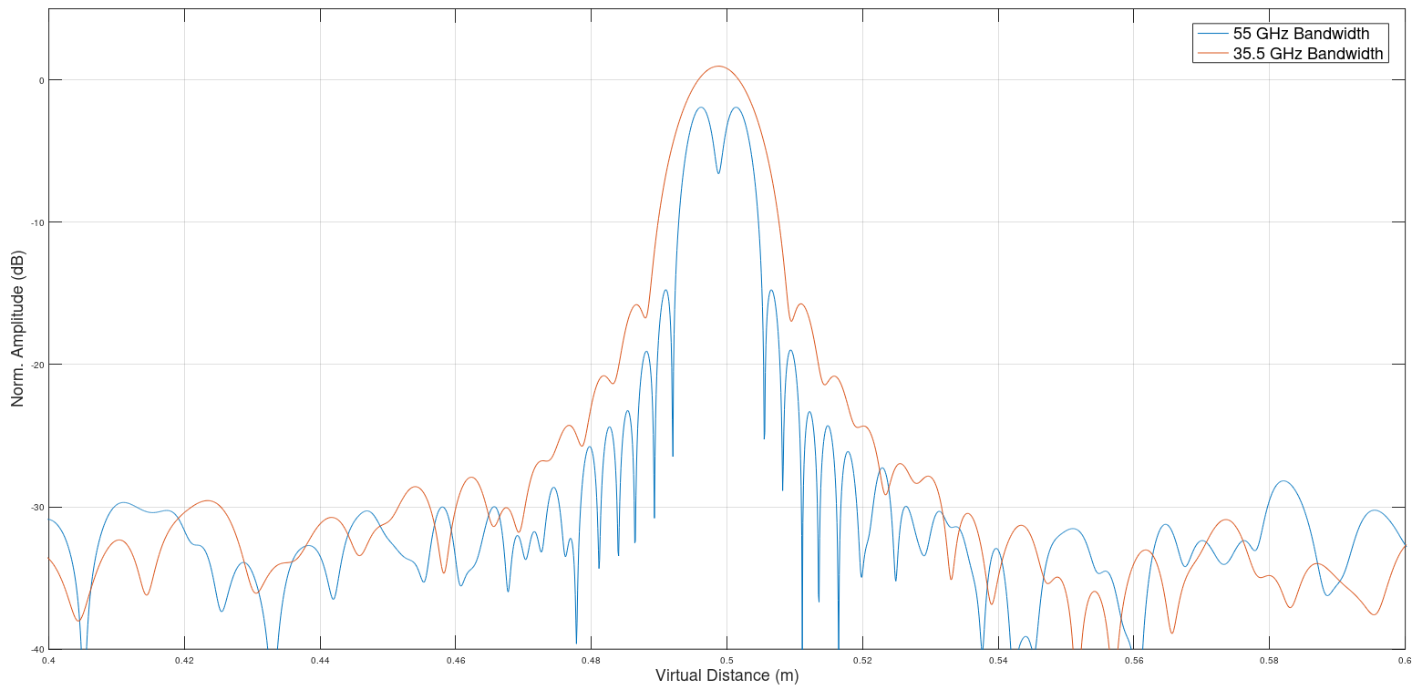

**Figure 4: Simulation of two targets with 5 mm distance, which reflects a typical high precision thin layer measurement task. The two targets can be resolved with 55 GHz of bandwidth, but cannot be separated with the smaller bandwidth of 32.5 GHz.**

* **High precision distance measurements** are another important application class that demands for a large continuous bandwidth. Millimetre precision distance measurements are nowadays widely used in terms of e.g. LPR/TLPR equipment with a bandwidth up to 10 GHz. For applications requiring sub-micrometer accuracy, the target transfer function has to be corrected in signal processing and a large bandwidth coverage is very important for this process. Newest research results [2] for example presented an absolute measurement accuracy compared to a laser interferometer with +/-5 µm in a distance of up to 5 metre measurement range based on this concept. By covering a large bandwidth, it is also possible to classify objects based on their transfer function or for more complex previously known objects, to estimate the actual view-angle of the object for 3D positioning. These systems also demand for a very high measurement rate to allow tracking of fast-moving objects.

## RDI-S AND NOTCHING OF ITU RR FOOTNOTE 5.340 BANDS

It surely is a valid question, if notching-out the ITU RR FN 5.340 bands might be possible for wideband RDI-S equipment. However, a general answer to this question is not possible and it highly depends on the application performance needs, the use-case und the used signal processing. For many of the above mentioned applications covering a large continuous bandwidth is essential. There are first approaches in research dealing with notching-out of bands in terms of compressed sensing techniques. While such an approach is shown to work in a controlled laboratory environment, it only works with limited success in real-world applications, where the interesting features of the radiodetermination application might also fall within the notched-out bands and the information that is needed for an accurate measurement result might then be missing.

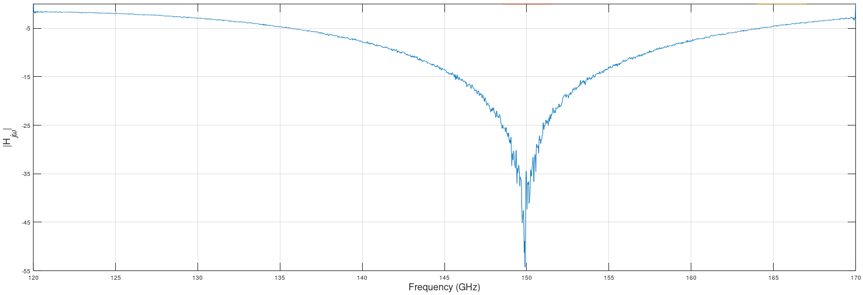

**Figure 1: Simulated magnitude of a RDI-S frequency response (FMCW up-ramp from 120 GHz to 170 GHz) with a Fabry–Pérot thin layer target with the minimum inside ITU RR FN 5.340 bands (red).**

For thin layer detection this is for example the case, if the measured material’s thickness is close to the bandwidth resolution limit and the combination of the parallel plate Fabry–Pérot interferometer leads to a single minimum that is located inside the notched-out bands, as shown in Figure 1. In this case the estimation of the exact local minimum with the required accuracy is not possible anymore. The regions outside do not work reliably enough with model-fitting approaches to predict the minimum location due to real-world application degradations like misalignment and so on. The other two applications (compare 1.3.3) have similar restrictions regarding missing in-band information. Notching might be acceptable for non-precision measurement tasks (that do not require the wide absolute bandwidth anyway), but notching out ITU RR 5.340 bands is not an option for high performance radiodetermination applications. Consequently, missing sub-bands can unfortunately not be accepted for most RDI-S applications. A network analyser measurement of a filter component with missing frequency ranges is also not an option if the interesting parts of the filter response are located within the missing ranges. Model based approaches with a-priori information can guess that there might be a filter response in the neglected frequency range, but no reliable measurement would be possible anymore with the missing in-band information. This could also happen for precise RDI-S measurements with the notched-out RR FN 5.340 bands.

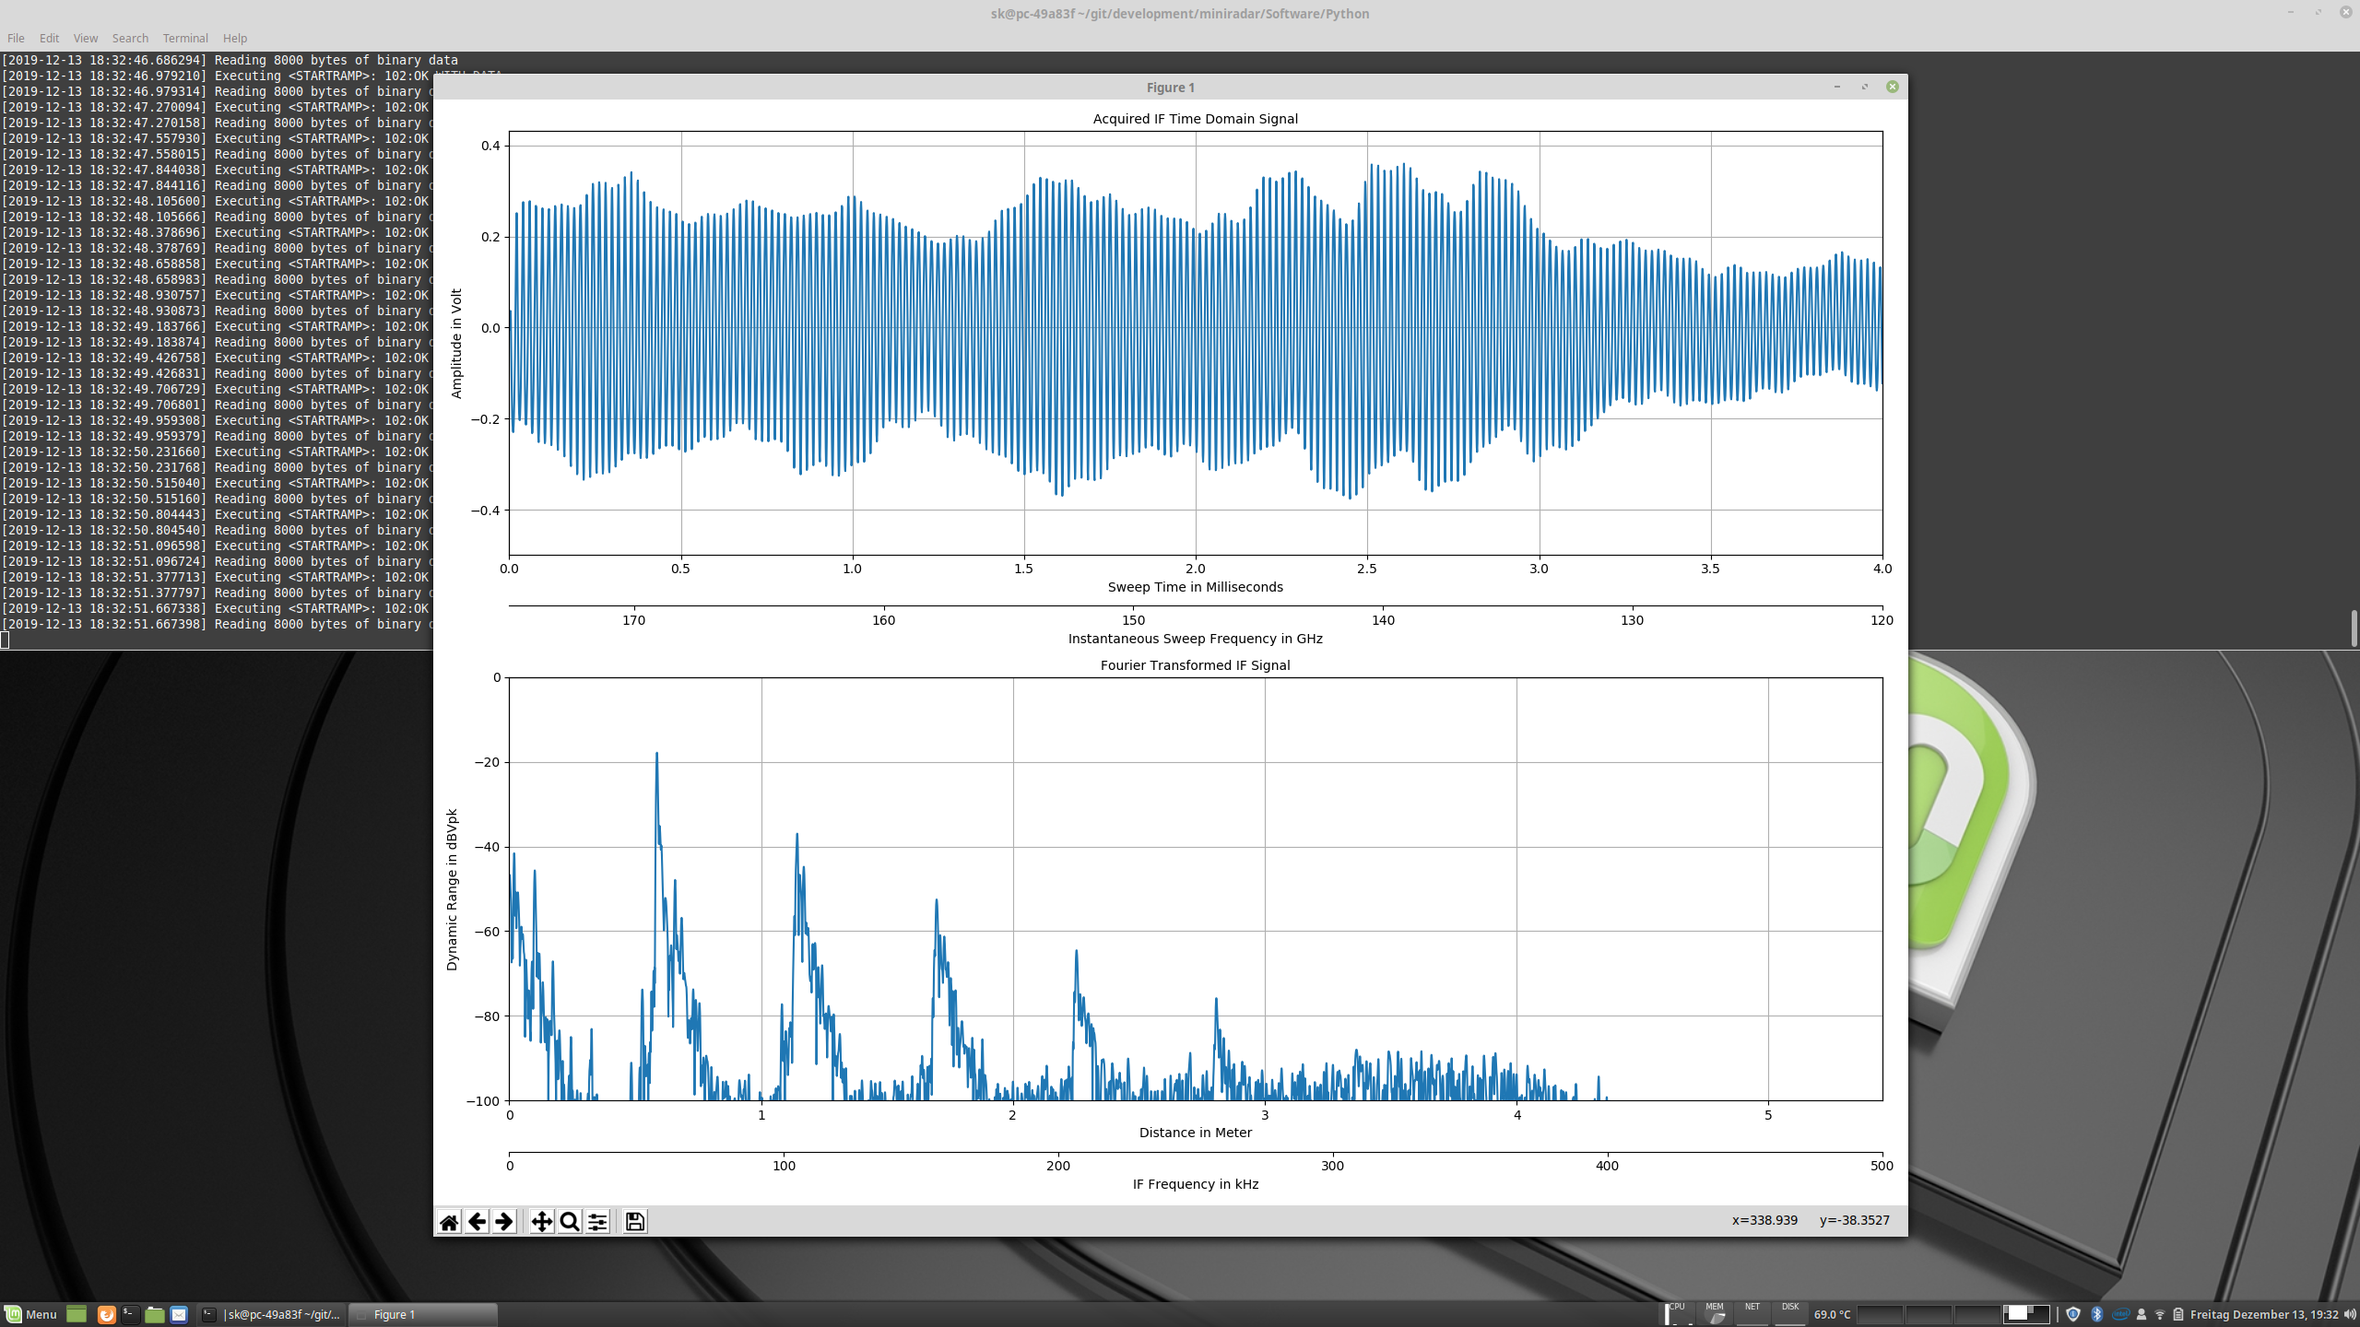

**Figure 2: Measured RDI-S IF signal for FMCW down-ramp from 175 GHz to 120 GHz with highlighted degraded ramp linearity regions (yellow) due to PLL settling effects if notching of 5.340 bands (red) is required.**

Additionally, the high sweep-rate (e.g. 4 ms for a complete 50 GHz sweep) needed for most applications due to high production line speed of the materials that need to be measured prevents notching-out frequency bands without losing FMCW sweep linearity, which can directly be translated into losing measurement performance and accuracy. The sub-micrometre precision measurements require an exceptional linear FMCW sweep without degraded regions. If bands are notched out by stopping the sweep and jumping over the ITU RR FN 5.340 bands this would result in degraded sweep performance close to the notched out regions due to the fact that phase locked loops (PLL) show an analogue settling behaviour, as shown in Fig. 2. Due to the use of window functions the non-avoidable regions of degraded ramp linearity at the outer start- and stop-regions of the sweep have only a minor influence compared to such regions in the middle of the covered bandwidth. In addition, spurious or/and out of band emissions with much higher power spectral density in the ITU RR FN 5.340 bands, because of PLL locking and settling processes at the FMCW start and stop regions, might be the consequence. Experience shows that the start and stop regions of a FMCW sweep are often the most critical parts in terms of power spectral density emission levels. Having a smooth and fast sweep through the ITU RR FN 5.340 bands with evenly distributed very low power spectral density will be preferable in terms of spectrum efficiency and sharing with passive band users. The generation of much higher power spectral density spurious signals, that might occur at the edge regions of the notched out bands, is therefore not an alternative. Another technique, the notching of bands with switchable components like amplifiers in the transmit path of the radar is unavoidably causing load pulling at the VCO, because of changing the load of the VCO during the highly linear frequency ramp. Phase locked loops will correct the frequency drift of the VCO caused by the changing load, but due to the analogue behaviour of the loop-filters this also highly influences the FMCW sweep linearity and is not suitable for high performance radiodetermination applications.

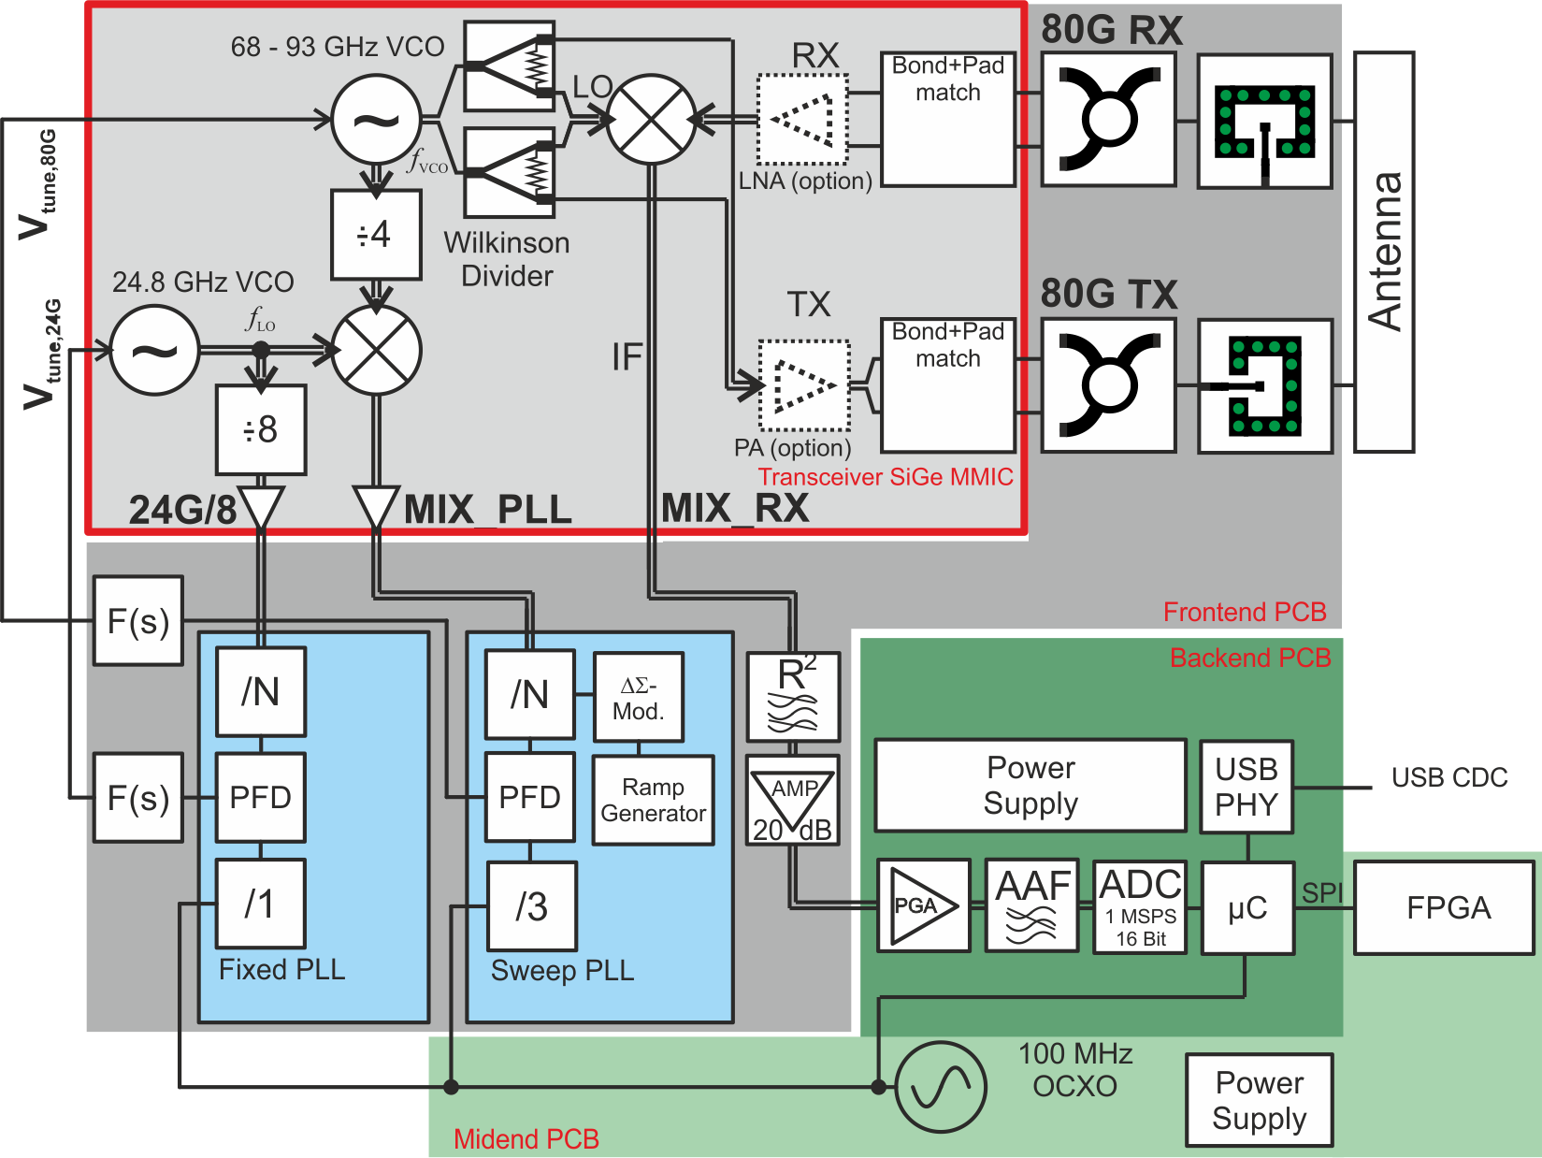

**Figure 3: Block diagram of a typical precision FMCW radar. This example system works at around 80 GHz, but with a frequency doubler behind the VCO the frequency range and the bandwidth can be doubled into the frequency range of interest.**

A block diagram of a typical high performance FMCW radar at 80 GHz is shown in Fig. 3, systems for the frequency range between 116 to 190 GHz might look similar with scaled frequencies or with an additional frequency doubler placed after the fundamental VCO.

**Summary:** Notching out ITU RR FN 5.340 bands is not an option for high performance radiodetermination applications as the measurement degradation would eliminate such an application. The sub-micrometre precision measurements like e.g. precision dielectric sheet thickness measurements require an exceptional linear FMCW sweep without degraded regions in order to function at all and have an inherent need to collect the frequency response from a large continuous bandwidth without missing sub-bands.

For non-precision measurement tasks, notching is acceptable if at all needed. TLPR is an example of such a non-precise application. Its use is limited to frequencies where no 5.340 bands are affected.

## RDI-S SHARING AND COMPATIBILITY IN RR FN 5.340 BANDS

### RDI-S sharing and compatibility - general considerations

ITU RR FN 5.340 states that, in these bands “all emissions are prohibited”. However, under the conditions of designating frequency bands to SRDs, as an underlay technology, administrations may deviate from the RR Table of Frequency Allocations, including ITU RR FN No. 5.340 within their own territory. CEPT, as a group of countries, is free to identify common technical conditions that ensure the protection of radiocommunication services for applications that operate on a non-protected and non-interference basis.

An example for such an approach is the UWB regulation (ECC Decision (07)01), where technical conditions are harmonised for the frequency bands 1400-1427 MHz and 2690-2700 MHz, which are listed in ITU RR FN No. 5.340. Details to the compatibility studies can be found in ECC Report 64 and ECC Report 123.

Protection criteria are already available (for EESS) or can easily derived (for RAS) for all passive services in the frequency region above 116 GHz. In addition, atmospheric losses are much higher compared to the below 10.6 GHz UWB range which adds additional protection from interference.

Proposed limits for RDI-S devices (defined outside the shielded enclosure) are given in Table 1. ERC Recommendation 74-01 (amongst many other examples) defines a limit of -30 dBm e.i.r.p. for SRDs’ spurious emission for bands > 1 GHz (some are consequently listed in ITU RR FN No. 5.340). The generic emissions of RDI-S devices are even 35 dB lower than these limits and it is proposed to adopt the limits derived from the RDI-S technical parameters, listed in Table X, for creating an emission mask for use by RDI-S devices under the considerations of the very special characteristics of this device class described in chapters 1.2 and 1.3.

Table 1: Proposed limits for RDI-S devices outside the shielding enclosure in the frequency bands protected by ITU RR FN 5.340

|  |  |  |
| --- | --- | --- |
| Frequency range | Maximum mean e.i.r.p.  spectral density | Maximum peak e.i.r.p.  (defined in 50 MHz) |
| Below 116 GHz | Typ. spurious limits | Typ. spurious limits |
| 148.5 to 151.5 GHz | -65 dBm/MHz | -20 dBm |
| 164 to 167 GHz | -65 dBm/MHz | -20 dBm |
| 182 to 185 GHz | -65 dBm/MHz | -20 dBm |
| 190 to 191.8 GHz | -65 dBm/MHz | -20 dBm |
| 200 to 209 GHz | -65 dBm/MHz | -20 dBm |
| 226 to 231.5 GHz | -65 dBm/MHz | -20 dBm |
| 250 to 252 GHz | -65 dBm/MHz | -20 dBm |

Due to the wide bandwidth, high shielding loss, low output power and fast sweeping behaviour, the expected emission of RDI-S devices will be even below the limits that are already allowed for short range device unwanted emissions in the spurious domain. The radiated energy outside the shielded enclosure is unwanted radiation, which unfortunately cannot be avoided for this application. Even with notching there still would be significant spurious energy being emitted inside the protected FN 5.340 bands by sweeping over parts of these bands for e.g. PLL settling (which would be unwanted out-of-band emissions). Especially starting and stopping close to the FN 5.340 bands might cause maybe even higher amount of energy that is leaked into these protected bands due to PLL settling effects (and might be allowed by the general spurious and out-of-band limits for short range radar devices, cp. ERC/REC 74-01, if adopted by the new regulation). In terms of spectrum efficiency and implementing maximum protection for the passive band users for this special device class, the usage of the bands protected by RR 5.340 is considered more efficient in this special case.

### RDI-S sharing and compatibility with RAS within RR 5.340 bands

[TBD 🡪 See current MCL calculations

Comments:

* Current MCL results show a maximum impact range for RDI-S devices to the known RAS stations of below 2km.
* [we can offer to agree to a general 30 km lump-sum protection radius to the IRAM/NOEMA RAS sites] ]

### RDI-S sharing and compatibility with EESS within RR 5.340 bands

[TBD 🡪 See current MCL calculations, will be updated soon with taking new apportionment and aggregation values into account and based on available protection criteria / contribution with EESS satellites.

Comments:

* (EESS 🡪 Uncritical because of 50 dB shielding loss (10 dB security margin to the indoor-to-outdoor loss of 60 dB that was defined in ECC Report 190 at 122 GHz) and additional margin due to even higher losses in EESS direction due to roof shielding which is significantly higher than 50 dB (see material measurements 🡪 only line of sight critical).
* First rough MCL calculations (will be updated soon) show compatibility/sharing of RDI-S and EESS with a margin of around 50 dB. Even with updated higher apportionment and aggregation RDI-S will remain uncritical.]

## CONCLUSION ON RDI-S anD RR 5.340 COMPATIBILBITY AND SHARING AND SUGGESTED ADDITIONAL SAFETY PRECAUTIONS FOR RR 5.340 BAND PROTECTION

From a technical point of view, the professional UWB radiodetermination application RDI-S does not cause harmful interference and ensures protection of passive radio services in the ITU RR FN 5.340 bands. Thus, sharing and compatibility with ITU RR FN 5.340 bands can be ensured and nothing objects to a regulation based on a non-protection and non-interference basis. The special character of the RDI-S application and its inherent need to cover a large bandwidth in short sweep time for precision radiodetermination inside a highly shielded, professional, and controllable industrial environment in combination with the inherent low risk of interference differentiates it dramatically from other applications, especially from consumer or communications applications, so that a regulation on a non-interference and non-protection basis for this special device class cannot be seen as a precedent for further opening of the bands protected by ITU RR FN 5.340.

[It is suggested to implement the following additional limitations to further restrict the number of RDI-S devices operating in ITU RR FN 5.340 bands to an absolute necessary minimum and ensure proper protection of these bands and services:

* Limitation of the use to RDI-S devices in highly shielded environments only.
* Limitation of the use to devices operated and installed by professionals to guarantee compliance with certain installation requirements (compare to TLPR devices)
* 30 km lump sum protection radius to all RAS sites using this frequency range (see Table RAS-locations IRAM/NOEMA)
* Limitation of the use to devices with the need and ability to use >50 GHz of bandwidth. Otherwise the band from 116 GHz to 148.5 GHz with 32.5 GHz available bandwidth (without affecting the ITU RR FN 5.340 protected bands) would be sufficient.
* Limitation of the use to fast sweeping devices with a ramp slope >10 GHz/ms. Flat ramp slopes should notch out the RR FN 5.340 bands. If the devices are used for material measurements in a laboratory-mode similar to network analysers and are operated inside a highly shielded laboratory environment, this limitation shall not apply.]

# References

[1] S. Thomas, C. Bredendiek and N. Pohl, "A SiGe-Based 240-GHz FMCW Radar System for High-Resolution Measurements," in IEEE Transactions on Microwave Theory and Techniques, vol. 67, no. 11, pp. 4599-4609, Nov. 2019, doi: 10.1109/TMTT.2019.2916851.

[2] L. Piotrowsky, T. Jaeschke, S. Kueppers, J. Siska and N. Pohl, "Enabling High Accuracy Distance Measurements With FMCW Radar Sensors," in *IEEE Transactions on Microwave Theory and Techniques*, vol. 67, no. 12, pp. 5360-5371, Dec. 2019, doi: 10.1109/TMTT.2019.2930504.