 |  | INFO 1 Doc
WGSE Project Team SE40
On Line, 23-25 June 2020
Date issued: | 10th June 2020
Source: | IARU Region 1
Subject: | Amateur vs RNSS
Group membership required to read? (Y/N)
N
Summary:
This INFO paper brings SE40 an IARU paper providing information on radio amateur repeater and beacon stations operating in the 1240-1300 MHz band including a survey of stations across a sample of CEPT countries.
Proposal:
SE40 is invited to note the contents of the document. An accompanying contribution has been made to propose an annex with this information for the draft report under SE40 WI 39.
Background:
The amateur band 1240-1300 MHz accommodates a variety of amateur service repeater and beacon stations. These are licensed on a national basis.


International Amateur Radio Union Region 1

Amateur radio repeater and beacon stations using the band 1240 – 1300 MHz in some countries within the CEPT region – May 2020

Introduction
The band 1240-1300 MHz (also known as the 23cm band) is a particularly important and interesting band to the amateur service. It sits at the boundary between the popular VHF/ UHF bands and the more experimental microwave GHz bands. It is an important springboard into these higher microwave bands which attract a great deal of technical and operational experimentation.

The European Commission and the European regulators have initiated a work item within CEPT to examine the amateur usage of the band 1240-1300 MHz and consider what steps might be necessary to ensure continued coexistence between these usages and the co-frequency Galileo radio navigation satellite service (RNSS). A wider topic (covering all the relevant RNSS systems in this band) has been agreed in the ITU-R for consideration under agenda item 9.1 to WRC-23.

The European work is being developed within the appropriate committees of the CEPT and the IARU is actively engaging on the topic on behalf of the amateur community.

The IARU consulted the national amateur radio society VHF/Microwave Managers in a sample of CEPT countries for national information about the number of repeater and beacon stations assigned frequencies in the band 1240-1300 MHz. This paper presents that information against the backdrop of the IARU Region1 band plan [1].

Amateur radio Repeater and Beacon Stations
As well as individual radio amateur stations the band is also occupied by stations operating as repeaters or beacons. These are always individually licensed for a particular location and operating frequency. Their assignment is coordinated on a national basis. In general a repeater station is established at an advantageous radio location to receive surrounding less well sited individual stations on a specific input frequency and relay (i.e. re-transmit) their traffic on an alternative specific output frequency from the better site. This increases the range for less well-sited individual stations. Repeaters may relay voice, amateur TV or data traffic. Voice and TV repeaters might carry either analogue or digital traffic.

Beacons are established for the purposes of monitoring propagation conditions in the band and providing a reliable off-air signal for test purposes.

licensing and assignment procedures
Repeater or beacon stations are usually licensed in their own right as an extension or addition to a specific radio amateur’s personal licence who then becomes the designated “keeper” for that station acting as the official point of contact. Importantly, the keeper (and designated deputies) has the responsibility to close down the transmitting station in a timely manner at the request of the authorities. Repeater station assignments are co-ordinated within the amateur service at a national level by the interested amateur parties usually before the application for a licence is submitted to the national regulatory body. Propagation beacons may additionally be co-ordinated regionally.
National regulatory bodies are often responsible for co-ordinating a licence application with other primary service spectrum users in the band with whom the amateur service is already sharing. This can lead to departures from the generic IARU band plan to take account of other national spectrum services.

voice and data repeaters
Repeater stations generally operate in a paired frequency duplex mode. There is an input frequency for the receiver and an output frequency for the transmitter. When not relaying traffic (in stand-by) the repeater output is silent apart from a periodic identification signal. However some stations do revert to a beacon mode when in stand-by. The transmitter is usually activated on receipt of an appropriate signal on the repeater input frequency. Other features can include “watch-dog” timers to time-out the transmissions if a signal persists on the input channel for longer than a specified time (usually a few minutes at the most).

The legacy analogue voice narrow-band FM mode remains common but digital mode usage is expanding. Certain manufacturers and other groups have developed a small number of digital voice modes with varying degrees of popularity. For the 23cm band the most common mode is ‘D-STAR’ (voice at 4800bps MSK) [2]. Other modes are DMR [3] and Fusion [4] but these two were not evident in the survey sample.

Repeater frequencies in 1240-1300MHz
The IARU R1 band plan includes the following sub-bands (identified here as sub-bands ‘a’ to ‘f’) that may be used for repeater operation. Not all frequencies are assigned in every country and the actual frequencies assigned can vary on a national basis.

All Mode (max bandwidth 20kHz):
Sub-Band a
- 1242.025-1242.700 MHz Repeater output, ch. RS1 – RS28 paired with:
- 1270.025-1270.700 MHz Repeater input, ch. RS1 -- RS28

Sub-Band b
- 1242.725-1243.250 MHz Digital communications, ch.RS29 - RS50 paired with:
- 1270.725-1271.250 MHz Digital communication, ch.RS29 – RS50
Sub-Band c
- 1293.150-1294.350 MHz Repeater input, paired with:
- 1258.150-1259.350 MHz Repeater output, ch.R20 - R68
FM Voice / Digital Voice (max bandwidth 20kHz with 25kHz channel spacing):

Sub-Band d
- Repeater input – ch.RM0 (1291.000 MHz) - RM19 (1291.475 MHz) paired with:
- Repeater output – ch.RM0 (1297.000 MHz) - RM19 (1297.475 MHz)

Additionally - All Mode, General mixed analogue or digital use in 25 kHz channels

Sub-band e
- 1298.025MHz (RS1) to 1298.975MHZ (RS39) [e]

data repeater frequencies
Amateur non-voice data ‘Packet Radio’ modes operate through narrow bandwidth traffic nodes and repeaters having similar bandwidth requirements to voice repeater stations. The digital voice mode ‘D-STAR’ has an associated ‘DD mode’ for higher rate data traffic (128kbs - TDD) that requires a single wider channel of 150 kHz.

The IARU bandplan includes these options in different sub-bands in the ‘all mode’ section from 1298 MHz to 1300 MHz for digital mode usage depending on bandwidth.

Sub-band f
- 1298.000 MHz to 1299.000MHz in 25 kHz channels
- 1299.000 MHz to 1299.750 MHz in 150 kHz channels
- 1299.750 MHz to 1300.000 MHz in 25 kHz channels

Voice and Data Repeater assignments – a survey of some CEPT countries
The data in the table below summarises the information received from a sample of IARU Region 1 VHF managers on the number of voice and data repeater stations licensed to operate in the IARU band plan repeater sub-bands in a number of countries. Whether the repeater stations are actually in-service at the time of the survey would require deeper analysis.

 | Voice and Data Repeaters
Sub-Band | a |  | b |  | c |  | d |  | e |  | f
Direction¹ | Tx | Rx | Tx | Rx | Tx | Rx | Tx | Rx | Tx | Rx | Tx | Rx
Belgium | - | 4 | - | - | - | - | 1 | 1 | 4 | - | 3 | 3
Denmark | - | - | - | - | - | - | 4 | 4 | - | - | - | -
France | - | 1 | - | - | - | - | 5 | 5 | - | - | 2 | 2
Italy^{2,} | 4 | 12 | - | - | - | - | 35 | 18 | - | - | - | -
Netherlands^{3,4} | 3 | 11 | 1 | - | - | - | - | - | 13 | - | 2 | 2
Switzerland^{5,6} | - | 3 | 1 | 2 | 6 | 7 | - | - | 4 | - | 9 | 7
UK | - | - | - | - | - | - | 9 | 9 | - | - | - | -

Notes:
- Direction Tx indicates a repeater transmitting output frequency and Direction Rx indicates a repeater receive input frequency.
- Two voice repeaters are transmitting on the input frequency in sub-band a (Rx) not in alignment with the IARU plan.1 voice repeater is transmitting in 1258.900 MHz, not aligned with the IARU band plan.
- National database doesn’t indicate the input receiving frequency or the duplex split. On line resources for the specific repeater stations consulted. Four remain unknown.
- In addition two repeaters receive in channels above 1297.700MHz.
- Source CEPT WGSE PTSE40 Document SE40(20)010R1.
- In addition seven repeaters are transmitting and eight are receiving on frequencies that are at variance with the IARU band plan including the ‘All Mode’ sections, the satellite section and the beacon section.

Amateur TV (ATV) repeaters

ATV Repeater frequencies in 1240-1300MHz
The IARU R1 band plan identifies the following sub-bands for analogue and digital TV repeaters. Not all frequencies are assigned in every country and the actual usage varies on a national basis.

- 1243.250 -1260.000 MHz - Identified here as ‘Sub-band a’
- 1272.000 -1290.994 MHz – Identified here as ‘Sub-band b’

In some cases, for national reasons, frequencies outside these ranges may be assigned for ATV repeater operation.

repeater architecture
There is no standard TV repeater station and the architecture complexity and mode(s) of operation (e.g analogue or digital standard) are a free choice for the station proposer (unless prohibited by national licence conditions). The features can be chosen to support the interests of local groups of amateur station operators. However the licence might reflect the technology choice in which case regulatory action might be needed if the mode of operation is changed.

An ATV repeater station may exhibit any of the following operational characterisitics and features:
- Input and output frequencies that are both in-band or cross-band with input or output frequencies in other bands (e.g. commonly 2.3 GHz or 10 GHz).
- The repeater station may have more than one input frequency and more than one output frequency.
- Older technology analogue ATV repeaters employ frequency modulation.
- Analogue TV repeaters are assigned a wider bandwidth channel – usually 12 to 16 MHz.
- Newer technology digital ATV repeaters are usually based on adaptations of commercially standardised air interfaces (see trends below).
- Digital TV repeaters are assigned narrower channels as low as 6 or 8 MHz.
- The repeater station may handle only analogue TV signals or digital TV signals (or both).
- The repeater may re-modulate analogue TV signals onto a digital carrier.
- The repeater may support control functions (e.g. access request, output mode...) signalled in other frequency bands (e.g VHF amateur bands).
- The repeater station may be flexible to handle various digital TV modes (e.g.symbol rate, coding, error correction etc.).
- The repeater may operate in a beacon mode when not in use (e.g. a test card or video loop).
- The repeater may be completely de-activated when activity is unlikely (e.g. overnight) to reduce power consumption.

repeater trends
Legacy analogue TV repeaters continue to operate but modern installations deploy spectrally efficient digital TV repeaters transmitting DVB-S/MPEG-2 signals (usually 2Msym/sec or 4Msym/sec). This is actively encouraged by the most forward-looking national interest groups who work hard to develop the appropriate hardware and operating practices. Use of these air interfaces reduces the transmission bandwidth and improves the inter-service co-ordination potential. Further experimentation continues to increase the spectrum efficiency of amateur TV signals and it has been shown possible to transmit HD MPEG-4 signals with symbol rates less than 333kSym/sec in a reduced bandwidth (500 kHz).

Repeater assignments – a survey of some CEPT countries
The data in the table below summarises the information received from a sample of IARU Region 1 VHF managers on the number of ATV repeater stations licensed to operate in the ATV repeater sub-bands identified in the IARU band plan for a sample of CEPT countries. Whether the repeater stations are actually in-service at the time of survey would require deeper analysis.

 | ATV Repeaters
Sub-Band | a |  | b
Direction¹ | Tx | Rx | Tx | Rx
Belgium | - | 5 | 6 | 3
Denmark | - | - | - | -
France | 20 | 1 | 4 | 5
Germany^{2,3} | - | N/K | 53 | N/K
Italy⁴ | 11 | 1 | - | 1
Netherlands | 1 | 4 | 8 | 1
Switzerland | 4 | 1 | 2 | -
UK⁵ | - | 21 | - | 4
Notes:
- Direction Tx indicates a repeater transmitting output frequency and Direction Rx indicates a repeater receive input frequency.
- In Germany 16 digital ATV repeaters are transmitting on a centre frequency of 1291 MHz and these are included in “sub-band b”.
- Receiver input frequencies not provided in data.
- In addition, seven TV repeaters are transmitting between 1240 MHz and 1243 MHz just below sub-band a and one is transmitting at 1267 MHz between sub-bands a and b. Ten TV repeaters are receiving just below sub-band a in 1240- 1243 MHz.
- In the UK there are 25 TV repeaters transmitting outside the band between 1304 MHz and 1322 MHz. This is a national agreement.

Propagation beacons

Propagation beacon frequencies in 1240-1300 MHz
Propagation beacons are built and installed at a remote location by radio amateurs to provide stable and accurate off-air signal sources for receiver system testing and importantly to provide an indication of the radio propagation conditions over longer paths. The beacon might be installed to operate with an omni-directional or directional antenna. Usually the beacon emits a narrow band continuous wave signal with an identification (callsign) and location information message repeated on a regular basis using closely spaced FSK. In some cases amateur digital mode signals are employed enabling automated monitoring of the beacon reception. Most beacons are transmitting continuously.

The IARU R1 band plan identifies the following frequency sub-bands for propagation beacons:
- 1296.750-1296.800 Local Beacon (10W ERP max)
- 1296.800 - 1296.994 Beacons exclusive
The data in the table below summarises the number of beacon stations licensed to operate in the IARU band plan propagation beacon sub-bands for a sample of CEPT countries.
 | Beacons
Belgium | 5
Denmark | 3
France | 15
Germany | 20
Italy | 13
Netherlands | 4
Switzerland | 2
UK | 11

Observations
The survey data suggests:
- The number of voice repeaters in this band is relatively low compared to those in the amateur service VHF and UHF frequency bands.
- It is the most popular band for amateur TV repeaters.
- Actual station frequency assignments can depend heavily on the national situation and sharing with the primary services (both within and outside the amateur service).
- National situations can result in departures from the IARU R1 band plan.

References
[1] IARU R1 VHF Handbook https://www.iaru-r1.org/wp-content/uploads/2019/08/Latest-VHF_Handbook.pdf
[2] D-STAR: https://icomuk.co.uk/What-is-D-STAR
[3] DMR: https://en.wikipedia.org/wiki/Digital_mobile_radio
[4] Fusion: http://systemfusion.yaesu.com/what-is-system-fusion/

Acknowledgements
Amateur Radio National Society VHF/Microwave Managers from Belgium, Denmark, France, Germany, Italy, Netherlands and the UK.

Annex 1
An example coverage map for 23cm band ATV Repeaters in the UK

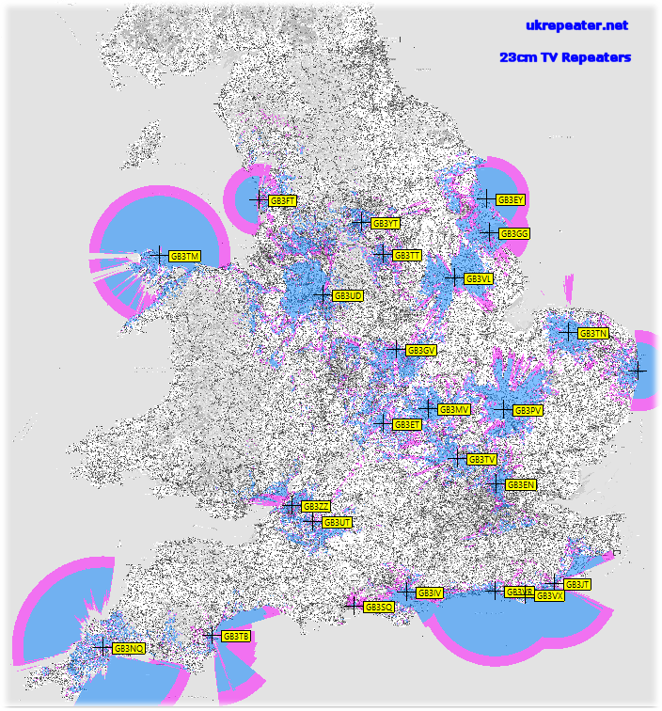
Source: https://www.ukrepeater.net/tvr.htm

