Coexistence between the radionavigation-satellite and the amateur services in the frequency range 1 240 - 1 300 MHz

[approved DD Month YYYY]

ECC Report <RNSS_AS>

# Executive summary

1. The executive summary will be dealt with when the report will be finalized

The frequency range 1 240-1 2600 MHz, used by GLONASS systems of the Russian Federation and frequency range 1260-1300 used by the the European GALILEO system as well as by the Chinese Beidou and the Japanese QZSS (and planned to be used by the Korean KPS)for the global provisioning of radion avigation-satellite service (RNSS), occupies the frequency band 1 240‑1 300 MHz which is also allocated to the amateur and amateur-satellite services on a secondary basis in the ITU Radio Regulations. Further, this band is shared with primary allocations to the radiolocation (RLS), radionavigation (RNS) on a co-primary basis and with the Earth exploration-satellite service (EESS (active)) on a co-secondary basis.

With the implementation of the new RNSS system applications or services, and considering the fact that RNSS signals are characterised by uubiquitous, wideband, very low received power and continuous emissions, it has become necessary to clarify more specifically the operating conditions for certain applications (operating modes) in the amateur and amateur satellite services to ensure the continued use of this band and to ensure an appropriate long-term development of both services.

The allocation in the frequency band 1 240-1 300 MHz to the amateur service is important to the radio amateurs worldwide. The allocation closes the gap between the 'neighbouring' allocations 430-440 MHz and 2 300-2 450 MHz to the radio amateur service, as the physical conditions are very specific for propagation monitoring and communication experiments.

TABLE OF CONTENTS

0 Executive summary 2

1 Introduction 7

2 AMATEUR SERVICES 8

2.1 Amateur services in 1 240 – 1 300 MHz 8

2.1.1 Introduction 8

2.1.2 Characteristics of amateur signal emissions 8

2.1.3 IARU band plan 9

2.1.4 Amateur Station Categorisation 11

2.1.4.1 2.2.4.1 Home Station 11

2.1.4.2 2.2.4.2 Temporary ”Portable” Station 12

2.1.4.3 Permanent Installation 12

2.1.5 Typical Amateur Station Type Characterisitcs 13

2.1.5.1 Home Station 13

2.1.5.2 Temporary ”Portable” Station 13

2.1.5.3 Permanent Installation 14

2.1.6 Typical Usage Patterns 14

3 Scenarios for coexistence evaluation 16

3.1 Frequency overlap betweeN, RNSS and amateurs 16

3.2 SELECTED REPRESENTATIVE SCENARIOS 16

3.2.1 Scenario 1: 16

3.2.2 Scenario 2: 17

3.3 Propagation model: [For Further Discussion – This needs to account for path terrain and clutter at the receiver end] 17

3.3.1 Time variability effects 18

3.3.2 Space variability effects 18

4 RNSS systems 20

4.1 typical RNSS applications in the 1240-1300 MHz BAND 20

4.1.1 High Precision applications 20

4.1.1.1 Government: Transportation and environmental management 20

4.1.1.2 Agriculture 20

4.1.1.3 Construction – Heavy and civil engineering 21

4.1.1.4 Automotive navigation 21

4.1.1.5 -Surveying and mapping 21

4.1.1.6 Utilities, energy, mining, oil and natural gas 21

4.1.2 Authentication applications 21

4.1.2.1 Maritime 22

4.1.2.2 Road 22

4.1.2.3 Timing 22

4.2 Galileo Emissions and Protection requirements 24

4.2.1 Galileo system description 24

4.2.2 GALILEO E6 Signal Baseline 24

4.2.2.1 High Accuracy Service (HAS) 25

4.2.2.2 Commercial Authentication Service (CAS) 25

4.2.3 GALILEO Protection requirements 25

4.3 GLONASS EMISSIONS and protection requirements 26

4.3.1 GLONASS system description 26

4.3.1.1 GLONASS Signal description 26

4.3.1.2 Signals with frequency division multiple access 26

4.3.2 GLONASS Protection requirements 28

4.4 OTHER RNSS 28

5 Methodology 29

6 Simulations 31

7 Measurements 32

8 Quantification of interference and options for RFI mitigation 33

8.1 Analysis of protection criteria 33

8.2 [RFI mitigation on GALILEO E6-B receiver] 33

8.3 Mitigation in amateur emissions 33

8.4 Statistics of use of band by amateur services (time and location) 33

9 Conclusions 34

ANNEX 1: List of references 35

ANNEX 2: AMSS regulations and deployment in Switzerland 37

ANNEX 3: 40

ANNEX 4: Amateur radio repeater and beacon stations using the band 1240 – 1300 MHz in some countries within the CEPT region – May 2020 44

9.1 Amateur radio Repeater and Beacon Stations 44

9.2 licensing and assignment procedures 44

9.3 VOICE AND DATA REPEATERS 44

9.3.1 Repeater frequencies in 1240-1300MHz 44

9.3.2 Data Repeater frequencies 45

9.3.3 Voice and Data Repeater assignments – a survey of some CEPT countries 45

9.4 Amateur TV (ATV) repeaters 46

9.4.1 ATV Repeater frequencies in 1240-1300MHz 46

9.4.2 Repeater Architecture 46

9.4.3 Repeater Trends 47

9.4.4 Repeater Assignments – a survey of some CEPT countries 47

9.5 Propagation beacons 48

9.5.1 Propagation Beacon Frequencies in 1240-1300 MHz 48

9.6 References 48

ANNEX 5: Measurements made in Germany 51

9.6.1.1 SSB voice (Test Cases G1-07, G1-08, G1-13) 56

LIST OF ABBREVIATIONS

|  |  |
| --- | --- |
| **Abbreviation** | **Explanation (style: ECC Table Header red font)** |
|  |  |
| ARNS | Aeronautical Radionavigation Service (ITU RR) |
| ATV | Amateur television (usually analogue FM emissions) |
| BOC | Binary Offset Carrier |
| BPS | Bits per second |
| BPSK | Binary phase shift keying |
| CAS | Commercial Authentication Service (GALILEO E6) |
| CBOC | Composite Binary Offset Carrier modulation |
| CDMA | Code Division Multiple Access |
| C/NAV | Commercial Navigation message (provided in E6-B signal) |
| cps | Chips per second |
| CRC | Cyclic Redundancy Check |
| CW | Continuous wave (in amateur service also used for Morse telegraphy communication |
| DATV | Digital Amateur TV (applying DVB-S and DVB-S2 Standards) |
| ECC | Electronic Communications Committee |
| FEC | Forward Error correction |
| FSK | Frequency Shift Keying |
| HAS | High-Accuracy Service (GALILEO E6) |
| IARU-R1 | International Amateur Radio Union ([Region 1](https://www.iaru-r1.org/))[1]; |
| ICD | European Union, “Galileo Open Services Signal in Space Interface Control Document (OS SIS ICD)”; <http://ec.europa.eu/growth/sectors/space/galileo/> |
| ISU | Interference Suppression Unit |
| ITU-R | ITU Radiocommunications Sector |
| GNSS | Global Navigation Satellite Service |
| OS | Open Service (GALILEO) |
| PSA | Precision Step Attenuator |
| PSD | Power Spectral Density |
| RFI | Radio Frequency interference |
| RNSS | Radionavigation-Satellite Service (ITU RR) |
| RR | ITU-R Radio Regulations |
| SIS | Signal-In-Space |
| MGM  sps | Machine Generated Mode  Symbols per second |

# Introduction

1. This section will be dealt with when the report will be finalised

The frequency range 1 240-1 260 MHz, used by the Russian Federation Glonass system and the frequency range 1 260-1 300 MHz, used by the European GALILEO system as well as by the Chinese Beidou and the Japanese QZSS (and planned to be used by the Korean KPS) for the provisioning of radio navigation -satellite service (RNSS), occupies the frequency band 1 240- 1 300 MHz which is also allocated to the amateur and amateur-satellite services on a secondary basis in the ITU Radio Regulations. This band is further shared with primary allocations to the radiolocation (RLS), radionavigation (RNS) on a co-primary basis and with the Earth exploration-satellite service (EESS (active)) a co-secondary basis.

With the implementation of the GALILEO system, it has become necessary to clarify more specific the operating conditions for certain applications (operating modes) in the amateur and amateur satellite services to ensure the continued use of this band and to ensure an appropriate long-term development of both services.

For radio amateurs worldwide the allocation to the amateur service in the frequency band 1 240-1 300 MHz, also known as the “23cm-band”, is an important frequency band between the allocations in 430-440 MHz and 2 300-2 450 MHz as the physical conditions are very specific for propagation monitoring and communication experiments.

This report analyses conditions for the coexistence of the RNSS receiver processing the signals with emissions from stations operating in the amateur and amateur-satellite services allocated in the frequency range 1 240-1 300 MHz. It is based on two measurement campaigns (2, 3).

# AMATEUR SERVICES

## Amateur services in 1 240 – 1 300 MHz

### Introduction

The ITU Radio Regulations allocate the frequency band 1 215 – 1 300 MHz to the amateur service and the amateur-satellite service with a secondary status. ITU RR no. 1.56 define the amateur service as: “A radiocommunication service for the purpose of self-training, intercommunication and technical investigations carried out by amateurs, that is, by duly authorized persons interested in radio technique solely with a personal aim and without pecuniary interest.” According to this, the amateur service incorporates a large portfolio of different applications in terms of signals and usage scenarios.

### Characteristics of amateur signal emissions

The characteristics of typical applications are shown in Table 2.

Table 2: Amateur service applications and usage scenarios in the frequency range 1 240-1 300 MHz

| Application | Typical Bandwidth | Details | Remarks |
| --- | --- | --- | --- |
| Digital Voice | 12,5 kHz (Tetra: 25 kHz) | DMR, D-Star DV, NXDN, Tetra, APCO 25, C4FM | simplex and repeaters (interconnected by the Internet), mobile/ handheld/ stationary usage  DMR: TDMA Access (two timeslots – 50% duty cycle) |
| Digital Data | 12,5 – 150 kHz | Packet Radio (AFSK 1k2, FSK 9k6), D-Star, Digital Data 128 kbit/s | signal bursts, automatic stations, mobile/ stationary usage |
| Morse Code | 500 Hz | CW (100 WPM) | Moon bounce (high power), Beacons (24/7 automatic stations), Contests (Activity weekends), stationary usage |
| Analogue Wide | 12,5 kHz | FM | simplex and repeaters (some interconnected by the Internet – Echolink), mobile/handheld/stationary usage |
| Analogue Narrow | 2 700 Hz | SSB | simplex and linear transponders, Contests (Activity weekends), stationary usage |
| MGM (machine generated mode) | 6 – 2 700 Hz | RTTY, SSTV, PSK31, WSPR | simplex, operator controlled (no automatic stations), Contests (Activity weekends), satellites (only CO-65 in space), stationary usage |
| Analogue ATV | 16 – 18 MHz | FM-ATV | simplex and repeaters, stationary usage |
| Digital ATV | 2 – 8 MHz | DATV (DVB-T, DVB-S) | simplex and repeaters, stationary usage |

### IARU band plan

As an affair of the worldwide amateur service's self-administration, the International Amateur Radio Union (IARU) coordinates the interests of its Member Organisations. The three IARU Regions are organized to broadly mirror the structure of the ITU and its related regional telecommunications organizations. In any case, national regulatory provisions prevail and may lead to different regulations.

Currently [IARU recommends the band plan](https://www.iaru-r1.org/index.php/spectrum-and-band-plans/uhf/23-centimeter) shown in Table 3 below for the amateur allocation in the frequency range 1 240 – 1 300 MHz in IARU Region 1.

[Editor: OK for the deletion of this text but it should be moved to the annex with measurements done in Germany]

Table 3: IARU Region 1 band plan for 1 240 - 1 300 MHz

|  |  |  |  |
| --- | --- | --- | --- |
| Frequency | Max. Bandwidth | Mode | Usage |
| 1240 - 1240.5 | 2700 Hz | All Mode | (reserved for future) |
| 1240.5 - 1240.75 | 500 Hz | Telegraphy MGM | Beacons (reserved for future) |
| 1240.75 - 1241 | 20 kHz | FM/Digital voice | (reserved for future) |
| 1241 - 1243.25 | 20 kHz | All Mode | 1240.000-1241.000 Digital communications 1242.025-1242.250 Repeater output, ch. RS1 -- RS10 1242.250-1242.700 Repeater output, ch. RS11 -- RS28 1242.725-1243.250 Packet radio duplex, ch. RS29 -- RS50 |
| 1243.25 - 1260 | Bandwidth limits according to national regulations. | ATV Digital ATV | 1258.150-1259.350 Repeater output, ch. R20 -- R68 |
| 1260 - 1270 | Bandwidth limits according to national regulations. | Satellite Service |  |
| 1270 - 1272 | 20 kHz | All Mode | 1270.025-1270.700 Repeater input, ch. RS1 -- RS28 1270.725-1271.250 Packet Radio duplex, ch. RS29 -- RS50 |
| 1272 - 1290.994 | Bandwidth limits according to national regulations. | ATV Digital ATV |  |
| 1290.994 - 1291.481 | 20 kHz | FM Digital voice Repeater INPUT | RM0 (1291.000) -- RM19 (1291.475) 25 kHz spacing |
| 1291.494 - 1296 | Bandwidth limits according to national regulations. | All Mode | 1293.150-1294.350 Repeater input, R20 (1291.475) - R68 (1294.350) |
| 1296 - 1296.15 | 500 Hz | Telegraphy MGM | 1296.00-1296.025 Moonbounce 1296.138 PSK31 centre of activity |
| 1296.15 - 1296.8 | 2700 Hz | Telegraphy MGM SSB | 1296.200 Narrow-band centre of activity 1296.400-1296.600 Linear transponder input 1296.500 Image center (SSTV, FAX etc) 1296.600 Narrow band data center  (MGM, RTTY ...) 1296.600-1296.700 Linear transponder output 1296.741-1296.743 experimental MGM (500 Hz) 1296.750-1296.800 Local Beacon (10W ERP max) |
| 1296.8 - 1296.994 | 500 Hz | Telegraphy MGM | BEACONS EXCLUSIVE (b) |
| 1296.994 - 1297.481 | 20 kHz | FM Digital voice Repeater OUTPUT | RM0 (1297.000) -- RM19 (1297.475) 25 kHz spacing |
| 1297.494 - 1297.981 | 20 kHz | FM (c) Digital voice (e) | 1297.500-1297.975 SIMPLEX channels 25 kHz spacing SM20 - SM39 1297.500 FM activity centre 1297.725 Digital Voice Calling 1297.900-1297.975 Simplex FM Internet Voice gateways |
| 1298 - 1299 | 20 kHz | All Mode | General mixed analogue or digital use 25 KHz spacing channels  1298.005 RS1  1298.9755 RS1 |
| 1299 - 1299.75 | 20 kHz | All Mode | Arranged as 5x150 kHz channels for high speed Digital Data (DD) usage:  Centers: 1299.075, 1299.225, 1299.375, 1299.525, 1299.675 MHz  (+/- 75 kHz) |
| 1299 - 1299.75 | 20 kHz | All Mode | 8x25kHz channels (avaiable for FM/DV use):  Centers: 1299.775, 1299.975 |

### Amateur Station Categorisation

There are many applications in the amateur service but the stations and their usage patterns can be broadly categorised into three types:

* 1. Home Station.
  2. Temporary “Portable” Station.
  3. Permanent installations (away from an individual’s home address).

The operational details are considered specific to the band 1240-1300 MHz as they are dependent upon the nature of the equipment needed and operator skills to operate in this band as well as the propagation characteristics.

It should also be borne in mind that often nationally specific conditions can lead to variations in the operating pattern in particular the frequencies used by permanent installations.

#### 2.2.4.1 Home Station

This would be installed at the usual station licence holder home location. The majority of home station usage is for narrow band terrestrial ad-hoc communications with other similarly equipped amateur stations. However since the propagation characteristics are more challenging than those in lower UHF and VHF bands the band would not be the first choice for casual contacts or group/club on-air gatherings. Most stations are better equipped in the lower frequency bands for this type of operation. Casual random calls under flat propagation conditions are rare as high antenna gain and narrow beam widths preclude useful ”broadcast” calls. The highest level of home station activity occurs during (usually competitive) scheduled activity periods that take place on a publicised regular basis during weekday evenings and a number of weekends throughout the year. Generally analogue narrow band Morse, SSB and MGM applications are used in the range 1296 – 1298 MHz

Enhanced propagation conditions tend to be variable and can occur randomly throughout the year. They may last from minutes to days depending on the mechanism at work. These can encourage operation although activity levels will be less compared with the more popular lower UHF and VHF bands. Generally analogue narrow band Morse, SSB and MGM applications are used in the range 1296 – 1298 MHz.

In order to extend the communication distance that can be achieved, this band is popular amongst a few stations suitably equipped to overcome the losses inherent in an earth-moon-earth (EME) reflected path. Of course these are only possible when the moon is visible and require high performance low noise stations with larger antenna systems that may not be compatible with all locations. These weak signal contacts most commonly use analogue narrow band Morse and MGM applications in the range 1296 – 1298 MHz. MGM applications are most commonly used for random contacts.

This band is a popular choice for Amateur TV (ATV) applications due to the bandwidth available. Nowadays digital ATV (DATV) is encouraged and becoming the most popular application. As discussed above, random activity is quite rare but again activity (and contest) periods are scheduled as a focus for operation and experimentation. Simplex TV operation tends to occur around 1255 MHz.

For all applications, narrow band or wideband, the highest activity levels and band usage are concentrated into the scheduled activity periods summarised in the table below:

Typical Peak Activity based on some in-country data in CEPT[2]:

|  |  |  |
| --- | --- | --- |
| Usage Type | Annual Activity Periods | Active Home Stations |
| Narrow Band Activity Period and Contests | Total, on average 108 hrs over a year[3] | Between 100 (NL) and 260 (F) |
| EME | 5 x 24hrs contest periods | 10 (UK); 7 (F).  (Maximum 100 across Europe) |
| Wide band Activity Period and Contests (ATV) | Total, on average 120 hrs over a year | 10 maximum |

Operation through amateur satellites takes place within the uplink only band at 1260-1270 MHz and these can include tele-command activities as well as direct narrow band voice and low rate data communications. There are four currently active in this band at present but this is a lively area of interest.

#### 2.2.4.2 Temporary ”Portable” Station

Often the propagation constraints experienced for a home station (usually due to local clutter) can be overcome in part by temporarily siting a station in an advantageous position (usually high ground) away from the home location and usually in a rural setting. Again the majority of usage is for terrestrial ad-hoc communications with other amateur stations for short duration narrow band contacts usually associated with scheduled (competitive) activity periods.

ATV activity is also possible, although random activity is rarely seen outside scheduled activity (and contest) periods which act as a focus for operation and experimentation.

EME activity is unlikely as there is no advantage to be gained.

#### Permanent Installation

Permanent installations include specific voice repeaters, ATV (and occasionally data) repeaters and propagation beacons. As permanent stations, these are licensed in their own right for their specific location, operating frequency and output power (as ERP). The licence is usually associated with a licensed ”keeper” of the installation. Propagation beacons usually operate 24/7 and will typically emit a narrowband FSK signal with call sign ID and location information in the range 1296.8 – 1296.994 MHz.

Voice repeaters usually re-transmit narrow band analogue and digital voice traffic when activated with a signal on the input frequency and are mostly associated with extending mobile user coverage. Propagation at these frequencies does not lend itself to reliable wide area repeater coverage so activity is far less than in lower UHF and VHF bands (and fewer commercial radios are suitable for mobile installations). The most common installations transmit around 1297 - 1298 MHz although a few experimental systems may operate in other parts of the band.

Data and TV repeater stations transmit wider bandwidth amateur signals and often transmit test signals when not being accessed by a user station on the input channel. This band is the most popular for amateur TV repeaters which tend to operate with input and output frequencies in the range 1242 – 1260 MHz. Actual assignments can be nationally dependant. There are cases where alternative output frequencies are used to facilitate national inter-service coordination (e.g. UK TV repeater output frequencies are in the range 1300 – 1325 MHz).

### Typical Amateur Station Type Characterisitcs

There is no standard amateur station. The following antenna types and power levels are typical based on published information about the activity periods and operating contests. In general home and temporary stations would use highly directional antennas.

#### Home Station

Most Home Stations will use a single directional beam antenna, however in a few cases multiple beam antennas can be combined to increase the array gain. This is more usual for EME operators for whom high antenna gain is essential for overcoming the high path and reflection loss. A higher performance EME station might use a medium size dish antenna.

|  |  |  |
| --- | --- | --- |
| Antenna Type | Gain Typical | 3dB Beam width |
| Single Yagi beam (23 to 55 element) | 18 to 21 dB | 18 to 10 deg |
| Multiple Yagi (for EME)  Dish antenna (for EME) | 21 dB  (4m) 32 dB | 10 deg  4 deg |

Analysis of a typical activity period results (non EME) shows that around 15% of active stations used a multi-antenna array.

Analysis of the same activity period showed the following spread of transmitter power levels (NB: 100% = 34 stations only):

|  |  |
| --- | --- |
| Power Range (Watts) | % Stations |
| Up to 10 | 47%[4] |
| 11-25 | 9% |
| 26 - 100 | 26% |
| 101 - 300 | 12% |
| Over 300 | 6% |

For EME operation experiences have shown that a minimum performance station could expect to make MGM based contacts using around 50W of power into a multiple antenna beam array. Higher performance stations are likely to require at least around 10dB more EIRP through a combination of power level and increased antenna gain.

#### Temporary ”Portable” Station

As with Home Stations there is a spread of the same antenna types that might be used. Similarly analysis of the same activity period as above show that only 15% of stations used multi-antenna arrays. (The actual number was 3).

Analysis of the same activity period shows the following spread of transmitter power levels (NB: 100% = 13 stations only):

|  |  |
| --- | --- |
| Power Range (Watts) | % Stations |
| Up to 10 | 61.5%[5] |
| 11-25 | 7.5% |
| 26 - 100 | 7.5% |
| 101 - 300 | 15% |
| Over 300 | 7.5% |

#### Permanent Installation

Most permanent installations (beacons and repeaters) are less directional and are generally intended to provide coverage over an area. They are usually licensed to operate at a specific ERP.

|  |  |  |
| --- | --- | --- |
| Antenna Type | Gain Typical | 3dB Beamwidth |
| Various (e.g. Alford slot, Colinear array, horn, flat panel, big wheel...) | Up to around 13 dB | Omni to 60 deg |

|  |  |  |
| --- | --- | --- |
| ERP Range (Watts) | % NB Beacons | % Repeaters (ERP) |
| Up to 10 | 69% | 16% |
| 11-25 | 8% | 76% |
| 26 - 100 | 20% | 8% |
| 101 - 300 | 1% | 0% |
| Over 300 | 1% | 0% |

### Typical Usage Patterns

For all Home station applications, narrow band or wideband, the highest activity levels and band usage are concentrated into the scheduled activity periods summarised in the table below:

Table 4: Typical Peak Activity based on some in-country data in CEPT

|  |  |  |
| --- | --- | --- |
| Usage Type | Annual Activity Periods | Active Home Stations |
| Narrow Band Activity Period and Contests | Total, on average 108 hrs over a year | From 19 (NL) to and 150 (DE) maximum per country. |
| EME | 5 x 24hrs contest periods | Up to 10 maximum per country.  (Maximum <70 across Europe) |
| Wide band Activity Period and Contests (ATV) | Total, on average 120 hrs over a year | From 1 (CHF) to 24 (IT) maximum per country.  (Maximum <100 across Europe) |

For temporary "Portable" stations:

Table 5: Typical Peak Activity based on some in-country data in CEPT

|  |  |  |
| --- | --- | --- |
| Usage Type | Annual Activity | Active Portable Stations |
| Narrow Band Activity Period and Contests | Total, on average 108 hrs over a year | 15 to 20 |
| Wide band Activity Period and Contests (ATV) | Total, on average 120 hrs over a year | 10 maximum |

For permanent installation station types:

Table 6: Typical Activity Examples from some countries in CEPT

|  |  |  |
| --- | --- | --- |
| Usage Type | Annual Activity | Active Installations |
| Narrow Band Propagation Beacons | Transmitting 24/7 usually | 11 (UK); 15 (F); 20 (D); 4 (NL).  IARU R1 = 88 in total. |
| Narrow Band Repeaters | Low and only when activated on the input frequency.  Transmitting 24/7 if a beacon mode is present. | 9 (UK); 8 (F); 19 (NL). |
| ATV Repeaters | Low and only when activated on the input frequency.  Transmitting 24/7 if a beacon mode is present. | 18 (UK); 10 (F); 12 (NL) |
| ATV Repeater user | Random and sporadic | 5 to 10 per repeater |

# Scenarios for coexistence evaluation

1. This chapter should go after the chapter on RNSS
2. The list of scenarios may not be exhaustive

## Frequency overlap betweeN, RNSS and amateurs

1. The text and the figure should be updated adding the other systems as well

Figure 3 shows the spread GALILEO E6-signal and the corresponding portions with applications of the amateur service. Except the very wide-band modes of FM-ATV and various options for D-ATV (DVB-T/DVB-S) the remainder of applications falls into three categories which may show different grades of impact, if at all, on the reception and decoding of the GALILEO signals.

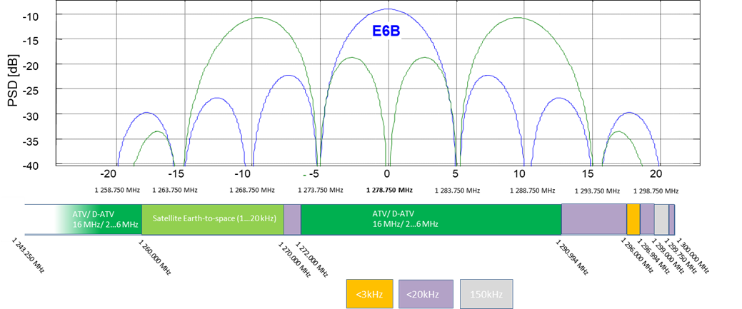

## SELECTED REPRESENTATIVE SCENARIOS

Amateur Transmitting Parameters for coexistence evaluation

Two scenarios are proposed to cover the majority of expected amateur and amateur satellite applications in the 1240-1300MHz band.

### Scenario 1:

Directional antenna radiating away from a home or temporary station site, the following parameters are considered.

These parameters can be considered to cover the home and temporary “portable” station situations with an amateur operator using narrow band telegraphy and telephony applications including MGM modes. Satellite uplink operation and EME operation can be taken into account by considering antenna off axis gain. Wideband modes such as DATV are included within this scenario. Nominal values are highlighted and a range of reasonable values can be considered if sensitivity analysis is needed.

### Scenario 2:

Omni-Directional antenna radiating away from a permanent station site.

These parameters cover permanent installations such as beacon and repeater station outputs (narrow band and wide band) using antennas intended for area coverage (omni/low gain).

|  |  |  |  |  |
| --- | --- | --- | --- | --- |
| Parameter | Scenario 1 (directional) | | Scenario 2 (omni) | |
|  | Nominal | Range | Nominal | Range |
| Tx Power (dBW) | 10 | up to 24 | 10 | up to 13 |
| Antenna Gain (dBi) | 20 | up to 30 | 6 | up to 10 |
| Antenna 3dB beam width (deg) | 18 | - | N/A | - |
| Height over ground (m) | 12 | - | 25 | - |
| Antenna off axis gain (dB) | -20 | - | N/.A |  |
| Propagation Model | ? |  |  |  |

## Propagation model: [For Further Discussion – This needs to account for path terrain and clutter at the receiver end]

1. Other propagation models, suitable for maritime and aeronautical receivers should be added

The goal is to estimate the dimension of interference areas. For doing so, several propagation models can be used; such as ITU-R P.452, ITU-R P.1546 or other models used for mobile radio planning, such as Okumura-Hata.

For each of the models cited above, the following considerations ca be made:

* Okumura-Hata is relatively easy to use and it is well known for its general reliability, but it has the limitation that ideally the transmitting station should be at least 30 m. The model is intended to calculate the media loss over a pixel of terrain at distance d from the transmitter. Because of this, if the model is used to calculate interference area, a margin factor should be inserted in the analysis in order to take into account the spatial variability of the electromagnetic field. If one applies Okumura-Hata, he must be aware of the limitations on its paramaters, including a maximum distance of 10 km, a minimum BS antenna height of 30 m. On the other side, since Okumura-Hata is conceived for frequencies up to 1500 MHz, its frequency range suites the case at hand.
* ITU-R P. 1546 does not have the limitation on antenna height of the TX (it can be as low as 10 m), but it has a limitation on the minimum distance, that should be at least 1 km. This model has the advantage of having built in location and time probabilities, so that it can be directly used for the analysis of interference areas.
* On the other side, ITU-R ITU-1812 is more versatile because it does not have significant limitations on the TX antenna height and the minimum distance, and it considers antenna probability. The minimum distance at which it can be used is 250 m.

For the models ITU-R P.1546 and ITU-R 1812 a tested Matlab implementation is available to ITU members.

For reference, the following figure gives the curves of propagation loss, along a path of 100 km, over rural terrain at 1300 MHz, for a transmitting antenna height of 10 meters, a receiving antenna height of 1.5, and a rural terrain. The two curves refer to two location probabilities, namely of 50% and 1%.



Figure 1

If one is interested in the magnitude of interference at very short distances, in the order of magnitude of a few hundreds of meters, more detailed analyses should be conducted, where the case of light of sight and free space propagation is also considered.

### Time variability effects

Due to the variation in the atmospheric conditions and propagation conditions, such as ducting, the interfering signal can show time variability. These phenomena are taken into account by the models ITU-R. P. 1546 and ITU-R. P. 1812, however, these time effects are mostly relevant over long distances, while at short distances they tend to be negligible.

### Space variability effects

The other aspect to be considered is the space variability of the electromagnetic field. By the way it is conceived, a propagation model such as Okumura-Hata gives the estimated median value of the received power in a given pixel of terrain. Inside this pixel of terrain, you can still have slow fading and fast fading. The effect of local statistical variations f the EM field also needs to be taken into account.

In order to appreciate this fact, consider a pixel of terrain 50x50 m wide. Assume that the maximum tolerable interfering power for the RNSS receiver is $P_{int}^{MAX}$. In order to declare that the pixel is free from interference it is not sufficient to verify that the interfering received power from the radio amateur station, calculated with the chose propagation model, is equal or below $P_{int}^{MAX}$. For instance, when its value is exactly equal to $P_{int}^{MAX}$ this means that 50% of the locations inside the pixel will be still be above this value. For this reason, the analysis of interference shall be conducted in such a way that, for a given pixel to be declared interference free, the interfering EM field shall below the reference threshold for, say, X=99% of its locations.

It is therefore necessary to have statistical model of the spatial variability of the EM field for a given pixel. In general, such a variation is composed of a slow variation (shadow fading) and fast variation (fast fading), that it due to multipath effects[6].

A characterization of the spatial variability of the field strength in various frequency band and for different propagation scenarios (the clutter at the location of the RX plays a fundamental role), is implicitly contained in the curves of ITU-R. 1546 and it is also treated in ITU-R. P1812, but it is excluded by Hata. Should one use Hata, an additional margin for fading should be added, in the same way it is added when Hata is used for mobile radio planning.

If one considers, for instance ITU-R. P.1812, for an outdoor location, at 1.5 meters, in the frequency band 1300 MHz, the standard deviation of spatial variation of the received power (that is assumed to be lognormal) is 5.5 dB for the 1300 MHz (see section 4.8 and Table 6). A value of 5.5 dB and the assumption of a lognormal fading clearly refer to the slow variation of the field, while the fast variation is not considered.

The following table gives a comparison of the propagation models presented above.

|  |  |  |  |  |  |
| --- | --- | --- | --- | --- | --- |
| Model | Scope | Limitations | Clutter loss consideration | Advantages | Drawbacks |
| ITU-R P.1546 | Point to area | Tx height $∈[10;3000]$ m  Distance $∈[1;1000]$ m | The clutter heights around the transmitter and the receiver are represented by two parameters | Works with sea paths |  |
| ITU-R P.1812 | Point to area | Distance > 250 m | 1) At each point on the profile between the transmitter and receiver point a clutter height is added to the terrain height.  This profile is used in the diffraction calculation (the antenna heights are also adjusted depending on the clutter at each end).  2) A terminal clutter correction is also applied, dependant on the clutter at the transmit and receiving end; this is the same as in P. 1546 | Representative of terrain, works with sea paths |  |
| Okumura-Hata | PtP, broadcast | Tx height > 30 m  Mobile station height $∈[1; 10]$ m  Distance $∈[1;10]$ km | Fit on measured data from urban environment, not terrain specific | Easy to use | Not representative of terrain configurations |

# RNSS systems

RNSS systems are in use around the globe, with billion RNSS devices in use. There are currently several systems that transmit signals within the frequency range 1240-1300 MHz. The band 1240-1260 MHz is currently used by the Russian Federation Glonass system while the band 1260-1300 MHz is used by the European Galileo system as well as by the Chinese Beidou and the Japanese QZSS. The same band is also planned to be used by the Korean KPS. Specific inputs are provided for Galileo within section 3.3, for Glonass within section 3.4 and for other RNSS within section 3.5, respectively.

Before going into the specific of each system, it is worth go give an overview of the RNSS applications that are typically provided within the band.

## typical RNSS applications in the 1240-1300 MHz BAND

1. This section should be reviewed making it more technical, EC to propose an update for the next meeting

Although the globally installed base of RNSS devices is greatly dominated by smartphones, followed a distant second by automobiles, the number of RNSS devices in use for professional applications continues to grow and serve a critical role in national economies, public safety, science, etc. Billions of people globally benefit from these high-end RNSS devices on a day-to-day basis, e.g. enjoying the production of sustainable and cost-effective agriculture, using efficiently coordinated transport networks, and leveraging RNSS-synchronized telecommunication networks.

RNSS is used for several type of applications including high precision applications.

### High Precision applications

#### Government: Transportation and environmental management

Commercial high-precision RNSS is used widely by national and local governments, including within the departments for administration of transportation, agriculture, forest and land management, and security as well as by emergency services/first responders and other departments and bureaus.

Local government uses of high-precision RNSS include mapping, surveying and other transportation uses, Geographic Information Systems (GIS) for asset management, emergency preparedness, disaster response and E911 mapping, public sector water, wastewater and electric utilities, public works, environmental management, dam and structure monitoring, environmental health, insurance rating districts, flood zones, tax appraisals, the provision of geodetic control networks, and other functions.

High-precision RNSS is used in response and disaster planning to capture the location of critical infrastructure for utilities, transportation and emergency services. By combining RNSS measurements with elevation models, planners can identify areas susceptible to flooding or other damage. The information is stored in Geographic Information Systems (GIS) where it can be accessed by emergency managers and response organizations.

RNSS is being increasingly used as an essential enabling technology to monitor and provide early warnings for natural phenomena such as earthquakes, landslides, volcanoes and flood hazards.

#### Agriculture

Precision agriculture uses high accuracy, real-time RNSS on-board agricultural machinery to manage distribution of fertilizer and pesticides, and planting and harvesting of crops.

Using RNSS precision guidance, farmers can plant rows closer together and with greater precision, to increase crop yields and reduce waste due to overlaps or gaps. When used on harvesting machines, the collection of RNSS precise positioning data, combined with information about crop yields, is applied to seeding and fertilization plans for the following season’s crops. The RNSS positioning adds precision to weed and insect control, allowing farms to decrease the use of potentially toxic pesticides and herbicides by as much as 80 percent. Precision agriculture requires 24/7 delivery of continuous real-time position accuracies with Key Performance Indicators (KPI) from 1 cm to 10 cm during agricultural operations. This positional capability enables the grower to operate a range of farm machinery, including at night that carefully follows precision farming plans requiring repeatable KPI throughout the growing cycle, from tilling through harvesting. Many precision agriculture receivers require a real-time differential data stream, often delivered by integrated MSS receiver equipment.

#### Construction – Heavy and civil engineering

RNSS construction machine control systems consist of rugged, high-precision RNSS receivers mounted on construction machines of various types. With reference to a computer model of a job grading plan, the RNSS system is required to determine the precise position of the machine’s blade continuously (24/7) to within one inch or less using the on-board computer to continuously compare the blade’s precise position to the design plan. By watching a display in the machine’s cab, the operator controls the machine to produce the desired results.

#### Automotive navigation

RNSS technology is the enabling technology for all automotive navigation. Integration with other sensors and communications networks is common, making RNSS integral to the development of smart cars and autonomous vehicles.

#### -Surveying and mapping

High-precision RNSS is used in many surveying functions necessary for civil engineering and architectural design, production and maintenance of maps and Geographic Information Systems (GIS), land management and title transactions, and management of critical assets such as utility infrastructure, pipelines, dams, roads, rail and waterways. High-precision RNSS is also used to provide services to cities and counties for tax appraisal purposes and flood zone mapping.

#### Utilities, energy, mining, oil and natural gas

High-precision RNSS is used by electric, gas and water utilities to map and manage their widely dispersed assets, in the avoidance and management of major power, water, or gas outages, in vegetation management, rapid location of damaged equipment, in pipeline integrity inspections and in tasks related to environmental and safety compliance. In Energy and Natural Resources, RNSS is used extensively in the construction of sustainable energy projects such as wind farms and solar power sites, seismic exploration and production of domestic oil and gas reserves, mine surveying, measurement and safety monitoring, pipeline construction, pipeline integrity and safety monitoring, drill location and environmental monitoring, measurement and compliance.

### Authentication applications

Nowadays, the use of RNSS as a primary source of PVT can be found in an increasing number of products and services. According to [16], 5.8 bln RNSS devices were in use in 2017. By 2025, this number is forecasted to increase to more than 9 bln. In this context, a failure or loss of signal due to outside influence can result in a range of consequences, as highlighted also in [17].

Due to the extreme low power, RNSS, can be harmed by several threats, intentional and unintentional. Normally these threats are classified in literature is three main categories:

Jamming is the act of directing electromagnetics energy toward communication (and navigation) system disrupting or preventing signal reception. It can be categorized as denial of service, since the GNSS is still available but its signal is interfered;

Spoofing is deliberate transmission of counterfeit RNSS signals with intention to manipulate GNSS receiver into providing false Position, Velocity and Time (PVT) information. The introduction of authentication functionalities is aiming to prevent to the extent technically possible this kind of manipulation.

Meaconing means recording and rebroadcasting of authentic RNSS signals in order to confuse a navigation system or user. In order to o mitigate these risks, several RNSS provide different authentication capabilities for civil use.

Several applications domain have been identified for authentication applications with the corresponding economic impact.

#### Maritime

Authentication applications are expected to bring the majority of benefits to autonomous vessels being able to provide continuous authentication that is required for real-time operations which is considered fundamental by this sector.

The potential benefits of this kind of applications have been ranked as medium/low for fishing vessels, with an added value for this application mainly in case of a depending on the cost of the service.

#### Road

Road presents some similarities with the maritime, especially for connected and automated vehicles:

Authentication applications are expected to positively impact mainly CAD (Connected and Automated Driving), due to its real time authentication capability.

#### Timing

For timing and synchronization, the experts think that a concrete impact can come from authentication applications for all the applications.

The table below provides a summary of the potential gross impacts of authentication applications, distinguishing between  
the two scenarios (free vs fee) and highlighting the type of benefit created.

|  |  |  |
| --- | --- | --- |
| Domain | Application | Impact (tot - 2025-2035) |
| Maritime | Autonomous vessels | 5.8 M€ |
| Fishing vessels | 6.1 M€ |
| Road | Connected and Automated Driving (CAD) | 1000 M€ |
| Dangerous and Valuable Goods (DVG) tracking | 0.5 M€ |
| Fleet management (FM) | 0.5 M€ |
| Road User Charging (RUC) | 0.5 M€ |
| Timing & Synchronization | Telecommunication applications | 13.3 M€ |
| Energy applications | 0.4 M€ |
| Finance applications | 2.3 M€ |
| Consumer Platform | Smartphones, Mobiles and PDAs (payments) | 1.67 M€ |
|  | Total | 1.65 b€ |

## Galileo Emissions and Protection requirements

### Galileo system description

The Galileo system consists of a constellation of 30 satellite positions (24 transmitting satellites and six in-orbit active spares) with ten satellites positioned on each of three 56° inclined equally spaced orbital planes. Each satellite transmits navigation signals on three carrier frequencies. These signals are modulated with a structured bit stream, containing coded ephemeris data and navigation messages, and have sufficient bandwidth to produce the necessary navigation precision without recourse to two‑way transmission or Doppler integration. The system provides accurate timing and position determination in three dimensions anywhere on or near the surface of the Earth. One of the three carrier frequencies is within the frequency band, 1260-1300Mhz, with a central frequency at 1278.75Mhz, and the signal baseline transmitted at that frequency is described in the following section.

### GALILEO E6 Signal Baseline

The Galileo E6 signal baseline is transmitted at the carrier frequency 1278.75 MHz. The E6 signal baseline includes two different signals, the E6-A signal carrying the “Public Regulated Service (PRS)”, and the signal commonly known as “Commercial Service (CS)”, with the components E6-B and -C. The E6-BC signal, which is specified in [1] and [15], includes the newly defined High Accuracy Service (HAS) and Commercial Authentication Service (CAS), as described below. In the following table some basic parameters for the E6-BC signal baseline are provided.

|  |  |  |
| --- | --- | --- |
| Service | E6 HAS | E6 CAS |
| Carrier Frequency | 1278.75 MHz | |
| Signal frequency range | 1260-1300 MHz | |
| Multiple Access Technique | CDMA | |
| Spreading Modulation | BPSK(5) | |
| Code Frequency | 5.115 MHz | |
| Primary PRN Code Length | 5115 | |
| Data Rate | 1000 sps | - |
| Minimum Received Power[7] | -155.25 dBW | |
| Polarization | RHCP | |

The signal component E6-B carrier the C-NAV data message supporting the High-accuracy service (HAS) and the Commercial Authentication Service (CAS), while E6-C is a data-less pilot component, implementing CAS. The multiplexing of the two signal components is represented in the figure next.

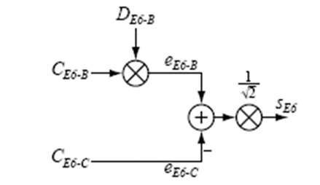Figure 1: Multiplexing of the GALILEO E6B+C signal

1. EC to consider in a future update to introduce a figure including PSD of E6-BC as well as of E6-A signals
2. EC to consider an update of 5.2.2.1 and 5.2.2.2

#### High Accuracy Service (HAS)

The Galileo High Accuracy Service (HAS) is transmitted on the E6-B signal component in the frequency band 1260-1300 MHz, as described above. HAS is aimed at market applications requiring higher accuracy performance than that offered by the Open Service [1], and provides added value services targeting 20 cm accuracy or better on a free charge basis, with content and format of data publicly and openly available on a global scale.

The High Accuracy Service complements the current offer of high accuracy solutions for demanding transport-related applications such as automated driving and drones. It also represents a strong entry level solution in precision agriculture and a useful service for mapping and GIS related applications.

#### Commercial Authentication Service (CAS)

The Galileo Commercial Authentication Service (CAS) is transmitted on the E6-C component in the frequency band 1260-1300 MHz, as described above. CAS provides the highest level of robustness for RNSS users by fully encrypting the E6-C component to protect against most spoofing attacks by helping to detect the occurrence of spoofing and allowing equipment and users to take mitigating action. The provision of E6-C can also support the adoption of triple-frequency receivers which are more resilient to interference.

GALILEO CAS is therefore contributing to ensuring the safety and the security of several applications, such as transport and automotive, which are progressively evolving towards higher digitalization, automation and connectivity. Similarly, the synchronization of critical infrastructures, as well as the mobile-based transaction leveraging on RNSS for user authentication, will benefit from using such a secure signal.

### GALILEO Protection requirements

TBC

## GLONASS EMISSIONS and protection requirements

### GLONASS system description

The GLONASS system is comprised of 24 satellites located in three orbital planes with eight satellites in each plane. The planes are separated from each other by 120 degree longitude. The orbit inclination angle is 64.8 degrees. The satellites are equally spaced by 45 degrees in a plane by argument of latitude. Their rotation period is 11 h 15 min. The height of the orbit is 19 100 km.

Each satellite transmits navigation signalsin three frequency bands: L1 (1.6 GHz), L2 (1.2 GHz) and L3 (1.1 GHz). The satellites transmit two types of signals: with frequency division multiple access and code division multiple access. Signals with frequency division multiple access are differentiated by carrier frequency; the same carrier frequency may be used by antipodal satellites located in the same plane. Navigation signals are modulated with a continuous bit stream (which contains information about the satellite ephemeris and time), and also a pseudo-random code for pseudo-range measurements. Signals with code division multiple access have the same carrier frequency and are differentiated by code. These signals are modulated by structured binary sequence that contains coded data about ephemerides and time. A user receiving signals from four or more satellites is able to determine the three location coordinates and the three velocity vector constituents with high accuracy. Navigational determinations are possible when on or near the Earth’s surface.

#### GLONASS Signal description

#### Signals with frequency division multiple access

The carrier frequencies of navigation signals with frequency division multiple access vary by an integer multiple of 0.4375 MHz in the L2 band.

Since 2006 new satellites in the GLONASS system use 14 to 20 carrier frequencies in different bands. In the L2 band carrier frequencies from 1 242.9375 MHz (lowest) to 1 248.6250 MHz (highest) are used. Nominal values of carrier frequencies of radionavigation signals used in the GLONASS system are given in table below.

| K (No. of carrier frequency) | FKL2 (MHz) |
| --- | --- |
| 06 | 1 248.6250 |
| 05 | 1 248.1875 |
| 04 | 1 247.7500 |
| 03 | 1 247.3125 |
| 02 | 1 246.8750 |
| 01 | 1 246.4375 |
| 00 | 1 246.0000 |
| −01 | 1 245.5625 |
| −02 | 1 245.1250 |
| −03 | 1 244.6875 |
| −04 | 1 244.2500 |
| −05 | 1 243.8125 |
| −06 | 1 243.3750 |
| −07 | 1 242.9375 |

Two phase-shift keying (by 180 degrees of the phase) navigation signals shifted in phase by 90 degrees (in quadrature) are transmitted at each carrier frequency. They are a standard accuracy (SA) signal and a high accuracy (HA) one.

The SA signal structure is a pseudo-random sequence which is Modulo-2 added to a continuous digital data stream transmitted with a 50 bit/s rate. The pseudo-random sequence has a chip rate of 0.511 MHz and its period is 1 ms.

The HA signal is also a pseudo-random sequence Modulo-2 added to a continuous data stream. The pseudo-random sequence chip rate is 5.11 MHz.

Digital data include information about the satellite’s ephemerides, clock time and other useful information.

Transmitted signals are elliptically right-hand polarized with an ellipticity factor no worse than 0.7 . The minimum guaranteed power of a signal at the input of a receiver (assumes a 0 dBi gain antenna) is specified as −161 dBW (−131 dBm) for both SA and HA signals.

In L2 frequency range there are two classes of emissions that are used in the GLONASS system: 1M02G7X and 10M2G7X. Characteristics of these signals are given in table below.

|  |  |  |  |  |  |
| --- | --- | --- | --- | --- | --- |
| Frequency range | Emission class | Tx bandwidth (MHz) | Maximum peak power of emission (dBW) | Maximum spectral power density (dB(W/Hz)) | Antenna gain (dB) |
| L2 | 10M2G7X 1M02G7X | 10.2 1.02 | 14 14 | −53 −43 | 10 |

The power spectrum envelope of the navigation signal is described by the function (sin x/x)2, where:



in which:

f: frequency considered

fc: carrier frequency of the signal

ft: chip rate of the signal.

The main lobe of the spectrum forms the signal’s operational spectrum. It occupies a bandwidth equal to 2(t. The lobes have a width equal to (t.

3.3.2.2 Signals with code division multiple access

The carrier frequency of GLONASS navigation L2 signal with code division multiple access is 1 248.06 MHz.

The signal with code division multiple access in L2 band includes four components.   
These components are formed by BPSK(1), BOC (1,1) and BOC (5,2.5) modulations.

Two CDMA signals emitted at a single carrier frequency 1 248.06 MHz at different quadrature with 90 degrees shift. Each signal consists of two components with a time-division multiplexing. The data transfer speed in two signals is 125 bit/s and 250 bit/s respectively.

The minimum guaranteed power of a signal at the input of a receiver (assumes a 3 dBi gain antenna with elevation no less than 5 degrees) is specified as −158,5 dBW (−128,5 dBm).

The GLONASS system uses three classes of emission in L2 frequency range: 2M05G7X, 4M10G7X, 15M4G7X. The characteristics of these signals are shown in table below.

| Frequency range | Emission class | Tx bandwidth (MHz) | Maximum peak power of emission (dBW) | Maximum spectral power density (dB(W/Hz)) | Antenna gain (dB) |
| --- | --- | --- | --- | --- | --- |
| L2 | 2M05G7X 4M10G7X  15M4G7X  15M4G7X | 2.05  4.1  15.4  15.4 | 14  14  14  14 | –45.6  –48.2  –52.8  –52.8 | 12.5 |

### GLONASS Protection requirements

[TBD]

## OTHER RNSS

# Methodology

1. Initial presentation at SE40 #68. Open for further refinement and clarification

In order to assess the potential for coexistence the IARU proposes the following steps:

1) Use an agreed calculation process for determining the losses expected between a transmitting amateur station and the Galileo receivers. This needs to take into account the effect of terrain between the transmitter and receiver and the local clutter that may be around the receiver.

2) Based on agreed coexistence criteria for the Galileo receiver determines the expected separation distances that might be required to achieve coexistence.

3) Considers how the results of the measurement campaigns can be taken into account.

4) Considers the probability for the potential for receiving an interfering signal at the Galileo receiver.

5) Considers other mitigation measures that might be available.

5) Coexistence Potential

Target Receiver Levels

4) Probability

3) Account for Measurement Results

Measurement Results +

Bandplan Specifics +

Application Bandwidths +

Coexistence criteria

Path Loss +

Terrain Loss +

Clutter Loss

Likelihood of interference

Amateur Transmitting Parameters

Amateur Application Parameters

1. Overall Propagation Loss

2) Separation Distances –

Amateur OperationalMitigations

Technical Mitigation Measures

Amateur Usage Locations

Amateur Usage Patterns

# Simulations

# Measurements

This chapter presents a discussion of the results of measurements presented in the Annexes.

[TBD]

# Quantification of interference and options for RFI mitigation

## Analysis of protection criteria

## [RFI mitigation on GALILEO E6-B receiver]

## Mitigation in amateur emissions

## Statistics of use of band by amateur services (time and location)

# Conclusions

1. List of references
2. European Union, “Galileo Open Services Signal in Space Interface Control Document (OS SIS ICD)”; <http://ec.europa.eu/growth/sectors/space/galileo/>; 2016
3. "Compatibility between Amateur Radio Services and Galileo in the 1260-1300 MHz Radio Frequency Band", Issue 1.1, European Commission, Joint Research Centre 2015 ([FM44(19)017](https://www.cept.org/ecc/groups/ecc/wg-fm/fm-44/client/meeting-documents/file-history/?fid=51335))
4. "Compatibility between Amateur Radio Services and GALILEO in the 1260- 1300 MHz Radio Frequency band". JRC Scientific and Policy Reports, Issue 1.1 2015
5. "Coexistence measurements: amateur radio service and Galileo E6 in the frequency range 1260 – 1300 MHz", Measurement report G 001/00261/18 and G 531/00282/18 BNetzA, Germany (PTA(19)032)
6. Recommendation ITU-R M.1787-3: Description of systems and networks in the Radio Navigation-Satellite Service (space-to-Earth and space-to-space) and technical characteristics of transmitting space stations operating in the bands 1 164-1 215 MHz, 1 215-1 300 MHz and 1 559-1 610 MHz”, International Telecommunication Union, Geneva, 2018
7. The International Amateur Radio Union, IARU Region 1 band plan for 1240 - 1300 MHz (Landshut, 2017); <https://iaru-r1.org/index.php/spectrum-andband-plans/uhf/23-centimeter>; last accessed: 2019-01-21
8. “Binary Offset Carrier Modulations for Radionavigation” John Betz, Journal of the Institute of Navigation (IoN), Vol. 48, No 4, Winter 2001/2002, USA,
9. “Effect of Narrowband Interference on GPS Code Tracking Accuracy”, John Betz, ION NTM 2000, 26-28 January 2000, Anaheim, CA
10. ”Effect of Partial-Band Interference on Receiver Estimation of C/No: Theory”, J. Betz, MITRE Report, 2006
11. “GNSS Disruptions,” in GNSS technology and applications series, Understanding GPS/GNSS: Principles and applications, E. D. Kaplan and C. J. Hegarty, Eds., Boston, London: Artech House, 2017, pp. 549–617
12. „A Dual-Frequency Interference Suppression Unit for E1/E5a Designed with National Instruments Software Defined Radios", Kraus T., Sailer S., Eissfeller B., Presentation at ION GNSS+2015, 17.09.2015, Tampa, Florida, USA
13. “Modul zur Unterdrückung von Störsignalen für globale Navigationssysteme mit NI SDR”, Kraus T., Sailer S., Eissfeller B., In: R. Jamal, R. Heinze (Hrsg.): Virtuelle Instrumente in der Praxis 2015. Begleitband zum 20. VIP-Kongress, VDE Verlag 2015, pp. 43-46
14. "Auswerten von CPU-gestützten Algorithmen zur Störsignalunterdrückung im GNSS-Bereich und FPGA-Implementierung eines SDRs", Sailer S. Diplomarbeit, Hochschule Mittweida, 2015
15. COMMISSION IMPLEMENTING DECISION (EU) 2017/224 of 8 February 2017 setting out the technical and operational specifications allowing the commercial service offered by the system established under the Galileo programme to fulfil the function referred to in Article 2(4)(c) of Regulation (EU) No 1285/2013 of the European Parliament and of the Council
16. "Galileo E6-B/C Codes" Technical Note; January 2019
17. "The Particular Importance of Galileo E6C", J. Curran, T. Melgrad, insideGNSS, vol. September/October 2016, pp. 57-63
18. "GNSS Antennas: An Introduction to Bandwidth, Gain pattern, Polarization and all that", G.J.K. Moernaut, D. Orban, GPS World
19. "State of the Art leading Edge Geodetic Antennas from Leica Geosystems", Leica Geosystems, Leica GNSS Reference antennas (White Paper)
20. "GNSS antennas RF design considerations for u-blox GNSS receivers Application note UBX-15030289-R03", u-blox AG, October 2019
21. "Antenna Survey 2018", GPS World
22. "Galileo E6-B/C Codes" Technical Note; January 2019 - available at www.gsc-europa.eu
23. GNSS Market Report, GSA Issue 5 2017
24. Global Navigation Space Systems: reliance and vulnerabilities, The Royal Academy of Engineering, 2011
25. Russian Space Systems, "Global Navigation Satellite System Interface Control Document (GLONASS ICD), Navigational radiosignal in bands L1, L2"; 2008
26. [25] Russian Space Systems, "Global Navigation Satellite System Interface Control Document (GLONASS ICD), General Description of Code Division Multiple Access Signal System"; 2016
27. Parsons, The Mobile Radio Propagation Channel, 2nd Edition, Wiley.
28. AMSS regulations and deployment in Switzerland

In 2019, Switzerland had 8 570 146 residents in an area of 41 285 km2. In the frequency range 1 240–1 300 MHz, there are 41 unmanned amateur radio stations registered in OFCOM’s database (see attached spreadsheet). It is possible that other such facilities are in operation due to ancient permits. The database does not contain systems that were put into operation before 1998 and have not been changed since, or the changes have not been approved by OFCOM. However, the number of such systems is expected to be very small.

|  |  |
| --- | --- |
| Unmanned Amateur Radio Stations in Switzerland in the Frequency Range 1 240-1 300 MHz | |
| Ratio of unmanned amateur radio stations to the total population | 4.784∙10-6  4.8 per million residents |
| Unmanned amateur radio station density | 1.0 per 1 000 km2 |

Table 1: Unmanned amateur radio stations in Switzerland  
in the frequency range 1 240-1 300 MHz

Unmanned stations are more or less in continuous operation, while manned stations only transmit sporadically. However, there is no database about the manned stations.



In Switzerland, the frequency range 1240–1300 MHz is assigned to the amateur and amateur-satellite service on a secondary basis with the following additional restrictions:

* 1 240–1 260 MHz: Special permissions[8] are required. The use of this band by the amateur-satellite service is prohibited.
* 1 260–1 270 MHz: The use of this band by the amateur-satellite service is limited to the Earth-to-space direction (according to RR footnote 5.282).
* 1 270–1 300 MHz: Special permissions1 are required. The use of this band by the amateur-satellite service is prohibited.
* The maximum power of the amplifier is 1 000 W peak envelope power (PEP) in all cases. Amateur radio equipment sold in Switzerland has to be compliant to ETSI EN 301 783.

As already noted in earlier SE40 meetings, the amateur radio parameters cover a wide range. It is very difficult, if not impossible, to make statements about their distributions due to their non-normal and asymmetrical behaviour. Thus, descriptive statistics is more helpful. In Table 2, some of the content in OFCOM’s database is summarized to “five-number summaries”:

* the sample minimum (smallest observation)
* the first quartile (Q1) or 25th percentile
* the median or 50th percentile
* the third quartile (Q3) or 75th percentile
* the sample maximum (largest observation)

|  |  |  |  |  |  |
| --- | --- | --- | --- | --- | --- |
| Parameters of Unmanned Amateur Radio Stations in the Frequency Range 1 240-1 300 MHz | Min | Q1  (25th) | Median  (50th) | Q3  (75th) | Max |
| Tx frequency [MHz] | 1 240.025 | 1 255.000 | 1 260.300 | 1 298.725 | 1 299.875 |
| Rx frequency [MHz] | 1 240.025 | 1 240.763 | 1 270.750 | 1 294.100 | 1 299.600 |
| Tx power [dBW] | -3.0 | 10.0 | 13.0 | 16.0 | 23.0 |
| Antenna gain [dBi] | 2.2 | 8.1 | 11.2 | 12.7 | 21.2 |
| Losses [dB] | 0.0 | 0.0 | 2.0 | 2.8 | 3.0 |
| Bandwidth [kHz] | 0.5 | 16.0 | 16.0 | 37.5 | 20 000.0 |
| Height above ground [m] | 2.0 | 7.5 | 12.0 | 20.0 | 50.0 |
| Height above sea level [m] | 257 | 739 | 946 | 1 464 | 3 574 |

Table 2: Parameters of unmanned amateur radio stations in Switzerland  
in the frequency range 1 240-1 300 MHz

Linear polarizations are mainly used, but occasionally circular polarizations can also be found. The information available on the antenna types used is only very general and can be seen in Table 3.

|  |  |
| --- | --- |
| Antenna Types of Unmanned Amateur Radio Stations in the Frequency Range 1 240-1 300 MHz | |
| Directional antennas | 53.7% |
| Non-directional antennas | 46.3% |

Table 3: Antenna types of unmanned amateur radio stations in Switzerland  
in the frequency range 1 240-1 300 MHz

OFCOM’s database also contains information about the types of traffic modes used (Table 4).

|  |  |
| --- | --- |
| Traffic Modes of Unmanned Amateur Radio Stations in the Frequency Range 1 240-1 300 MHz | |
| Semi-duplex | 75.6% |
| Simplex | 14.6% |
| Duplex | 4.9% |
| Broadcast | 4.9% |

Table 4: Traffic modes of unmanned amateur radio stations in Switzerland  
in the frequency range 1 240-1 300 MHz

1. A survey of the number of active (transmitting) amateur stations using the band 1240 – 1300 MHz at the busiest times in some countries within the CEPT region
2. [I added the IARU INFO Doc 001 text following the suggestion of the meeting #68. But it needs further work because formatting is mangled by the ECC template - like the hyperlinks.

However I did not copy across the IARU specific Conclusions from the White Paper]

Introduction

As well as taking into account the technical parameters associated with the amateur transmitters, it will be key to consider the number and geographical spread of active amateur transmitters that could interfere with the Galileo service users at any specific time. Although there are many tens of thousands of licensed amateurs in most large European countries and many hundreds that take an interest or may be equipped for the 23cm band, only a fraction of those are actively transmitting in the band at any one specific time.

This paper refers to published information and surveys the number of active transmitting stations recorded from the perspective of home and temporary portable simplex stations using narrow band and wide band modes. It does not deal with operation into repeater stations or the output signals from repeater stations (both narrow band and wideband ATV).

Readily available data from a number of CEPT countries has been consulted but of course stations are operational in all CEPT countries.

Amateur Activity Periods in 1240-1300MHz

In order to incentivise radio station development, regular national and regional contests and activity periods are organised throughout the year by the local national societies and interest groups . These activity periods are identified for narrowband terrestrial simplex communication applications as well as for more specialised activities like earth-moon-earth communications or broadband amateur TV.

These contest and activity periods attract by far the largest number of simultaneous users (and therefore transmissions) onto the 23cm band compared with other times when random transmissions might occur.

As contests require adjudication, the active station logs are submitted to a central source (usually the national radio society or contest organiser) and summaries are published in result tables. These summary tables can be consulted to estimate the number of active stations (and therefore transmitters) over the activity period.

Narrow Band Activity in the range 1296 – 1298 MHz

In many countries monthly activity periods are scheduled during a specific weekday evening usually lasting around 2.5 hours. In addition there are two main Europe-wide contest sessions scheduled during the spring and autumn time that last for 24 hours. The results from these periods can be surveyed to identify the busiest sessions in order to evaluate the maximum number of stations active on the band.

Active stations during the busiest period in some CEPT countries:

|  |  |
| --- | --- |
| Country | Active Stations |
| UK | 100 |
| Germany | 139 |
| France1 | 88 - 127 |
| Italy | 36 |
| Netherlands | 19 |
| Switzerland | 9 |

Note 1: Over each of the last 5 years. Power level data not available.

However not every active station will submit their activity log for adjudication and by way of an example:

The 23cm UK society contest manager reported that 155 different callsigns were active throughout 2019 at some point.

The Dutch society VHF manager indicated that 87 different callsigns were active during 2019 as a whole.

To be conservative the numbers in the table above could be increased by 50%.

Resources consulted:

GB - <https://www.rsgbcc.org/cgi-bin//vhfresults.pl?Contest=1.3GHz%20UKAC&year=2019>

CH - <https://www.uska.ch/amateurfunkpraxis/contest/schweizer-contest-uhfvhf/>

IT - <http://www.ari.it/index.php?option=com_content&view=article&id=6051&Itemid=352&lang=it>

DE - <https://www.darc.de/der-club/referate/conteste/ukw-conteste-start/archiv-ukw-conteste/>

Earth-Moon-Earth (EME) Activity in the range 1296 – 1298 MHz

There are five major activity contest periods scheduled each year by interest groups in Europe, USA and Italy. Each scheduled period is 24hrs although the moon will only be visible for around 15 hours from any single location.

Again these activity periods are the focus for activity and result in the busiest times on the band.

Active 23cm EME stations in the CEPT countries represented in the results:

|  |  |
| --- | --- |
| Country | Active Stations |
| Russian Federation | 7 |
| Czech Republic | 5 |
| Sweden | 5 |
| Germany | 4 |
| Fr / IT/ Poland | 3 each |
| + 8 more countries | 1 each |

In total 38 active stations across the CEPT region are noted for the specific event analysed. In addition another 19 stations across the CEPT region are noted as “multiband”. These stations will be active on frequencies in the lower VHF and UHF ranges as well as the 23cm band.

Resource:

<https://contests.arrl.org/ContestResults/2018/EME-2018-FinalFullResults.pdf>

Wide Band Activity (ATV) around 1260 MHz

There is one major regional activity contest period scheduled each year by the amateur TV community in Europe. This is a 30 hour event over a weekend. In addition some national societies organise scheduled activity weekends once a month.

Again these activity periods are the focus for activity and represent the busiest times on the band.

Recorded number of active stations by CEPT country:

|  |  |
| --- | --- |
| Country | Active Stations |
| Italy | 24 |
| Netherlands | 24 |
| UK | 15 |
| Sweden | 5 |
| Spain | 4 |
| France / Germany | 2 each |
| Switzerland | 1 |

In total 77 active stations across the CEPT region are noted for the 30hr regional activity contest. Using the UK as an example, the published results show that 8 of the 15 active stations were temporary “portable” stations.

Resource:

<https://wiki.batc.org.uk/images/c/ce/IARU_Region_1_ATV_Contest_2018_Results.pdf>

1. Amateur radio repeater and beacon stations using the band 1240 – 1300 MHz in some countries within the CEPT region – May 2020

The IARU consulted the national amateur radio society VHF/Microwave Managers in a sample of CEPT countries for national information about the number of repeater and beacon stations assigned frequencies in the band 1240-1300 MHz.

This annex presents that information against the backdrop of the IARU Region1 band plan [1].

## Amateur radio Repeater and Beacon Stations

As well as individual radio amateur stations the band 1240-1300 MHz is also occupied by stations operating as repeaters or beacons. These are always individually licensed for a particular location and operating frequency. Their assignment is coordinated on a national basis. In general a repeater station is established at an advantageous radio location to receive surrounding less well sited individual stations on a specific input frequency and relay (i.e. re-transmit) their traffic on an alternative specific output frequency from the better site. This increases the range for less well-sited individual stations. Repeaters may relay voice, amateur TV or data traffic. Voice and TV repeaters might carry either analogue or digital traffic.

Beacons are established for the purposes of monitoring propagation conditions in the band and providing a reliable off-air signal for test purposes.

## licensing and assignment procedures

Repeater or beacon stations are usually licensed in their own right as an extension or addition to a specific radio amateur’s personal licence who then becomes the designated “keeper” for that station acting as the official point of contact. Importantly, the keeper (and designated deputies) has the responsibility to close down the transmitting station in a timely manner at the request of the authorities. Repeater station assignments are co-ordinated within the amateur service at a national level by the interested amateur parties usually before the application for a licence is submitted to the national regulatory body. Propagation beacons may additionally be co-ordinated regionally.

National regulatory bodies are often responsible for co-ordinating a licence application with other primary service spectrum users in the band with whom the amateur service is already sharing. This can lead to departures from the generic IARU band plan to take account of other national spectrum services.

## VOICE AND DATA REPEATERS

Repeater stations generally operate in a paired frequency duplex mode. There is an input frequency for the receiver and an output frequency for the transmitter. When not relaying traffic (in stand-by) the repeater output is silent apart from a periodic identification signal. However some stations do revert to a beacon mode when in stand-by. The transmitter is usually activated on receipt of an appropriate signal on the repeater input frequency. Other features can include “watch-dog” timers to time-out the transmissions if a signal persists on the input channel for longer than a specified time (usually a few minutes at the most).

The legacy analogue voice narrow-band FM mode remains common but digital mode usage is expanding. Certain manufacturers and other groups have developed a small number of digital voice modes with varying degrees of popularity. For the 23cm band the most common mode is ‘D-STAR’ (voice at 4800bps MSK) [2]. Other modes are DMR [3] and Fusion [4] but these two were not evident in the survey sample.

### Repeater frequencies in 1240-1300MHz

The IARU R1 band plan includes the following sub-bands (identified here as sub-bands ‘a’ to ‘f’) that may be used for repeater operation. Not all frequencies are assigned in every country and the actual frequencies assigned can vary on a national basis.

All Mode (max bandwidth 20kHz):

Sub-Band a

* 1242.025-1242.700 MHz Repeater output, ch. RS1 – RS28 paired with:
* 1270.025-1270.700 MHz Repeater input, ch. RS1 -- RS28

Sub-Band b

* 1242.725-1243.250 MHz Digital communications, ch.RS29 - RS50 paired with:
* 1270.725-1271.250 MHz Digital communication, ch.RS29 – RS50

Sub-Band c

* 1293.150-1294.350 MHz Repeater input, paired with:
* 1258.150-1259.350 MHz Repeater output, ch.R20 - R68

FM Voice / Digital Voice (max bandwidth 20kHz with 25kHz channel spacing):

Sub-Band d

* Repeater input – ch.RM0 (1291.000 MHz) - RM19 (1291.475 MHz) paired with:
* Repeater output – ch.RM0 (1297.000 MHz) - RM19 (1297.475 MHz)

Additionally - All Mode, General mixed analogue or digital use in 25 kHz channels:

Sub-band e

* 1298.025MHz (RS1) to 1298.975MHZ (RS39) [e]

### Data Repeater frequencies

Amateur non-voice data ‘Packet Radio’ modes operate through narrow bandwidth traffic nodes and repeaters having similar bandwidth requirements to voice repeater stations. The digital voice mode ‘D-STAR’ has an associated ‘DD mode’ for higher rate data traffic (128kbs - TDD) that requires a single wider channel of 150 kHz.

The IARU band plan includes these options in different sub-bands in the ‘all mode’ section from 1298 MHz to 1300 MHz for digital mode usage depending on bandwidth.

Sub-band f

* 1298.000 MHz to 1299.000MHz in 25 kHz channels
* 1299.000 MHz to 1299.750 MHz in 150 kHz channels
* 1299.750 MHz to 1300.000 MHz in 25 kHz channels

### Voice and Data Repeater assignments – a survey of some CEPT countries

The data in the table below summarises the information received from a sample of IARU Region 1 VHF managers on the number of voice and data repeater stations licensed to operate in the IARU band plan repeater sub-bands in a number of countries. Whether the repeater stations are actually in-service at the time of the survey would require deeper analysis.

Voice and Data Repeater assignments – in some CEPT countries

|  |  |  |  |  |  |  |  |  |  |  |  |  |
| --- | --- | --- | --- | --- | --- | --- | --- | --- | --- | --- | --- | --- |
|  | Voice and Data Repeaters | | | | | | | | | | | |
| Sub-Band | a | | b | | c | | d | | e | | f | |
| Direction1 | Tx | Rx | Tx | Rx | Tx | Rx | Tx | Rx | Tx | Rx | Tx | Rx |
| Belgium | - | 4 | - | - | - | - | 1 | 1 | 4 | - | 3 | 3 |
| Denmark | - | - | - | - | - | - | 4 | 4 | - | - | - | - |
| France | - | 1 | - | - | - | - | 5 | 5 | - | - | 2 | 2 |
| Italy2, | 4 | 12 | - | - | - | - | 35 | 18 | - | - | - | - |
| Netherlands3,4 | 3 | 11 | 1 | - | - | - | - | - | 13 | - | 2 | 2 |
| Switzerland5,6 | - | 3 | 1 | 2 | 6 | 7 | - | - | 4 | - | 9 | 7 |
| UK | - | - | - | - | - | - | 9 | 9 | - | - | - | - |

Notes:

1 Direction: Tx indicates a repeater transmitting output frequency and Direction Rx indicates a repeater receive input frequency.

2 Two voice repeaters are transmitting on the input frequency in sub-band a (Rx) not in alignment with the IARU plan. One voice repeater is transmitting in 1258.900 MHz, not aligned with the IARU band plan.

3 National database doesn’t indicate the input receiving frequency or the duplex split. On line resources for the specific repeater stations consulted. Four remain unknown.

4 In addition two repeaters receive in channels above 1297.700MHz.

5 Source CEPT WGSE PTSE40 Document SE40(20)010R1.

6 In addition seven repeaters are transmitting and eight are receiving on frequencies that are at variance with the IARU band plan including the ‘All Mode’ sections, the satellite section and the beacon section.

## Amateur TV (ATV) repeaters

### ATV Repeater frequencies in 1240-1300MHz

The IARU R1 band plan identifies the following sub-bands for analogue and digital TV repeaters. Not all frequencies are assigned in every country and the actual usage varies on a national basis.

* 1243.250 -1260.000 MHz - Identified here as ‘Sub-band a’
* 1272.000 -1290.994 MHz – Identified here as ‘Sub-band b’

In some cases, for national reasons, frequencies outside these ranges may be assigned for ATV repeater operation.

### Repeater Architecture

There is no standard TV repeater station and the architecture complexity and mode(s) of operation (e.g analogue or digital standard) are a free choice for the station proposer (unless prohibited by national licence conditions). The features can be chosen to support the interests of local groups of amateur station operators. However the licence might reflect the technology choice in which case regulatory action might be needed if the mode of operation is changed.

An ATV repeater station may exhibit any of the following operational characteristics and features:

* Input and output frequencies that are either in-band or cross-band with input or output frequencies in other bands (e.g. commonly 2.3 GHz or 10 GHz).
* The repeater station may have more than one input frequency and more than one output frequency.
* Older technology analogue ATV repeaters employ frequency modulation.
* Analogue TV repeaters are assigned a wider bandwidth channel – usually 12 to 16 MHz.
* Newer technology digital ATV repeaters are usually based on adaptations of commercially standardised air interfaces (see trends below).
* Digital TV repeaters are assigned narrower channels as low as 6 or 8 MHz.
* The repeater station may handle only analogue TV signals or digital TV signals (or both).
* The repeater may re-modulate analogue TV signals onto a digital carrier.
* The repeater may support control functions (e.g. access request, output mode...) signalled in other frequency bands (e.g. VHF amateur bands).
* The repeater station may be flexible to handle various digital TV modes (e.g. symbol rate, coding, error correction etc.).
* The repeater may operate in a beacon mode when not in use (e.g. a test card or video loop).
* The repeater may be completely de-activated when activity is unlikely (e.g. overnight) to reduce power consumption.

### Repeater Trends

Legacy analogue TV repeaters continue to operate but modern installations deploy spectrally efficient digital TV repeaters transmitting DVB-S/MPEG-2 signals (usually 2Msym/sec or 4Msym/sec). This is actively encouraged by the most forward-looking national interest groups who work hard to develop the appropriate hardware and operating practices. Use of these air interfaces reduces the transmission bandwidth and improves the inter-service co-ordination potential. Further experimentation continues to increase the spectrum efficiency of amateur TV signals and it has been shown possible to transmit HD MPEG-4 signals with symbol rates less than 333kSym/sec in a reduced bandwidth (500 kHz).

### Repeater Assignments – a survey of some CEPT countries

The data in the table below summarises the information received from a sample of IARU Region 1 VHF managers on the number of ATV repeater stations licensed to operate in the ATV repeater sub-bands identified in the IARU band plan for a sample of CEPT countries. Whether the repeater stations are actually in-service at the time of survey would require deeper analysis.

ATV Repeater Assignments in some CEPT countries

|  |  |  |  |  |
| --- | --- | --- | --- | --- |
|  | ATV Repeaters | | | |
| Sub-Band | a | | b | |
| Direction1 | Tx | Rx | Tx | Rx |
| Belgium | - | 5 | 6 | 3 |
| Denmark | - | - | - | - |
| France | 20 | 1 | 4 | 5 |
| Germany2,3 | - | N/K | 53 | N/K |
| Italy4 | 11 | 1 | - | 1 |
| Netherlands | 1 | 4 | 8 | 1 |
| Switzerland | 4 | 1 | 2 | - |
| UK5 | - | 21 | - | 4 |

Notes:

1 Direction Tx indicates a repeater transmitting output frequency and Direction Rx indicates a repeater receive input frequency.

2 In Germany 16 digital ATV repeaters are transmitting on a centre frequency of 1291 MHz and these are included in “sub-band b”.

3 Receiver input frequencies not provided in data.

4 In addition, seven TV repeaters are transmitting between 1240 MHz and 1243 MHz just below sub-band a and one is transmitting at 1267 MHz between sub-bands a and b. Ten TV repeaters are receiving just below sub-band a in 1240- 1243 MHz.

5 In the UK there are 25 TV repeaters transmitting outside the band between 1304 MHz and 1322 MHz. This is a national agreement.

## Propagation beacons

### Propagation Beacon Frequencies in 1240-1300 MHz

Propagation beacons are built and installed at a remote location by radio amateurs to provide stable and accurate off-air signal sources for receiver system testing and importantly to provide an indication of the radio propagation conditions over longer paths. The beacon might be installed to operate with an omni-directional or directional antenna. Usually the beacon emits a narrow band continuous wave signal with an identification (call sign) and location information message repeated on a regular basis using closely spaced FSK. In some cases amateur digital mode signals are employed enabling automated monitoring of the beacon reception. Most beacons are transmitting continuously.

The IARU R1 band plan identifies the following frequency sub-bands for propagation beacons:

* 1296.750-1296.800 Local Beacon (10W ERP max)
* 1296.800 - 1296.994 Beacons exclusive

The data in the table below summarises the number of beacon stations licensed to operate in the IARU band plan propagation beacon sub-bands for a sample of CEPT countries.

Beacon Station Numbers in some CEPT countries

|  |  |
| --- | --- |
|  | Beacons |
| Belgium | 5 |
| Denmark | 3 |
| France | 15 |
| Germany | 20 |
| Italy | 13 |
| Netherlands | 4 |
| Switzerland | 2 |
| UK | 11 |

## References (move to reference section)

[1] IARU R1 VHF Handbook <https://www.iaru-r1.org/wp-content/uploads/2019/08/Latest-VHF_Handbook.pdf>

[2] D-STAR: <https://icomuk.co.uk/What-is-D-STAR>

[3] DMR: <https://en.wikipedia.org/wiki/Digital_mobile_radio>

[4] Fusion: <http://systemfusion.yaesu.com/what-is-system-fusion/>

An example coverage map for 23cm band ATV Repeaters in the UK

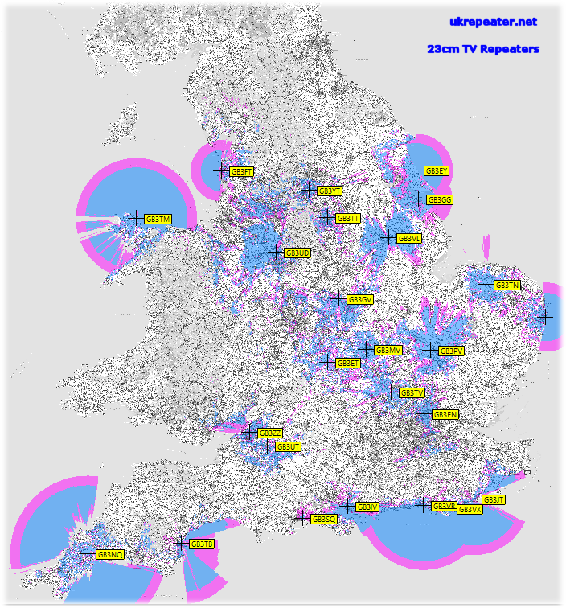

1. Measurements made in Germany
2. The content of this annex is still open for discussion
   1. Methodology and measurement setup

GALILEO E6 was represented by a constellation of ten E6 signals. One signal served as the victim while the other nine were considered as system internal noise, as they are discriminate by the spreading codes within the receiver.

Instead of performing go/no-go tests to a given threshold, the measurements were performed parametrically by applying a wider range of RFI power level while measuring the decrease of the post-correlation C/No of the used GNSS receiver.

The measurement setup is shown in Figure 4. One can see two separate signal paths, one for the GALILEO E6B/C signal and one for the currently tested amateur radio signal out of Groups 1-4. The RFI signals were applied separately, one after the other. Victim and interfering signals from both sides are added at controlled power level and fed into the GNSS receiver.

All receiver input signals are also available to a set of monitoring and measurement equipment (devices 11, 12 and 13). The receiver, like all other active elements in the test set-up, except the RSA (device 11), are interconnected and controlled via LAN. Some test cases include a special Interference Suppression Unit (ISU, device number 24) which is then inserted in front of the GNSS receivers input. Precision step attenuators in both paths enable controlled setting of signal levels. This concept was preferred as it assures reproducible test conditions of the RF power levels. This allowed to compensate the power loss due to the ISU insertion, making sure that the victim receiver is always supplied with the same C/No.

The amateur radio equipment was located in a separate room about 10 m apart from the laboratory hosting the GNSS test set-up. All parts involved in the generation of the amateur radio signals were real life devices (no measurement signal generators involved). All signals were delivered to the main measurements room via high performance coaxial cable to enable unambiguous RF power level conditions at the GNSS receiver input. This separation proofed successfully the rejection of radiation that was measurable in the close vicinity of some transmitters.

Details on each source of amateur signals are provided in [4]. A commercial GNSS simulator generates 10 GALILEO E6B/C-signals and 10 GPS-L1-C/A signals. The GPS L1-signal is used as a time marker. The simulator also adds controlled noise to simulate a defined C/No-condition in the GNSS receiver.

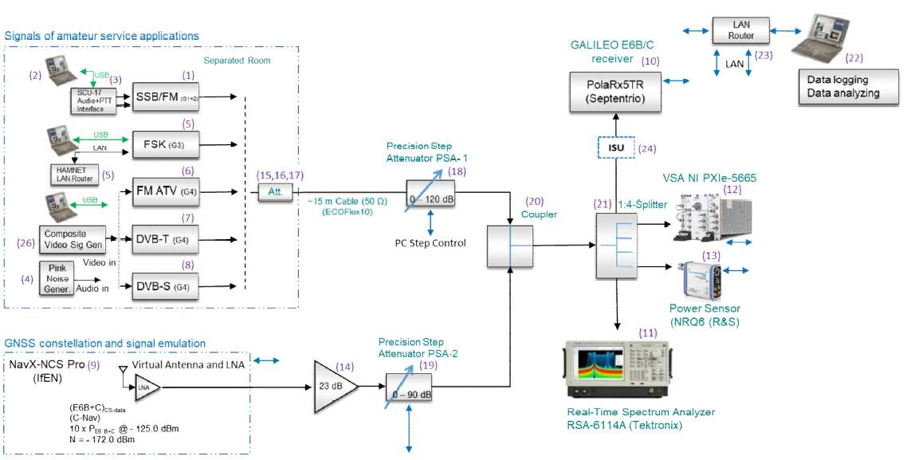

Figure 4: Measurement set-up

The scenario is as follows: the GNSS signal path is levelled in such a way that a C/N0 at the receiver's output of about 45 dBHz is achieved. The power and noise levels within the signal chain are measured. Changes to the levels in the GNSS signal path were only done via the corresponding step attenuator (noise level in that chain is dominated by the GNSS simulator and the line driver amplifier (device number 14) to maintain a constant C/No at the RF domain.

For each amateur signal, the full level at the lowest setting of the step attenuator in the amateur path (device number 18) was measured. Afterwards, the interfering level was set via the step attenuator only. This keeps the relation of the signal and the generated noise and unwanted emissions (spurious resp. out of Band domain) for any power level fed to the victim receiver. Device number 15 to 17 was applied to limit the max. power offered to the precision step attenuator.

The measurement procedure was as follows: the receiver was allowed to settle with the wanted signal active only. Then, a strong level from the unwanted signal was applied to enforce a strong dip in the C/No at the receiver; the interferer was disabled again for a few seconds (allowing the receiver to settle again) and finally the interferer was slowly ramped up in power. During the testing time, the C/No-values were logged, synchronized with the attenuator settings in the interfering signal path.

For any signal group, a test case investigating the worst case conditions was performed, where the amateur radio signal was placed on the E6-centre frequency (as long as long as the device allowed that setting). Furthermore, frequency offsets as low as possible (according to the IARU-bandplan) were introduced.

* 1. Measurement evaluation

Each test case produced files originally created by the receiver's internal measurement feature that were exported to a RINEX file. An evaluation tool transforms the C/No vs. time information of the PSA steps into a representation of C/No vs. the absolute power values at the input of an 0 dBi GNSS-antenna.

The mapping from the receiver input to the input of a 0 dBi antenna is as follows:   
Given the noise level $N_{{BW}_{Noise}}$ in the E6-signal’s system bandwidth $BW_{Noise}$ of 40.92 MHz and an assumed noise figure of the active receive antenna ${(NF_{Ant})}_{dB}$ of 2 dB, the gain of the antenna ${(G_{Ant})}_{dB}$ can be derived from the thermal noise level (-174 dBm/Hz). This gain is also applied to the amateur radio signal level, resulting in the level at the input of a 0 dBi antenna.



The evaluations also include a modelled result curve according to the equation of [10, p. 556], where the interference resistance factor Q has been chosen in such a way to smooth the model’s result close to the measured values.



* 1. Test cases and measurement results
     1. Test case overview

The test cases were chosen in such a way that all available amateur signal groups were used. The carrier frequencies were varied to measure at least (if possible) the interfering signal on the Galileo E6-centre frequency (worst case scenario) and with the least possible frequency separation from the E6-centre frequency, if IARU's band plan for region I is respected (bound to the transmitter's available channel selection options).

The following Table XXX gives an overview of all measurements performed. Within the table, the columns have the following meaning:

Group: indicates the group of emission classes the interfering signal belongs to.

Topic: contains a short description of the test’s settings.

Interfering freq.: centre frequency of the amateur radio signal, in MHz

Offset from E6-centre: the difference between the amateur radio signal’s centre frequency and the E6-centre frequency, in MHz.

Level type (amateur radio): refers to the detector/measurement type used in measuring the RFI at 0 dB attenuation.

Table 1: Measurements Galileo E6 vs. amateur radio - overview of test cases performed

|  |  |  |  |  |
| --- | --- | --- | --- | --- |
| Group | Topic | Interfering freq./MHz | Offset from E6-centre/MHz | Level type (amateur radio) |
| 1 | Morse, IARU band plan | 1296.20 | 17.45 | PEP |
| 1 | Morse, centre frequency | 1278.75 | 0.00 | PEP |
| 1 | SSB voice, IARU band plan | 1296.20 | 17.45 | PEP |
| 1 | SSB voice, centre frequency | 1278.75 | 0.00 | PEP |
| 1 | SSB voice, centre frequency, ISU mitigation | 1278.75 | 0.00 | PEP |
| 2 | FM voice, IARU band plan | 1297.50 | 18.75 | PEP |
| 2 | FM voice, centre frequency | 1278.75 | 0.00 | PEP |
| 2 | FM voice, centre frequency, AIM+ filter | 1278.75 | 0.00 | PEP |
| 2 | FM voice, centre frequecy, ISU mitigation | 1278.75 | 0.00 | PEP |
| 3 | FSK 128 kbps, IARU band plan | 1299.21 | 20.46 | PEP |
| 3 | FSK 128 kbps, centre frequency | 1278.75 | 0.00 | PEP |
| 3 | FSK 128 kbps, centre frequency ISU mitigation | 1278.75 | 0.00 | PEP |
| 4 | FM-ATV, IARU band plan | 1280.00 | 1.25 | PEP |
| 4 | DVB-T 1, IARU band plan | 1288.00 | 9.25 | RMS |
| 4 | DVB-T 1 MHz, centre frequency | 1278.75 | 0.00 | RMS |
| 4 | DVB-T 1 MHz, centre frequency, ISU mitigation | 1278.75 | 0.00 | RMS |
| 4 | DVB-T 4 MHz, IARU frequency | 1286.00 | 7.25 | RMS |
| 4 | DVB-T 4 MHz, centre frequency | 1278.75 | 0.00 | RMS |
| 4 | DVB-S 6 MHz, centre frequency | 1278.75 | 0.00 | RMS |
| 4 | DVB-T 1 MHz, frequency sweep | various | various | RMS |
| 4 | DVB-T 1 MHz, center frequency | 1278.75 | 0.00 | RMS |

* + 1. Measurement results

The following sections detail the result for the individual test case, sorted by the interfering signal. In any section, two plots are given - one that shows the total test result over the whole RFI power tested and a second one that concentrates on the CN0 degradation in a range of -5 … 0 dBHz relative to the 45 dBHz baseline.   
The figures relate the CN0 as reported by the victim receiver to the interfering power supplied by the output of an 0 dBi antenna. . The relationship between the power supplied to the receiver's input port and the equivalent power at the reference antenna is given above.

* + - 1. Morse (Test Cases G1-03, G1-04)

The results for the Morse signal are shown in Figure 25. The C/No plots indicate strong variations. It can be seen that a frequency separation of 17.45 MHz from the centre frequency relaxes the C/No-degradation by approx. 30 dB. Figure 26 shows the changes in C/No relative to a reference of 45 dBHz.  
Table 5 shows that at a C/No degradation of 1dB, an additional e.g. 0.5 dB increases the margin of interference power by 2 dB.

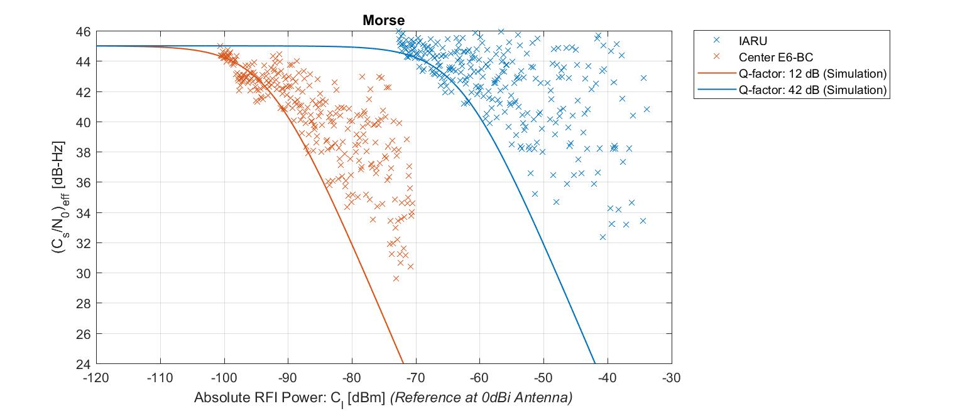

Figure 1: Processed results summary for Morse signal

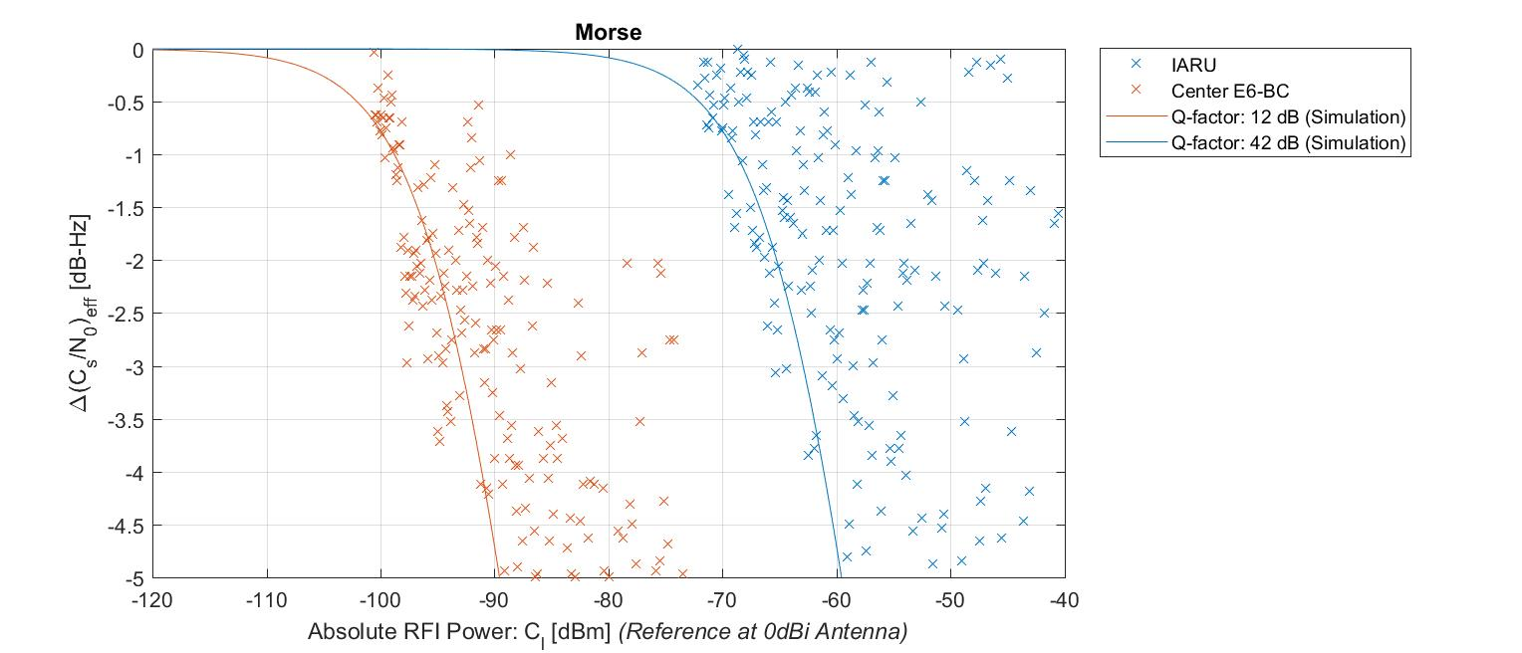

Figure 2: Result summary showing C/N0 changes relative to 45 dBHz for Morse signal

|  |  |  |  |
| --- | --- | --- | --- |
| ΔC/N0 | Morse 1296.20 MHz | Morse 1278.75 MHz | Morse 1278.75 MHz with ISU |
| -1 dB | -68,8 dBm | -98,8 dBm | N/A |
| -1,5 dB | -66,7 dBm | -96,8 dBm | N/A |
| -5 dB | -59,6 dBm | -89,6 dBm | N/A |
| Q-factor | 42 dB | 12 dB | N/A |

Table 2: Key values for Morse signal: maximum signal power at 0 dBi antenna to certain C/N0 degradation allowance

#### SSB voice (Test Cases G1-07, G1-08, G1-13)

The results for the SSB voice signal are shown in Figure 27. Figure 28 shows the changes in C/N0 relative to a reference of 45 dBHz. It can be seen that a frequency separation of 17.45 MHz away from the centre frequency relaxes the C/N0-degradation by almost approx. 40 dB.   
If the ISU is not inserted in the centre frequency scenario, the C/N0 degrades fast.

Table 6 shows that at a C/N0 degradation of 1dB, an additional e.g. 0.5 dB increases the margin of interference power by 2dB.

Furthermore, the significant improvement by the ISU is clearly visible: although the ISU has to mitigate the RFI on Galileo’s E6 centre frequency, it allows even more interference signal power than in the offset frequency case where the ISU is not inserted. Considering that the SSB signal has a certain similarity to the Morse signal (both are narrow band, “pulse-type” emissions; but the amplitude variations in the signal envelope differ) the ISU produces a significant improvement on RFI mitigation.

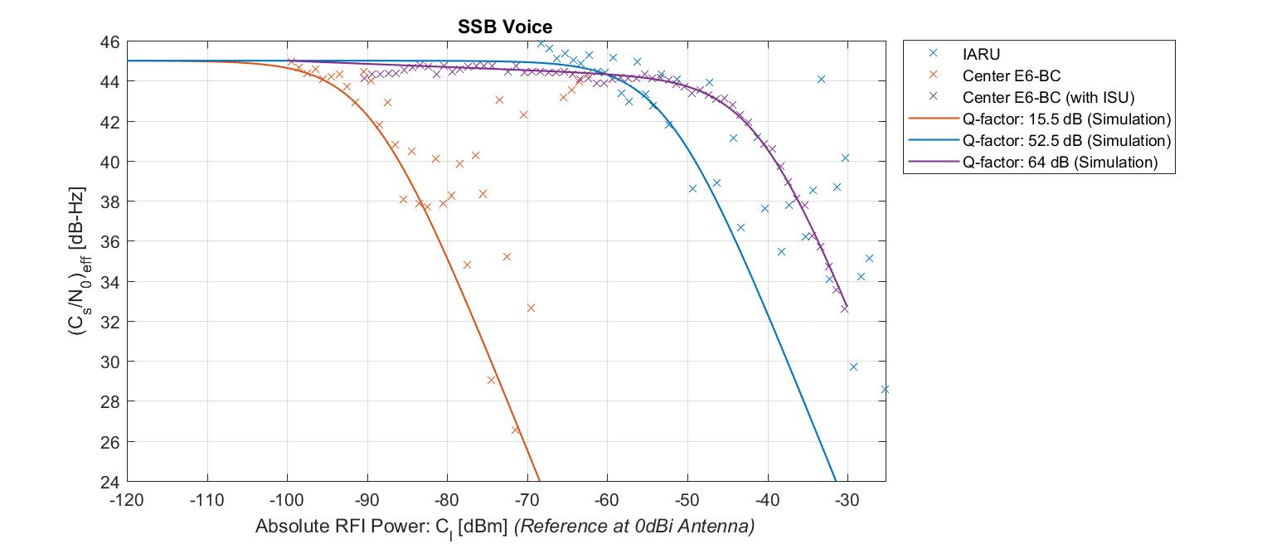

Figure 3: Result summary for SSB voice signal

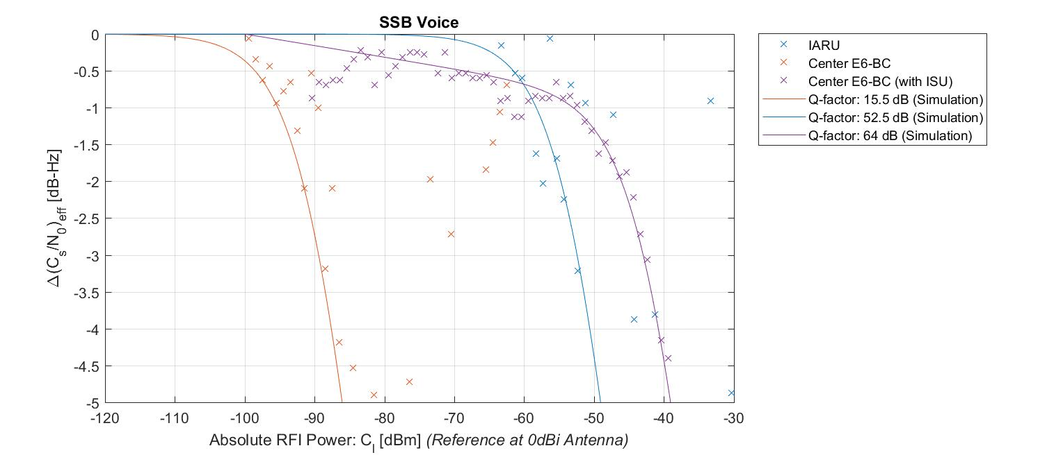

Figure 4: Result summary showing C/N0 changes relative to 45 dBHz for SSB voice signal

|  |  |  |  |
| --- | --- | --- | --- |
| ΔC/N0 | SSB voice 1296.20 MHz | SSB voice 1278.75 MHz | SSB voice 1278.75 MHz with ISU |
| -1 dB | -58,3 dBm | -95,3 dBm | -53 dBm |
| -1,5 dB | -56,3 dBm | -93,3 dBm | -48,6 dBm |
| -5 dB | -49,1 dBm | -86,1 dBm | -39,1 dBm |
| Q-factor | 52,5 dB | 15,5 dB | 64 dB |

Table 3: Key values for SSB voice signal: maximum signal power at 0 dBi antenna to certain C/N0 degradation allowance

* + - 1. FM voice (Test Cases G2-03, G2-04, G2-04 w/WB, G2-05)

The results for the FM voice signal are shown in Figure 29. Figure 30 shows the changes in C/N0 relative to a reference of 45 dBHz. Apparently, a frequency offset of 18.75 MHz from the centre frequency improves the C/N0-degradation by more than 40 dB.

No difference can be seen between the receiver operated with and without the receiver’s built-in AIM+ mitigation.  
The ISU compensates the interfering signal on the centre frequency at least as good as a frequency offset from the centre frequency, i.e. operates on frequencies in accordance with IARU Band plan.

Table 7 shows that at a C/N0 degradation of 1 dB, an additional e.g. 0.5 dB increases the margin of interference power by 2 dB.

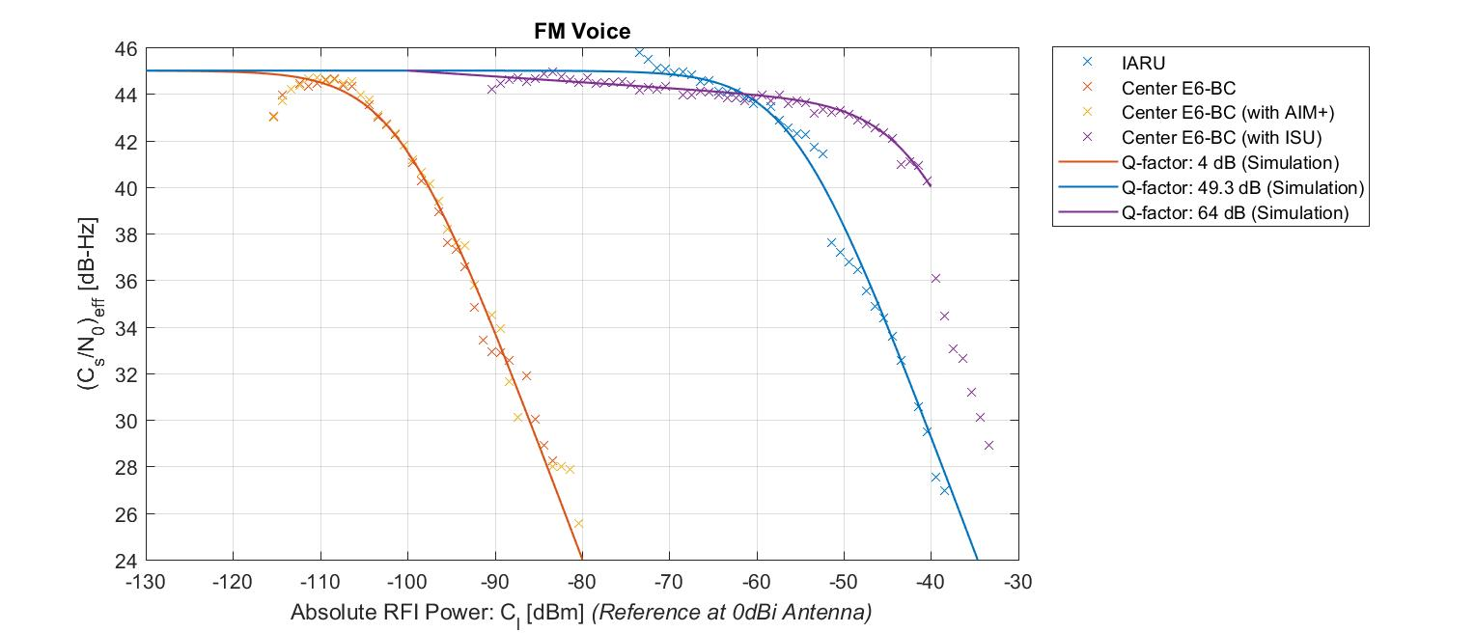

Figure 5: Result summary for FM voice signal

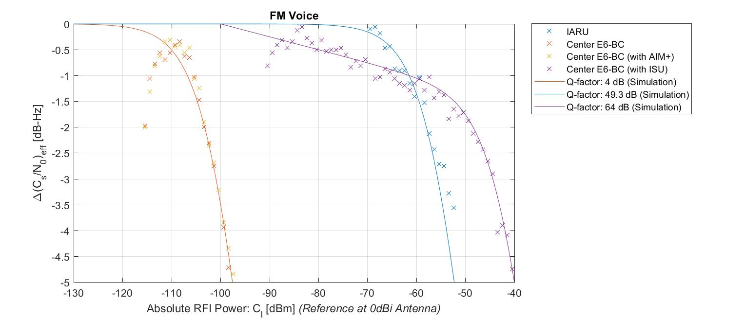

Figure 6: Result summary showing C/N0 changes relative to 45 dBHz for FM voice signal

|  |  |  |  |
| --- | --- | --- | --- |
| ΔC/N0 | FM voice 1297.50 MHz | FM voice 1278.75 MHz | FM voice 1278.75 MHz with ISU |
| -1 dB | -61,5 dBm | -106,8 dBm | -61,5 dBm |
| -1,5 dB | -59,5 dBm | -104,8 dBm | -52,2 dBm |
| -5 dB | -52,2 dBm | -97,6 dBm | -40 dBm |
| Q-factor | 49,3 dB | 4 dB | 64 dB |

Table 4: Key values for FM voice signal: maximum signal power at 0 dBi antenna to certain C/N0 degradation allowance

* + - 1. FSK 128 kbps (Test Cases G3-03, G3-04, G3-06)

The results for the FSK are shown in Figure 31. Figure 30 shows the changes in C/N0 relative to a reference of 45 dBHz. A frequency separation of 20.46 MHz off the centre frequency improves the C/N0-degradation by more than 50 dB. The ISU compensates the interfering signal on the centre frequency almost as good as compared to the signal operated with an offset from the centre frequency.

Table 8 shows that at a C/N0 degradation of 1dB, an additional e.g. 0.5 dB increases the margin of interference power by 2 dB.

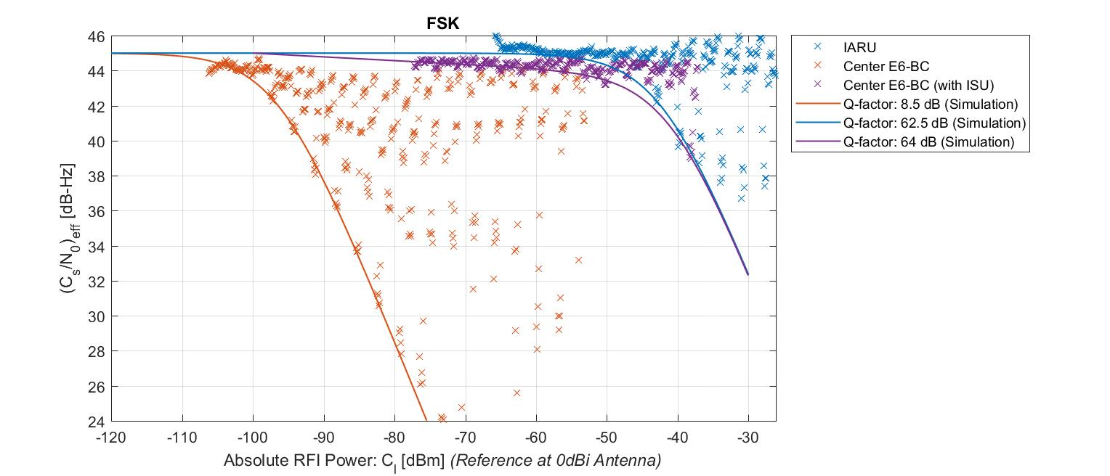

Figure 7: Result summary for FSK signal

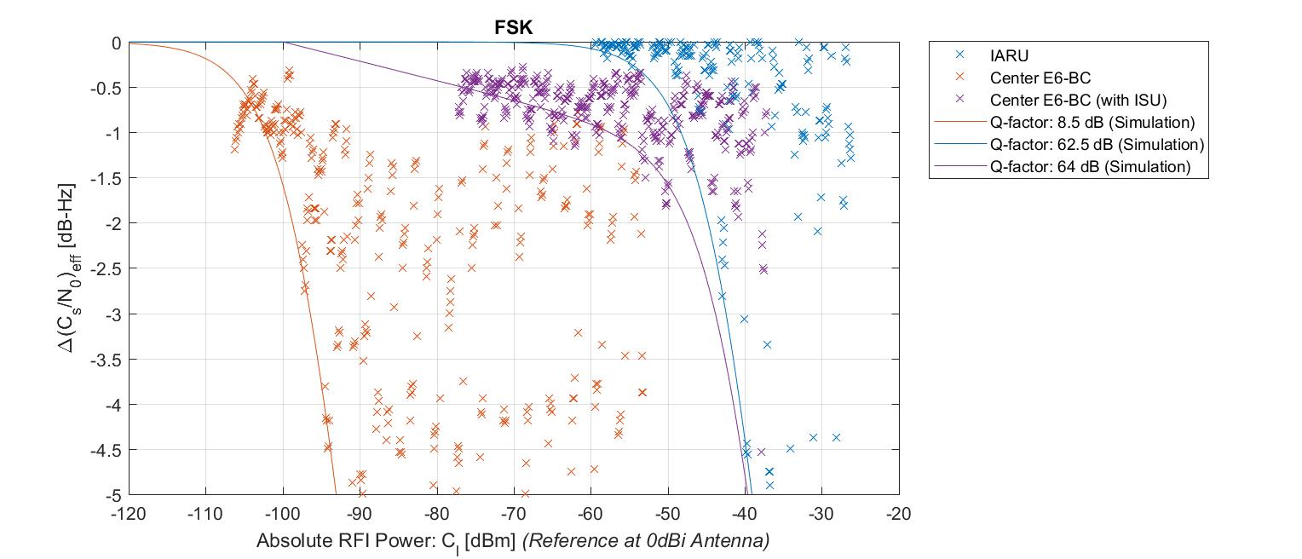

Figure 8: Result summary showing C/N0 changes relative to 45 dBHz for FSK signal

|  |  |  |  |
| --- | --- | --- | --- |
| ΔC/N0 | FSK 1299.21 MHz | FSK 1278.75 MHz | FSK 1278.75 MHz with ISU |
| -1 dB | -48,3 dBm | -102,3 dBm | -57,7 dBm |
| -1,5 dB | -46,3 dBm | -100,3 dBm | -50,7 dBm |
| -5 dB | -39,1 dBm | -93,1 dBm | -39,7 dBm |
| Q-factor | 62,5 dB | 8,5 dB | 64 dB |

Table 5: Key values for FSK signal: maximum signal power at 0 dBi antenna to certain C/N0 degradation allowance

* + - 1. FM-ATV (Test Case G4-01)

The result for the FM-ATV signal is shown in Figure 33. Figure 34 shows the changes in C/N0 relative to a reference of 45 dBHz. The signal was offset by 1.25 MHz from the centre frequency. It can be seen that the modulation’s constant envelope prevents strong fluctuations in the C/N0-indication.

Table 9 shows that at a C/N0 degradation of 1dB, an additional e.g. 0.5 dB increases the margin of interference power by 2dB.

Further tests regarding frequency offsets were not performed: according to the IARU Band plan, this type of signal normally uses that frequency.

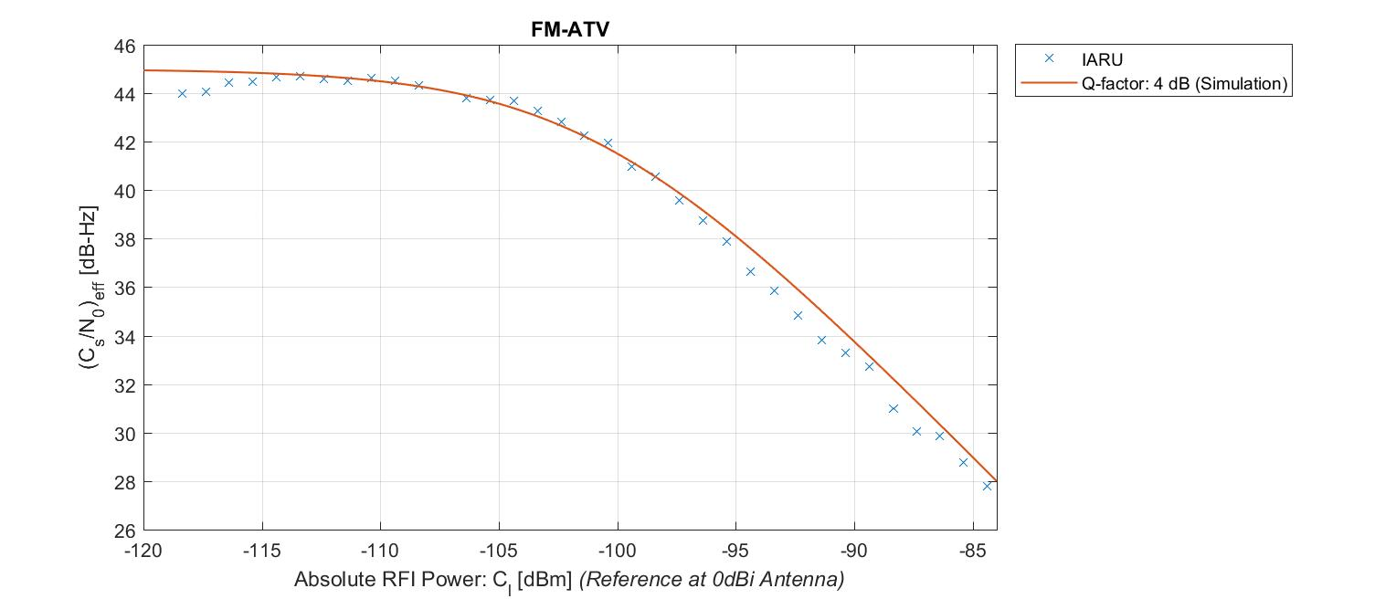

Figure 9: Result summary for FM-ATV

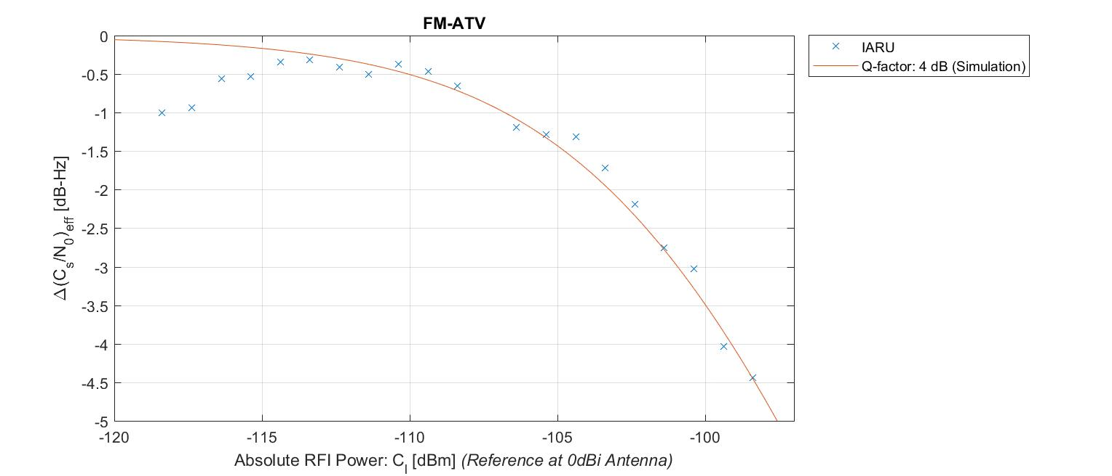

Figure 10: Result summary showing C/N0 changes relative to 45 dBHz for FM-ATV

|  |  |  |  |
| --- | --- | --- | --- |
| ΔC/N0 | FM ATV 1280.00 MHz | FM ATV 1278.75 MHz | FM ATV 1278.75 MHz with ISU |
| -1 dB | -106,8 dBm | N/A | N/A |
| -1,5 dB | -104,8 dBm | N/A | N/A |
| -5 dB | -97,6 dBm | N/A | N/A |
| Q-factor | 4 dB | N/A | N/A |

Table 6: Key values for FM ATV signal: maximum signal power at 0 dBi antenna to certain C/N0 degradation allowance

* + - 1. DVB-T ATV with 1MHz bandwidth (Test Cases G4-05, G4-06, G4-06x)

The result for the DVB-T ATV-signal with a bandwidth of 1 MHz is shown in Figure 35. Figure 36 shows the changes in C/N0 relative to a reference of 45 dBHz. In the offset case, the interfering signal’s centre frequency was shifted 9.25 MHz away from E6 centre frequency. No strong fluctuations can be seen as compared to e.g. the Morse or FSK signal.

The result shows that a frequency offset relaxes the interference situation. Furthermore, the ISU performs differently as compared to the narrow band emissions, albeit for the power levels tested it still prevents the C/N0 to degrade to less than 38 dBHz. This might be due to the following reasons:

The current state of the ISU’s development is to perform best on small band signals.

The ISU removes those parts of the spectrum that have been identified as an unwanted signal. The wider the removed spectrum, the more power of the Galileo spectrum is also removed. Because of this removal, an inherent drop of C/N0 by approx. 2 dB occurs. This can be seen at RFI level of approx. -71 dBm.

The bump in the ISU-curve is due it's detection threshold: as long as the incoming signal is not rated as interference, the ISU does nothing at all.

Table 10 shows that at a C/N0 degradation of 1dB, an additional e.g. 0.5 dB increases the margin of interference power by 2 dB.

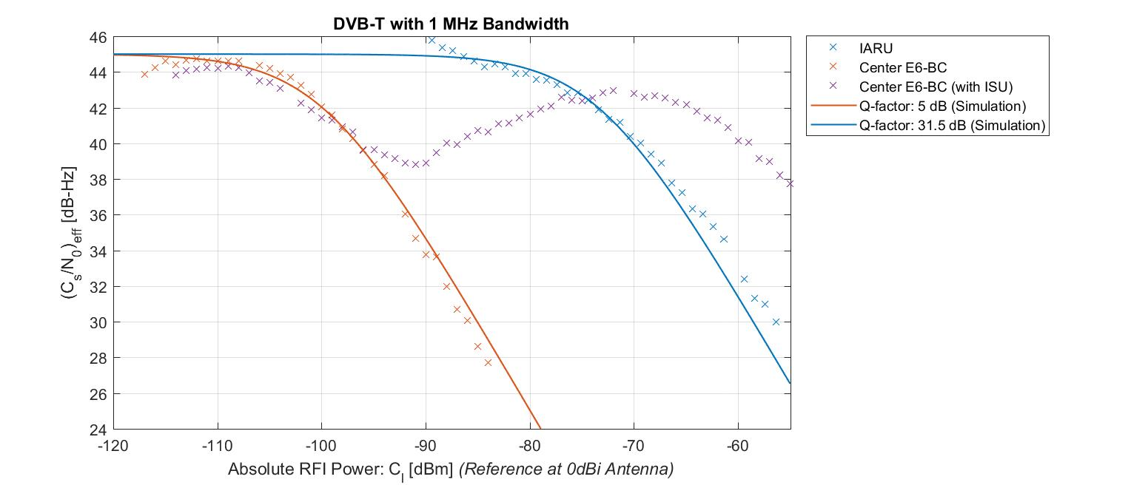

Figure 11: Result summary for DVB-T ATV, 1 MHz bandwidth

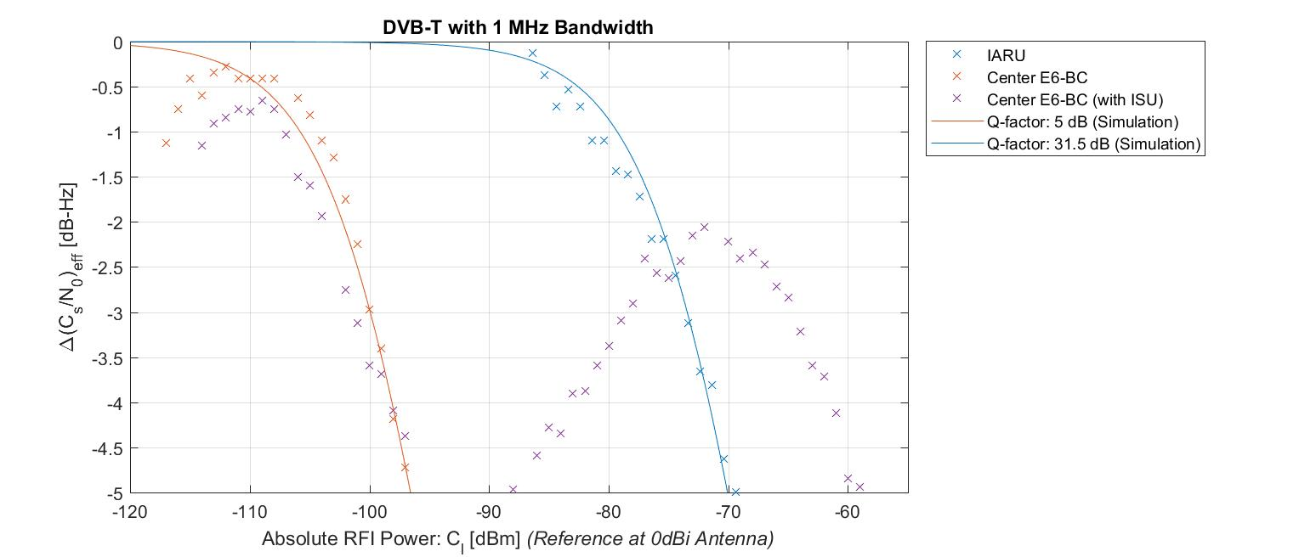

Figure 12: Result summary showing C/N0 changes relative to 45 dBHz for DVB-T ATV, 1 MHz bandwidth

|  |  |  |  |
| --- | --- | --- | --- |
| ΔC/N0 | DVB-T ATV 1 MHz  1280.00 MHz | DVB-T ATV 1 MHz 1278.75 MHz | DVB-T ATV, 1 MHz, 1278.75 MHz with ISU |
| -1 dB | -79,3 dBm | -105,8 dBm | - |
| -1,5 dB | -77,3 dBm | -103,8 dBm | - |
| -5 dB | -70,1 dBm | -96,6 dBm | - |
| Q-factor | -31,5 dB | 5 dB | - |

Table 7: Key values for DVB-T ATV signal (1 MHz bandwidth): maximum signal power at 0 dBi antenna to certain C/N0 degradation allowance

* + - 1. DVB-T ATV with 1MHz bandwidth, variable centre frequency offsets (Test Case G4-18)

In addition, further tests were performed to study the influence of various carrier frequencies for the DVB-T signal. For that, the DVB-T signal level was kept constant, while the frequency was shifted through a portion of GALILEO’s signal spectrum. The result is shown in Figure 37 with absolute C/N0 values on the left Figure and C/N0-values relative to the value at Δf=15 MHz in the right Figure).

The figure can be read as follows: the GALILEO signal is the more affected the closer the interferer is to its centre frequency. This complies largely with results reported in the previous sections. The spectral zero at the offset ‑5 MHz is not as vulnerable as the centre frequency, but more sensitive than the zero at ‑15 MHz.

The test was not extended to the positive frequency offset range, since the spectra of the E6B/C signals involved are symmetric around their centre frequency. This general finding is considered sufficient for an initial estimation of the RF compatibility situation.



Figure 13: Influence of different centre frequencies of the DVB-T signal. Left hand side: absolute C/N0 values; right hand side: C/N0-values relative to the values at the frequency offset of ‑15 MHz

* + - 1. DVB-T ATV with 4 MHz bandwidth (Test Cases G4-09, G4-10);  
         DVB-S ATV with 6 MHz bandwidth (Test Case G4-14)

The results for the DVB-T ATV-signal with a bandwidth of 4 MHz and the DVB-S signal (bandwidth: 6 MHz) are shown in Figure 38. Figure 39 shows the changes in C/N0 relative to a reference of 45 dBHz. In the offset case (DVB-T only), the RFI carrier frequency was shifted 7.25 MHz away from E6 centre frequency. No strong fluctuations can be seen as compared to e.g. the Morse or FSK signal. When comparing this Figure to the 1 MHz DVB-T case, one has to remember that the offset in this case is smaller (interferer is closer to the centre frequency) and the signal is wider (interferer’s power is spread wider across the spectrum, reaching even further to the centre frequency). Apart from that, the DVB-S signal has a constant envelope, in contrast to the DVB-T OFDM signal.

The result shows that a frequency offset relaxes the interference situation, but far less than in the 1 MHz bandwidth case.

Table 11 shows that at a C/N0 degradation of 1dB, an additional e.g. 0.5 dB increases the margin of interference power by 2dB.

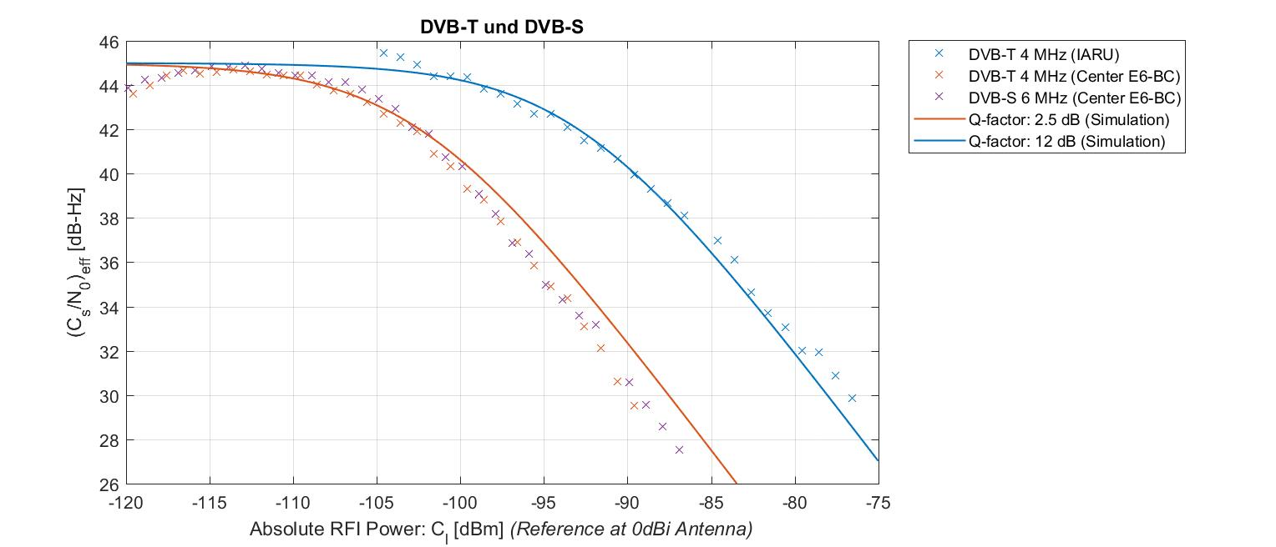

Figure 14: Result summary for DVB-T ATV, 4 MHz bandwidth and DVB-S ATV, 6 MHz bandwidth

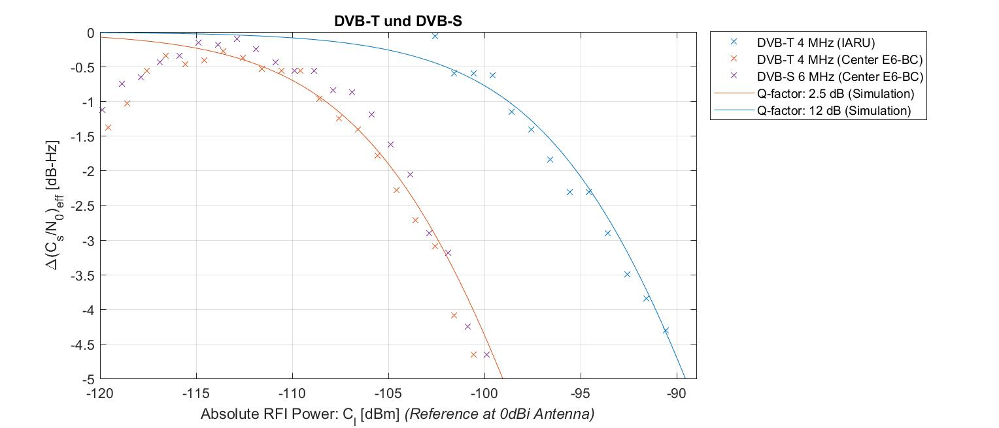

Figure 15: Result summary showing C/N0 changes relative to 45 dBHz for DVB-T ATV, 4 MHz bandwidth and DVB-S ATV, 6 MHz bandwidth

|  |  |  |  |
| --- | --- | --- | --- |
| ΔC/N0 | DVB-T ATV 4 MHz  1286.00 MHz | DVB-T ATV 4 MHz, and DVB-S 6 MHz 1278.75 MHz | DVB-T ATV, 4 MHz,and DVB-S 6 MHz 1278.75 MHz with ISU |
| -1 dB | -98,8 dBm | -108,3 dBm | N/A |
| -1,5 dB | -96,8 dBm | -106,3 dBm | N/A |
| -5 dB | -89,6 dBm | -99,1 dBm | N/A |
| Q-factor | 12 dB | 2,5 dB | N/A |

Table 8: Key values for DVB-T ATV signal (4 MHz Bandwidth) and DVB-S (6 MHz Bandwidth): maximum signal power at 0 dBi antenna to certain C/N0 degradation allowance

* + - 1. Test for independence of initial C/N0 (Group G4-20)

To study if the initial set C/N0-ratio has an influence on the measurement result, the following test was performed: the level of the simulated GALILEO signals was set in such a way that every two satellite signals had the same power. The noise power level remained unchanged with respect to the previous measurements.  
Then, the DVB-T signal with 1 MHz bandwidth was applied as RFI on the E6 centre frequency. The test sequence started again (setting a trigger point, returning to the initial signal power level and gradually increasing the RFI power). The result is shown in Figure 40 below.

It can be seen that all lines run in parallel to each other. This means that the absolute value of the initial C/N0 has no influence on C/N0 degradation as long as that C/N0 is far above the receiver's sensitivity to capture the wanted signal.

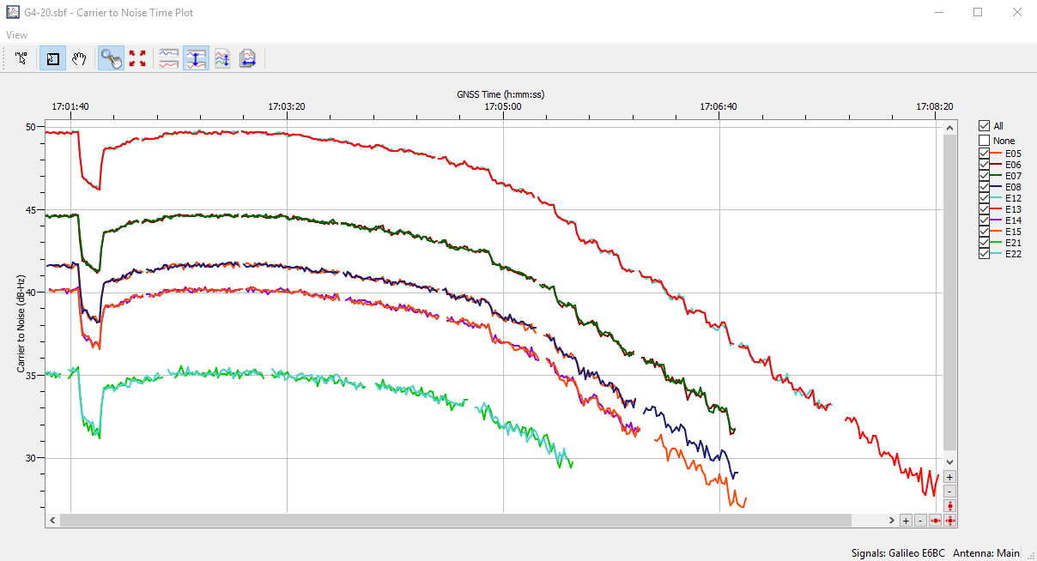

Figure 16: C/N0 vs. time with different GALILEO signal power levels, interfered by a DVB-T signal (1 MHz bandwidth, E6 centre frequency)

* + 1. Summary

Measurements were performed to study the effects on the post-correlation C/N0 when different amateur radio signals arrive at a 0 dBi antenna of a GALILEO E6B/C DS SS CDMA receiver. Many different signal types and frequency combinations were investigated to cover not only worst case, but also typical situations.

The tests performed considered all signals that are usually emitted in the amateur service on frequencies in accordance with the IARU band plan as well as on the E6 centre frequency.

The findings can be summarised as follows:

* The worst case occurs when an interfering signal is applied on the E6 centre frequency
* Vice versa: frequency separation from centre frequency yields significantly higher tolerable levels for the interfering signal (e.g. when using frequencies i.a.w. the IARU Band plan)
* A non-constant envelope of the interfering signal leads to high scattering of the receivers observed C/N0.
* Although DVB-T OFDM-signals also employ a non-constant envelope, they are fast enough to avoid such fluctuations and have apparently less dynamic amplitude changes than, for example, an on/off-keyed narrow band signal such as used in Morse telegraphy
* The used Interference Suppression Unit (ISU) can significantly reduce the impact of interfering signals, particularly for narrowband signals (B < 150 kHz).
* Even if the ISU’s performance was not tested against the Morse signal, one can expect a similar behaviour as seen in the e.g. SSB signal case.
* Against the wider amateur TV signals, the used ISU did not lead to a strong receiver immunity.
* The wider the signal to be supressed (i.e. filtered), the more energy is taken from the E6 signal. This reduction of the RF signal's CN0 leads to a worse CN0 at the receiver's output.
* It is to be noted that the used receiver’s input filter is smaller than specified in [1] (30 MHz instead of 40.92 MHz). Nonetheless, the RF level measurements respect the full channel bandwidth.
  1. GALILEO E6B probability of bit error conditions under varying C/No
     1. Relation between Eb/No and C/No

In the Galileo system, the following relation holds between the carrier to noise and energy per bit to noise ratios:

$${\left(\frac{C}{N_{0}}\right)}_{|dB}= {\left(\frac{E_{b}}{N_{0}}\right)}_{|dB}+10lg⁡(R_{d}∙r∙D)$$

where the symbol transmission rate is given by $R_{d}$, the channel code rate $r$ and the power distribution between the data and pilot channel D.

The E6B signal has a gross bit rate of 1000 symbols per second with one symbol representing one bit. The error correction scheme is three-fold: a cyclic redundancy check (CRC), a half-rate convolutional forward error correction (FEC) and block interleaving. The net bit rate is approx. 500 bps. The power distribution in the RF channel is equal between the pilot and data channel. This leads to:

* + 1. BER for E6B-C

In an AWGN channel with an assumed coherent receiver (perfect tracking performance in terms of time and frequency), the BER is given by

$$P_{b}=\frac{1}{2}\operatorname{erfc}{(\frac{E_{b}}{N_{0}})}$$

Using Matlab's® BER-Tool, the following figures can be derived for the uncoded and coded (hard- and soft decision decoder) case. The simulations are verified by measurements on two receivers [16].

In the following, a hard decision decoder is assumed.

Figure 17: BER for Galileo E6-B/C with no channel coding and convolutional decoding with hard and soft decision in AWGN channel, no implementation losses assumed

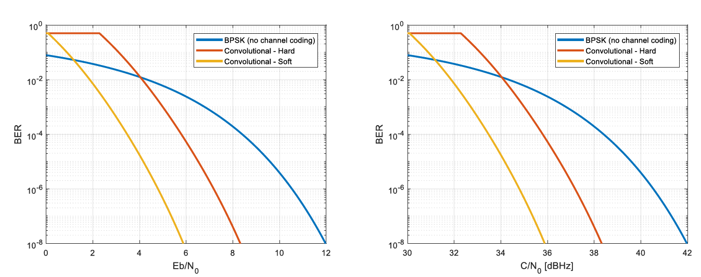

* + 1. Relation between minimum power level of Galileo E6-B/C and C/N0

[1] states that the Galileo satellites provide the minimum signal level of -125 dBm for user elevation angles above 5 degrees (nadir) at the output of an ideally matched (RHCP) 0 dBi antenna.

The gain pattern of an antenna is a function of azimuth and elevation. For GNSS receive antennas, the azimuth pattern is typically uniform and can be neglected.

The gain pattern for the elevation is dependent on the model. In the following, two different elevation patterns of (geodetic) antennas are sketched.

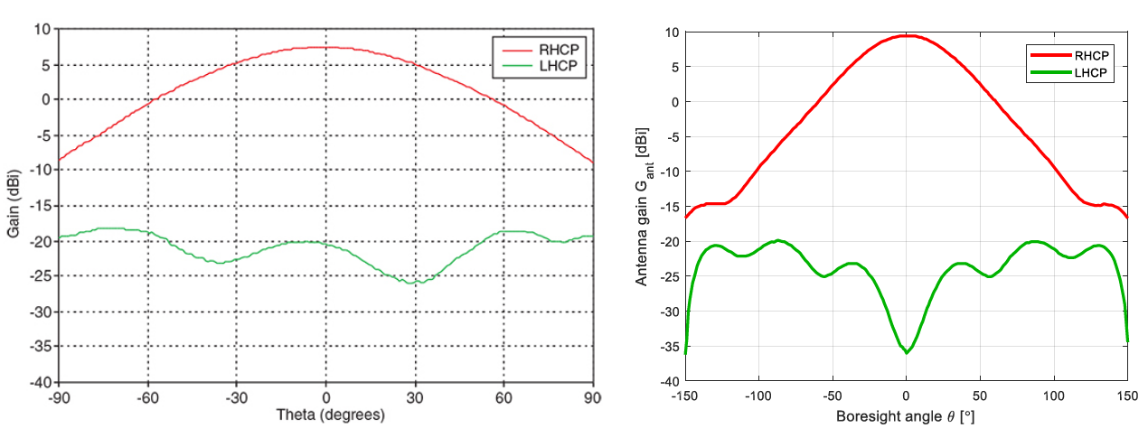

Figure 18: Example of elevation gain patterns of two different geodetic antennas [17], [18]

Patterns related to more consumer-oriented products -- focussed on the performance of GPS on L1 -- can be taken from [19]. For the two antennas shown, one can see that the 0 dBi-line is reached at a boresight angle of approx. 60°. At 5° above nadir, both antennas are at about -8 dBi.

The noise figure of GNSS receivers is typically dominated by the noise of the active antennas. A typical value of the antenna noise figure F is 2 dB [20].

In total, the expectable Carrier-to-Noise level for a satellite 5° above nadir is given by:

* 1. Quantification of interference and options for RFI mitigation
     1. Analysis of protection criteria
     2. Protection criteria determined by CN0 degradation down to a certain BER

The difference between the reception at the minimum signal level and a target BER is the degradation allowance due to any kind of RFI or signal propagation related phenomena.  
If one assumes the minimum CN0 of 39 dBHz as stated in section 7.4.3 and allows a minimum BER of 1e-2 (coupled to an CN0 of 34 dBHz, c.f. section 7.4.2), then a margin of 5 dB is allowed.

* + 1. RFI mitigation on GALILEO E6-B receiver

1. There is no agreement on whether the following text or parts of it could be moved to the main body of the report.

Galileo E6 receivers typically employ a pulse-blanking mechanism to handle the pulses from aeronautical large-area radar installations. Those blankers typically feature a level triggered disable circuit to interrupt the potential high level pulses into the receiver's sensitive circuits. The resulting loss of signal is in the time span of nanoseconds, which neither causes the loss of a bit (gross data rate of 1000 bps) nor the loss of the receiver's synchronization.

On the other hand, amateur radio signals -- even if keyed -- are in the range of at least milliseconds. Employing receivers with circuits to supress amateur radio emissions seems to be an attractive option if one considers that modern receivers sometimes are equipped with jammer mitigation capabilities. Along with certain sensing strategies, those jammers work by adaptive filtering in time or frequency domain of suspect signals. Even more advanced schemes for high grade receive systems incorporate steered antennas to mitigate interference signals.

With those considerations in mind, the recommendation of mitigation circuits seems a viable option, for not only the robustness against amateur radio signals is enhanced.

1. Regions 2 and 3 comprise the same areas as Regions defined by the ITU; IARU coordinates the band plan for the frequency band [1 240- 1 300 MHz](https://www.iaru-r1.org/index.php/spectrum-and-band-plans/uhf/23-centimeter)
2. Annex 3 contains further detail about these data
3.
4. This corrsponds to 16 stations
5. This corresponds to 8 stations
6. A comprehensive discussion of fast and slow fading can be found, for instance, in Parsons, *The Mobile Radio Propagation Channel*, 2nd Edition, Wiley.
7. The minimum received power on the surface of the Earth is measured at the output of an isotropic 0 dBic receiver antenna for any elevation angle equal or above 5°
8. Authorizations in this frequency range are only granted on an individual basis after evaluation by OFCOM (CH).