SE40 |  | Doc. SE40 (21) 013
SE40 (meeting #72)
Web meeting
Date issued: | 15.03.2021
Source: | France
Subject: | Amateur vs RNSS, interference areas
Group membership required to read? (Y/N)
N
Summary:
This document presents studies about the extension of interference areas around radioamateur stations.

Proposal:
To consider this study for insertion on the draft report on WI 39.
Background:
SE40 is tasked with developing possible scenarios with conditions or limitations that may be applied to the amateur service to ensure the future coexistence of both services and avoid cases of interference considering the allocations in the frequency band 1240 - 1300 MHz to the radionavigation-satellite service (RNSS) with a primary status and to the amateur service and a portion to the amateur-satellite service, both with secondary status as well as to other services.

- Introduction
The aim of the study is to provide an assessment of the geographical extension of the interference cause by stations of the radio amateur service into Galileo E6 Receivers.
The methodology consists considering several types of radio amateur stations and calculating the area around them where the protection criterion of the Galileo E6 receiver would not be met.

- Parameters of the radio amateur stations
The parameters of the radio amateur stations are given in document 4C/119-E.

- Propagation models
The propagation loss has been calculated using Recommendation ITU-R P.1546. The setting of the model are: type of terrain: land, area type: rural. The height of the RNSS RX above ground is 1.5 m. Two values have been used for the clutter height: 10 m and 0 m (open land).
It has to be noted that with a clutter height of 10 m and a receiver at 1.5 m above ground the direction of arrival of the main propagation path is usually, via a diffraction for the clutter top. This means the elevation of arrival of the main propagation path could usually be above 5°. If this the case, the assumption of using – 6 dB as the gain for the RNSS receiver could be too optimistic, therefore for a clutter height of 10 m, the antenna gain of the RNSS receiver has been set equal to 3 dBi. On the other side, when the clutter height is set to 0 m, the RNSS receiver height is set to -6dB.
The polarization loss considered in this study is 3 dB.

  - Time variability effect
Due to the variation in the atmospheric conditions and propagation conditions, such as ducting, the interfering signal can show time variability. These phenomena are taken into account by ITU-R. P. 1546. However, these time effects are mostly relevant over long distances, while at short distances they tend to be negligible.

  - Location variability effects
The other aspect to be considered is the spatial variability of the electromagnetic field. By the way it is conceived, a propagation usually gives the estimated median value of the received power in a given pixel of terrain. This is the case, for instance, of the curves given by ITU-R P.1546.
Inside this pixel of terrain, you can still have slow fading and fast fading. The effect of local statistical variations f the EM field also needs to be taken into account.
In order to appreciate this fact, consider a pixel of terrain 50x50 m wide. Assume that the maximum tolerable interfering power for the RNSS receiver is $P_{int}^{MAX}$. In order to declare that the pixel is free from interference it is not sufficient to verify that the interfering received power from the radio amateur station, calculated with the chose propagation model, is equal or below $P_{int}^{MAX}$. For instance, when its value is exactly equal to $P_{int}^{MAX}$ this means that 50% of the locations inside the pixel will be still be above this value. For this reason, the analysis of interference shall be conducted in such a way that, for a given pixel to be declared interference free, the interfering EM field shall below the reference threshold for, say, X=99% of its locations.
It is therefore necessary to have statistical model of the spatial variability of the EM field for a given pixel. In general, such a variation is composed of a slow variation (shadow fading) and fast variation (fast fading), that it due to multipath effects.
A characterization of the spatial variability of the field strength in various frequency band and for different propagation scenarios (the clutter at the location of the RX plays a fundamental role), is described in section 12, Annex 5 of ITU-R P.1546-6.
ITU-R P.1546 gives curves of basic propagation loss for different location probability. The curve of propagation loss given for 50% of probability means that, for that given pixel, 50% of the locations will actually have a propagation loss lower than the value given by the model and 50% a propagation loss higher than that. If, on the other side on considers the curves referring to a location probability equal to 1%, this means that for a given pixel and a corresponding propagation loss, for 99% of the locations inside that pixel the propagation loss will be actually higher (and, therefore, interference lower).
In other words, if one calculate the contour of the interfered area with the model set at 50% location probability, the contour will be the locus where , for a pixel of terrain, say, 50x50 m wide, half of the surface will be interfered and half interference-free. Inside the contour, of course, the interference probability will be higher, and outside lower. On the other side, if one traces the contour with the model set at 1% location probability, the contour will be the locus where, for a pixel 5àx50 wide, 99% of the locations inside that pixel will be interference free. Outside the contour the interference probability will be progressively higher, outside, progressively lower.
In this study both contours at 50% and 1% location probability are provided.
- Protection requirements of Galileo
The protection requirements of Galileo, together with parameters of the RNSS receiver, are specified in Recommendation ITU-R M.1902. This recommendation is being reviewed by WP 4C, inter alia, with respect to the Galileo protection requirements. However, it was agreed by WP 4C that the values provided in the PDNR can already be used in the studies.
The protection requirements are the following:
For a narrow band interfering signal (Bw< 1 kHz) interfering the Galileo received in tracking mode: -134.5 dBW at the output of the RX antenna
For a wideband interfering signal (Bw> 1 MHz) interfering the Galileo received in tracking mode: -140 dBW at the output of the RX antenna
The characteristics of the Galileo receiver are copied in the table below.
Table 1. Galileo RX parameters
Parameter | Value | Notes
Polarization | Circular
Antenna gain upper hemisphere | 3 dB
Antenna gain lower hemisphere | -6 dB | To be used for elevations up to 5°

For the study, the value of -140 dBW has been used, corresponding to the wideband interferer. For the choice of the RNSS receiver antenna gain, see the section about the propagation model.

- Parameters of the radio amateur stations
Parameters for the radio amateur station vary significantly, both in terms of transmission power and type of signal.
Based on the information contained in document 4C/119-E the following ‘typical stations’ have been considered.

  - Home stations
Two set of parameters for the home stations have been considered (the power varying for each of the two types). They are given in the tables below.
Table 2. Parameters for station: Home station 1
Parameters | Value
Antenna | Single Yagi, 18 dBi gain, 18° 3 dB aperture
TX power | 1 W, 10 W, 25 W, 100 W, 300 W
Antenna height above ground | 10 meters
Polarization | Vertical

The following figures give the graphical representation of the antenna diagram of the Single Yagi antenna with 18 dBi gain and 18°dB 3dB-beamwidth obtained using ITU-R F. 1336.

Figure 1. Antenna diagrams (F. 1336), Yagi antenna 18 dBi, 18° dB half beamdwidth (home station n. 1)

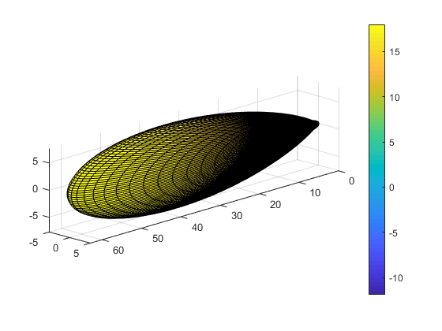
Figure 2. 3D representation of the antenna diagram. Colorbar units is dBi.

Table 3. Parameters for station: Home station 2
Parameters | Value
Antenna | Dish (4m), 32 dBi gain, 4° 3 dB aperture
TX power | 10 W
Antenna height above ground | 10 meters
Polarization | Vertical

Figure 3. Antenna diagram, home station type 2
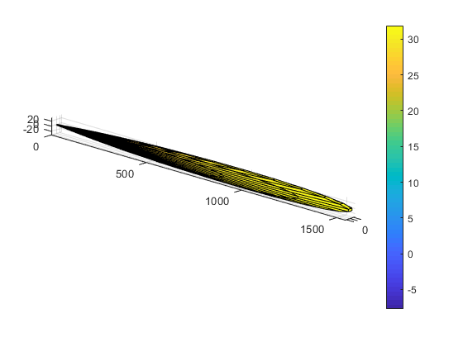
Figure 4. 3D representation of the antenna diagram. Colorbar units is dBi.

  - Permanent installation
This class of station is constituted by stations not installed at the home location of the radio amateur, used as relay and beacons. For this station it is considered only one type of station, whose parameters are given below.

Table 4. Permanent installation parameters
Parameters | Value
Antenna | 13 dBi gain, 60° 3dB beamwidth
TX power | 1 W, 10 W, 25, 100, 300
Antenna height above ground | 10 meters
Polarization | Vertical

Figure 5. Antenna diagram, permanent installation

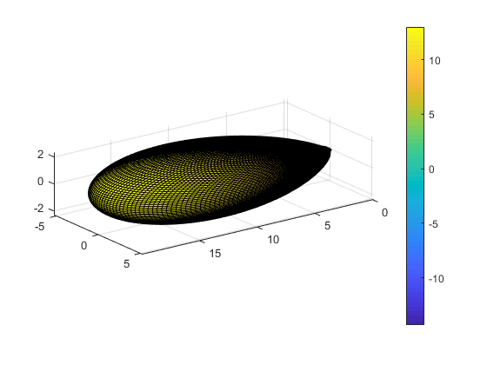
Figure 6. 3D representation of the antenna diagram. Colorbar units is dBi.

  - Type of service and frequency overlap with the RNSS
As indicated above, ITU-R M.1902 prescribes two protection criteria, differing depending on whether the interfering signal is narrowband or wide band. In ITU-R M.1902, however, the protection criterion for system 6 (corresponding to Galileo E6) does not depend, also in the case of a narrowband interferer, on where the interfering signal inside the useful band of the Galileo signal. Also, the protection criteria in the Recommendation are independent of the modulation and other emission parameters such as duty cycle.
As a result of this assumption, the in-band interference analysis conducted using ITU-R M.1902 leads to two type cases only: narrowband interfering signal and wideband interfering signal.

- Results of simulations

  - Home station-1
The following set of figures represents the interfering received power for a home station type 1 whose parameters are contained in Table 1, for different Tx powers and for different location probabilities (50% and 1%). It has to be noted that ITU-R P.1546 is not defined for distances less than 1 Km, and this is reflected in the circular area around the transmitter, with radius 1 km (in dark blue in the figures), where the Loss is not calculated.
Figure 7. Home station 1, rural environment, Tx power 300 W, location probability 50%, clutter height 0 m (RNSS RX gain – 6 dBi)

Figure 8. Home station 1, rural environment, Tx power 300 W, location probability 1%, clutter height 0 m (RNSS RX gain – 6 dBi)

Figure 9. Home station 1, rural environment, Tx power 1 W, location probability 50%, clutter height 0 m (RNSS RX gain – 6 dBi)

Figure 10. Home station 1, rural environment, Tx power 1 W, location probability 1%, clutter height 0 m (RNSS RX antenna gain -6dB)

Figure 11. Home station 1, rural environment, Tx power 1 W, location probability 50%, clutter height 10 m (RNSS RX antenna gain 3dB)

Figure 12. Home station 1, rural environment, Tx power 1 W, location probability 1%, clutter height 10 m (RNSS RX antenna gain 3dB)

  - Home station-2
The following figures refer to the home station, type 2.

Figure 13. Home station type 2, rural, location probability 50%, clutter height 0 m, RNSS RX grain – 6dBi
Figure 14. Figure 11. Home station type 2, rural, location probability 1%, clutter height
0 m, RNSS RX grain -6 dBi

Figure 15. Home station type 2, rural, location probability 50%, clutter height 10 m, RNSS RX grain 3 dBi
Figure 16. Home station type 2, rural, location probability 1%, clutter height 10 m, RNSS RX grain 3 dBi

  - Permanent installation

Figure 17. Permanent installation, broadband interferer, Tx power 1 W, location probability 50%, clutter height 0 m, RNSS RX gain – 6dBi
Figure 18. Permanent installation, broadband interferer, Tx power 1 W, location probability 1%, clutter height 0 m, RNSS RX gain -6 dBi

Figure 19. Permanent installation, broadband interferer, Tx power 1 W, location probability 50%, clutter height 10 m, RNSS RX gain 3dBi
Figure 20. Permanent installation, broadband interferer, Tx power 1 W, location probability 1%, clutter height 0 m, RNSS RX gain 3 dBi

- Conclusions
The simulations indicate interference areas around radio amateur stations with an extent of several km, depending on the case.
Further analysis could consider frequency dependent protection criteria and specific applications where very directive antennas are pointed in direction that reduce the interference, such as moon-bounce communications.

