|  |  |  |  |
| --- | --- | --- | --- |
| WG FM | | Doc. FM(20)056 - Annex 11  (Doc. FM(19)150 (18 Sept. 2019)  FM56(19)026) | |
| FM56 #10 | |  | |
| Lille (France), 4-5 September 2019 | | |  |
|  | |  | |
| Date issued: | 5 September 2019 | | |
| Source: | Chairman | | |
| Subject: | Synthesis of the questionnaire | | |
| Group membership required to read? (Y/N)  N | | | |
|  | | | |

CEPT is currently working on a Commission Mandate with the objective to “identify appropriate spectrum bands, study technical feasibility and develop harmonised technical conditions for a sustainable and efficient use of such bands for the operation of the future railway mobile communications system (FRMCS), which is the successor of GSM-R”.

In this work, CEPT issued a questionnaire on the 2290-2400 MHz range, which has been identified as a potential complementary band for RMR.

The purpose of this document is to provide an analysis of the answers received.

**Respondents**

There are 48 CEPT countries. 6 of them have no rail network: Andorra, Iceland, Malta, San Marino, Vatican and Cyprus. It has also to be noted that Monaco has a 1.7km rail line operated by SNCF (French infrastructure manager) and that Liechtenstein has a 9.5km rail line operated by ÖBB (Austrian infrastructure manager).

The figure below summarises the number of respondents.

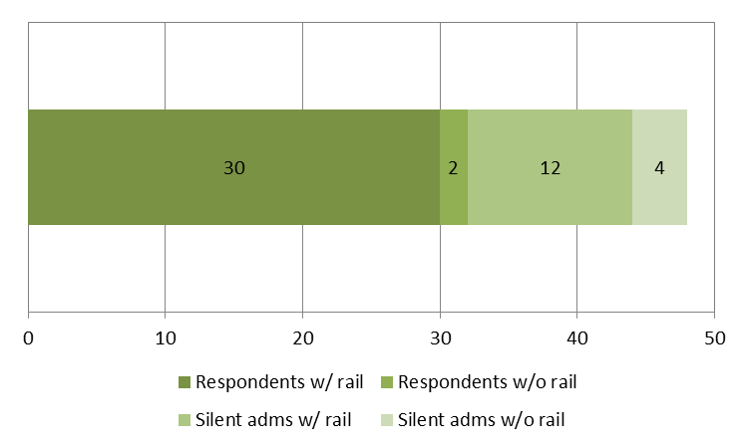

32 CEPT administrations (i.e. 66.7%) answered the questionnaire; 2 of them have no rail network. Among administrations having a rail network, 71.4% (i.e. 30) answered. In the following sections, only those 30 administrations are considered.

**Question 1: What part (if any) of the frequency range 2290-2400 MHz do you consider as feasible in your country to make available approximately 10 MHz bandwidth for RMR usage along rail tracks (typically hotspots scenario)?**

The figure below has been derived from the answers.

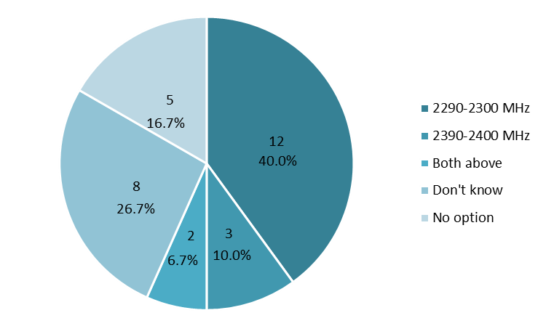

14 administrations stated that the frequency band 2290-2300 MHz is expected to be feasible. Sweden, Croatia and Portugal mentioned 2390-2400 MHz as another possibility, which could also be an option for 2 other countries[1]. 8 administrations replied that they didn’t know whether the introduction of RMR would be feasible (this includes Austria who didn’t provide any information with respect to 2290-2300 MHz however they proposed 2352-2362 MHz for RMR), noting 5 administrations are planning the introduction of MFCN in the frequency range considered. 5 other administrations replied that they didn’t see any possibility to introduce RMR.

**Question 2: What are the existing applications currently using the 2290-2400 MHz range?**

Here is a list of the main applications listed by the respondents:

* Defence/Governmental, including telemetry, aeronautical systems, PMR;
* Video PMSE;
* Fixed links;
* MFCN;
* Deep space research, only in Germany (two stations with which coordination is expected to be feasible) and Russia;
* Radioastronomy, only in UK, Sweden and Russia;
* Amateur, on a secondary basis.

When taking into account both existing and planned MFCN in the 2300-2400 MHz frequency band, the total number of administrations with MFCN goes up to 17 countries, i.e. 56.7%. In these countries, the question of synchronisation between RMR and MFCN TDD networks would need to be addressed.

**Question 3: What are your future plans for the range 2290-2400 MHz considering a time frame of 2025 and beyond?**

The figure below has been derived from the answers.

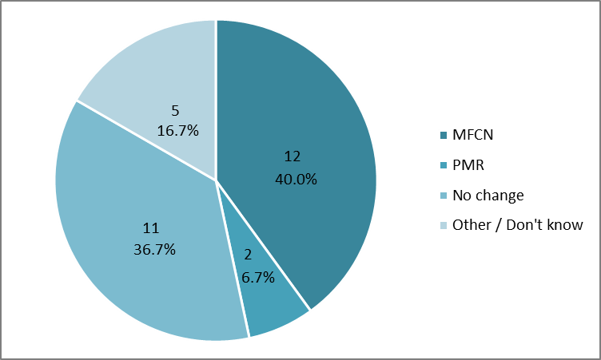

**Question 4: Do you see any possibility to refarm or share spectrum (around 10 MHz) within the 2290-2400 MHz range or to move (part of) current usage to another frequency band, in order to adapt to a possible introduction of RMR in the 2290-2400 MHz range?**

The figure below has been derived from the answers which focussed on refarming.

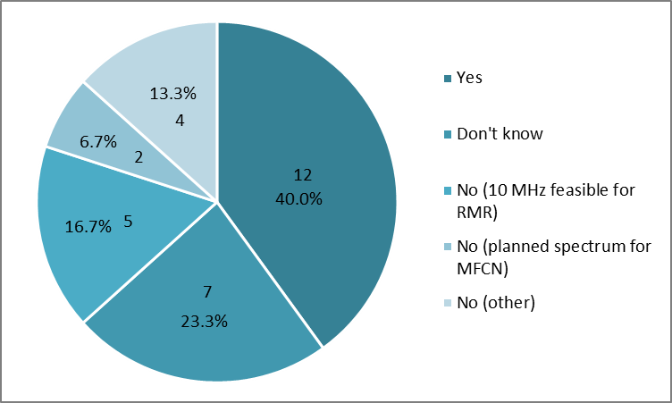

In total, 17 (12+5) administrations answered that it is expected they could make 10 MHz available for RMR.

Only France mentioned the 2.7 GHz band as an alternative for ground-to-ground video PMSE.

1. 2390-2400 MHz was part of the range proposed by Malta.