|  |  |  |
| --- | --- | --- |
| ECC PT1 | | ECC PT1(20)XXX |
| ECC PT1 #XX | | |
| Web-meeting, 10th November 2020 | | |
|  | | |
| Date issued: | XX XX 2020 | |
| Source: | Huawei, Ericsson | |
| Subject: | Definition of the list of the adjacent and in-band incumbent services and applications for the 2300-2400 MHz band | |
| Group membership required to read? (Y/N)  N | | |
|  | | |
| Summary: This contribution proposes updates to the list of the adjacent and in-band incumbent services and applications for the 2300-2400 MHz band as after existing ECC Reports and up-to-date information using the ECO Frequency Information System database. | | |
|  | | |
| Proposal: We propose to account for this input while populating the Draft ECC Report. | | |
|  | | |
| Background: In ECC #52 March plenary the WI [PT1_28](http://eccwp.cept.org/WI_Detail.aspx?wiid=734) was approved | | |
|  | | |

# 

# **Background**

The following usages apply to the 2300-2400 MHz band and to the bands below and above is:

Table 1: Overview of usages in and around the 2300-2400 MHz band (source: ECC Report 172)



# Summary from ECC Report 172 studies

Among the usages listed in the table above, the following table describes the studies that were carried out in ECC Report 172 for the different services and applications operating in the band and around it:

Table 2: Summary of the studies carried out in ECC Report 172

|  |  |  |  |
| --- | --- | --- | --- |
| Service / Application | Frequency range | Methodology of study  in ECC Report 172 | Conclusions from ECC Report 172 wrt. LTE-TDD  (Summary of the resulting regulatory measure) |
| RLANs | 2400-2485 MHz | Simulations | *The results for the impact of macro LTE TDD BS on WLAN show that coexistence is feasible for indoor WLAN systems at antenna height of 1.5 m with an interference probability smaller than 1%. The outdoor placed WLAN systems at 10 m height (worst case) will have very high interference probability. For the indoor case, WLAN AP interfering the Pico LTE TDD BS, there is a degradation in average bit rate. The results clearly show that increasing the offset frequency of LTE TDD decreases the bit rate degradation significantly. In all scenarios it is shown that using WLAN channel 5 instead of channel 1 will improve the situation significantly so that the coexistence between LTE TDD and WLAN would be feasible without mutual harmful interference.* |
| Bluetooth | 2400-2485 MHz | Link budget analysis | *…In certain worst case scenarios when Bluetooth is operating close to the 2400 MHz band edge there can be interference issues.*  *Fortunately in this situation the device has full control over the choice of Bluetooth channels and may allocate them such that frequency usage close to the 2400 MHz edge is avoided by means of adaptive frequency hopping…* |
| BWS | 2300-2400 MHz | Minimum coupling loss | *It can be concluded that two BWS BSs, operating in close proximity and in adjacent frequency blocks, should be synchronized and coordinated in order to be able to use high power amplifiers and antennas. In case of non-synchronized systems the necessary frequency separation will be large or the output power will be very low.* |
| SRS - Space Research (Space to Earth) | 2200-2290 MHz | Link budget analysis | In conclusion, BWS does not have any considerable negative impact on space to space service. |
| SRS - Space Research (deep Space) | 2290-2300 MHz | Simulations | *It can be concluded that having a very sensitive Deep Space earth station receiver close to a broadband wireless system such as LTE TDD might require some mitigation techniques.* |
| RAS | Below 2300 MHz | Minimum coupling loss | *Regarding co-existence with radio astronomy earth stations, it was shown that protection of these stations can be achieved for example by a suitable co-ordination zone around the relatively few observatory stations* |
| Telemetry (Defence) | 2200-2400MHz | Minimum coupling loss | From 0,7km to 170Km distance separation is needed  *This study provides a worst-case analysis regarding telemetry. The results of this deterministic study show that in a co-channel configuration, large separation distances are needed to avoid harmful interference on telemetry system from LTE (and vice versa).In adjacent channel, the separation distances decrease drastically so that the operation of TLM and LTE is possible. Some reasonable mitigation techniques may however be needed to ensure that no interference occurs when the airborne TLM is in the main lobe of the LTE base station antenna. In practice, depending on the trajectory of the aircraft, an airborne TLM might not stay in the LTE base station main beam for a long time.* |
| UAS | In band | Minimum coupling loss | *The results show that LTE and UAS cannot share spectrum on a co-channel basis. Frequency separation, geographical separation, time sharing or a combination of these mitigation methods help to ensure coexistence. It needs to be mentioned that constraints from LTE on UAS are almost the same as constraints from UAS on LTE.* |
| Fixed Service | Below 2300 MHz | NA | *Interference studies were not performed in this report as the risk of interference was, because of highly directional antennas and the probable deployment in rural areas, considered to be very low* |
| PMSE - Programme Making and Special Events: SAP/SAB video links | 2300-2400 MHz | Minimum coupling loss | Separation distance from some m to several 100km  *The results regarding scenario 1 “Cordless Camera Link” indicate that coexistence can be feasible in the adjacent and alternate channel case, since the required separation distance is moderate. If the receiver performance of wireless video links and the LTE transmitter performance exceed the requirement values in Table 6: and Table 13:, the observed separation distances can further be reduced to even smaller values. It has to be decided on a case-by-case basis if additional protection and sharing mechanisms have to be employed. In the co-channel case, dedicated protection and coexistence mechanisms would be required under worst case conditions.*  *In scenario 2 “Mobile Video Link”, such further protection and coexistence mechanisms are probably required except in the presence of a guard band of more than 20 MHz between the systems. For the case of video link as a victim, this is mainly due to the very low path loss propagation model under worst case conditions and large coverage of the receiver antenna mounted on a helicopter. This is certainly a special propagation case which calls for dedicated coordination measures. In the case of video link transmitters interfering into LTE receivers in this scenario, separation distances are significantly reduced.*  *The results for scenario 3 “Portable Video Link” indicate that coexistence based on geographical separation is feasible at least in the alternate channel (guard band) case if on a case-by-case basis, some additional protection measures are deployed. If certain separation corridors around the main lobe of the narrow-beam video link receive antenna could be employed, geographical separation could be feasible in the adjacent channel case as well, especially if the employed devices exceed the performance limits by a significant amount. In the co-channel case, additional dedicated protection and coexistence mechanisms would be probably be required due to significant necessary separation distances.* |
| Amateur Service (secondary service) | In band | Minimum coupling loss | *In co-channel case where the antenna main lobes are pointing at each other, the required MCL between LTE and stations in the Amateur Service can be significant. Various mitigation techniques can be used to protect both BWS and Amateur service.*  *Constraints from LTE on the AS are almost the same as constraints from the AS on LTE. It should be noted that the Amateur Service is a secondary user of the band* |

The following sections provide motivations for not addressing some the above listed services / applications with specific studies within the new ECC draft Report.

# EFIS, ERC Report 25 and ECO Report 03

EFIS database, ERC Report 25 and ECO Report 03 provide relevant information in and around the 2300-2400MHz band. This information are related to:

* Allocation in region 1
* Allocation in European
* ECC/ERC harmonization measure
* Applications
* Standard
* Licensing of mobile band

It is proposed to add several tables in the update of the ECC draft report (see paragraph 10)

# Remark on SRD

According to the working document, the figure 2 includes the incumbent services and applications. SRD includes unlicensed services/technologies like WiFi, Bluetooth, etc. and this is regulated in ERC Rec 70-03. Such SRDs in general cannot claim protection from radio services, see ERC Rec 70-03 considering.

# **Remarks on the Fixed Service**

According to the assessment from Report 173, the usage of the adjacent bands below 2300 MHz and above 2400 MHz by Fixed Service can be summarized as follows:

* Below 2290MHz: there is limited use from fixed links, 128 fixed links in total across CEPT countries. A “temporary use” and a PMSE use are also recorded;
* Above 2400MHz: point-to-point links and point-to-multi-point central stations are deployed in one CEPT country only.

The more detailed assessment from ECC Report 173 is provided in Annex 1.

Due to the varying characteristics of different types of FS systems and their deployment, no single compatibility solution can be applied e.g. separation distance, guard band or signal strength limit. If needed, co-existence can be achieved through coordination on a case-by-case basis, at national level.

According to ECC Report 172 “*Interference studies were not performed in this report as the risk of interference was, because of highly directional antennas and the probable deployment in rural areas, considered to be very low*”.

Based on the above, it is proposed to make a specific remark in the list on fact that no specific studies will be developed in this report for coexistence between MFCN (including 5G and AAS) and the Fixed Service.

# **Remarks on srd (Wifi, Bluetooth, etc technology)**

The following aspects should be taken into account when assessing the Bluetooth/WIFI technology:

* It is a short range technology;
* About Bluetooth and according to ECC Report 172 “*In-device coexistence properties between LTE TDD and Bluetooth are studied*”
* The LTE TDD UE technical characteristics described in ECC Report 172 will not change significantly when considering 5G NR UEs;
* In-device coexistence between cellular services and WiFi, Bluetooth (SRD) is challenging in terminals as the bands are adjacent
* WiFi, Bluetooth and 5G NR are already available in commercial devices supporting the 2300-2400 MHz band (3GPP band n40) and their coexistence has already been take into account.
* The additional baseline requirements above 2403 MHz needs to be defined for AAS using TRP as the metrics

Based on the above, it is proposed to make a specific remark in the list on fact that no specific studies will be developed in the new ECC draft Report for the coexistence between MFCN and the WiFi, Bluetooth technology.

# **Remarks on the Amateur radio service**

ECC Report 172 reaches the following conclusion with reference to the Amateur Service:

“*In co-channel case where the antenna main lobes are pointing at each other, the required MCL between LTE and stations in the Amateur Service can be significant. Various mitigation techniques can be used to protect both BWS and Amateur service.*

*Constraints from LTE on the AS are almost the same as constraints from the AS on LTE. It should be noted that the Amateur Service is a secondary user of the band.”*

Similar technical compatibility solutions are expected for 5G and AAS.

Based on the above, it is proposed to make a specific remark in the list on fact that no specific studies will be developed in this report for coexistence between MFCN and the Amateur service.

# **proposal on Incumbent Services and applications addressed**

Based on the above, it is proposed to:

1. Consider the up-to-date information on in-band and adjacent services for the 2300-2400 MHz band
2. On coexistence studies that
   1. In the list of the new ECC Report that for “Fixed service” no specific studies will be developed about coexistence with MFCN, and, to add in the working draft Report the explanations above, in paragraph 4
   2. In the list of the new ECC Report that for “Bluetooth and WiFi technology” no specific studies will be developed about coexistence with MFCN, and, to add in the working draft Report the explanations above, in paragraph 5
   3. In the list of the new ECC Report that for “Radio amateur service” no specific studies will be developed about coexistence with MFCN, and, to add in the working draft Report the explanations above, in paragraph 6

# Draft list of services and applications

Based on the information above, a list of services and applications is proposed as:

### In 2000MHz to 2290MHz band

SRS Space Research (Space to Earth)

RAS

Telemetry (MOD)

Aeronautical mobile service (MOD)

FS (Not need coexistence study with 5G NR and AAS)

### In 2290MHz to 2300MHz band

SRS - Space Research (deep Space)

Telemetry (MOD)

### In 2300MHz to 2400MHz band

MFCN - BWS

RAS

PMSE - Programme Making and Special Events: SAP/SAB video links

Aéronautique mobile service (e.g. UAS)

Telemetry (MOD)

Amateur Service (secondary service) (Not need coexistence study with 5G NR and AAS)

### In 2400MHz to 2483.5MHz band

SRD (RLAN – WIFI – Bluetooth…) (Not need coexistence study with 5G NR and AAS)

# Update of the ECC Draft Report

Based on all information above, it is proposed to add relevant information in and around the 2300-2400MHz band in the ECC draft Report “Analysis of the suitability and update of the regulatory technical conditions for 5G MFCN and AAS operation in the 2300-2400 MHz band”.

It is also proposed to update some other points:

* Change the 3GPP reference and to use the ETSI reference
* Move in annex the ETSI reference
* Align the synchronization principle on the principle of the ECC Report 172
* Remove the square brackets

# Annex 1: Extract from ECC Report 173 (27 April 2018)

**Band 13: below 2290MHz: about 128 fixed links + 1 temporary use + 1 PMSE use**

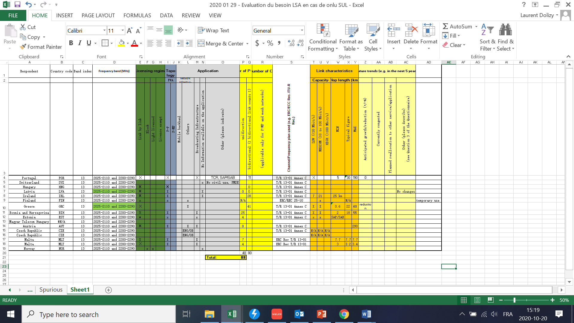

**Band 15: above 2400MHz: about 8922 P-P + 4108 CS**

