Analysis of the suitability and update of the regulatory technical conditions for 5G MFCN and AAS operation in the 2300-2400 MHz band

approved xyz

ECC Report xyz

# Executive summary

This report studies the update of the 2300-2400 MHz MFCN band to include 5G and AAS. The work started in the March 2020 52nd ECC Plenary and contains two WIs (PT1_28/ PT1_29).

TABLE OF CONTENTS

0 Executive summary 2

1 Introduction 5

2 Existing Regulatory framework for MFCN systems 6

2.1 Existing Band plan 6

2.2 Existing technical conditions – BEM requirements 6

3 Other services and applications in-band and adjacent band 7

4 Suitability of the current technical framework for 5G 8

4.1 Suitability for non-aas MFCN Base stations 8

4.2 Suitability for AAS MFCN base stations 8

5 2300-2400MHz In-band and Adjacent band applications / Services overview and coexistence 9

5.1 Overview Spectrum situation 9

5.2 Detailed information of allocations and applications in 2200 to 2483.4 MHz in Region 1/Europe 10

5.3 Existing mobile licenses in europe for 2300-2400 MHz band (ECO Report 03) 13

5.4 List of incumbent services and applications 15

5.5 In band and Adjacent band coexistence 16

5.5.1 Existing analysis for non-AAS 16

5.5.2 Revise to include AAS 18

5.6 Parameters and scenarios for the relative AAS/non-AAS compatibility study 19

5.7 Technical summary 20

6 Recommended updates to the Regulatory Framework 21

6.1 Recommended Band plan 21

6.2 Applicable technical conditions 21

AAS LRTCs for BS 21

6.2.1 21

6.2.2 MFCN Terminal 23

7 Conclusions 24

LIST OF ABBREVIATIONS

|  |  |
| --- | --- |
| Abbreviation | Explanation |
| 3GPP | 3rd Generation Partnership Project |
| AAS | Active Antenna Systems |
| BEM | Block Edge Mask |
| BS | Base Station |
| e.i.r.p. | Equivalent Isotropic Radiated Power |
| LTE | Long Term Evolution |
| NLOS | Non Line of Sight |
| Non-AAS | Non-Active Antenna Systems |
| NR | New Radio |
| OOB | Out of Band |
| OTA | Over The Air |
| RAN | Radio Access Network |
| TRP | Total Radiated Power |
| WBB ECS | Wireless Broadband Electronic Communications Services |
|  |  |
|  |  |
|  |  |
|  |  |
|  |  |

# Introduction

This Report analyses the necessary changes in the existing ECC Decision (14)02, [1], for the 2300 - 2400 MHz frequency band in order to introduce 5G, namely New Radio (NR) and Active Antenna Systems (AAS). The analysis is based on existing reports for non-AAS:

* ECC Report 172, "Broadband Wireless Systems Usage in 2300-2400 MHz", [2];

New studies/simulations for AAS with respect to non-AAS within the band coexistence and to adjacent services, RAS and radar, are done. The analysis assumes that the current technical conditions will also remain as part of the regulatory framework to ensure that current and future deployments of non-AAS MFCN will not be impacted. As a result, this ECC Report gives the least restrictive technical condition for the introduction of 5G and updated Block Edge Masks (BEMs).

# Existing Regulatory framework for MFCN systems

## Existing Band plan

ECC Decision (14)02,

|  |  |  |  |  |  |  |  |  |  |  |  |  |  |  |  |  |  |  |  |
| --- | --- | --- | --- | --- | --- | --- | --- | --- | --- | --- | --- | --- | --- | --- | --- | --- | --- | --- | --- |
| TDD  (MHz) | | | | | | | | | | | | | | | | | | | |
| 2300 MHz  2305 MHz | 2305 MHz  2310 MHz | 2310 MHz  2315 MHz | 2315 MHz  2320 MHz | 2320 MHz  2325 MHz | 2325 MHz  2330 MHz | 2330 MHz  2335 MHz | 2335 MHz  2340 MHz | 2340 MHz  2345 MHz | 2345 MHz  2350 MHz | 2350 MHz  2355 MHz | 2355 MHz  2360 MHz | 2360 MHz  2365 MHz | 2365 MHz  2370 MHz | 2370 MHz  2375 MHz | 2375 MHz  2380 MHz | 2380 MHz  2385 MHz | 2385 MHz  2390 MHz | 2390 MHz  2395 MHz | 2395 MHz  2400 MHz |
| 5 | 5 | 5 | 5 | 5 | 5 | 5 | 5 | 5 | 5 | 5 | 5 | 5 | 5 | 5 | 5 | 5 | 5 | 5 | 5 |

Figure 1: Harmonised frequency arrangement for MFCN in the 2300-2400 MHz band, [1]

## Existing technical conditions – BEM requirements

[The ECC Decision (14)02 provides already technical parameters for MFCN non-AAS.]

# Other services and applications in-band and adjacent band

[deployed, planned or switched-off]

# Suitability of the current technical framework for 5G

1. Do we need Chapter 3?

## Suitability for non-aas MFCN Base stations

[TBD if needed]

## Suitability for AAS MFCN base stations

[TBD if needed]

# 2300-2400MHz In-band and Adjacent band applications / Services overview and coexistence

## Overview Spectrum situation

The figure below shows the 2300-2400 MHz spectrum situation and the adjacent band and in-band situation to other services as listed in ECC Report 172 [2] and ECC Dec (14)02 [1].

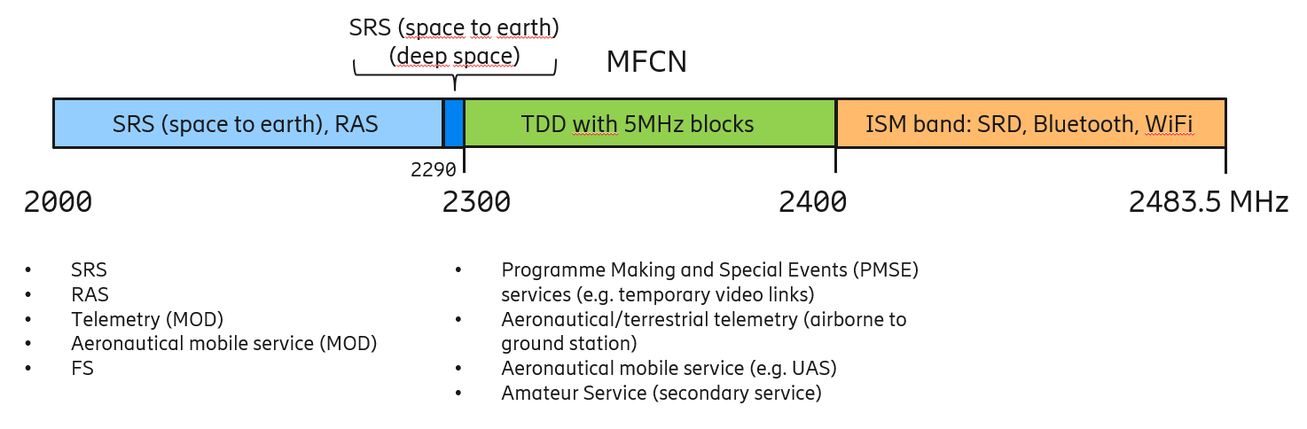

Figure 2: In-band and adjacent services for the 2300-2400 MHz MFCN band

[Comment: The figure above will be updated when 5.2 is finalised]

Table 1 gives an overview of main usages inband and adjacent to the 2300-2400 MHz band. More details about the European Common Allocations and the relation to European Standards can be found in subsequent sections.

Table 1: Overview of allocations and applications inband and adjacend for the 2300-2400 MHz band for Europe/Region 1, from EFIS ECO Report 03 (Nov 2020).

|  |  |  |  |  |  |
| --- | --- | --- | --- | --- | --- |
|  | Europe Allocations and Applications in and around 2300-2400MHz band | | | | |
| Lower Frequency | 2200 MHz | 2290 MHz | 2300 MHz | 2400 MHz | 2450MHz |
| Upper Frequency | 2290 MHz | 2300 MHz | 2400 MHz | 2450 MHz | 2483.5MHz |
| Allocations | EARTH EXPLORATION-SATELLITE (SPACE-TO-EARTH) (SPACE-TO-SPACE) FIXED MOBILE  SPACE OPERATION (SPACE-TO-EARTH) (SPACE-TO-SPACE) SPACE RESEARCH (SPACE-TO-EARTH) (SPACE-TO-SPACE) | SPACE RESEARCH (DEEP SPACE) (SPACE-TO-EARTH) MOBILE EXCEPT AERONAUTICAL MOBILE FIXED | (ECA36)  FIXED MOBILE Amateur Radiolocation | FIXED Radiolocation MOBILE Amateur Amateur-Satellite | FIXED MOBILE |
| Applications | Aeronautical military systems Land military systems Maritime military systems Radio astronomy Space research Telemetry/Telecommand (military) Fixed PMSE | PMSE Space research Land mobile | Amateur Maritime military systems Aeronautical military systems Land military systems Aeronautical telemetry PMSE Telemetry/Telecommand (military) MFCN | Wideband data transmission systems PMSE Amateur ISM Amateur-satellite Non-specific SRDs Radiodetermination applications RFID | RFID Radiodetermination applications Non-specific SRDs ISM PMSE Wideband data transmission systems |

## Detailed information of allocations and applications in 2200 to 2483.4 MHz in Region 1/Europe

For the band in and around 2300-3400 MHz band, ERC Report 25 [6] indicates the systems operating below 2300MHz, in the band 2300-2400MHz and above 2400MHz.

ECO Report 03 [7] shows result of search for information in ranges 2300 MHz - 2400 MHz from tables: ' Cyprus, Portugal, Iceland, Greece, Austria, Latvia, Monaco, Luxembourg, Slovenia, Vatican, Hungary, Ukraine, Moldova, Belarus, Albania, Turkey, Belgium, Finland, North Macedonia, Italy, Georgia, Germany, Russian Federation, Malta, Netherlands, Sweden, Andorra, Ireland, Kosovo*, Liechtenstein, Poland, Slovakia, Bulgaria, France, Lithuania, Serbia, Bosnia and Herzegovina, Croatia, Romania, United Kingdom, Switzerland, Spain, Azerbaijan, Czech Republic, Norway, Denmark, San Marino, Montenegro, Estonia' in total 14 entries.

The table 2 is an extract which provides details about the allocations and also the relevant standard, applications and some notes as:

* Below 2300MHz,
* In the 2300-2400MHz band,
* Above 2400MHz,

Table 2: Detailed information of allocations and applications inband and adjacend for the 2300-2400 MHz band for Europe/Region 1, from reference [https://efis.cept.org/view/compare-applications.do (Nov 2020) Extract from ERC Report 25]

* Below 2300 MHz

|  |  |  |  |  |  |
| --- | --- | --- | --- | --- | --- |
| Band | European Common Allocation and ECA Footnotes | ECC/ERC harmonisation measure | Applications | Standard | Notes |
| 2200 MHz  - 2290 MHz | EARTH EXPLORATION-SATELLITE (SPACETO-EARTH) (SPACE-TO-SPACE) FIXED MOBILE 5.391 SPACE OPERATION (SPACE-TO-EARTH) (SPACE-TO-SPACE) SPACE RESEARCH (SPACE-TO-EARTH) (SPACE-TO-SPACE) 5.392 ECA16A ECA36 | T/R 13-01 | Aeronautical military systems |  |  |
|  | Fixed | EN 302 217 |  |
|  | Land military systems |  |  |
|  | Land military systems |  |  |
| ERC/REC 25-10 | PMSE | EN 302 064 | Portable or mobile wireless video and cordless cameras |
|  | Radio astronomy |  | Continuum observations, VLBI (used by SRS) |
| ECC/REC/(10)01 | Space research |  | EESS Satellite payload and platform telemetry |
|  | EESS Satellite payload and platform telemetry |  |  |

|  |  |  |  |  |  |
| --- | --- | --- | --- | --- | --- |
| band | European Common Allocation and ECA Footnotes | ECC/ERC harmonisation measure | Applications | Standard | Notes |
| 2290 MHz  - 2300 MHz | FIXED MOBILE EXCEPT AERONAUTICAL MOBILE SPACE RESEARCH (DEEP SPACE) (SPACETO-EARTH) |  | Land mobile |  | Land mobile |
|  | PMSE | EN 302 064 | Portable or mobile wireless video and cordless cameras |
|  | Space research |  | Satellite payload and platform telemetry for space research (deep space). Continuum observations, VLBI (used by SRS) |

* In the 2300-2400MHz

|  |  |  |  |  |  |
| --- | --- | --- | --- | --- | --- |
| Band | European Common Allocation and ECA Footnotes | ECC/ERC harmonisation measure | Applications | Standard | Notes |
| 2300 MHz - 2400 MHz | FIXED MOBILE 5.384A Amateur Radiolocation ECA36 |  | Aeronautical military systems |  |  |
| ERC/REC 62-02 | Aeronautical telemetry |  | Parts of the band are used for aeronautical telemetry on a national basis |
|  | Amateur | EN 301 783 | Within the band 2300-2450 MHz |
|  | Land military systems |  |  |
| ECC/DEC/(14)02 ECC/REC/(14)04 | MFCN | EN 301 908 | Shared use of spectrum envisaged |
|  | ECC/REC/(14)04 |  |  |
| ERC/REC 25-10 | PMSE | EN 302 064 | Portable or mobile wireless video and cordless cameras |
|  | Telemetry/Telecommand (military) |  |  |

* Above 2400MHz

|  |  |  |  |  |  |
| --- | --- | --- | --- | --- | --- |
| Band | European Common Allocation and ECA Footnotes | ECC/ERC harmonisation measure | Applications | Standard | Notes |
| 2400 MHz - 2450 MHz | FIXED MOBILE Amateur Amateur-Satellite Radiolocation 5.150 5.282 |  | Amateur | EN 301 783 | Within the band 2300-2450 MHz |
|  | Amateur-satellite |  |  |
|  | ISM |  |  |
| ERC/REC 70-03 | Non-specific SRDs | EN 300 440 | Within the band 2400.0-2483.5 MHz |
| ERC/REC 25-10 | PMSE | EN 302 064 | Portable or mobile wireless video and cordless cameras |
| ERC/REC 70-03 | RFID | EN 300 440 | Within the band 2446-2454 MHz |
| ERC/REC 70-03 | Radiodetermination applications | EN 300 440 | Within the band 2400.0-2483.5 MHz |
| ERC/REC 70-03 | Wideband data transmission systems | EN 300 328 | Within the band 2400.0-2483.5 MHz |

|  |  |  |  |  |  |
| --- | --- | --- | --- | --- | --- |
| Band | European Common Allocation and ECA Footnotes | ECC/ERC harmonisation measure | Applications | Standard | Notes |
| 2450 MHz - 2483.5 MHz | FIXED MOBILE 5.150 |  | ISM |  |  |
| ERC/REC 70-03 | Non-specific SRDs | EN 300 440 | Within the band 2400.0-2483.5 MHz |
| ERC/REC 25-10 | PMSE | EN 302 064 | Portable or mobile wireless video and cordless cameras |
| ERC/REC 70-03 | RFID | EN 300 440 | Within the band 2446-2454 MHz |
| ERC/REC 70-03 | Radiodetermination applications | EN 300 440 | Within the band 2400.0-2483.5 MHz |
| ERC/REC 70-03 | Wideband data transmission systems | EN 300 328 | Within the band 2400-2483.5 MHz |

## Existing mobile licenses in europe for 2300-2400 MHz band (ECO Report 03)

The table below shows existing cellular licenses in the 2300-2400 MHz band in Europe.

[Comment: add license information if needed like #of operators, license additional information]

Table 2: Existing license for the 2300 - 2400 MHz band in Europe, from reference [ECO Report 03, https://efis.cept.org/views2/report03.jsp , Nov 2020]

|  |  |  |  |  |  |  |  |  |
| --- | --- | --- | --- | --- | --- | --- | --- | --- |
| Frequency Table | Frequency band downlink | Frequency band uplink | Application | Licence holder | Start date | Expiry date | Location Information | Spectrum Trading |
| Denmark | 2300.000 - 2360.000 MHz | N/A | TRA-ECS | TDC Netco A/S | 2019-04-26 | 2041-12-31 | 100 Landsdaekkende | Yes |
| Denmark | 2380.000000 - 2380.000001 MHz | 2307.000000 - 2307.000001 MHz | Fixed | Total E&P Danmark A/S | 2002-11-07 | 2027-12-31 | One Transmitter: Long:005E0620 Lat: 55N2841 | Yes |
| Estonia | 2300.000 - 2330.000 MHz | N/A | MFCN | Tele 2 Eesti AS | 2016-04-01 | 2030-01-27 | National coverage | No |
| Estonia | 2330.000 - 2360.000 MHz | N/A | MFCN | Tele2 Eesti AS | 2006-05-19 | 2030-05-19 | National coverage | No |
| Georgia | 2300.000 - 2350.000 MHz | N/A | MFCN | Silknet LLC | 2016-05-05 | 2026-05-05 | Tbilisi | Yes |
| Georgia | 2300.000 - 2350.000 MHz | N/A | MFCN | Silknet LLC | 2017-01-18 | 2027-01-18 | National coverage | Yes |
| Latvia | 2300.000 - 2330.000 MHz | N/A | IMT | Latvijas Mobilais Telefons | 2012-12-06 | 2027-12-05 | National coverage | Yes |
| Latvia | 2330.000 - 2360.000 MHz | N/A | IMT | Bite Latvija | 2012-12-06 | 2027-12-05 | National coverage | Yes |
| Lithuania | 2310.000 - 2390.000 MHz | N/A | TRA-ECS | AB Lietuvos radijo ir televizijos centras | 2014-07-24 | 2029-07-25 | National coverage | Yes |
| Norway | 2300.000 - 2320.000 MHz | N/A | BWA | Neptune Energy Norge AS | 2009-10-01 | 2021-12-31 | gjøa-feltet | Yes |
| Russian Federation | 2300.000 - 2400.000 MHz | N/A | IMT | T2 Mobile | 2016-04-01 | 2019-12-31 | Regional Coverage | No |
| Russian Federation | 2300.000 - 2340.000 MHz | N/A | IMT | Vainah Telecom | 2016-04-01 | 2019-12-31 | Regional Coverage | No |
| Russian Federation | 2370.000 - 2400.000 MHz | N/A | IMT | Vainah Telecom | 2016-04-01 | 2019-12-31 | Regional Coverage | No |
| United Kingdom | 2350.000 - 2390.000 MHz | N/A | TRA-ECS | TELEFONICA UK LIMITED | 2018-04-05 | 2100-01-01 | National coverage | Yes |

## List of incumbent services and applications

Thus, the list of incumbent services and applications has been established as:

* In 2000MHz to 2290MHz band
  1. SRS Space Research (Space to Earth)
  2. RAS
  3. Telemetry (MOD)
  4. Aeronautical mobile service (MOD)
  5. FS (Not need coexistence study with 5G NR and AAS; for explanations see paragraph 5.4.2)
  6. In 2290MHz to 2300MHz band
  7. SRS - Space Research (deep Space)
  8. Telemetry (MOD)
* In 2300MHz to 2400MHz band
  1. MFCN - BWS
  2. RAS
  3. PMSE - Programme Making and Special Events: SAP/SAB video links
  4. Aéronautique mobile service (e.g. UAS)
  5. Telemetry (MOD)
  6. Amateur Service (secondary service) (Not need coexistence study with 5G NR and AAS; for explanations see paragraph 5.4.2)
* In 2400MHz to 2483.5MHz band
  1. SRD (RLAN – WIFI – Bluetooth…) (Not need coexistence study with 5G NR and AAS; for explanations see paragraph 5.4.2)

## In band and Adjacent band coexistence

### Existing analysis for non-AAS

Among the usages listed in the table above, the following table describes the studies that were carried out in ECC Report 172 for the different services and applications operating in the band and around it:

Table 1: Summary of the studies carried out in ECC Report 172

|  |  |  |  |
| --- | --- | --- | --- |
| Service / Application | Frequency range | Methodology of study  in ECC Report 172 | Conclusions from ECC Report 172 wrt. LTE-TDD  (Summary of the resulting regulatory measure) |
| RLANs | 2400-2485 MHz | Simulations | The results for the impact of macro LTE TDD BS on WLAN show that coexistence is feasible for indoor WLAN systems at antenna height of 1.5 m with an interference probability smaller than 1%. The outdoor placed WLAN systems at 10 m height (worst case) will have very high interference probability. For the indoor case, WLAN AP interfering the Pico LTE TDD BS, there is a degradation in average bit rate. The results clearly show that increasing the offset frequency of LTE TDD decreases the bit rate degradation significantly. In all scenarios it is shown that using WLAN channel 5 instead of channel 1 will improve the situation significantly so that the coexistence between LTE TDD and WLAN would be feasible without mutual harmful interference. |
| Bluetooth | 2400-2485 MHz | Link budget analysis | …In certain worst case scenarios when Bluetooth is operating close to the 2400 MHz band edge there can be interference issues.  Fortunately in this situation the device has full control over the choice of Bluetooth channels and may allocate them such that frequency usage close to the 2400 MHz edge is avoided by means of adaptive frequency hopping… |
| BWS | 2300-2400 MHz | Minimum coupling loss | It can be concluded that two BWS BSs, operating in close proximity and in adjacent frequency blocks, should be synchronized and coordinated in order to be able to use high power amplifiers and antennas. In case of non-synchronized systems the necessary frequency separation will be large or the output power will be very low. |
| SRS - Space Research (Space to Earth) | 2200-2290 MHz | Link budget analysis | In conclusion, BWS does not have any considerable negative impact on space to space service. |
| SRS - Space Research (deep Space) | 2290-2300 MHz | Simulations | It can be concluded that having a very sensitive Deep Space earth station receiver close to a broadband wireless system such as LTE TDD might require some mitigation techniques. |
| RAS | Below 2300 MHz | Minimum coupling loss | Regarding co-existence with radio astronomy earth stations, it was shown that protection of these stations can be achieved for example by a suitable co-ordination zone around the relatively few observatory stations |
| Telemetry (Defence) | 2200-2400MHz | Minimum coupling loss | From 0,7km to 170Km distance separation is needed  This study provides a worst-case analysis regarding telemetry. The results of this deterministic study show that in a co-channel configuration, large separation distances are needed to avoid harmful interference on telemetry system from LTE (and vice versa).In adjacent channel, the separation distances decrease drastically so that the operation of TLM and LTE is possible. Some reasonable mitigation techniques may however be needed to ensure that no interference occurs when the airborne TLM is in the main lobe of the LTE base station antenna. In practice, depending on the trajectory of the aircraft, an airborne TLM might not stay in the LTE base station main beam for a long time. |
| UAS | In band | Minimum coupling loss | The results show that LTE and UAS cannot share spectrum on a co-channel basis. Frequency separation, geographical separation, time sharing or a combination of these mitigation methods help to ensure coexistence. It needs to be mentioned that constraints from LTE on UAS are almost the same as constraints from UAS on LTE. |
| Fixed Service | Below 2300 MHz | NA | Interference studies were not performed in this report as the risk of interference was, because of highly directional antennas and the probable deployment in rural areas, considered to be very low |
| PMSE - Programme Making and Special Events: SAP/SAB video links | 2300-2400 MHz | Minimum coupling loss | Separation distance from some m to several 100km  The results regarding scenario 1 “Cordless Camera Link” indicate that coexistence can be feasible in the adjacent and alternate channel case, since the required separation distance is moderate. If the receiver performance of wireless video links and the LTE transmitter performance exceed the requirement values in **Error! Reference source not found.** and **Error! Reference source not found.**, the observed separation distances can further be reduced to even smaller values. It has to be decided on a case-by-case basis if additional protection and sharing mechanisms have to be employed. In the co-channel case, dedicated protection and coexistence mechanisms would be required under worst case conditions.  In scenario 2 “Mobile Video Link”, such further protection and coexistence mechanisms are probably required except in the presence of a guard band of more than 20 MHz between the systems. For the case of video link as a victim, this is mainly due to the very low path loss propagation model under worst case conditions and large coverage of the receiver antenna mounted on a helicopter. This is certainly a special propagation case which calls for dedicated coordination measures. In the case of video link transmitters interfering into LTE receivers in this scenario, separation distances are significantly reduced.  The results for scenario 3 “Portable Video Link” indicate that coexistence based on geographical separation is feasible at least in the alternate channel (guard band) case if on a case-by-case basis, some additional protection measures are deployed. If certain separation corridors around the main lobe of the narrow-beam video link receive antenna could be employed, geographical separation could be feasible in the adjacent channel case as well, especially if the employed devices exceed the performance limits by a significant amount. In the co-channel case, additional dedicated protection and coexistence mechanisms would be probably be required due to significant necessary separation distances. |
| Amateur Service (secondary service) | In band | Minimum coupling loss | In co-channel case where the antenna main lobes are pointing at each other, the required MCL between LTE and stations in the Amateur Service can be significant. Various mitigation techniques can be used to protect both BWS and Amateur service.  Constraints from LTE on the AS are almost the same as constraints from the AS on LTE. It should be noted that the Amateur Service is a secondary user of the band |

### Revise to include AAS

#### Fixed Service

According to the assessment from Report 173, the usage of the adjacent bands below 2300 MHz and above 2400 MHz by Fixed Service can be summarized as follows:

Below 2290MHz: there is limited use from fixed links, 128 fixed links in total across CEPT countries. A “temporary use” and a PMSE use are also recorded;

Above 2400MHz: point-to-point links and point-to-multi-point central stations are deployed in one CEPT country only.

The more detailed assessment from ECC Report 173 is provided in Annex 1.

Due to the varying characteristics of different types of FS systems and their deployment, no single compatibility solution can be applied e.g. separation distance, guard band or signal strength limit. If needed, co-existence can be achieved through coordination on a case-by-case basis, at national level.

According to ECC Report 172 “Interference studies were not performed in this report as the risk of interference was, because of highly directional antennas and the probable deployment in rural areas, considered to be very low”.

Based on the above, it is proposed to make a specific remark in the list on fact that no specific studies will be developed in this report for coexistence between MFCN (including 5G and AAS) and the Fixed Service.

#### SRD (Wifi, Bluetooth, etc)

The following aspects should be taken into account when assessing the Bluetooth/WIFI technology:

* It is a short range technology;
* About Bluetooth and according to ECC Report 172 “In-device coexistence properties between LTE TDD and Bluetooth are studied”
* The LTE TDD UE technical characteristics described in ECC Report 172 will not change significantly when considering 5G NR UEs;
* In-device coexistence between cellular services and WiFi, Bluetooth (SRD) is challenging in terminals as the bands are adjacent
* WiFi, Bluetooth and 5G NR are already available in commercial devices supporting the 2300-2400 MHz band (3GPP band n40) and their coexistence has already been take into account.
* The additional baseline requirements above 2403 MHz needs to be defined for AAS using TRP as the metrics

Based on the above, it is proposed to make a specific remark in the list on fact that no specific studies will be developed in the new ECC draft Report for the coexistence between MFCN and the WiFi, Bluetooth technology.

#### Amateur radio service

ECC Report 172 reaches the following conclusion with reference to the Amateur Service:

“In co-channel case where the antenna main lobes are pointing at each other, the required MCL between LTE and stations in the Amateur Service can be significant. Various mitigation techniques can be used to protect both BWS and Amateur service.

Constraints from LTE on the AS are almost the same as constraints from the AS on LTE. It should be noted that the Amateur Service is a secondary user of the band.”

Similar technical compatibility solutions are expected for 5G and AAS.

Based on the above, it is proposed to make a specific remark in the list on fact that no specific studies will be developed in this report for coexistence between MFCN and the Amateur service.

## Parameters and scenarios for the relative AAS/non-AAS compatibility study

The parameters can be found in [TBD]

## Technical summary

Various stakeholders provided simulation results and the details are given in [TBD] to …

# Recommended updates to the Regulatory Framework

## Recommended Band plan

It is recommended to not change the existing frequency arrangement in ECC Decision (14)02, the frequency arrangement is based on 20 blocks of 5MHz:



Figure 3: Harmonised frequency arrangement for MFCN in the 2300-2400 MHz band, [1]

[It is noted that the channel bandwidth for 5G NR is mainly based on a block up to 100MHz for a mobile operator.]

## Applicable technical conditions

### AAS LRTCs for BS

For AAS base stations, TRP is the metric to be used for regulatory power limits.

Base station BEM definition

To obtain a BEM for a specific block, the BEM elements that are defined in Table 6.2.1-1 are used as follows:

1. In-block power limit is used for the block assigned to the operator.
2. Baseline is used for synchronised WBB ECS networks except from the operator block in question and corresponding transitional regions.
3. Transitional regions are determined, and corresponding power limits are used.
4. Restricted baseline is used for unsynchronised WBB ECS networks,

Table 2: BEM elements and applicable frequencies

|  |  |
| --- | --- |
| BEM element | Definition |
| In-block | Block for which the BEM is derived. |
| Baseline | Spectrum used for MFCN, except from the operator block in question and corresponding transitional regions. |
| Transitional region | The transitional region applies 0 to 10 MHz below and above the block assigned to the operator.  Transitional regions do not apply to TDD blocks allocated to other operators, unless networks are synchronised.  The transitional regions do not apply below 2300 MHz or above 2400 MHz. |
| Restricted baseline | Spectrum used for WBB ECS by networks unsynchronised or semi-synchronised with the operator block in question |

#### AAS BS In-Block power

Table 3: In-block power limit

|  |  |  |
| --- | --- | --- |
| BEM element | Frequency range | AAS TRP limit (1) |
| In-block | Block assigned to the operator | Not obligatory.  For femto base stations, the use of power control is mandatory in order to minimise interference to adjacent channels. |
| (1) see ECC Report 281 | | |

#### AAS BS Out-of-block power limits for: Interference between synchronised MFCNs

The following out-of-block power limits are proposed, based on core requirements from MSR BS spec for AAS BS TS 37.105, for coexistence of synchronised MFCN BSs. Less stringent technical parameters, if agreed among the operators of such networks, may also be used.

ETSI Limits

The detail information is provided in annex 1



CEPT TRP limits for AAS BS (through integration of the above 3GPP values)

Table 4: Baseline and transitional power limits for synchronised MFCN networks, for AAS base stations

|  |  |  |
| --- | --- | --- |
| BEM element | Frequency range | AAS TRP limit dBm/(5 MHz) per cell (1) |
| Transitional region | -5 to 0 MHz offset from lower block edge  0 to 5 MHz offset from upper block edge | Min(PMax'-40,16) (1)(2) |
| Transitional region | -10 to -5 MHz offset from lower block edge 5 to 10 MHz offset from upper block edge | Min(PMax'-43,12) (1)(2) |
| Baseline | Below -10 MHz offset from lower block edge. Above 10 MHz offset from upper block edge. Within 2300 - 2400 MHz. | Min(PMax'-43,1) (1)(2) |
| (1) The transitional regions and the baseline power limits apply to the synchronised operation of MFCN networks as defined in ECC Report 281.  (2) PMax' is the maximum mean carrier power in dBm for the base station measured as TRP per carrier in a given cell.  Note: for TDD blocks the transitional region applies in case of synchronised adjacent blocks, and in-between adjacent TDD blocks that are separated by 5 or 10 MHz. The transition region does not extend below 2300 MHz or above 2400 MHz. | | |

#### Out-of-block power limits AAS BEM: Interference between unsynchronised or semi-synchronised MFCN networks

It is proposed to add the following TRP restricted baseline for AAS BS operating in unsynchronised or semi-synchronised mode.

Table 5: Restricted baseline power limits for unsynchronised and semi-  
synchronised MFCN networks, for AAS base stations in the same geographical area

|  |  |  |
| --- | --- | --- |
| BEM element | Frequency range | AAS TRP limit dBm/(5 MHz) per cell (1) |
| Restricted baseline | Unsynchronised blocks.  Below the lower block edge.  Above the upper block edge.  Within 2300-2400 MHz | TBD |
| (1) In a multi-sector base station, the radiated power limit applies to each one of the individual sectors. | | |

The out-of-block power limit applies to unsynchronised and semi-synchronised MFCN base stations if no geographic or indoor/outdoor separation is available. Less stringent technical parameters, if agreed among operators of such networks, may also be used, such as where there is appropriate radio isolation (e.g. due to geographic or indoor/outdoor separation) between networks. In addition, depending on national circumstances, CEPT Administrations may define a relaxed alternative “restricted baseline limit” applying to specific implementation cases to ensure a more efficient usage of spectrum.

### MFCN Terminal

The same technical parameters as per current ECC decision are to be maintained i.e.:

In-block requirements for all user equipment

This decision provides a recommended upper limit of 25 dBm for the in-block power of the user equipment (UE).

This power limit is specified as e.i.r.p. for UE designed to be fixed or installed and as TRP [1][1] for the UE designed to be mobile or nomadic.

A tolerance of up to + 2 dB has been included in this limit, to reflect operation under extreme environmental conditions and production spread.

Administrations may relax this limit in certain situations, for example fixed UE in rural areas, providing that protection of other services, networks and applications is not compromised and cross-border obligations are fulfilled.

# Conclusions

This ECC Report

1. Technical parameters based on ETSI TS 137 105

Universal Mobile Telecommunications System (UMTS); LTE; 5G Active Antenna System (AAS) Base Station (BS) transmission and reception

9.7.5.2 Minimum requirement for MSR operation

9.7.5.2.1 General

The MSR operating band unwanted emission minimum requirements are given in subclauses 9.7.5.2.2, 9.7.5.2.3, and 9.7.5.2.4.

9.7.5.2.2 Minimum requirements for Band Categories 1 and 3 For an MSR RIB operating in BC1 or BC3 bands, the minimum requirements are specified in tables 9.7.5.2.2-1 to 9.7.5.2.2-4, dependent on BS class and output power.

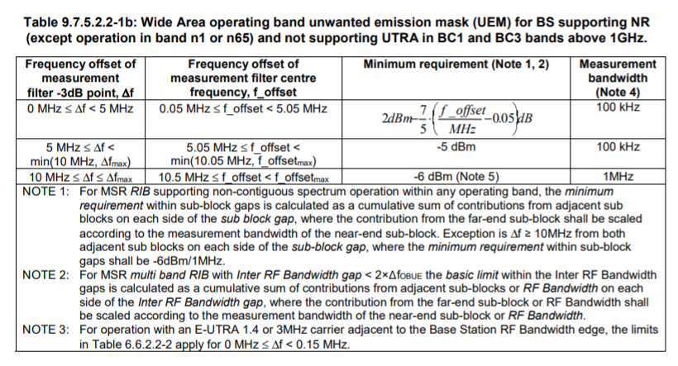

1. Extract from ECC Report 173 (27 April 2018)

Band 13: below 2290MHz: about 128 fixed links + 1 temporary use + 1 PMSE use

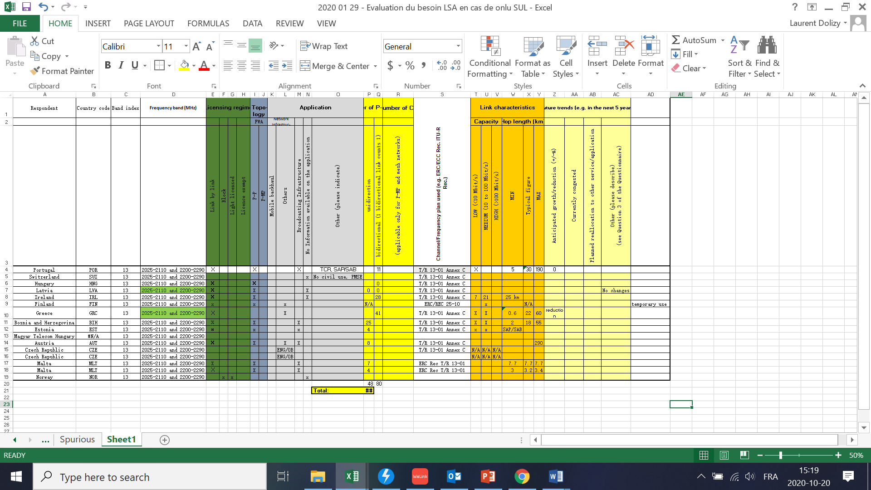

Band 15: above 2400MHz: about 8922 P-P + 4108 CS

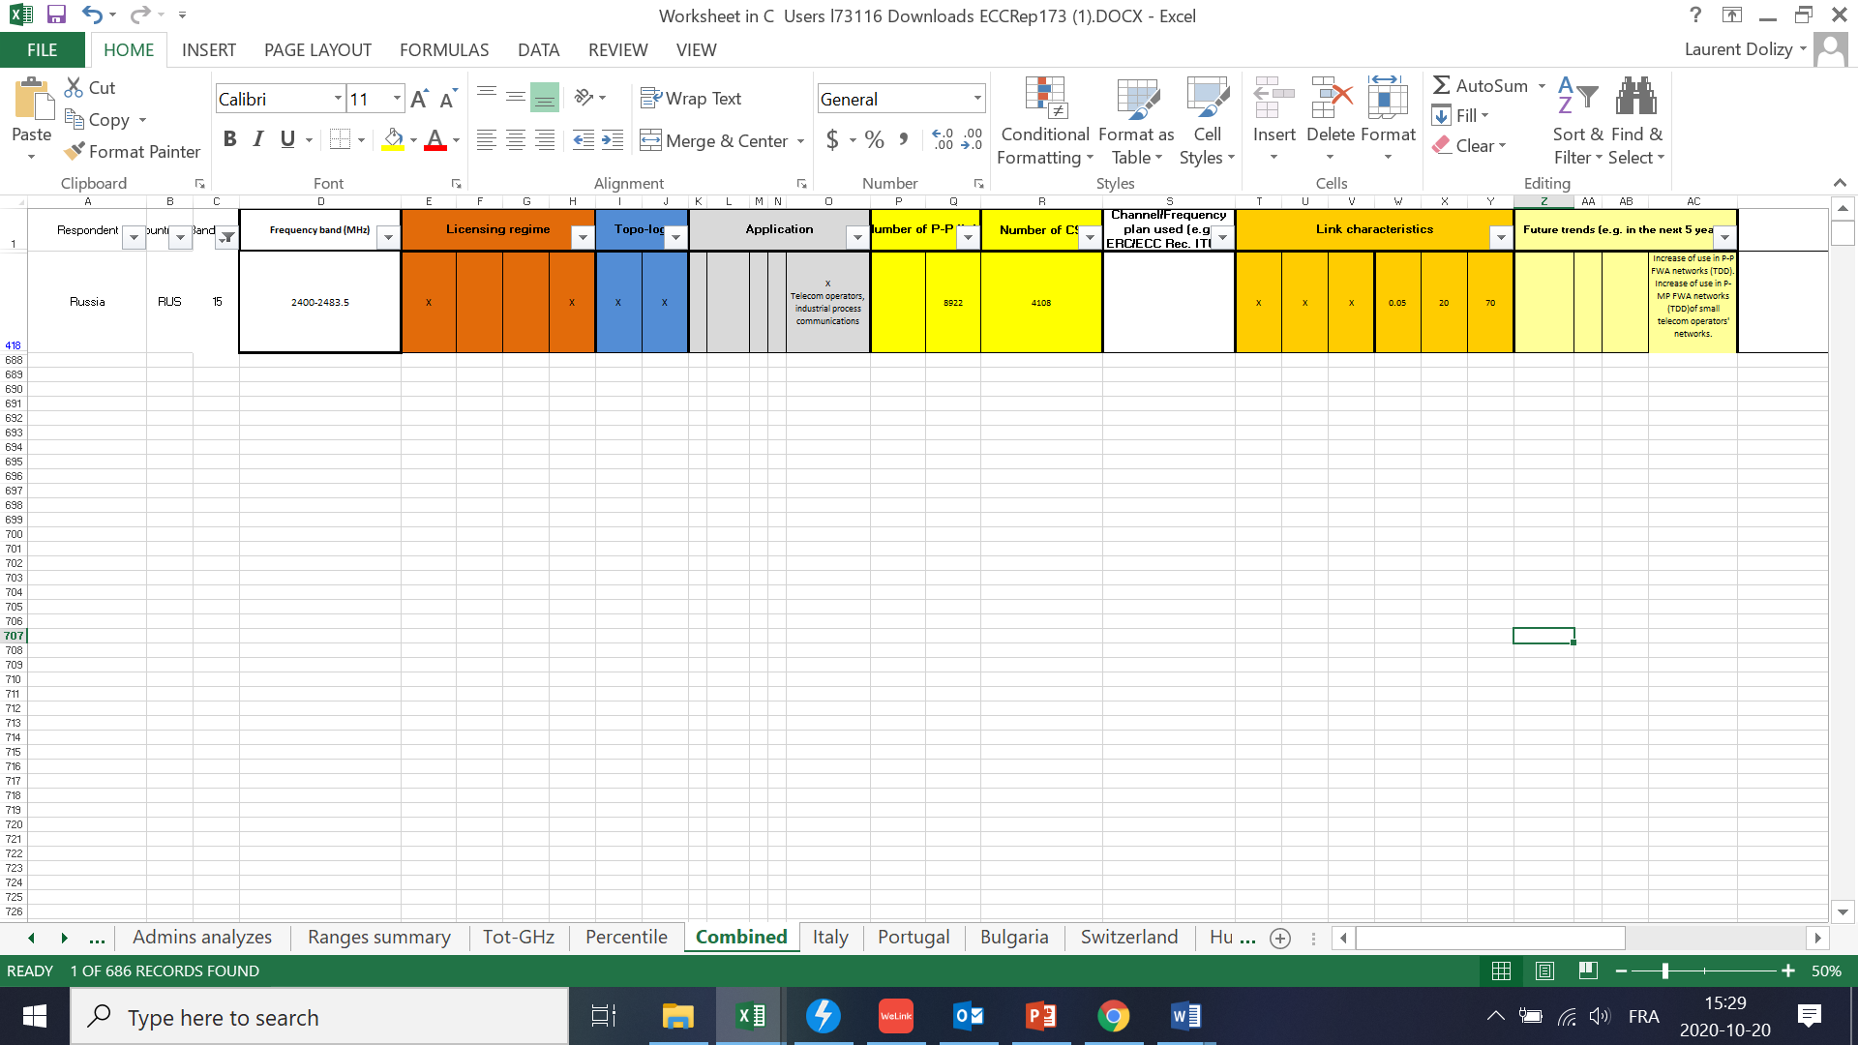

1. STUDY #1 FOR...
2. STUDY #2 FOR...
3. List of References

1. [ECC Decision (14)02](https://www.ecodocdb.dk/download/b02d6dab-2b58/ECCDEC1402.DOCX), "Harmonised technical and regulatory conditions for the use of the band 2300-2400 MHz for Mobile/Fixed Communications Networks (MFCN)", Approved 27 June 2014

1. [ECC Report 172](https://www.ecodocdb.dk/download/01a8e2ae-8ede/ECCREP172.DOC), "Broadband Wireless Systems Usage in 2300-2400 MHz", March 2012
2. [CEPT Report 55](https://www.ecodocdb.dk/download/77dfd5d8-7dc8/CEPTREP055.DOCX), "Report A from CEPT to the European Commission in response to the Mandate on ‘Harmonised technical conditions for the 2300-2400 MHz (‘2.3 GHz’) frequency band in the EU for the provision of wireless broadband electronic communications services’", Report approved on 28 November 2014 by the ECC
3. [CEPT Report 56](https://www.ecodocdb.dk/download/16fde9f8-9f82/CEPTREP056.PDF), " Report B1 from CEPT to the European Commission in response to the Mandate on ‘Harmonised technical conditions for the 2300-2400 MHz (‘2.3 GHz’) frequency band in the EU for the provision of wireless broadband electronic communications services’", Report approved on 6 March 2015 by the ECC
4. [CEPT Report 58](https://www.ecodocdb.dk/download/46bb826d-3b28/CEPTREP058.DOCX), " Report B2 from CEPT to the European Commission in response to the Mandate on ‘Harmonised technical conditions for the 2300-2400 MHz (‘2.3 GHz’) frequency band in the EU for the provision of wireless broadband electronic communications services", Report approved on 3 July 2015 by the ECC
5. ERC Report 25, " THE EUROPEAN TABLE OF FREQUENCY ALLOCATIONS AND APPLICATIONS IN THE FREQUENCY RANGE 8.3 kHz to 3000 GHz (ECA TABLE)", Report approved March 2019
6. [ECO Report 03](https://efis.cept.org/views2/report03.jsp)  " THE LICENSING OF "MOBILE BANDS" IN CEPT", Report approved 27 August 2020
7. [ECC Report 173](https://docdb.cept.org/download/6fd0de6b-f796/ECCRep173.PDF) " Fixed Service in Europe Current use and future trends post 2016" , Last updated 27 April 2018

1. [1] TRP is a measure of how much power the antenna actually radiates. The TRP is defined as the integral of the power transmitted in different directions over the entire radiation sphere. For an isotropic antenna radiation pattern, e.i.r.p. and TRP are equivalent. For a directional antenna radiation pattern, e.i.r.p. in the direction of the main beam is (by definition) greater than the TRP.