Input parameters for feeder loss and body loss

It seems reasonable to put the input parameters for feeder loss and body loss for all systems onto a common place, if possible. As both are – at least indirectly – connected to the overall loss between TX and RX of the link path, the ‘Positioning and Propagation’ tab might be appropriate. Placing the parameters there would help avoiding confusion, which is foreseeable when e.g. the feeder loss would have been placed at the receiver settings of a cellular downlink system.

- cellular systems
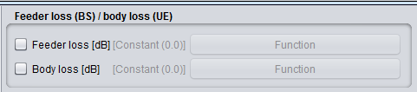
the feeder loss is always assigned to the BS and the body loss to the UE
- generic systems
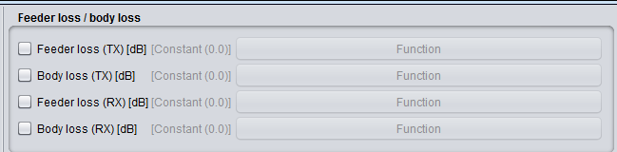
as on generic systems both components TX and RX can act like a ‘BS’ or a ‘UE’, respectively, both parameters feeder loss and body loss should be applicable, but on each component only one selectable, e.g.:
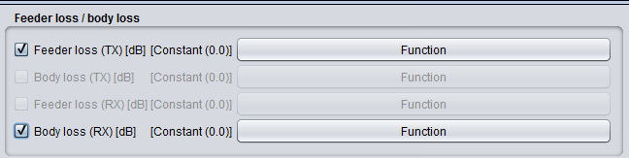
or
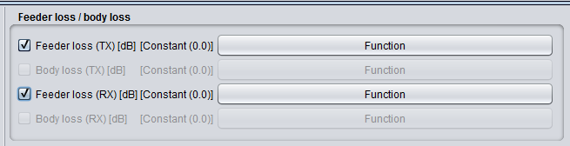
Reasoning for the parameter type ‘Function’:
although the Report ITU-R M.2292 (referenced by the initial contribution STG(19)085) uses for both parameters constant values, it had during the discussion in STG #65 been argued that some kind of ‘distribution’, i.e. a frequency dependency of the feeder loss and an ‘antenna like pattern’ of the body loss, should be applicable. In SEAMCAT the distributions generate random values, i.e. not related to e.g. a frequency offset, hence not feasible to provide this flexibility. The parameter type ‘Function’ does it.

Concerning the implementation (general):
- as we are talking about losses, the values must be ≥ 0 dB (consistency check)
- the feeder loss is
  - subtracted from the applied power if BS is transmitter (on generic systems the TX)
  - subtracted from the received signal if BS is receiver
(on generic systems the RX, not to be considered if User defined dRSS is simulated)
- the body loss is added to the path loss
- as proposed with STG(19)085, the information icons regarding the supplied power are to be removed

Concerning the implementation (with respect to not constant values):
- feeder loss
if the system / the interference link uses a frequency distribution, the lowest value of this distribution is the reference which the function’s offsets are based on (Δ frequency). The offset range must comply with the bounds of the frequency distribution (consistency check).
- body loss
on a first approach, the offset values are supposed to refer to the antenna azimuth (without additional offsets, e.g. pointing angles) towards the BS (on generic systems towards the system link component). Therefore the range of the offsets must be 0 … 360 degree (consistency check).
Note: if this would be acceptable, one could also think about to implement instead of a ‘default’ function a pattern interface similar to the horizontal antenna pattern.

Author:
Karl Koch (adhoc@heiseka.de)

