**FM54(16)56 Annex 4**

26 September 2016

|  |  |  |
| --- | --- | --- |
|  | **European Conference of Postal and Telecommunications Administrations - CEPT**  **Electronic Communications Committee - ECC**  **WG FM - FM54#11**  **Copenhagen, Denmark, 19-20 September 2016** |  |

**ECO Summary**

WGFM QUESTIONNAIRE TO CEPT ADMINISTRATIONS ON NATIONAL COORDINATION BETWEEN GSM-R AND MFCN

FM54 is requested to consider this ECO summary and make some assessments and recommendations for the WGFM.

# WGFM QUESTIONNAIRE TO CEPT ADMINISTRATIONS ON NATIONAL COORDINATION BETWEEN GSM-R AND MFCN

**The following 22 CEPT administrations provided an answer (in bold):**

|  |  |
| --- | --- |
| **Albania**  Andorra  Austria  Azerbaijan  Belarus  Belgium  **Bosnia Herzegovina**  Bulgaria  Croatia  Cyprus  **Czech Republic**  Denmark  **Estonia**  **Finland**  **France**  Georgia  **Germany**  **Greece**  **Hungary**  Iceland  **Ireland**  **Italy**  **Latvia**  **Liechtenstein** | **Lithuania**  Luxembourg  Former Yugoslavian Republic of Macedonia (FYROM)  Malta  Monaco  Montenegro  Moldova  **Norway**  Poland  Portugal  Romania  Russian Federation  San Marino  Serbia  **Slovak Republic**  **Slovenia**  Spain  **Sweden**  **Switzerland**  **The Netherlands**  **The United Kingdom**  **Turkey**  Ukraine  Vatican City |

Statement from Turkey: We have not observed any interference between these two services. The reasons for our case can be that E-GSM frequency band has started to be used in this year so its penetration is low and the usage rate of R-GSM is very limited. Thus, we considered that our case is different to the questionnaire and so we preferred not to reply to the individual questions.

Statement from Estonia: GSM-R in Estonia is not deployed. A Rail Baltic Project is planned using GSM-R technology.

**Group:** WG FM, FM 54   
**Submission dates:** 31-05-2016 - 26-09-2016   
**Introduction:**

During its 83rd meeting (18-22 May 2015), WGFM approved ECC Report 229 providing guidance for improving coexistence between GSM-R and MFCN in the 900 MHz band.

ECC Report 229 describes a coordination/cooperation process and guidelines for the dialogue amongst administrations as well as GSM-R and MFCN licensees, and provides several technical tools to facilitate the coordination.

In addition, the same meeting “agreed to carry out investigations in about one year, preferably by the means of a questionnaire to assess the suitability of the measures as described in ECC Report 229”

In this context, the present questionnaire aims at:

* collecting feedback from CEPT administrations on the implementation, experience and effectiveness of guidance/recommendations from ECC Report 229, and also ECC Report 162;
* identifying opportunities for improvements of ECC Report 229.

It is planned to issue such a questionnaire as necessary, in order to address as best the changes in the situation and the suitability of the technical measures described in the Report, and make appropriate developments in it.

This questionnaire follows the earlier request for information in 2013 (summary of the results, see ref [FM(13)065](http://www.cept.org/Documents/wg-fm/10450/fm-13-065_eco-summary-of-interference-into-gsm-r-questionnaire)), based on information for the period 2010-2012.

Finally, the results of this questionnaire could be shared with interested parties and contribute to improvements of the coexistence between GSM-R and MFCN.

CEPT administrations without railway network or GSM-R network are not requested to provide an answer.

Note from the ECO – due to software limitations, the format of the questionnaire has had to be modified. The content remains as agreed at WGFM#85.

**Questions:**

### ECC Report 229

**Question 1:** Are you following the guidelines for coordination/cooperation described in ECC Report 229?

|  |  |
| --- | --- |
| Albania | No |
| Bosnia Herzegovina | No |
| Czech Republic | No |
| Finland | No |
| France | Yes |
| Germany | Yes |
| Greece | No |
| Hungary | No |
| Ireland | Yes |
| Italy | No |
| Latvia | No |
| Liechtenstein | No |
| Lithuania | No |
| Netherlands | Yes |
| Norway | No |
| Slovak Republic | No |
| Slovenia | Yes |
| Sweden | No |
| Switzerland | No |
| United Kingdom | No |

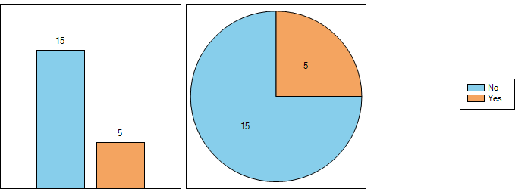

**5 administrations indicated to follow or consider the guidelines in the future for coordination/cooperation described in ECC Report 229.**

**Question 1.1:** If yes,

|  |  |  |
| --- | --- | --- |
|  | **what feedback can you provide with respect to the effectiveness of the process?** | **what is the expected duration of the transition period corresponding to the coordination/cooperation process implemented in your country?** |
| France | The national coordination process has been established on the basis of the process described in section 7of the ECC Report 229.   A pilot project from July 2015 to September 2016 resulted in the implementation of an operational coordination procedure. This coordination procedure is currently under review | The expected duration of the transition period in France is 2016-> end 2021  See [FM54(16)49](http://www.cept.org/Documents/fm-54/32396/fm54-16-49_french-gsm-r-experience-at-joint-risc-rsc-meeting) for further information. |
| Germany | It is intended to follow the guidelines for coordination/cooperation described in ECC Report 229. Details are still under development. | It is too early to answer this question concerning the situation in Germany. |
| Ireland | ComReg intends to amend its guidance relating to GSM-R in the future, as the need arises, to take account of the recommendations contained in ECC Report 229– to date, there has been no requirement to do this, given the very limited extent to which the GSM-R network has been rolled out so far within Ireland. |  |
| Netherlands | Coordination process worked out well to avoid/solve interference issues in advance of implementation of robust train radio equipment. Currently most of the rolling stock in NL has been modified. | Transition period has been ended as of mid 2016 and officially lasted for 2 years. |
| Slovenia | LIcence conditions from license for GMS-R No. 38115-14/2016/6 for Slovenske železnice - Infrastruktura, družba za upravljanje in vzdrževanje železniške infrastrukture ter vodenje železniškega prometa, d.o.o. valid from 18. 04. 2016 do 18. 04. 2026 states:  Operation is allowed in frequency range: 921 - 924,6 MHz/876 - 879,6 MHz  1. Radio frequencies are allocated to the holder for providing the GSM-R services in accordance with Decision CEPT ECC Decision (02) 05 and ECC Report 229th  2. In case that a GSM-R receivers operating in accordance with the ETSI TS 102933 to 1 in. 131, co-ordination in accordance with the ECC Report 229, Chapter 7 is not necessary. Otherwise, we recommend coordination with the operator Telemach in the band 880-885 MHz / 925-930 MHz, which is in accordance with the license obliged to co-ordinate 4 km from the railway track, and as well with the operator Si.mobil in the band 885-890 MHz / 930-935 MHz who has no such obligation in his license.  3. In case that a GSM-R receivers are operating in accordance with the ETSI TS 102933 to 1 in. 131, after preliminary testing of any potential harmful interference and on the GSM-R license owner own responsibility a sub-band 924.6 to 924.8 MHz paired with 987.6 to 987.8 MHz can be used as well.  4. In border areas the coordination agreements with the administrations of neighboring countries should be considered when planning the network (http://www.akos-rs.si/direktive,-priporocila-in-mednarodni-sporazumi).  Explanatory notes:  In accordance with ECC Report 229 which in executive summary describes cases of harmful in years 2013 and 2014 between narrow band GSM-R and wideband UMTS (5 MHz) and LTE (5 MHz and 10 MHz systems in adjacent band, which caused blocking of GSM-R receivers the use of GSM-R equipment in accordance with ETSI TS 102 933-1 v. 131 is recommended. For transition period therefore the coordination in accordance with chapter 7 of ECC Report 229 is obligatory with the operator Telemach mobil in the band 880-885 MHz / 925-930 MHz, which is in accordance with the license obliged to co-ordinate 4 km from the railway track, and as well with the operator Si.mobil in the band 885-890 MHz / 930-935 MHz who has no such obligation in his license.  As Ireland restricted the use of GSM-R to frequency band 921 - 924,6 MHz/876 - 879,6 MHz and based on findings of ECC Report 229, AKOS as well decided to limit the use of GSM-R to frequency band 921 - 924,6 MHz/876 - 879,6 MHz due to security reasons. If GSM-R are operating in accordance with ETSI TS 102 933-1 v. 131, the license holder may after preliminary testing of any potential harmful interference and on the GSM-R license owner own responsibility a sub-band 924.6 to 924.8 MHz paired with 987.6 to 987.8 MHz can be used as well. In that case as well the coordination in accordance with chapter 7 of ECC Report 229 is not obligatory. | see above |

**Question 1.2:** If not, please describe the coordination/cooperation process you are using. Do you take proactive or corrective measures?

Albania, Bosnia Herzegovina, and Latvia: GSM-R not in use. Slovak Republic: no procedure yet, but plans for further GSM-R build-out and use of new improved GSM-R receivers.

The Czech Republic, Hungary. Lithuania, Norway, Sweden, and the United Kingdom have measures and/or a coordination/cooperation process in use.

Greece, Italy indicated that a process is still under development/ to be implemented.

|  |  |
| --- | --- |
| Albania | The Albanian administration does not implement yet a railway network or GSM-R network |
| Bosnia Herzegovina | GSM-R neither in operation in Bosnia Herzegovina nor any plans known yet. Thus, no coordination between GSM-R and MFCN or any other application was conducted. If and when this issue arises, we will use CEPT documents, including reports that are subject of this questionnaire. |
| Czech Republic | Proactive measures are established in The Radio Spectrum Utilisation Plan and further legal documents. |
| Greece | In Greece, an individual spectrum right of use has been issued on behalf of the service provision company that manages the National Railway Infrastructure. The network is currently under construction, so no interference problems have ever been reported and no coordination process has been implemented yet. |
| Hungary | The GSM-R network is still under construction in Hungary. There is no formal coordination process, GSM-R operator takes informal coordinator role.  Decree No. 7/2015(XI.13) NMHH on the national frequency allocation and the rules of using frequency bands incorporates stipulation for obligation of mutual coordination between the operators of the GSM-R and of the mobile network operators, and both parties should take mutually the necessary steps in order to mitigate or avoid the interference. |
| Italy | So far the coordination/cooperation process is still under development/definition.  We take corrective measures. |
| Latvia | According to the Latvian National Radio Frequency Allocation Table the frequency bands 876–880 MHz / 921–925 MHz are designated for GSM-R systems in Latvia. However these frequency bands currently are not used for GSM-R because these systems are not implemented in Latvia yet. |
| Lithuania | There is a general coordination/cooperation process between radio frequency users and National Regulatory Authority (NRA). There was no case to take some measures to ensure cooperation between GSM-R and MFCN licensees. |
| Norway | Same as before, see answer to question 5 in “WGFM Questionnaire on interferences into GSM-R caused by MFCN to be sent to CEPT administrations by the ECO” submitted in March 2013. We use both scanners and GSM-R terminals on a measurement train to do proactive measurements. |
| Sweden | The GSM-R community and the mobile 900 MHz operators have been working actively together on the GSM-R interference issue since 2012. However, the dialogue started already in 2009, thus years before the publication of ECC Report 229. Sweden has found no need of e.g. a coordinator.   In 2009, PTS established technical restrictions in conjunction with the prolongation of the mobile operators’ 900 MHz licences and opening the band for UMTS and LTE. PTS thus made an effort to lay down and promote a long term solution to the co-existence between GSM-R and LTE/UMTS. After a transitional period of some years, the technical restrictions were to be mitigated.   The principle that governed the design of these restrictions was that of even distribution of burden, where all involved parties, i.e. the public mobile operators, the GSM-R operator and the railway undertakings, had to take measures to achieve a common goal.   As long as all parties fulfil their obligations, the risk of interferences will be negligible and will also prevents future ad-hoc dispute resolutions.   On the 28th of January 2015, a hearing was held with all the involved actors.  The outcome of this hearing was that a steering group was formed to tackle the issue.   The Swedish Ministry of Enterprise, Energy and Communications chaired the steering group with the aim of solving the interference issue and to monitor the progress of installations.   Members of the steering Group:  Swedish Post and Telecom Authority  Swedish Transport Agency  Trafikverket (operator of GSM-R)  Railway undertakings  AB Transitio  The Association of Swedish Train Operating Companies (represented by SJ and Hector Rail)  Stockholm Public Transport (SL)  the Swedish Public Transport Association  Swedish Association of Local Authorities and Regions (SKL)  Mobile operators (represented by Telenor)   The group has had regular meetings since February 2015. It was closed in June 2016 as a result of “mission completed”.   The coordination/cooperation has been performed as a Common agreement - ”Handshake” between parties and a commitment to exchange information.   Further, in May 2015 the Swedish government assigned to Trafikverket (the Swedish authority that operates the GSM-R network) to coordinate the installations of protective measures in GSM-R equipment. A compensation scheme was introduced.   Some pieces of the puzzle were identified in order to move forward:  • - Technical solution - agreed, specified and tested  • - Transitional period - extended restrictions for the public mobile operators  - Handling of the effects on border crossing traffic - e.g. need for re-authorisation?  - Financing - compensation to Railway operators   The extended technical restrictions that were combined with the 900 MHz licences were initially due 30 June 2015, but then prolonged to 30 June 2016. The intention was to offer reasonable time for the railway undertakings to implement protective measures in their GSM-R equipment on-board all vehicles.   By 1 July 2015, the EU regulations had been revised so that the railway equipment upgrades would be TSI compliant.   From 1 July 2016 the remaining restrictions are aimed to lead to a long term equal distribution of burden between the involved parties. |
| Slovak Republic | The coexistence of GSM-R and MFCN in Slovak Republic has not yet been solved due to the low utilization of frequencies for GSM-R. |
| United Kingdom | The UK’s coordination process was put in place prior to report 229 being published.  The coordination procedure applies to the protection of GSM-R base station sites and GSM-R train mounted equipment in operation at the time a new 3G or 4G site is deployed or its technology or EIRP changes. In addition to this proactive coordination some more informal reactive coordination is also being undertaken between the relevant parties in certain circumstances. The UK is looking at options to update the formal coordination procedure with these elements, many of which are based on the principles of Report 229.   For the proactive coordination, the 900 MHz operator (MNO), using data supplied by the GSM-R operator (Network Rail), must establish if a proposed 3G or 4G site is likely to breach the coordination thresholds specified in the coordination procedure.   If, as reasonably determined by the MNO, the thresholds specified are not likely to be breached, then no coordination is required. If any of the thresholds specified are likely to be breached, the 3G or 4G site cannot be brought into operation until it has been successfully coordinated with the GSM-R operator.   When coordination is required, the MNO will contact the GSM-R operator with details of the proposed 3G or 4G site.  In a reactive way, following detection (and based upon analysis by Network Rail and MNOs), MNOs have reduced sector powers or the GSM-R operator has undertaken supplementary cell deployment.   An updated process is likely to consist of two phases, whereby more restrictions are placed on the MNOs in the short term until improved GSM-R cab mobile receivers are installed when restrictions would be relaxed. However, the greater restrictions will be unacceptable long term due to the constraints on the MNOs and the impact on consumers on or in the vicinity of the train lines.   Q2:  Yes, (But we note that that there are other tools and approaches that deliver the same outputs / end position) |

**Question 2:** Do you find that ECC Report 229 contains all relevant information to allow efficient coordination/cooperation for the operations of GSM-R and MFCN?

|  |  |
| --- | --- |
| Czech Republic | Yes |
| Finland | Yes |
| France | No |
| Germany | Yes |
| Greece | Yes |
| Hungary | Yes |
| Ireland | Yes |
| Italy | Yes |
| Liechtenstein | Yes |
| Lithuania | Yes |
| Netherlands | No |
| Norway | Yes |
| Slovak Republic | Yes |
| Slovenia | Yes |
| Sweden | No |
| Switzerland | Yes |
| United Kingdom | Yes (but noting that there are other tools and approaches that deliver the same outputs/ end position) |

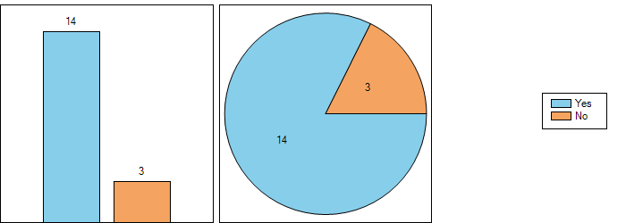

**Discuss the need for additional information in ECC Report 229 or separate Report. See also suggestions under 5.1, 9.1, and 11.1, e.g to consider additional use cases to be described (e.g. Inter Mod 3 frequencies, or to share national best practices to solve remaining critical coexistence issues (ECO web site?).**

**Question 2.1:** If not, what elements should be added?

|  |  |
| --- | --- |
| France | While ECC Report 229 served as the basis, some complements were added to the French national coordination process such as the definition of the IM3 thresholds for 50% GSM-R coverage level and the target time of response from the different actors. The calculation of the interference risk (IM3 only) is under the responsibility of SNCF Réseau. |
| Netherlands | How to deal with interference due to unwanted emission can be further refined? The interference potential is proportional to the local field strength of the GSM-R signal, which is often higher than the minimum coverage level. Therefore, only incidentally at some locations additional filters at the MFCN side or increase of GSM-R power could be necessary. |
| Sweden | An element that could be added would be a general approach to achieve legal certainty so that the users know their rights and obligations.   Railways need uninterrupted 24/7 operations of GSM-R with known conditions over time to be able to deliver high availability.   Mobile operators need to evolve their networks in order to meet consumers’ demands and to get reasonable financial return of interest.   A long time solution would include obligations regarding:  • Fixed maximum OOB emission into GSM-R from mobile broadband networks  • Maximum power levels from mobile broadband networks along the railways   As a result:  • It is necessary to increase GSM-R power levels to maintain availability of GSM-R services  • Install filters or improved receivers in all vehicles.  • Adjustments of mobile operators’ base stations  along railways. |

### ECC Report 162

**Question 3:** Are you applying the recommendations/toolbox provided by ECC Report 162?

|  |  |
| --- | --- |
| Czech Republic | No |
| Finland | No |
| France | Yes |
| Germany | Yes |
| Greece | No |
| Hungary | Yes |
| Ireland | Yes |
| Italy | Yes (partially) |
| Liechtenstein | No |
| Lithuania | No |
| Netherlands | Yes |
| Norway | Yes |
| Slovak Republic | No |
| Slovenia | No |
| Sweden | No |
| Switzerland | No |
| United Kingdom | Yes |

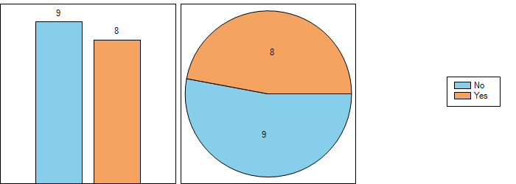

**Question 4:** Do you find that ECC Report 162 contains all relevant information to allow the deployment of practical mechanisms to improve the compatibility between GSM-R and MFCN?

|  |  |
| --- | --- |
| Czech Republic | Yes |
| Finland | Yes |
| France | Yes No (see under 4.1) |
| Germany | Yes |
| Greece | Yes |
| Hungary | Yes |
| Ireland | Yes  No (not at present, too early) |
| Italy | Yes |
| Liechtenstein | Yes |
| Lithuania | Yes |
| Netherlands | Yes |
| Norway | Yes |
| Slovak Republic | Yes |
| Slovenia | No |
| Sweden | No |
| Switzerland | Yes |
| United Kingdom | No |

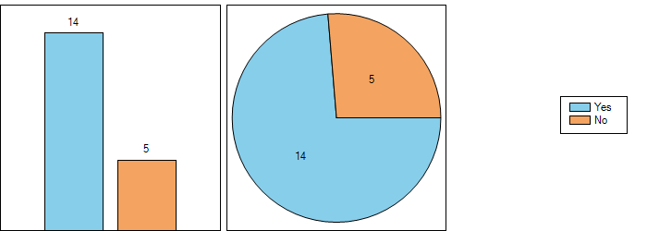

**Question 4.1:** If not, what elements should be added?

It seems that no suggestions are made with regard to addings in ECC Report 162.

|  |  |
| --- | --- |
| France | This Report provides some general good practices to resolve interferences. It has not been used during the discussions between MNOs, SNCF and ANFR, which started in 2015 as the Report 229 was more appropriate. Report 162 is however considered when interference cases are raised in order to find solutions. |
| Ireland | ComReg is of the view that, at present, given the limited extent of GSM-R network roll-out within Ireland, ECC Report 162, in the current Irish context, contains all relevant information to allow the deployment of practical mechanisms to improve the compatibility between GSM-R and MFCN |
| Slovenia | We feel that is too complicated. We prefer the use of GSM-R equipment in accordance with ETSI TS 102 933-1 v. 131 and approach in ECC Report 229 |
| Sweden | The Swedish solution has not been based on coordination activities as presented in the Report; therefore the report's toolbox has not been used. |
| United Kingdom | Network Rail also employs other tools, e.g. train based monitoring of interferer levels and interference impact, however the output is the same. |

### Additional considerations

**Question 5:** Do you have any further consideration that you believe should be addressed in addition to the elements in ECC Report 229 or ECC Report 162?

|  |  |
| --- | --- |
| Czech Republic | No |
| Finland | No |
| France | Yes No (see under 5.1) |
| Germany | No |
| Greece | No |
| Hungary | Yes |
| Ireland | No (not at present) |
| Italy | No |
| Liechtenstein | Yes |
| Lithuania | No |
| Netherlands | No |
| Norway | No |
| Slovak Republic | No |
| Slovenia | No |
| Sweden | Yes |
| Switzerland | Yes |
| United Kingdom | Yes |

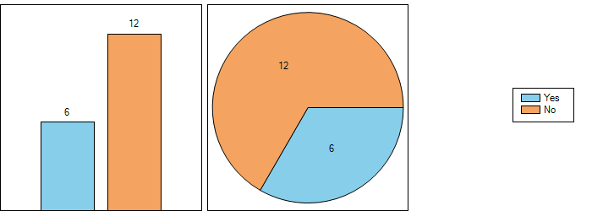

**Question 5.1:** If yes, what elements should be added?

|  |  |
| --- | --- |
| France | The information provided in the ECC 229 Report related to intermodulation thresholds (based on the tests performed in Munich) could be further detailed and clarified as some of the measurements and analysis are not included but only available within the working group folders which in time may no longer be available. A dedicated report on these measurements could be compiled and published to ensure this work available. |
| Liechtenstein | We apply similar methods as described by Switzerland in regards of OOB interference from the MFCN base stations. |
| Sweden | Another aspect that would have been fruitful to address regards the impact of retrofit requirements on the GSM-R receivers. |
| Switzerland | In ECC Report 229, for the calculation of the allowed MFCN OOB levels, the slow fading (shadowing) of the OOB interference from the MFCN base station was unfortunately neglected. In Switzerland we took this fading into account and the median of the allowed MFCN OOB level at the antenna input of the GSM-R receiver is therefore only -107 dBm/200 kHz, instead of -101 dBm/200 kHz + 6 dB = -95 dBm/200 kHz (median level at radio connector + HW losses) proposed in ECC Report 229, Table 4. |
| United Kingdom | Any solutions proposed should allow individual administrations to take into account their own unique circumstances. They must also be appropriate for the likely upgrade path to next generation railway systems. This could be within 10 years in the UK.   Considering logically separated radio bearers and railway functionalities in future railway systems will facilitate alternative options for avoiding the co-existence challenges that GSM-R faces. |

### Improved GSM-R receivers or additional filtering

**Question 6:** Has the implementation of improved GSM-R receivers and/or additional filtering in the vehicles authorised to run in your country commenced? You can provide additional information about the process towards improved GSM-R receivers and/or additional filtering e.g. roll-out time plan, percentage of trains equipped.

|  |  |
| --- | --- |
| Czech Republic | No |
| Finland | Yes |
| France | No |
| Germany | No |
| Greece | No |
| Hungary | Yes |
| Ireland | No |
| Italy | Yes |
| Liechtenstein | Yes |
| Lithuania | No |
| Netherlands | Yes |
| Norway | No |
| Slovak Republic | No |
| Slovenia | Yes |
| Sweden | Yes |
| Switzerland | No |
| United Kingdom | Yes |



**Question 6.1:** If yes, as of when, and what is the experience with regard to interference susceptibility?

It seems that initial experience with improved GSM-R receivers is very positive and improving the situation, i.e. solving significantly existing problems and improving quality.

|  |  |
| --- | --- |
| Finland | As of 2014. Additional filtering has improved the situation. |
| Hungary | The GSM-R network in Hungary is still in the implementation phase. |
| Ireland | In the event that harmful interference occurs, ComReg has recommended that efforts to resolve the interference between affected parties should be undertaken by the relevant operators, in accordance with the co-ordination methods as detailed in ECC Reports 96, 146, and 162 (as appropriate). This may entail, amongst other mitigation techniques, the need to employ additional filtering on GSM-R equipment. However, taking into account the limited extent to which the GSM-R network has been rolled out so far within Ireland, ComReg has not yet seen the need to implement a formal requirement (beyond that stated directly above) for improved GSM-R receivers and/or additional filtering in the vehicles authorised to run in Ireland. |
| Italy | Trains equipped with UIC filters enhance significantly ETCS QoS performance. |
| Liechtenstein | We don’t have filter on the Cabradios and ETCS Mobiles |
| Netherlands | Currently, in most of the rolling stock robust equipment has been installed. Interference susceptibility works out well. |
| Slovenia | See answer to Q1 |
| Sweden | During the last year all vehicles with operations in Sweden have been equipped with interference protection (2700 filters and 300 improved receivers). In total 3000 GSM-R equipment is protected 2700 CAB-radios and 300 ETCS modems.   Any remaining unprotected vehicles suffering from interference will be handled case by case on the basis of shared risks between the railway undertakings and mobile operators or through targeted supervision activities by the regulatory authorities.   The improved radio performance of ETSI TS 102 933-1 is now mandatory to all new, renewed or upgraded vehicles as the new CCS TSI now is in force. |
| United Kingdom | Based upon work undertaken by Network Rail on behalf of the UIC, which indicated that the improved receiver mitigates many of the open issues, Network Rail have contracted its supplier to further develop the UK Cab Radio such that it can be fitted with an improved receiver. |

### Coordination/cooperation process for the coexistence of GSM-R and MFCN

**Question 7:** Have you implemented a coordination/cooperation process within your country?

|  |  |
| --- | --- |
| Czech Republic | No |
| Finland | Yes |
| France | Yes |
| Germany | Yes |
| Greece | No |
| Hungary | Yes |
| Italy | No |
| Lithuania | Yes |
| Netherlands | Yes |
| Norway | Yes |
| Slovak Republic | No |
| Slovenia | No |
| Sweden | Yes |
| Switzerland | Yes |
| United Kingdom | Yes |

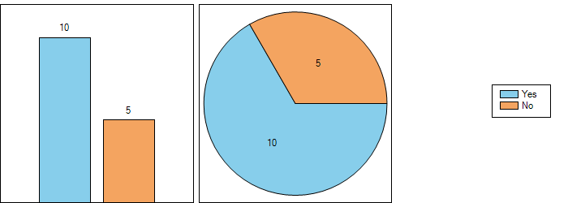

**Question 7.1:** If yes, was it implemented prior to the publication of ECC Report 229? Remarks (e.g. process still under development/definition in your country)

|  |  |
| --- | --- |
| Finland | Yes |
| France | No |
| Germany | No |
| Hungary | Yes |
| Ireland | As stated above, ComReg recommends that efforts to resolve interference concerns between operators should be undertaken between the relevant, potentially affected, parties, in accordance with the co-ordination methods as detailed in ECC Reports 96, 146, and 162 (as appropriate). |
| Lithuania | Yes |
| Netherlands | Yes |
| Norway | Yes |
| Sweden | Yes |
| Switzerland | Yes |
| United Kingdom | Yes |

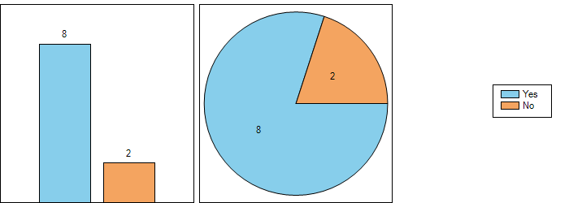

**Question 8:** Did you modify the existing national processes based on the conclusions of the ECC Report 229 and/or lessons learnt? Remarks (e.g. process still under development/definition in your country)

**Only Slovenia and the United Kingdom indicated to have used ECC Report 229 to modify the existing national processes. Note however that activities in this regard were conducted often in parallel on national level and in ECC.**

|  |  |
| --- | --- |
| Czech Republic | No |
| Finland | No |
| France | No |
| Germany | No |
| Greece | No |
| Hungary | No |
| Ireland | No, not yet. However, ComReg intends to take the conclusions of ECC Report 229 into account as the GSM-R network further expands, with such expansion expected to take place over the course of the forthcoming year. |
| Italy | No |
| Liechtenstein | No |
| Lithuania | No |
| Netherlands | No |
| Norway | No |
| Slovak Republic | No |
| Slovenia | Yes |
| Sweden | No |
| Switzerland | No |
| United Kingdom | Yes |

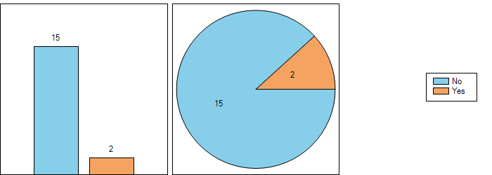

### Changes for the GSM-R/ MFCN coordination/cooperation process in your country since 2012

**Question 9:** Have you implemented changes to the GSM-R/ MFCN coordination/cooperation process in your country since 2012?

5 administrations have implemented changes since 2012.

|  |  |
| --- | --- |
| Czech Republic | No |
| Finland | No |
| France | Yes No |
| Germany | Yes |
| Greece | No |
| Hungary | Yes |
| Ireland | No (licence to National Rail Operator only issued in 2015) |
| Italy | No |
| Liechtenstein | No |
| Lithuania | No |
| Netherlands | No |
| Norway | No |
| Slovak Republic | No |
| Slovenia | Yes |
| Sweden | Yes |
| Switzerland | No |
| United Kingdom | Yes |

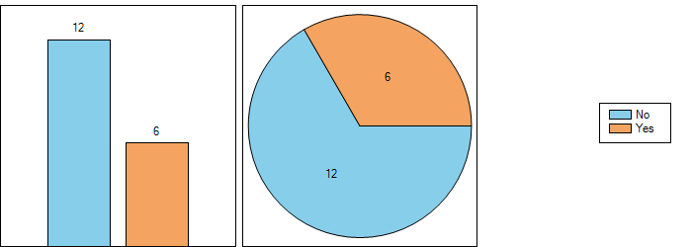

**Question 9.1:** If yes, please describe the changes. If possible, you can also provide a link or document here.

|  |  |
| --- | --- |
| France | Operational trial of the coordination process started in January 2016 (after the definition of the national coordination process in 2015). See FM54(16)49 form information. |
| Germany | The process is still under development in Germany.  To date there are bilateral agreements with the public mobile operators for the areas along the new high-speed railway lines (e.g. Erfurt-Leipzig) were ETCS Level2 is in use. These agreements will be adopted until end of 2016. |
| Hungary | See question 1 |
| Slovenia | 18. 04. 2016 |
| Sweden | See answers to Q1 and Q7   The counterparts have been working together on the GSM-R interference issue since 2012. However, the dialogue began already in 2009.   A steering Group was established to handle the interference situation that was to occur from 1 July 2016 when the mobile operators' user specific restrictions were to be relieved.   The Swedish government introduced a compensation scheme to the railway undertakings; a regulation regarding reimbursements for safety equipment and the installation of safety equipment in the railroad's communication system. The time frame given was one (1) year. Equipment bought and installed before 1 March 2016 was compensated up to 4000€, and after that up to 2000€. The scheme is in force until 31 December 2017.   The compensation scheme has been vital to progress.   More information about compensation scheme and co-existence can be found at <http://www.trafikverket.se/en/startpage/operations/Operations-railway/co-existence-gsm-r-3g4g/> . |
| United Kingdom | The coordination procedure was updated 9 July 2013 to replace the previous version of 26 January 2012. It was updated to include coordination of sites operating 4G technology in the 900 MHz band and also take account of any power increases permitted through the varying of Mobile licences |

### Reported interference cases

**Question 10:** Since 2012, within your country, how many new interference cases into GSM-R have been reported and how many were caused by MFCN?

Reported cases from 9 administratations: Finland, France, Germany, Hungary, Italy, Netherlands, Norway, Switzerland, and the United Kingdom. The majority of the cases is reported to be caused by MFCN.

|  |  |
| --- | --- |
| Czech Republic | Until now no case reported. |
| Finland | 54 cases have been reported. 10 cases have been investigated and in these MFCN has been the cause. In all cases MFCN has been suspected to be the cause of interference. |
| France | Since 2012, 6 cases have been investigated by the ANFR:  • 4 cases of IM3 are still under investigation.  • 2 cases are closed:   - -  Additionally, during the coordination/cooperation process, SNCF Réseau has reported 101 cases of IM3 and 1 case of blocking:  • 8 cases are now solved  • 92 have a minor impact on the railway operation  • 2 have of loss of communication over a certain distance.   21 cases of loss of communication are currently under investigation by SNCF Réseau |
| Germany | There are 284 reported interference cases since 2008. Since 2012 till August 2016, 109 were reported, of which 92 were caused by MFCN. |
| Greece | There are no interference cases reported since the network is under construction. |
| Hungary | The network still under construction. The National Media and Infocommunications Authority, Hungary received 1 interference announcement. When the Authority’s Measurement Unit tried to measure, they did not experience the interference problem.  Troubleshoot of the existing 12 interference cases are in progress in cooperation with operators of the GSM-R and of the mobile network operators in accordance with the Decree No. 7/2015(XI.13) NMHH on the national frequency allocation and the rules of using frequency bands. |
| Ireland | No interference cases have yet been reported. |
| Italy | #45 interference zones, all caused by MFCNs. |
| Liechtenstein | none |
| Lithuania | 0 |
| Netherlands | Only a few interference cases (< 10) have been reported due to MFCN in the last years. |
| Norway | Approx. totally 18 between 2012 and 2016 that possibly are caused by MFCN. |
| Slovak Republic | Since 2012 we received no interference case report for GSM-R. |
| Slovenia | No |
| Sweden | Because of the temporary specific restrictions on mobile networks in the 900 MHz band until 30 June 2016, almost no interference issues have been raised.   Sweden anticipates the number of interference cases to stay very low since the vast majority of the railway fleet has been fitted with protective measures. |
| Switzerland | Less than 10 cases. Most caused by MFCN. Since 2013 the number of interference cases didn’t increase. The reason could be, that SBB is coordinating with the MFCN’s the implementation of filters in their BTS. |
| United Kingdom | No formal reports were submitted to Ofcom but Network Rail, the company which operates the track and trackside communications in the UK, has noted that there have been approximately 180 local reports of interference which have been dealt with by informal cooperation between Network Rail and the MNOs. Local interference is being dealt with under the coordination procedure as enhanced by informal cooperation while improved GSM-R cab radios are being investigated. |

### ECC Report 229 deals with intermodulation products of three frequencies.

**Question 11:** Have you ever noticed interference from intermodulation products of three frequencies into GSM-R?

France, Germany, Italy and the United Kingdom have experienced interference from intermodulation products of three frequencies into GSM-R, though difficult to assess in individual cases.

|  |  |
| --- | --- |
| Czech Republic | No |
| Finland | No |
| France | Yes |
| Germany | Yes |
| Greece | No |
| Hungary | Yes |
| Ireland | No |
| Italy | Yes |
| Liechtenstein | No |
| Lithuania | No |
| Netherlands | No |
| Norway | No |
| Slovak Republic | No |
| Slovenia | No |
| Sweden | No |
| Switzerland | No |
| United Kingdom | Yes |

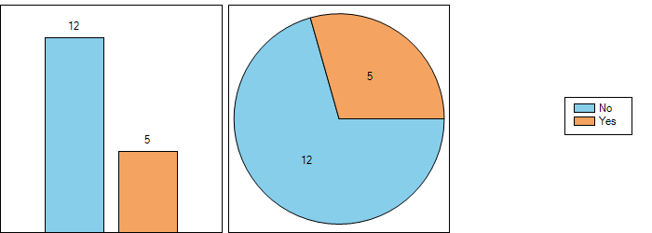

**Question 11.1:** If yes, how often? Please describe.

|  |  |
| --- | --- |
| France | 1 case of three frequencies IM3. |
| Germany | Interference cases based on IM products are known, but according to the interference statistic it is not possible to say whether 3 MFCN frequencies caused the interferences. |
| Hungary | No information |
| Italy | We have 5 interference areas where signals from 3 MFCNS are all >-30dBm. |
| United Kingdom | Although the detail of interference mechanisms can be difficult to capture when resolving issues, Network Rail believes the causes to be in the order 50% intermodulation products, 40% blocking, 10% out of band emissions from MNO ENodeBs (as a cause, is noted the latter appears be an upward trend). |

### GSM-R deployment, use and coordination distance.

**Question 12:** GSM-R deployment, use and coordination distance.

15 answers

Coordination distances between up to 500 m and up to 4 km are used. In some countries it’s not defined (yet), or under operators’ self-coordination, or based on power and not distance.

|  |  |  |  |  |  |  |
| --- | --- | --- | --- | --- | --- | --- |
|  | **a) What is the total length of rail tracks (length in km) in your country?** | **b) What amount of rail tracks (length in km) has been covered by GSM-R?** | **c) How much remains to be covered?** | **d) How many GSM-R base stations are currently deployed in your country?** | **e) What coordination distance is considered in your country?** | **f) How many MFCN base stations are currently deployed within the coordination distance around the rail tracks in your country?** |
| Czech Republic | 9500 km | 1500 km | 1200 km | 320 | n/a - under negotiation | 0 |
| Finland | 5944 | ≈5000 | None. Railway traffic will move from GSM-R to existing TETRA based network in the 400 MHz band from year 2018 (planned). | - | - | - |
| France | 30 000 km | 16 000 km of deployed GSM-R network  8 000 km of operational GSM-R coverage | The roll out of the GSM-R network infrastructure is done. The process to migrate the analog system to GSM-R system is in progress (end planned in 2017) | 2 500 BTS | 1000 m in trial period of the coordination process managed by ANFR in cooperation with various railways and mobile stakeholders. 500 m is planned to be used in the permanent coordination process to be established around Q3 2016 (various criteria under discussion to ensure a proper operation of the national ex-ante coordination process). | Additional comments :  Over the 1st half of 2016 (trial period), more than 2 000 creations/modifications of MFCN base stations (operating in 900 MHz) have been detected in the coordination distance around the rail tracks (i.e. 1000 m). 24 out of those 2 000 cases have been reported to the National Authority as potential IM3 cases for GSM-R ( less than 2% of the 900MHz projects in the coordination zone) |
| Germany | ca. 34,000 km | ca. 29,000 km | ca. 1,000 km | ca. 3,800 | up to 2 km | There are certain MFCN base stations deployed within the coordination distance around the rail tracks in Germany. However, precise numbers cannot be named until the submission date of this questionnaire. |
| Greece | about 2500 km | about 690 km | 17 km | 96 | No coordination process has been implemented yet. |  |
| Hungary | 7938 km | 935 km | approx. 2394 km | 147 | There is coordination distance considered in Hungary. | We don’t have information about the base stations deployed nearby the railway network |
| Ireland | Approximately 2400 km | Approximately 100 km | 2300 | 42 | ComReg, rather than currently stipulating specific coordination distances, recommends at present that operators generally co-ordinate in accordance with the methods as detailed in ECC Reports 96, 146, and 162, as appropriate. Please also note that ComReg only issued its GSM-R licence to the National Rail Operator in 2015. | In the event that interference occurs, ComReg currently encourages all relevant operators to liaise with one another in order to mutually resolve any interference concerns. As such, and also given that (1) the GSM-R network within Ireland which has been rolled out to date is very limited, and (2) no interference cases have been reported to date, ComReg has not yet identified the need to consider this matter. |
| Italy | 16.726 Km | 11.166 Km | 5.560 Km | 1825 | Not defined | Not defined. |
| Liechtenstein | ~10 Km | ~10 Km |  | 1 | 4 km. |  |
| Lithuania | 1779 | 1563 | 216 | 127 | 0 | 0 |
| Netherlands | ~4000 km | All | n/a | ~250 | 500 m | There are ~1500 MFCN sites within the coordination distance (most of those sites contain multiple base stations). About 5% of these sites are considered a risk. |
| Norway | Approximately 3800 km. | Approximately 3800 km. | Most of the Norwegian track is already covered. Only some low used side tracks are not covered, and they are not planned to be covered either. | Approximately 540 BTSs. | 700m | Unknown |
| Slovak Republic | 3625 | 400 | 3225 | 64 | NRA did not determine coordination distance.  Distance between BS of mobile operators and rail tracks vary according to the location of their facilities (station, building, and their own towers). | NRA does not determine coordination distance for MFCN around the rail tracks in Slovak Republic. |
| Slovenia | N/A | N/A | N/A | N/A | 4 km, see as well Q1 | N/A |
| Sweden | 11 000 km | 11 000 km | 0 km | 1 400 base stations and 250 repeaters | Not applicable in Sweden | The 900 MHz band is self- coordinated. PTS does not have any information on the placement of MFCN base stations.   However, according to non- confirmed figures, more than 1 000 MFCN base stations are placed near the railway. |
| Switzerland | ~5380 km (normal gauge) | SBB ~2050 km  SBB including other companies ~2280 km | SBB ~2800 km  SBB including other companies ~3100 km | SBB ~650 (planed 840 more)  SBB including other companies ~700 (planed 900 more) | 4 km.  Coordination is only needed when the median of the OOB interferences from MFCN base stations exceed the level of -107 dBm/200 kHz at the train antenna input (i.e. 30 dBµV/m/200 kHz). See also Remarks to Question 7. |  |
| United Kingdom | 15,500km | 15,108 km | All Network Rail controlled infrastructure has been fitted with GSM-R, with the exception of a few remote lines, where no fitment plans exist | 3053 cells / 2427 sites | Coordination is based on power level rather than distance | Not applicable as coordination is based on a power level rather than distance |

### -END-