SUMMARY OF THE QUESTIONNAIRE TO USERS OF THE ECO FREQUENCY INFORMATION SYSTEM (EFIS)
Group: WG FM, EFIS/MG
Submission dates: 22-05-2018 - 07-09-2018
Introduction
EFIS (www.efis.dk) is the official European database providing information on how spectrum must be used and is actually used in all countries. This database is maintained by the European Communication Office (ECO) in compliance with EC Decision 2007/344/EC.
Since 2014, ECO has added a wealth of information and intends to develop EFIS further, which is why ECO has published this questionnaire designed to assess users’ satisfaction on the type of information available in EFIS, on the quality of it, on the features of EFIS, on the ease of use and learnability of this website.
A workshop on EFIS was held September 2017 and it was agreed to develop this questionnaire on EFIS to CEPT administrations and Users of the EFIS. See also the ECC Newsletter published after the EFIS workshop for more information about EFIS and the workshop.
The purpose of this questionnaire has been to collect information that helps to develop the EFIS further.
Please note that ECO will not disclose your name and administration / company in the subsequent report.

Questions:

PART I. About you
Question 1:
Please tell us how often you use EFIS?

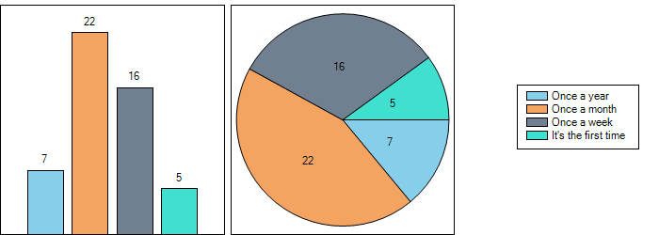
Question 2:
With regard to question 1. What do you use it for?

Please indicate in some words for which purpose you use the EFIS
Researching spectrum availability and applicable requirements
Checking who are the existing incumbents in bands of interest
Allocations, restrictions, RED risk assessment, applicable standards
Overview on regulatory information related to frequency assignment
To find the applications in certain frequency bands
For information and analysis.
radio regulations
Harmonised standards
- used frequency bands
- search for ETSI specifications
- applications per frequency band
Look for frequency allocation
Check the allocated use of certain frequency band (especially any changes)
Document review
Checking the frequency allocation of various wireless services and direct access to Rec 70-03
In order to compare the frequency band allocations between services in the neighbouring countries and other European countries if needed
Updating French data.
Checking assigned frequency bands for different countries and if any restrictions are applicable
Type approval matters and compliance matters
To check how our neighbours use frequency bands.
To compare the use of frequencies in different countries or in ECA/ITU tables.
To verify the correct use of some frequencies within EU.
To look for documentation associated to certain application/frequencies.
Checking the allowed railway channels for lab approvals
To learn how a particular chunk of spectrum is used in Europe
Updating and checking information for Ireland.
Compare information NTAF/interfaces radio between countries
For design new products and services for the GNSS Receive in the surveying and construction market places.
management of Slovenia table, compare the services in different countries
Primarily used for Spectrum management
Comparison with allocation/application tables, look at ITU-R allocation table
- Updating the national information in EFIS
- Getting information about the spectrum utilization in CEPT countries
Main use: In each CEPT country, what applications do we have in which frequency band?
Mainly to check administrations' implementation of Article 4.4 allocations and frequency allocations which appear in the ECA and footnote ECA17
NB assessment according to directive 2014/53/EU
Check frequency allocations
I check the information.
frequency range
Updating information, making inquiries
ECA table, searching for Applications, Interfaces and RoU in different countries. Checking and updating information concerning Estonia.
As an equipment vendor, it is useful to see which bands are allocated in which countries, to target both sales and R&D effort.
to find out if it is possible to use a radio equipment in a Country (for market surveillance)
• To take necessary information on frequency usage in other CEPT countries;
• To analyse frequency usage in CEPT countries by different servicers/applications and analyse corresponding technical conditions of such usage
Case 1: I use it sometimes to verify, when people claim that other countries allow for much more power in band xy than Switzerland.
Case 2: To look which of the mobile operators use which part of the LTE, UMTS, GSM band since and until when.
I'm the Administration contact of EFIS in Portugal.
Mainly to compare uses among CEPT members.
I've never used EFIS.
Obtain information on the use of spectrum in Europe and Portugal (Allocation and Application)

Question 3:
Please indicate in which field you work within your organisation?

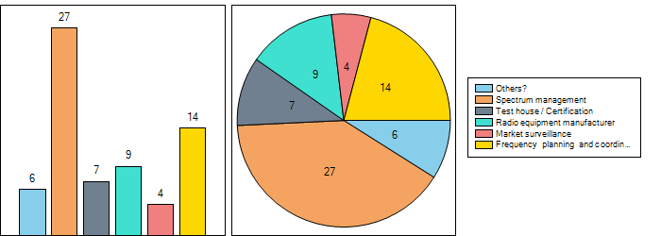

Question 3.1: Please specify

R&D Standards & Strategy
Regulatory and standards for wireless
Consultant for compliance matters and type approval
policy matters and international relations
Spectrum and regulatory matters for amateur and amateur-satellite services
Notified Body

Question 4:
Are you familiar with how the radio regulatory environment works? (e.g. ITU, CEPT, EC, ETSI, etc., Radio Regulations, ECC Decisions, etc)

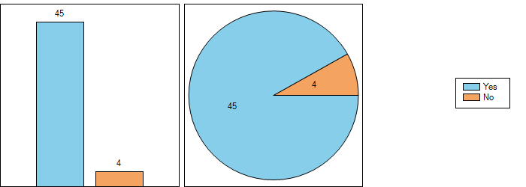
This confirms that EFIS is used by the ‘interested public’, i.e. the experts in the different field of spectrum management from administrations, industry, operators, test houses etc.

Question 5:
Your questions when searching information in EFIS. It would be good to know for which purpose you use the EFIS. Therefore, It would be helpful to indicate some questions which you have when searching for information in EFIS. This question is intended to identify the type of information queried by you as an EFIS users?
Please specify your question(s)/ consideration(s) (which will be taken into account for possible improvement of the EFIS)
Could one do the following xxxxxx in the 2.4 GHz band? - If that's not possible why? what are the alternatives in this spectrum or somewhere else? Looking for unlicensed spectrum beyond 2.4 where is there a possibility for yyyy?
Allocations, restrictions, possible interfering users in spectrum
Is the specific frequency available throughout Europe?
What restrictions apply in which country?
Additional documents/regulations
Spectrum use in the European countries – rights of use in the European countries
RED equipment classes
Harmonised standards applied to Marine equipment
Which application is used in which frequency band?
Radio-LAN is used in which frequency band?
Which other RF applications are operating near DECT, 2.4GHz ISM and 5GHz-RLAN frequency band?
none
whether certain use (say RLAN) is allowed in certain band (say 5725-5875 MHz)
1. I want to use xx MHz for my transmitter - what, if any, countries allow the use of this frequency?
2. Is there a licenced band in xx country for this type of transmitter
3. I have a wireless water meter (e.g.) - what frequency does it have to be on to be acceptable in xx country
1) Which services are allocated in the frequency band concerned in the neighboring countries in order to compare with BLR?
2) What are the conditions of the usage of the frequency bands concerned in the neighboring countries and other European countries if needed?
3) Which new technologies or applications are deployed or planned to deploy in the perspective frequency bands?
I compare French data with data from all CEPT countries to find out inconsistencies in national information.
Applicable frequencies and standards for worldwide type approval
Which services use exact frequency band in neighbouring countries?
What documents regulate the usage of exact frequency band in neighbouring country and in Europe?
For what use (allocation/application) a certain frequency band is allocated in the neighbouring country?
Sometimes I would like to ask by application without enter the frequency, but I haven't found the way to do it.
type approvals and certification
Example: What services are using band X in Europe?
Example: Is Y country using band Z for service A?
Etc.
Our GNSS Receiver with integrated radio is being shipped to more than 80 countries. We need to know the allowed frequency bands in each of those countries to design our SW to turning on/off those bands.
It would be beneficial for multi-national companies if EFIS could include other developing APAC countries as well (Australia, New Zealand, China, India, Japan, S. Korea, Taiwan, Singapore, Malaysia, Indonesia etc.) The world is getting smaller and well connected now.
modifications of data for Slovenia, data for each document, interface, RoU
CEPT's agreements and information
What is the allocation, application, technical interface, documents in Country A,B,C,.. for X-Y frequency range? If the page can show all these information in a single page, this will be better for understanding the usages in these countries for this range. The list can be grouped by country name, i.e. country names can be listed in rows not in columns.
List the countries which use X-Y frequency range for Z application or allocation?
- Radio Interface information
- Applications information
The number of administrations authorising amateur use of 1850-2000 kHz, 69.9-70.5 MHz, 50-52 MHz, 3400-3410 MHz etc
Frequencies allocations
Application over frequency.
Documents over frequency and applications.
SRD information over frequency.
frequency allocations
frequency planning
In the Interface section when searching for an exact frequency or a certain frequency range, the system generates a report that contains frequencies outside that range.
ECA table and documents. In the main cases I'm searching for applications and documents concerning frequency bands of my interest.
Would like to be able to get lists of operators holding area licenses for PMP applications, specifically at 10.5, 26, 28, 42GHz. Maybe this is very specific but that would be our actual ideal outcome.
Which are requirements for a specific frequency (range)?
Standard questions, which are already realised in the EFIS (i.e. what are frequency allocations, applications, radio interfaces and corresponding documents covering usage of frequency bands?)
Parameters like TX power EIRP, duty cycle, licence conditions, applicable standards, foreseen purposes. Usually companies come with their special radio Equipment and claim that other European regulators accepted it. And we usually want to know on which legislative basis they did it.
Is the information up to date? Is some information missing (e.g. a specific application in a specific frequency band)?
I use EFIS to search for information / compare uses among CEPT members: which applications are in use in other countries, etc.

Part II. The type of information available in EFIS
Question 6:
Which sections of the EFIS do you consider as helpful for your work? (You can tick all sections which you consider as helpful and valuable for your work.)

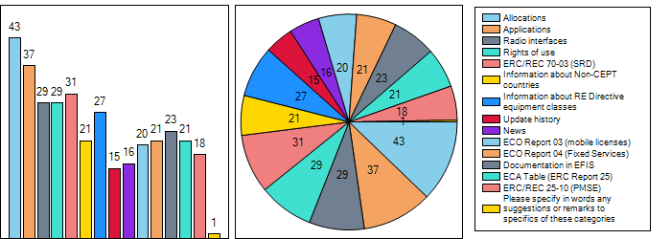The responses indicate a widespread distribution over all sections of the EFIS.

Question 6.1: Please specify in words any suggestions or remarks to specifics of these categories

With regard to ERC/REC 70-03
Two possible entry pages depending where you're coming from:
https://efis.dk/sitecontent.jsp?sitecontent=srd_regulations (EFIS)
https://www.erodocdb.dk/document/845 (ECO Doc)
Personally, I much prefer ECO Doc version. The pdf version is easier to read.
I would merge both pages. This new page would be made of the ECO Doc version (without the list of EN which is useless since already in the pdf) + the text below the list of Annexes in the EFIS version + in the "European SRD information in EFIS" I would replace the text by one link per Annex, e.g. "Export Annex 10 to CSV".

Only one suggestion has been made. SRD/MG is requested to look on this suggestion. Note that synergies between the documentation in DocDB and EFIS are anyway identified as an issue to look on in the near future.

Question 7:
Do you think some information in EFIS is missing, including some helping information for the user, which could be added?

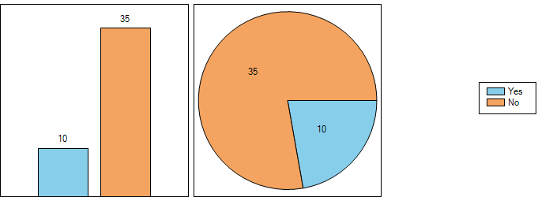

Question 7.1: If yes,

Please specify your suggestion for additional information
It always a question of, can I trust that the information is up-to-date and complete?
actual deployments per country i.e. fixed links
Helping information in general
As answer before in question 5, the information is there but I cannot manage to retrieve the application information without enter the frequencies.
NAT pdfs of CEPT countries can also be added.
Summary over frequency range for SRD (70-03), pmse and fixed.
Not sure if actual licensees are visible?
It should be far more intuitive not just for a frequency planning guy but also for a market surveillance guy. Seems to me still two different worlds market surveillance and frequency planning.
Maybe a help menu, or easier, a short document highlighting the possibilities of EFIS.
It would be helpful to have a short document (Tutorial) explaining what information can be queried.

The answers reveal the need for more information. The following action item is proposed by EFIS/MG: add throughout EFIS tooltips which provide helping information. These tooltips should also include cross-references/links to explain where other related information is found and the user can use the links to jump to this information in a new window.

Part III. Quality of information
Question 8:
National information in EFIS is uploaded by CEPT administrations. Have you spotted out-of-date information?

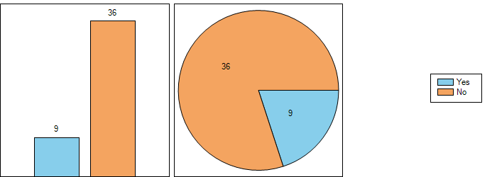

Question 8.1: If so,

Please specify your suggestion for improvement.
I'm not sure out of date, but e.g. Ukraine only provides information on frequency, not power etc
Problems with French data: RIS and part of ROU.
As soon as administrations are quite bureaucratic, to encourage them to update information it could be helpful to send an appropriate circular letter once a year.
Maybe, web services can be established between NATs and EFIS.
How do you get admins to keep records up to date?
We notice that for some countries there are lack of information or that the data is not up-to-date and information should be obtained from other sources (country websites, newsletters, etc.)
Some information still needs to be updated.
Not out-of-date information but missing information. I understand that it is the Administrations' responsibility to fill in the data.

Part IV. Features of EFIS
Question 9:
Which features of EFIS do you use on a regular basis?

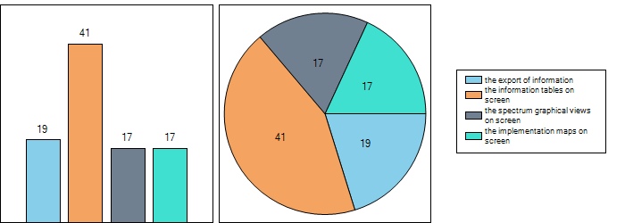

Question 10:
With regard to question 9. What would you improve relating to:

The information tables on screen? | The spectrum graphical views on screen? | The implementation maps on screen? | The export of information?
 |  |  | Better export possibilities, now some information is lost, and must be done copied from screen
 | There is no description about the abbreviations  "MFCN"  "MCV"  "RAS"  etc.  in "application"->"Graphical search" -> here: e.g. 300MHz-3GHz/Germany/Application/->Search  Maybe you add a list or link for them. |  | I need several times to understand how to set the lower and upper frequency selection (e.g. "application"->"Graphical search" -> here: e.g. 300MHz-3GHz/Germany/Application) when clicking to the create image /export table button. It's unclear that the "create image /export table button" sets the lower frequency and "highlight term" the upper frequency.  Why not using the selection in frequency bands for the "create image /export table button" (i.e. without clicking additionally on the graph)?
The band information is often broken into a few sub-bands. So it is hard to identify whether the entire band is allowed for the same use. |  |  | The "related documents" button is helpful to get the documents (with download links).
Find out means to process information so that it is always displayed on one screen.
Table of Application Search Results: When comparing results of several Frequency Tables together the columns are not so clearly separated from each other’s since there are no borders on the columns. | Allocation/Application, Graphical Search:  Highlight term: Recycled Bin icon is not visible in IE 11.0.9600.19100.  Google Chrome Version 68.0.3440.106 (Official Build) (32-bit) is fine.
No Update here | This is very helpful. The blocks under the application section are very helpful. The Zoom button is a good feature. The creation of a table is also very useful. | No improvement here. | The excel report to match the webpage. When I download the CSV excel from the right of use webpage everything is in column A. It is all compressed and the text doesn't appear in other cells.
no suggestions
use the hierarchy (search for Level1 can give also services from level 2 and 3) | I like it | I like it | I like it
When searching a frequency range for multiple countries, the page lists the frequencies defined by the countries searched and so the frequency ranges are listed non-consecutively. Instead of this, the page could list the frequencies consecutively. | It will be much better since colours used in graphical views are less user-friendly. Plus a legend can be added in somewhere in the graph and it can be saved as a jpeg file.
When selecting several countries, it soon gets unreadable.  I would suggest to have one line per country (instead of one column) + When country A has defined an entry over e.g. 869-880 MHz and country B over 873-880 MHz, it would be nice if we could get one column "869-873 MHz" and another one "873-880 MHz" instead of "869-880" and "873-880".  Furthermore, it would be good to have an option not to show entries very large, e.g. UWB or radiodetermination 30 MHz-12.4 GHz. | I hardly use it. It is not shown on the home page, so I don't have the reflex. | I must confess I don't know where I can find implementation maps.
To me it seems a bit that the user has to know some hidden tricks to make it run. E.G. how to select multiple countries in a list. Also the layout contains many elements, several scrollbars on the page. | As i said, i just use it once a year. I don’t know EFIS in detail. but every time i use it my overall impression is not that good. The idea to run a European database like EFIS on the other hand i find great.
 | Improved way to capture the URL associated with "Use this HTML for embedding the graph". Copying is not immediate and requires some work to try copy the complete address.

Actions identified: improvements for the frequency band split when comparing several countries, graphical view (highlight term) including link under consideration.

Part V. Ease of use and learnability for improvement
Question 11:
Do you find easily the data you look for?

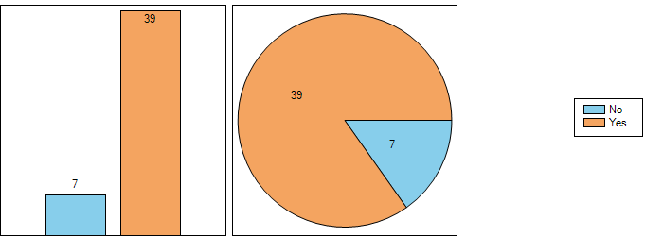

Question 11.1: If yes,

Is there still something that should be improved
Sometimes standards for e.g. R-LANs are found for 2GHz, 5GHz, etc. sometimes none of them are found (same settings). That's a bit annoying.
An "instruction book" to help newcomers
Only the search by application stated before
Maybe have a help button somewhere along the top which include the abbreviations.
to include lower levels
I would like to see usage of spectrum in different countries in one list. It works only when the countries are listed side by side.

Action to add tool tips already identified above (question 7.1). The following action item is proposed by EFIS/MG: add throughout EFIS tooltips which provide helping information. These tooltips should also include cross-references/links to explain where other related information is found and the user can use the links to jump to this information in a new window.

Question 11.2: If no,
What would you improve
It is in general difficult to locate
It is not straight forward when you need to select the level1/2/3 terms first.
Not all the time. I know that there is a frequency allocation at ~410-420MHz which has been licenced to Arquiva in the UK - this is very difficult to find and when I do find it, it undermines my confidence that when I search for a country that I don't know as much about their frequency allocations, i get the right result.
A search method more flexible
It is not easy but sometimes I find it. Think it depends also on the different mentality of the countries.
The documentation database. And the radio interfaces.

Note that synergies between the documentation in DocDB and EFIS are anyway identified as an issue to look on in the near future.

At this stage: no change of L1/L2/L3 search selection principles.

Question 12:
Do you think that the width of pages, the size of the reading screen, the fonts and the use of colours make reading smooth?

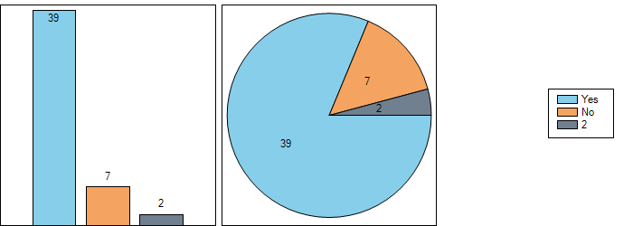

The next EFIS design modernisation is underway. The responses do not reveal any big issues with the current design

Question 13:
Are you able to grasp at a glance the structure of all pages?

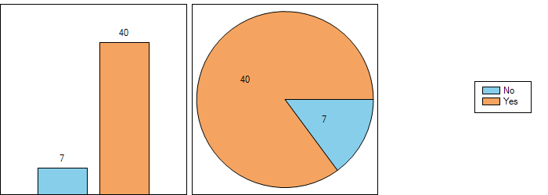

The next EFIS design modernisation is underway. The responses do not reveal any big issues with the current design.

Question 13.1: If yes
Is there anything that you would like to have improved
See last proposal in Q16: the layout of the search results could be organized in different sections, for well understanding.
For question 12: Grey background is not so nice.
The search result field could be expanded to fill the screen as much as possible

Question 13.2: If no,
What would you improve?
short introduction paper or adjusted colour/size/font/etc template scheme
See my remarks on question 11.
the structure of pages should be though, so that use of the scroll bar is as limited as possible.
some tracks are hard to find, for example for Report 03 has one extra click to get to "ECO Report 03 Information"
More explanatory text if you hover
Efis. Is not that intuitive. Also Facebook to me is not intuitive. Doodle is intuitive, and what’s app.
EFIS is useful for someone who works regularly with it. It should be also useful for a product manager or an electrical engineer which knows at least that frequencies are regulated with e.g. licences but does not know much about Regulation processes in Europe.

Check EFIS for the avoidance of extra clicks and shorten scroll bars by providing the possibility to select certain content (suppress/collapse the content which is not selected)

Question 14:
Do you find that the language used is difficult to understand?

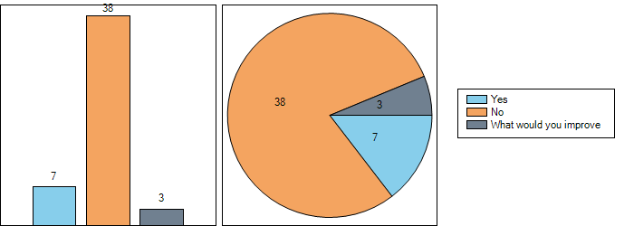

Question 14.1: Please specify what you would improve
The minimum level of skills required to use EFIS should be defined (the new comer) and on this basis, some text / short screen videos should be added on the main pages so that the newcomer can learn to become an EFIS expert.
No It is straightforward. There is an option to change the language if it is too difficult to read

Video tutorial and newcomer presentation(s) with EFIS usage examples to be included on the EFIS homepage.

Question 15:
Export of information from the EFIS: Do you think the features for the export of information from the EFIS should be improved?
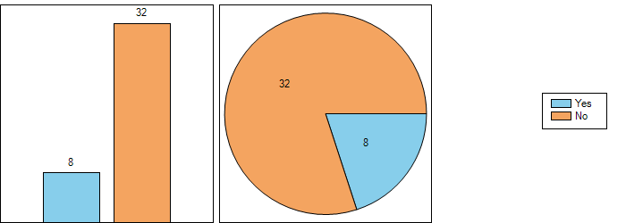

Note that there is a new export option becoming available with the EFIS application programming interface (API).

Question 15.1: If yes,
Please specify your suggestion.
Too coarse outcome, some info is missing. Page printout in pdf with re-designed layout would be good.
It should be more intuitive. Easier to select what you want to receive information about
When I export information, it would be really helpful to be able to plot country against frequency allocation - at the moment i have to rely of some very expert skills (by someone else) to get the data in an easy format to read.
Yes the excel report need working on. Everything is in column A and merge into it.
comments in documents
Exporting graphical search in a jpg file will be better.

Check csv exports. Split lower and upper frequencies in two columns. When having several tables, make sure that result is clear for each single table. Users can use their own tool to cut pictures.

Part VI. Further ideas?
Question 16:
Should you have further ideas to make EFIS more relevant in your work

Please feel free to develop them (you can also attach a file, here, to demonstrate your proposal(s)
Easier navigation around the page. Easier search. More information about what is behind the menus etc.
Add a search textbox through which get everything is concerned with the written keywords (documents, frequency allocation, restrictions in some Countries, ...).
I take this opportunity for a couple of remarks on ECO Doc and the way documents are sorted by default.
- ECC Decisions and EC Decisions should be sorted from the most recent year of FIRST publication to the oldest, and then within a year from the largest to the smallest order number.
(Thus, ERC/DEC/(01)19 to (00)02 should come before ERC/DEC/(99)26.)
- ECC Recommendations should be sorted similarly for ECC/REC and ECTRA/REC. Then ERC/REC/(01)02 to ERC/REC/(00)04, then ERC REC xx-yy from the largest xx-yy to the smallest, then T/R xx-yy similarly to ERC REC.
- ECC, CEPT and ECO Reports should be sorted from the highest to the smallest number.
The out of the database generated pdf should have bookmarks so the navigation in the document is easier (REC 70-03 as example).
EFIS system should be more promoted from the side of and inside the Administrations, also for clients, small manufactures and telecom operators. May be it should be more easily to find / read users’ manual, video tutorial with some searching examples and information what parameters, documents, graphs and so on could be searchable in EFIS. This might promote the usage of the system between "ordinary users".

The following action item is proposed by EFIS/MG: add throughout EFIS tooltips which provide helping information. These tooltips should also include cross-references/links to explain where other related information is found and the user can use the links to jump to this information in a new window.

One action identified for the DocDB: sorting documents from most recent to the oldest (default). The current sorting is suboptimal.

Ergonomics study from ANFR is to be taken into account by ECO for manual improvements (headlines, structure of text, links etc.) and also software improvements (borders, structure in showings). Several items identified for the action list. One tooltip should lead with a link to the update history, so users can easily find how old the information is.

