Cover Letter to Draft ECC Report 339:
“eCall Call-back Functionality”

WG NaN #23 meeting, 23-25 November 2021 has agreed to send into Public Consultation the draft ECC Report 339 “eCall Call-back Functionality”.

CEPT administrations and other stakeholders are invited to provide comments to
- section 4.4, do you have any further inputs as to whether the Calling Line Identity (CLI) of the Third Party Service eCall Provider (TPSP) or the In-vehicle System (IVS)-SIM is sent to the PSAP, and whether this is passed as part of the TPS-eCall Set of Data (TSD)?

eCall Call-back Functionality
approved DD Month YYYY
ECC Report 339

Executive summary
eCall is the pan-European emergency system for vehicles. According to Decision 585/2014/EU [1], EU Member States were required to deploy, by 1 October 2017, the necessary Public Safety Answering Point (PSAP) infrastructure to receive and handle eCalls. According to Regulation (EU) No 2015/758 [2], the fitting of the eCall in-vehicle system (IVS) is mandatory in all new types of M1 and N1 vehicles from 31 March 2018.
In a number of CEPT countries, eCall functionality has been tested end-to-end in order to verify whether all infrastructure components, including the IVS, electronic communications networks and PSAPs, are ready to handle eCalls. One of the tests carried out involves a call from the PSAP back to the IVS in the vehicle. This is referred to as an eCall call-back. It appears from such tests, and has since been noticed in actual operation, that in a number of cases it is not possible to make a call-back to the IVS.
The call-back functionality is an important element of the eCall system. For example, call-back might be necessary if the call is dropped for some reason (e.g., poor coverage) or if the PSAP calls back as a follow up after the initial eCall (e.g., for an update on the medical situation).
National experience demonstrates that there are several causes contributing to the eCall call-back failure particularly as consequence of the numbering choice. The matter is also complex due to the involvement of many actors, including PSAPs, PSAP hosting providers, fixed-line operators, mobile operators, and vehicle Original Equipment Manufacturers (OEMs).
From a technical-regulatory perspective, CEPT Administrations are to encourage electronic communications networks and/or services providers, where economically feasible, to provision the numbering ranges used for eCall in their networks to facilitate call-back from the PSAPs. All stakeholders should support technical developments that mitigate call-back issues related to erroneous transmission or absence of Calling Line Identity (CLI) to PSAPs.
With regard to commercial practices, increased outreach by OEMs and PSAPs with respective electronic communications networks and/or service providers, coupled with reasonable tariffs both for roaming access to SIMs used in IVS and for calls terminating on numbering ranges used for eCall which originate from PSAPs, would go a long way to resolve call-back issues.
The purpose of this ECC Report is to identify and describe the main causes of eCall call-back failure. The report also identifies mitigating measures and solutions that can, or in some cases have already been, implemented to resolve the problem while also indicating which actions are required from which parties in the supply chain.
Following the analysis undertaken and in accordance with ECC Recommendation (17)04 [18], the Report puts forward some potential solutions to address the operational issues identified as the main causes of eCall call-back failure:
- Increased awareness on the numbering ranges used for Subscriber Identity Modules (SIMs) in IVS to reduce cases where those involved in the conveyance of eCall call-back would have in place configurations which prohibit calls to these numbering ranges;
- Increased effort among stakeholders to establish roaming agreements and to take the necessary measures to ensure that SIMs in IVS would be valid, compatible, and remain seated correctly in the device even upon impact. This should reduce the quantity of eCalls being made while the device is in Limited Service State (LSS) when a Calling Line Identity (CLI) would not be made available to the PSAP call taker;
- Measures to ensure that whenever the CLI would be available for an eCall, this would be presented to the PSAP call taker in a valid and dialable format;
- PSAPs are also encouraged to discuss with their operators any excessive retail prices they may be charged for eCall call-back, especially for call-backs towards ITU global numbering ranges.
Furthermore, it should be recalled that ECC Recommendation (17)04 [18] amongst others recommends that:
- where E.164 numbering resources for global services (assigned by ITU TSB) or national numbering resources from another country are used, assignees are responsible and should make reasonable efforts to ensure that the numbers are diallable and facilitate call-back from the PSAP to the vehicle Europe-wide;
- encourage all operators to notify the ECO of numbering ranges assigned to them which are used, or plan to be used, for eCall;
- encourage all those operators involved in the conveyance of eCall call-back to commit to charging reasonable tariffs at both wholesale (termination and transit) and retail levels for calls originating from PSAPs towards numbering ranges used for eCall.
- ’For repondents to public consultation:
Based on the information provided in section 4.4, do you have any further inputs as to whether the CLI of the Third Party Service eCall Provider (TPSP) or the IVS-SIM is sent to the PSAP, and whether this is passed as part of the TPS-eCall Set of Data (TSD)?

TABLE OF CONTENTS

0 Executive summary 3
1 Introduction 6
2 Definitions 7
3 Regulatory framework and relevant standards for eCall call-back 8
4 The Impact on call-back of different implementations of eCall 9
4.1 eCall call flow 9
4.2 eCall call-back call flow 10
4.3 TPS eCall call flow 10
4.4 TPS eCall call-back flow 11
4.5 Active or dormant SIM 11
4.6 Global numbering resources or national numbers 12
4.7 SIM from a provider with or without roaming agreements 12
5 Problem description of inability to call back 13
5.1 CLI not Available 13
5.2 Correct CLI sent, but IT IS NOT CORRECTLY RECEIVED BY THE PSAP 13
5.3 CLI CORRECTLY RECEIVED BUT CANNOT BE CALLED BACK BY THE PSAP 14
6 Commercial aspects related to call costs 15
7 Conclusions 17
ANNEX 1: List of References 18

LIST OF ABBREVIATIONS

Abbreviation | Explanation
AECS | Accident Emergency Call Systems
CEN/EN | European Committee for Standardisation/European Standard
CEPT | European Conference of Postal and Telecommunications Administrations
CLI | Calling Line Identity
Ecall | Emergency call
ECC | Electronic Communications Committee
EENA | European Emergency Number Association
eSafety | electronic Safety
ETSI | European Telecommunications Standards Institute
EU | European Union
HLAP | High Level Application Requirements
IMEI | International Mobile Equipment Identity
IMSI | International Mobile Subscriber Identity
ITU | International Telecommunication Union
ITU-TSB | Telecommunication Standardisation Bureau
IVS | In-vehicle System
LSS | Limited Service State
MS | Mobile Station
MSD | Minimum Set of Data
M2M | Machine-to-Machine
MNO | Mobile Network Operator
NRA | National Regulatory Authority
OEM | Original Equipment Manufacturer
PBX | Private Branch Exchange
PLMN | Public Land Mobile Network
PSAP | Public Safety Answering Point
SIM | Subscriber Identity Module
TSD | TPS-eCall Set of Data
TPS eCall | Third Party Service eCall
TPSP | Third Party Service eCall Provider
UE | User Equipment
UNECE | United Nations Economic Commission for Europe
USIM | Universal Subscriber Identity Module

Introduction
Emergency call (eCall) is the pan-European emergency system for vehicles. According to Decision 585/2014/EU [1], EU Member States were required to deploy, by 1 October 2017, the necessary Public Safety Answering Point (PSAP) infrastructure to receive and handle eCalls. According to Regulation (EU) No 2015/758 [2], the fitting of the eCall in-vehicle system (IVS) is mandatory in all new types of M1 and N1 vehicles from 31 March 2018.
The eCall service may be implemented in two different ways [2]:
- The first is referred to as the 112-based eCall service where eCalls are directly routed to the PSAP;
- The second is referred to as third party services supported eCall (TPS eCall) service where the first leg of the eCall is routed to a service centre of a vehicle manufacturer (OEM) and the second leg is subsequently routed by the Third Party Service Provider (TPSP) service centre to the PSAP.
112-based eCall is mandatory while the implementation of TPS eCall is optional. When the vehicle is equipped with both eCall systems, the vehicle owner must be able to choose which eCall system to use at all times as these two systems cannot be active simultaneously but one system must always be active.
In a number of CEPT countries, eCall functionality has been tested end-to-end in order to verify whether all infrastructure components, including the IVS, electronic communications networks and PSAPs, are ready to handle eCalls. One of the tests carried out involves a call from the PSAP back to the IVS in the vehicle. This is referred to as an eCall call-back. It appears from such tests, and has since been noticed in actual operation, that in a number of cases it is not possible to make a call-back to the IVS.
The call-back functionality is an important element of the eCall system. For example, call-back might be necessary if the call is dropped for some reason (e.g. poor coverage) or if the PSAP calls back as a follow up after the initial eCall (e.g. for an update on the medical situation).
From national investigations of the eCall call-back issue, it appears that there may be several different causes with a technical, regulatory or commercial element contributing to the failure. The matter is also complex due to the involvement of many actors, including PSAPs, PSAP hosting providers, fixed-line operators, mobile operators, and vehicle OEMs.
The purpose of this ECC Report is to identify and describe the main causes of eCall call-back failure. The report also identifies mitigating measures and solutions that can, or in some cases have already been, implemented to resolve the problem while also indicating which actions are required from which parties in the supply chain.
Some issues with eCall call-back have already been resolved at a national level in some countries. In order to ensure that call-back functions right across Europe, the cooperation of all stakeholders in the supply chain is required. It is important to recall the ECC Recommendation (17)04 [18] Numbering for eCall which recommends the different numbering options and linked responsibilities of the assignees of the numbering resources made available for eCall. PSAPs need to be able to rely on the CLI so that a call-back can be made.
This may also include a need for clarification and/or adaptation of the European legal framework for eCall in the future.

Definitions
In the table below, some definitions are provided directly from other sources (e.g. European legislation, ETSI standards etc). Other definitions have been formulated from multiple sources solely for the context of this Report.
Term | Definition
Dormant SIM | In the context of eCall, a dormant SIM does not camp on to a mobile network but is only activated when an eCall is made. While in the dormant state, the eCall IVS is not transmitting in a way that allows the device to be tracked [5].
eCall | EU Regulation 2015/758 [6] defines an eCall as an "in-vehicle emergency call to 112, made either automatically by means of the activation of in-vehicle sensors or manually, which carries a minimum set of data and establishes an audio channel between the vehicle and the eCall PSAP via public mobile wireless communications".
In-Vehicle System (IVS) | EU Regulation 2015/758 [6] defines an IVS as "an emergency system, comprising in-vehicle equipment and the means to trigger, manage and enact the eCall transmission, that is activated either automatically via in-vehicle sensors or manually, which carries, by means of public mobile wireless communications networks, a minimum set of data and establishes a 112-based audio channel between the occupants of the vehicle and an eCall PSAP".
Limited Service State (LSS) | If a mobile device is unable to find a suitable cell to camp on, or the SIM is not inserted, or the location registration failed, it attempts to camp on a cell irrespective of the Public Land Mobile Network (PLMN) identity, and enters a "limited service state" in which it can only attempt to make emergency calls.
Minimum Set of Data (MSD) | EU Regulation 2015/758 [6] defines the MSD as "the information defined by the standard ‘Intelligent transport systems — eSafety — eCall minimum set of data (MSD)’ (EN 15722:2011) which is sent to the eCall PSAP". This includes information such as Vehicle Type, Vehicle Identification Number, Position Latitude, Position Longitude and Vehicle Direction.
Originating Network | An originating network is the network to which the IVS is directly connected when an eCall is made.
Provisioning provider | The provisioning provider is responsible for providing and activating a customer's services on a mobile network. In the context of eCall, the provisioning provider has an agreement to supply a vehicle manufacturer with SIM for its IVS. This would include associated identifiers such as E.212 International Mobile Subscriber Identity (IMSI) resources and E.164 telephone numbering resources. Connectivity would then be provided to the IVS using the provisioning provider's home network or would be based on roaming agreements between the provisioning provider and a visited network when the home network is not available.
PSAP | The EECC [4] defines a PSAP as a "physical location where an emergency communication is first received under the responsibility of a public authority or a private organisation recognised by the Member State".
SIM-less emergency call | ETSI TS 123 271 V7.10.0 [7] defines a SIM-less emergency call as "an emergency call that is originated from a User Equipment (UE), which does not have a SIM or Universal Subscriber Identity Module (USIM)".

relevant standards for eCall call-back
Regardless of whether a 112-based or TPS eCall service implementation is adopted by OEMs, the provisions of Article 3.1 of EU Delegated Regulation on eCall (305/2013) [8] apply, namely that "Member States shall ensure that any eCall PSAP is equipped to handle eCalls and receive the MSD originating from the in-vehicle equipment according to the standards ‘Intelligent transport system - eSafety - pan-European eCall - Operating requirements’ (EN 16072) and ‘Intelligent transport systems eSafety - eCall High Level Application Requirements (HLAP)’ (EN 16062)".
eCall call-back is not specifically mentioned in the Regulation but European Committee for Standardisation/European Standard (CEN/EN) 16062 [9] and CEN/EN 16072 [10] are specifically referenced and include specifications for testing of the call-back functionality for the in-vehicle equipment (IVS – In Vehicle System). In particular, Section 7.17.2 of CEN/EN 16072 sets out that "the IVS shall remain registered on the network for at least 60 minutes after an eCall is terminated in order to allow call back from the PSAP". By extension, the definition of a period of time to allow for call-back implies that call-back itself is an operating requirement for handling eCalls.
Article 4 of EU Delegated Regulation on eCall (305/2013) [8] states that "Member States shall designate the authorities that are competent for assessing the conformity of the operations of the eCall PSAPs with the requirements listed in Article 3 and shall notify them to the Commission. Conformity assessment shall be based on the part of the standard ‘Intelligent transport systems - eSafety - eCall end to end conformance testing’ (EN 16454) that relates to PSAPs conformance to pan-European eCall". Despite this requirement, a test for eCall call-back is not currently part of the type approval procedure although satisfying the conformity requirements of CEN/EN 16454 [11] implies that it should be.

The Impact on call-back of different implementations of eCall
An eCall is an emergency call (to 112) with some added features. When an eCall is made and a connection is established with the PSAP, the MSD is sent "in-band" over the same voice channel to the PSAP. Equipment at the PSAP is able to process the MSD and display it on the call taker's screen during the call. The CLI, if available, and the eCall discriminator flag (indicating whether the eCall was manually or automatically triggered) are sent in the signalling channel with the call and this information is also displayed on the call taker's screen.
If the PSAP wishes to call back, for whatever reason, the CLI is used to do so. This will usually be done via a fixed network to which the PSAP is connected. If the PSAP's network operator (and any transit operators involved) are capable of conveying calls towards the called number, a connection can be made.
In the implementation of eCall, there are many choices to be made and they are made by many different parties involved. It is the combination of these choices and parties that makes it sometimes hard to determine what it is that makes the call-back fail. This Chapter examines some of those choices. It looks at the call flows for both pan-European 112 eCall and TPS eCall and identifies points of failure for eCall call-back.

eCall call flow
In March 2020, an article published in ITU News [3] included an informative diagram which illustrates the call flows, and involved actors, for both an eCall and an eCall call-back. This diagram is reproduced below in Figure 1. In this example ITU-T E.164 numbers with country code 882 and 883 are used but the principles described also apply to other numbering ranges such as national mobile and Machine-to-Machine (M2M) numbering ranges.
The top-half of Figure 1 describes the eCall call flow. In the top-left of Figure 1, the vehicle is fitted with an IVS which camps on to a base station and has the capability to make an emergency call to 112. If eCall is activated, either manually or automatically, a call to 112 is made. The call is carried from the originating network (i.e. the visited mobile network in the figure) to a national operator serving the PSAP. The emergency call is terminated at the PSAP. A call to 112 is free of charge and, even if the IVS is in LSS, the call will be carried. Only national operators are involved in originating and terminating the call.
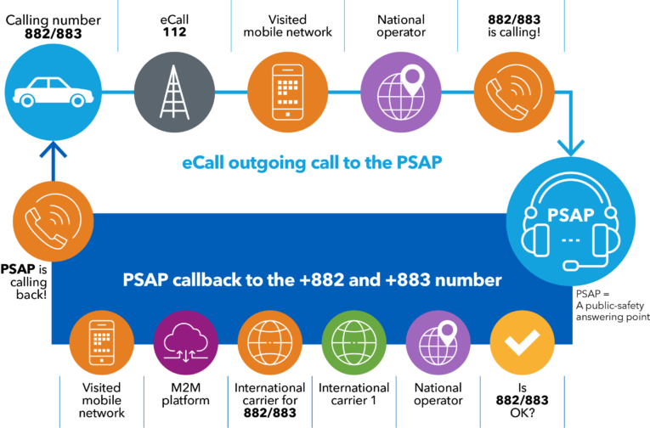

Figure 1: eCall call flows (Source: ITU News)

eCall call-back call flow
eCall call-back can be more complex and more actors may be involved. The bottom-half of Figure 1 above describes this in the context of an IVS which is assigned a 15-digit telephone number with country code 882 or 883. When the initial eCall is made, the PSAP operator will receive the originating telephone number in the CLI field with the call. This is provided that the IVS has fully registered on the visited mobile network and is not in LSS. The CLI received is used to place a call to the IVS. If the call fails, the problem, which may be technical and/or commercial in nature, could reside with any of the actors in the supply chain. There are many different numbering ranges that could be assigned to eCall IVS devices (e.g. national mobile numbers, national M2M numbers, other global numbers). All of the numbering options have different characteristics including digit length and call cost. Some or all of the issues described in the next sections could arise irrespective of the type of number used in the IVS.

TPS eCall call flow
The regulatory framework for eCall leaves some discretion to OEMs and electronic communications service providers on how to implement eCall. Some OEMs have offered in-vehicle services for many years. The driver of the vehicle can press a button in the vehicle and be connected to an assistant who can help with services such as hotel bookings, directions, vehicle diagnostics and roadside assistance. Many, if not all, of these services must be paid for (e.g. via subscription). These types of services also offer an emergency service similar to eCall and the regulatory framework leaves room for the existence of, what is referred to as, a TPS eCall. With this approach a customer buying a new vehicle may opt for either the mandatory eCall service (pan-European eCall) or for TPS eCall provided the following four conditions are met:
- The TPS service must comply with CEN/EN 16102 [12];
- Only one system can be active at a time and in the case the private TPS does not function, pan-European 112 eCall will be triggered instead;
- The vehicle owner may at any time choose to use the pan-European eCall instead of the TPS service; and
- No exchange of data can take place between the TPS system and the pan-European 112 eCall system.
Figure 2 below illustrates the additional steps involved in the TPS eCall call flow when compared to the pan-European 112 eCall service.
Figure 2: Pan-European eCall Vs TPS eCall (Source: EENA)
With pan-European eCall, the eCall is sent directly to the PSAP and is a public service which is free of charge to the caller. TPS eCall introduces a third party in the eCall call flow using other standards for handling the call. When TPS eCall is triggered the call is to the TPSP. The call taker will evaluate the call and if it is a real emergency, they will forward the call to the PSAP together with the TSD. An agreement is required between national PSAPs and TPSPs regarding the handling of these calls.

TPS eCall call-back flow
- ’For respondents to public consultation:
Based on the information provided in this section, do you have any further inputs as to whether the CLI of the TPSP or the IVS-SIM is sent to the PSAP, and whether this is passed as part of the TSD?
When a TPS eCall is received by the TPSP, the CLI of the IVS will be presented to the TPSP call taker. If the caller requires emergency services assistance, a call will be placed to the most appropriate PSAP. The CLI of the TPSP, not the IVS, will be presented to the PSAP call taker. This is a problem for call-back as the PSAP will need to call back to the IVS in the vehicle. It is possible that the CLI of the IVS is provided either as part of the TSD over a data connection or verbally to the PSAP call taker. For the purposes of this Report, it has not been established what kind of arrangements exist at present. This is illustrated in Figure 3.
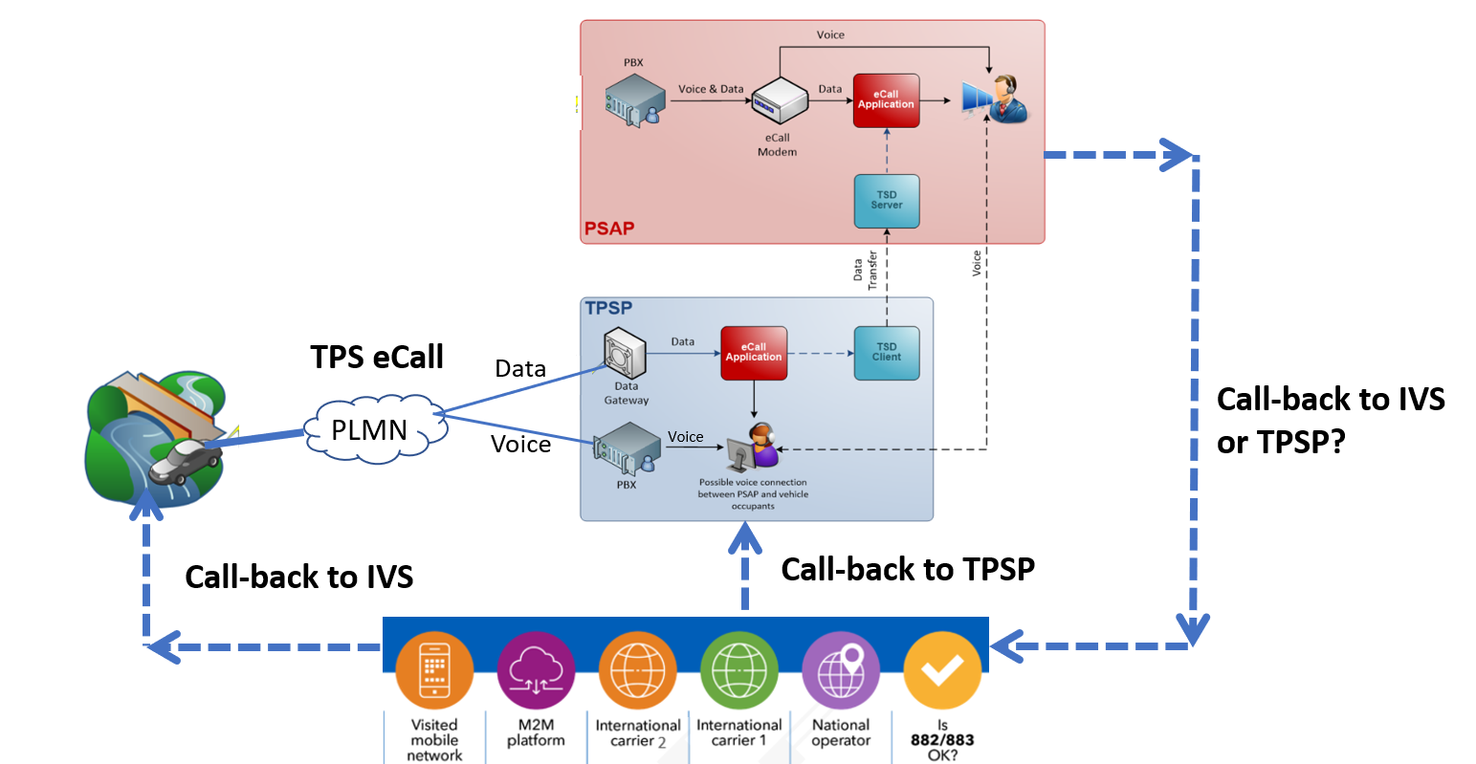
Figure 3: Pan-European eCall Call-back

Active or dormant SIM
A European Commission Impact Assessment from 2011 [14] discusses the need for eCall to comply with legislation on privacy and the protection of personal data. Section 2.5 of the document states that "unless an accident happens or an occupant presses the manual button, the in-vehicle device will be dormant. Thus, eCall will not allow a vehicle to be remotely located unless there is an accident. The call will be directed to Public Safety Answering Points (PSAPs), which will ensure respect of protection of personal data, as it is currently the case for emergency calls. Minimisation of data has been applied when designing the contents of the Minimum Set of Data to be transmitted". The concept of this stipulation is that whilst the eCall IVS is in idle mode waiting to place a call, it is sleeping or dormant and therefore not registered on the network. This implies that the IVS is not transmitting in a way that allows the device to be tracked.
The document also gives guidance on the situation for TPS eCall. In case the eCall in-vehicle platform is used to provide value added services other than the emergency call (optional choice by the consumer if available), provisions for privacy and protection of personal data should be covered by the appropriate contract between the user and the TPS provider. For TPS eCall, it is important to note that the SIM would need to be active all the time to support the value added services offered.
Therefore, there are two variants regarding the SIM, namely, active and dormant.
If the eCall IVS contains an active SIM it will register on an available network when the vehicle is switched on in accordance with CEN/EN 16072. If the network is a home network (i.e. the provisioning provider's network) or a visited network with which the home network has a roaming agreement, the IVS will fully register on the network. If an eCall is made in this situation the CLI of the IVS will be sent to the PSAP with the call and the PSAP should be able to make a call-back to the IVS using this CLI if required. If there is no roaming agreement or there is poor coverage on the home network, the connection will be in LSS on an available network.
With a dormant SIM, the registration will only happen when an eCall is initiated. This will result in a delay as the IVS will need to register on the network before the eCall can be made. The length of this delay may vary. It would depend on factors such as the length of time that has elapsed since the IVS last connected to a network and whether or not the device is roaming. If the delay is too long it is possible that the device will connect to an available network in LSS.

Global numbering resources or national numbers
Each IVS SIM must be assigned an E.164 number by the provisioning provider. This number can be a global number from an ITU numbering range (e.g. 15-digit numbers with country code 882 or 883) or a number from a national numbering plan (typically a mobile number or an M2M number). Service providers in Europe are required, where economically feasible, to make calls possible to all national numbers pertaining to EU/EEA Member States in accordance with Article 97 of the EECC [4]. No such obligation exists in the EECC for access to numbers other than those in national numbering plans of EU/EEA Member States or to Universal International Freephone Numbers (UIFNs).

SIM from a provider with or without roaming agreements
The SIM can be provisioned by a provider from inside or outside the EU/EEA. Provisioning providers from outside the EU/EEA may be the cause of several issues, such as absence of roaming agreements resulting in LSS with no CLI or high costs involved in the call-back.
In some countries, emergency calls from devices in LSS have the International Mobile Equipment Identity (IMEI) (and/or another identifier such as the IMSI) of the device inserted into the CLI field by the originating operator. An IMEI number is an identifier and is used in the telecom domain to make it possible to identify wireless devices on a GSM, UMTS or other IMEI-supported wireless network [15]. It is possible that the originating network could also send the IMEI and/or IMSI from the calling IVS in LSS when the CLI is not available. This would depend on national implementation. In most countries no information will be available in the CLI field for emergency calls from devices in LSS.
IMEI and IMSI numbers have a similar length as E.164 numbers when expressed in international format. It is therefore possible that this identifier may be mistaken for a CLI. This increases the risk that the 112 PSAP attempts a call to a number that will not connect them to an eCall IVS but could connect them to someone else.

Problem description of inability to call back
In this section possible categories of failure of eCall call-back are described. There are three main categories for call-back failure, namely:
- There is no CLI available with the eCall;
- There is a CLI but it is not correctly received by the PSAP;
- The CLI is correctly received but cannot be called back by the PSAP.

For each of these categories, some underlying causes and potential solutions are identified.

CLI not available
If there is no valid CLI sent to the PSAP with the eCall, it will not be possible to initiate a call-back. The CLI must be presented to the call taker in a valid and dialable format. The most common reason for an eCall not having a CLI is in the case where the IVS is connected to the mobile network in LSS. In general, LSS can happen if:
- A mobile device's home network is not available and there is no roaming agreement between the home network and the visited network;
- The device does not contain a valid SIM, the SIM is incompatible, or the SIM is not seated correctly.
It should be noted that emergency calls from SIM-less devices are prohibited in several European countries so the eCall IVS should always have a SIM.
SOLUTION: There is no currently available solution to provide a CLI for a device in LSS. Nevertheless, Mobile Network Operators (MNOs) should ensure that roaming agreements are in place to ensure that full registration on all European mobile networks is possible.
SOLUTION: Every effort should be taken by OEMs and MNOs to ensure that eCall IVS devices are installed with valid and compatible SIMs. Also, sufficient stress testing of devices should be undertaken to ascertain that SIMs remain seated correctly in the device, even upon sudden impacts (e.g. vehicle crash).

Correct CLI sent, but it is not correctly received by the PSAP
Even when the CLI has been correctly sent by the IVS, it is sometimes impossible to call back to the vehicle since the CLI is not correctly received by the PSAP. This happened in Portugal but a fix has since been implemented. The problem related to eCalls received from IVS which erroneously generated a CLI with17-digits in length (e.g. the international prefix 00 with a 15-digit international telephone number beginning with 88). The PSAP's system was configured to only process a CLI with the maximum of 15 digits. This resulted in the last two digits being truncated. As a consequence, the correct CLI was not presented to the call taker, and it was therefore not possible to call-back. This case is illustrated in Figure 4 below.
SOLUTION: PSAPs, and all solutions providers and operators involved in the conveyance of eCall should work together to ensure that the CLI is presented to PSAP call takers in a valid and dialable format.

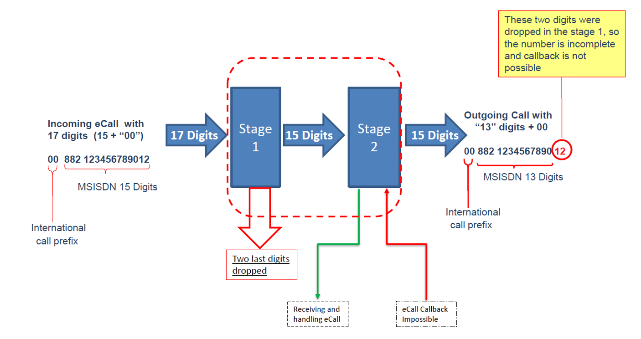
Figure 4: Portuguese Case (Source: Secretaria Geral da Administração Interna)

CLI correctly received but cannot be called back by the PSAP
Another issue might arise in particular with the use of global numbering resources whereby the PSAP's Private Branch Exchange (PBX) may be configured to prohibit those numbers from being dialled or the PSAP's service provider (or any transit operator involved) may not allow calls to such numbers on their networks (e.g. due to lack of awareness of the numbering ranges used for eCall or due to concerns on misuse and/or fraudulent use of numbers from such ranges due to past incidents). The cost of calling these numbers is also an issue which is discussed in detail in the next Chapter.
SOLUTION: In line with the ECC Recommendation (17)04 Numbering for eCall, parties required to provide eCall connectivity should in their evaluation of the numbering resources to be used, weigh the advantages and disadvantages of the different options (using national or ITU global numbering resources) and take into account, among others, the requirement for call-back. The ECC, through an amendment to ECC Recommendation (17)04, is taking steps to provide a central reference point for information on such numbering ranges to facilitate this.
SOLUTION: PSAPs, and all solutions providers and operators involved in the conveyance of eCall should work together to ensure that the correct configuration is in place to facilitate a call-back to any known numbering range that may be used in eCall IVS devices.

Commercial aspects related to call costs
In a national context, consumers have a reasonable expectation regarding the charges they will incur for calling different types of national numbers. When numbers are unrecognisable it is difficult for consumers to determine what they will be charged for a call to those numbers. This logic also extends to PSAP call takers when they need to make a call-back to an emergency caller.
It is very likely, and indeed evidence is already present, that eCall IVS devices will be assigned numbers from many different numbering ranges, both from national numbering plans and international numbering plans. For example, during a meeting of the European eCall Implementation Platform, France presented its experience with eCall since it came into effect in April 2018. In 2019, approximately 66% of eCalls received in France had a CLI beginning with 882 or 883 and at least three large operators with a multi-country footprint have made a notification to the ITU [16] that they are using numbers with prefixes 882 and 883 for SIMs in eCall IVS systems. These numbers are intended for international networks for services not dedicated to a single country such as M2M and high-tariff satellite services.
To gather information on the situation in CEPT countries on the numbering ranges in use for eCall and the associated tariffs that apply on calling back on these number ranges, the ECC circulated a questionnaire to CEPT administrations in June 2020. 15 responses were received.
The questionnaire focused on these issues for the following main reasons:
- Commercial aspects, which include both wholesale and retail considerations, might give rise to issues when the call-back is towards global numbers, as opposed to an eCall IVS provisioned with national fixed or mobile numbers;
- ITU TSB Circular 249 of 12 May 2020 [17], says that a call to those global numbers should not exceed the cost of a "traditional international call to a mobile number";
- Since ITU TSB Circular 249 encourages NRAs to open national networks to those global numbers, the questionnaire also sought to weigh the respective implications of such action, including respective economic feasibility considerations;
- It is important to understand what European country numbers actually are in use for eCall in Europe.
The questionnaire sought to:
- Find out if specific numbering ranges have been designated in national numbering plans for eCall;
- Understand which types of numbers are actually in use for eCall whether from national numbering plans of European countries or others; and
- Obtain an overview on the tariffs being charged to PSAPs at the retail level for calls to the ITU Global numbering ranges with prefixes 882 37, 882 39 and 883 130, and (for comparative purposes) to a European mobile number.

The information requested on call costs is important in order to facilitate understanding as to why call costs, both at wholesale and retail level, vary considerably when the call-back is towards national fixed or mobile numbers, as opposed to an eCall IVS provisioned with global numbers.
On the numbering aspects, the results of the questionnaire can be summarised as follows:
- Three countries have a numbering range designated for M2M which may also be used for eCall;
- One of these three countries also permits the use of national mobile numbers for eCall;
- One non-EU country, the Russian Federation, has an exclusive numbering range for their own eCall-style system called ERA GLONASS;
- Eleven countries have not decided yet or did not answer this question.
On the call cost aspects, respondents were asked to provide the cost of making a call-back from a PSAP to the ITU Global numbering ranges with prefixes 882 37, 882 39 and 883 130, and it was verified that the costs differ widely and can be very expensive (range between € 0.050 and € 9.3489 per minute), particularly compared to calls towards national mobile numbers. In some countries, the tariff for all three numbering ranges is the same while in other countries operators use different tariffs for these ranges. This is applicable for both fixed and mobile operators.

At the wholesale level, it was mentioned by an operator in one country that it has no commercial agreement with one or more of those networks utilising global numbering resources and so that operator networks are not open on mobile or / and fixed level.
Of course, it is understood that these tariffs are a snapshot and may change over time. But it is clear that call costs of several Euros per minute may raise a significant economic barrier for eCall call-back.
A call to an IVS in effect is a call to a mobile device. There may be other actors involved in case the IVS uses a number not pertaining to the national numbering plan of the country where the PSAP is located, which could raise costs especially when a global ITU number is used. However, from a technical perspective this does not justify the enormous variation in costs when compared to a regular call to a mobile device originated and terminated in Europe. Furthermore, it was observed from the questionnaire responses that prices may differ significantly between operators in one country and at times significant variations were also observed for charges applied by one operator for calls to the different ITU global numbering ranges. It seems that many operators charge as if these calls are calls to satellite operated phones which they are not.
Nevertheless, there have been cases where PSAPs incurred high charges for calls to these numbers. PSAPs are therefore recommended to contact their operators to discuss the prices they are charged for calls to these ITU global numbering ranges. This has already been done in some cases and based on information provided in response to the questionnaire, in one country the call charges for PSAPs were reduced to acceptable levels.
For ITU global numbering ranges with country codes 882 and 883 used for eCall to be accessible from national networks and not barred at PSAP level, all those operators involved in the conveyance of eCall call-back are encouraged to commit to charging reasonable tariffs at both wholesale (termination and transit) and retail levels for calls originating from PSAPs towards numbering ranges used for eCall, in accordance with the amendments introduced to ECC Recommendation 17(04) [18].

Conclusions
The problems facing eCall call-back can be summarised under two root causes - difficulties of a 'technical regulatory' nature, or limitations stemming from unsupportive commercial relationships particularly as consequence of the numbering choice. Indeed, given the issues raised in this report, parties required to provide eCall connectivity should, in their assessment of the chosen numbering resources, take into account not only the benefits of the numbering range, but also those facets that can result in difficulties to effect eCall call-back.
From a technical-regulatory perspective, CEPT Administrations are to encourage electronic communications networks and/or services providers, where economically feasible, to provision the numbering ranges used for eCall in their networks to facilitate call-back from the PSAPs. All stakeholders should support technical developments that mitigate call-back issues related to erroneous transmission or absence of CLI to PSAPs.
With regard to commercial practices, increased outreach by OEMs and PSAPs with respective electronic communications networks and/or service providers, coupled with reasonable tariffs both for roaming access to SIMs used in IVS and for calls terminating on numbering ranges used for eCall which originate from PSAPs, would go a long way to resolve call-back issues.
It should be recalled that ECC Recommendation (17)04 [18] amongst others recommends:
- where E.164 numbering resources for global services (assigned by ITU TSB) or national numbering resources from another country are used, assignees are responsible and should make reasonable efforts to ensure that the numbers are diallable and facilitate call-back from the PSAP to the vehicle Europe-wide;
- encourage all operators to notify the ECO of numbering ranges assigned to them which are used, or plan to be used, for eCall;
- encourage all those operators involved in the conveyance of eCall call-back to commit to charging reasonable tariffs at both wholesale (termination and transit) and retail levels for calls originating from PSAPs towards numbering ranges used for eCall.
Hereunder is a summary of potential solutions being proposed in order to address the operational issues identified in this report and in accordance with ECC Recommendation (17)04 as the main causes of eCall call-back failure:
- Increased awareness on the numbering ranges used for SIMs in IVS to reduce cases where those involved in the conveyance of eCall call-back would have in place configurations which prohibit calls to these numbering ranges;
- Increased effort among stakeholders to establish roaming agreements and to take the necessary measures to ensure that SIMs in IVS would be valid, compatible, and remain seated correctly in the device even upon impact. This should reduce the quantity of eCalls being made while the device is in LSS when a CLI would not be made available to the PSAP call taker;
- Measures to ensure that whenever the CLI would be available for an eCall, this would be presented to the PSAP call taker in a valid and dialable format;
- Operators involved in the conveyance of eCall call-back are encouraged to commit to charging reasonable tariffs at both wholesale (termination and transit) and retail levels for calls originating from PSAPs towards numbering ranges used for eCall;
- PSAPs are also encouraged to discuss with their operators any excessive retail prices they may be charged for eCall call-back, especially for call-backs towards ITU global numbering ranges.
Solving the problems of eCall call-back functionality requires a Europe-wide approach. In the meantime, it could be possible that certain partial measures could be taken at national level as proposed in ECC Recommendation (17)04 and this ECC Report to address some of the identified issues.
- List of References

- Decision No 585/2014/EU of the European Parliament and of the Council of 15 May 2014 on the deployment of the interoperable EU-wide eCall service
- Regulation (EU) 2015/758 of the European Parliament and of the Council of 29 April 2015 concerning type-approval requirements for the deployment of the eCall in-vehicle system based on the 112 service and amending Directive 2007/46/EC
- ITU News Article: “Why ITU-assigned numbering ranges are critical to road safety”, March 2020
- Directive (EU) 2018/1972 of the Parliament and of the Council of 11 December 2018 establishing the European Electronic Communications Code (Recast)
- European Commission - eCall Phase 2: “Technical requirements and test procedures for the type-approval of eCall in-vehicle systems”, June 2015
- Regulation (EU) 2015/758 of the European Parliament and of the Council of 29 April 2015 concerning type-approval requirements for the deployment of the eCall in-vehicle system based on the 112 service and amending Directive 2007/46/EC
- ETSI TS 123 271 V7.10.0: “Digital cellular telecommunications system (Phase 2+); Universal Mobile Telecommunications System (UMTS); LTE; Functional stage 2 description of Location Services (LCS) (3GPP TS 23.271 version 7.10.0 Release 7)”, January 2010
- Commission Delegated Regulation (EU) No 305/2013 of 26 November 2012 supplementing Directive 2010/40/EU of the European Parliament and of the Council with regard to the harmonised provision for an interoperable EU-wide eCall
- CEN/EN 16062: “Intelligent transport systems - eSafety - eCall high level application requirements (HLAP) using GSM/UMTS circuit switched networks”
- CEN/EN 16072: “Intelligent transport systems - eSafety - Pan-European eCall operating requirements”
- CEN/EN 16454: “Intelligent transport systems - eSafety - eCall end to end conformance testing”
- CEN/EN 16102: “Intelligent transport systems - eCall - Operating requirements for third party support”
- EENA Factsheet: “eCall - Everything you wanted to ask but did not know”, 2015
- European Commission Staff Working Paper: “Impact Assessment accompanying the document Commission Recommendation on support for an EU-wide eCall service in electronic communication networks for the transmission of in-vehicle emergency calls based on 112 ('eCalls')”, September 2011
- ETSI TS 123 003 V15.7.0: “Digital cellular telecommunications system (Phase 2+) (GSM); Universal Mobile Telecommunications System (UMTS); Numbering, addressing and identification (3GPP TS 23.003 version 15.7.0 Release 15)”, July 2019.
- ITU-T Operational Bulletin No. 1155-4, September 2018 (see note from TSB on page 4)
- ITU-T TSB (Study Period 2017) Circular 249: “Global numbers used for the in-car emergency services such as European eCall service”, May 2020
- ECC Recommendation 17(04): “Numbering for eCall”, approved November 2017 and amended December 2020

Category M: used for the carriage of passengers. Category M1: no more than eight seats in addition to the driver seat (mainly, cars)
Category N: used for the carriage of goods (trucks): Category N1: having a maximum mass not exceeding 3.5 tonnes (7700 lb)
Category M: used for the carriage of passengers. Category M1: no more than eight seats in addition to the driver seat (mainly cars)
Category N: used for the carriage of goods (trucks): Category N1: having a maximum mass not exceeding 3.5 tonnes (7700 lb)
TPS providers are allowed to add any valuable information to the original MSD transmission from the vehicle. In this case, the final package will be called TSD (TPS-eCall Set of Data).

